
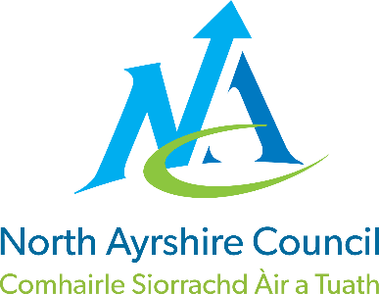

Dykesmains Primary School

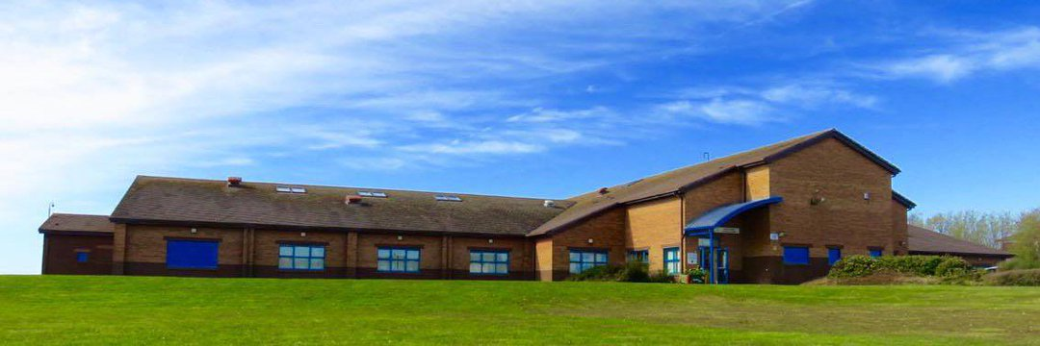

STANDARDS AND QUALITY REPORT
June 2026
This report will inform you of the school’s progress and achievements in the last session and let you know about our plans for 2026-2027.
I hope that you find it helpful and informative.

Elizabeth Gribben

Head Teacher

OUR SCHOOL
Dykesmains Primary is an open plan building situated in Saltcoats, a town on the west coast of Scotland. The school is non-denominational, with a current role of 183 pupils (June 2026). We have built a strong school community, with 40% of our pupils living within the Scottish Index of Multiple Deprivation (SIMD) deciles 1 and 2. This is the Scottish Governments standard approach to represent areas of deprivation in Scotland. To promote equity, wellbeing and positive outcomes for all children we work closely with partners to offer a wide range of opportunities across the year. We have excellent links with our local secondary school, Ardrossan Academy and offer a wide range of experiences through clubs and events working closely with Active Schools, Phunky Foods, Area Inclusion Worker, Family Wellbeing Team and our local library.
OUR VISION, VALUES AND AIMS
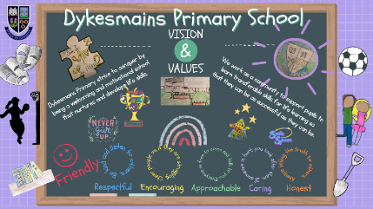
Our Vision
Dykesmains Primary is a welcoming and motivational school that nurtures and develops life skills. We work as a community to support pupils to learn transferable skills for life to enable pupils to achieve the best possible outcomes.
Our Aims
- To create a safe, healthy and welcoming school.
- To ensure our children feel happy and secure within our community.
- To support children and families educationally, emotionally and socially.
- To provide a wide variety of opportunities and experiences to enable us to maximise each child’s potential.
- To encourage our children to be independent and take responsibility for their own learning.

- To equip our children with the knowledge and skills to make healthy choices now and in the future.
Our Values
We strive for excellence and equality for all through our school values.
Friendly, Respectful, Encouraging, Approachable, Caring, Honest
Click here to View our Vision and Values video or use the QR code.
ATTAINMENT & ACHIEVEMENT
Throughout the year, we gather information on how our children are progressing in their learning. To monitor their progress, we observe children working through tasks, listen to what they say, ask questions, set challenges and use standardised assessments.
North Ayrshire Council ask us to provide information on pupil progress in reading, writing, listening and talking and numeracy/maths. We record children who have reached the end of Early, First and Second Levels. These levels are usually, but not always, achieved in P1, P4 and P7. We are proud of how well our children are achieving

2024-2025 | Listening & Talking | Reading | Writing | Maths
Primary 1 | 93% | 89% | 82% | 89%
Primary 4 | 85% | 85% | 85% | 85%
Primary 7 | 86% | 86% | 86% | 82%

Attendance and Exclusion
Current attendance for pupils is 94%, This has remained steady over the last 3 years. Dykesmains Primary is slightly above North Ayrshire Council attendance average, 92%. There have been no exclusions across the last 4 years.
WIDER ACHIEVEMENT
Digital Learning
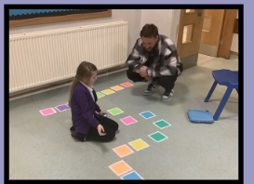
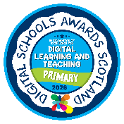
In line with our School Improvement Plan, there was a significant emphasis on digital learning, ensuring opportunities for progression across the school.
We are delighted to have been awarded the Digital Schools Award. This award recognises schools for effectively using digital technology to support learning, teaching and leadership, helping to develop pupils’ digital skills for the future.
This year coding skills were a focus. We introduced our children to Sphero Mini and Sphero Indi robots and invited families into school to learn alongside their child.

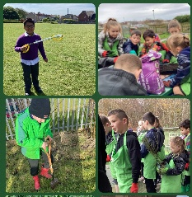
RSPB Wild Challenge Award

Over the last 3 years, our children have been involved in the RSPB Wild Challenge. Children take part in the Bronze, Silver and Gold Award by completing three ‘Experiencing Nature’ and three ‘Helping Nature’ activities for each level.
Our Primary 4-7 classes have now achieved their Gold Award, Primary 2 their Silver and Primary 1 have been introduced to the award this year and have achieved their Bronze Award. The Wild Challenge links into our Learning for Sustainability progression planner and will support the development of our outdoor learning curriculum next session.

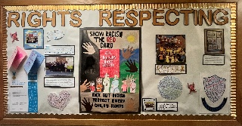
Rights Respecting Schools Re-accreditation

We are proud to have been reaccredited as a Gold Rights Respecting School for the second time, recognising our continued commitment to embedding children’s rights throughout our school community. This achievement reflects our dedication to creating a positive, inclusive environment where pupil participation, wellbeing and the rights of every child are valued and respected.

Learner participation
At Dykesmains Primary we strive to provide a wide range of wider opportunities to promote learner participation across the whole school. We track pupil involvement and regularly engage in pupil voice to ensure provision is relevant to our school community.

Please use the QR code or visit this link to view a video sharing our Learner Participation in:

- Personal Achievements
- Decision Making
- Wider Community
- Learning and Teaching

HOW SUCCESSFUL HAVE WE BEEN IN IMPROVING OUR ESTABLISHMENT?
Priority 1
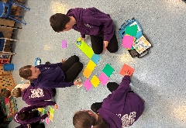
To review and develop the curriculum to ensure it stays relevant, future focused, inclusive and aligned to the learning needs of all students. Please see some examples below of successful areas identified.

Digital Learning
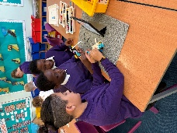
- Introducing both the Sphero Mini and Sphero Indi robots further supported our commitment to a creative curriculum this session. These digital resources supported early coding, problem-solving, sequencing, collaboration skills and encouraged curiosity in Science, Technology, Engineering and Mathematics (STEM).
- ChatterPix enabled pupils to communicate their learning through voice and storytelling across different areas of the curriculum including Rights Respecting themes and Learning for Sustainability.
- Progression planning for this session continued to build on opportunities to use LEGO Spike to promote problem solving, teamwork and coding skills through hands on building linked to real work contexts.

Targeted Support
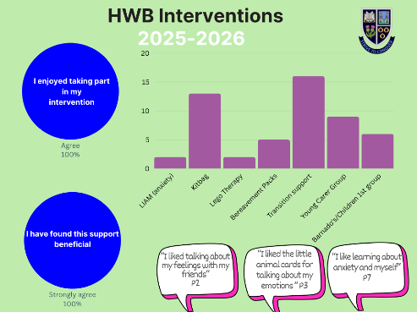
Targeted Support Teacher
- Supported 50 pupils through targeted 1:1 and small-group interventions in Literacy, Numeracy and Health and Wellbeing.
- Collaboration with class teachers and Pupil Support Assistants ensured pupils effectively transferred their learning into class work.

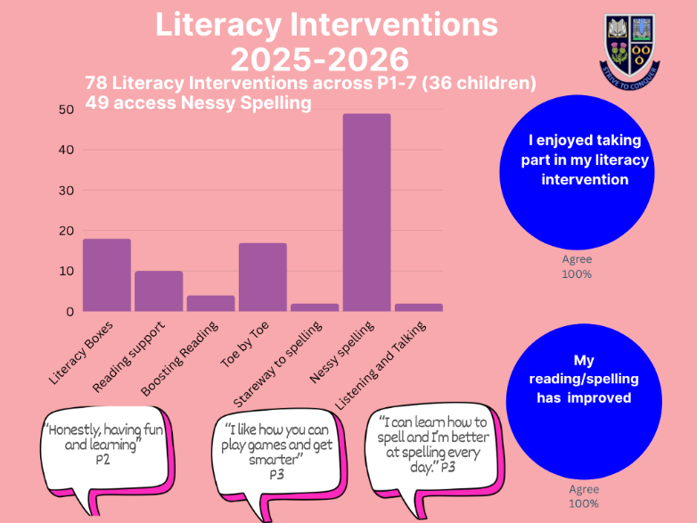
Literacy Interventions
- 76 literacy interventions were delivered to 36 children this session.
- Almost all learners made progress which is evidenced through tracking pre and post-assessments.
- Literacy interventions include Boosting Reading, Literacy Boxes, Toe by Toe, Stareway to Spelling and Writing support groups.

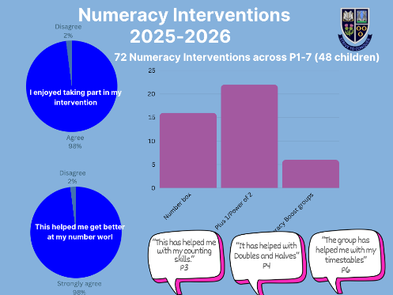
Numeracy Interventions
- 72 numeracy interventions were delivered to 49 pupils.
- Almost all learners are making progress, this is assessed through pre and post assessments.
- Numeracy interventions include the 5 Minute Number Box, Plus 1, Power of 2 and small support groups.

Priority 2

To create a whole school approach integrating Learning for Sustainability and children’s rights and fostering a learning environment that inspires and empowers every learner to lead positive change and develop sustainable thinking. Please click on this link or use the QR code to view pupil voice on our school priorities.

Outdoor Learning
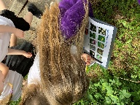
- Partnership with Learning through Landscapes provided a grant for resources and training webinars for all staff. Support was given to complete an outdoor audit of school grounds and used to plan. Outdoor clothing, grab and go boxes and progression plans are now in place to support outdoor learning. Progression planners will incorporate the RSPB Wild Challenge to ensure the sustainability of this award.
- 16 Primary 2 and 3 pupils also took part in a lunchtime Wild Outdoors group to enhance exploring and helping nature.

Pupil Leadership
- Primary 7 pupils completed their leadership programme with Active Schools and led a wide range of lunchtime clubs including art, dance, football, basketball and fitness, shaped by pupil voice.
- Primary 6 pupils supported classes with new technology, building pupil and staff confidence
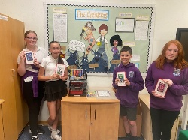
- All pupils contributed to a school committee to support positive changes in line with the School Improvement Plan.
- The Library and Reading Committee worked with the Parent Council to promote reading for enjoyment. They expanded the range of graphic novels, dyslexia friendly books, adventure books and wellbeing reading materials.
- The Pupil Council continued to develop a nurturing and inclusive playground, linking the school values to expected behaviours in the playground.
- The Right Respecting Schools Committee led monthly whole school focuses and gathered a wide range of evidence for the Gold Award re-accreditation.
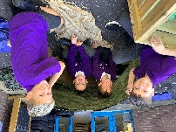
- Developing the Young Workforce strengthened our community links to bring real life context to the world of work.
- Our Health and Wellbeing Committees work together gathering pupil voice to shape activities to improve physical, social and emotional wellbeing across the school. This included a diverse health fortnight with our community partners.
- Our Digital Committee purchased new technology and supported classes to implement these into their classroom learning.

QUALITY INDICATORS
Provide your evaluation & brief summary statement for each of the 4 core QIs
QI 1.3 Leadership of Change | Evaluation | 5 Very Good
Over this session we have continued with our commitment to continuous improvement and achieving
the highest standard for all our learners. Our school values are evident in relationships and
embedded in the ethos of the school. Our staff are committed to collective responsibility in the
process of change and feel supported and guided by senior leaders. Self-evaluation activities as a
whole school community have been effective in allowing us to reflect on and develop our practice and
strategic vision.

QI 2.3 Learning, Teaching & Assessment | Evaluation | 5 Very Good
Staff provide a calm, nurturing learning environment that supports children’s learning well. All teachers
have high expectations and aspirations for children. All teachers use consistent classroom routines,
clear instructions and meet learning needs well. Children are fully involved in their learning and
interact well with peers and staff. Teachers are committed to improving outcomes for pupils and have
committed to their own continuous development, notably in digital technologies over this session. All
children are valued and encouraged to contribute fully to the life of the school.

QI 3.1 Ensuring Wellbeing, Equality & Inclusion | Evaluation | 5 Very Good
We are committed to ensuring all our learners are included, engaged and involved in the life of the
school. Promoting the wellbeing of our school community is at the heart of all we do. All staff have a
strong understanding of the socio-economic factors that can affect children and families. Funding is
used effectively to provide resources and additional staffing to support wellbeing, equality and
inclusion.

QI 3.2 Raising Attainment & Achievement | Evaluation | 5 Very Good
School data is reliable and reviewed regularly. We have developed very effective processes to track children’s attainment using a consistent and interconnected approach. Robust termly attainment
meetings are held to discuss children’s progress and target any identified needs. Pupils benefit from these targeted interventions, and this is bringing about further improvements in attainment. Teachers have skills in data analysis, and this ensures ownership of data at a classroom level. Our pupils enjoy achieving widely and sharing their successes and staff are proactive in planning a range of opportunities to broaden children’s experiences across different activities.

PUPIL EQUITY FUNDING
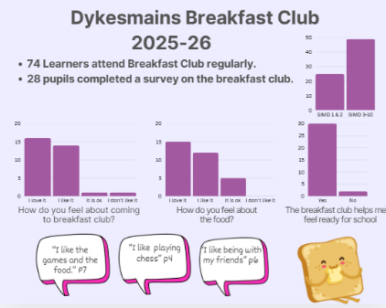
Breakfast club
75 children of 183 have accessed the breakfast club across this session, on average the attendance is over 30 children each day. 33% of children who attend live in SIMD 1 and 2, 67% of children live in SIMD 3-10. Due to the high demand and number of children accessing breakfast club, an additional staff member was employed through PEF to offer additional support where required. Almost all children report to enjoy breakfast club and that they feel are ready to learn afterwards.

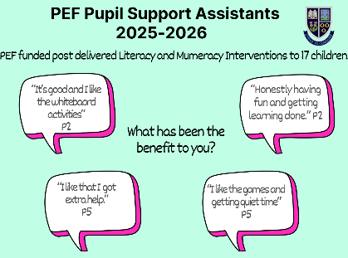
Pupil Support Assistants
Feedback from pupils and parent/carers, continue to identify the positive impact on additional pupil support assistants. PEF funded 1 full time and 1 part time Pupil Support Assistant. As well as the positive impact on the school community, these post supported literacy and numeracy interventions being delivered to 17 children. All children accessing these interventions made progress and there was a positive impact on their attainment using these interventions, monitored through a range of assessments.

IMPROVEMENT PLAN PRIORITIES 2026-2027
Priority 1: Improving learning outcomes for all.
- Numeracy - Through high-quality professional learning and collaborative practice we will optimise learning outcomes for pupils through the introduction and development of research based pedagogical practices in Mathematics.
- Learning For Sustainability – Further develop and embed Learning for Sustainability by fostering a learning environment that inspires and empowers every learner to lead positive change and develop sustainable thinking.
Priority 2: Supporting needs, wellbeing, equality and inclusion
- We will work in partnership with a North Ayrshire initiative to further enhance our whole school approach. This priority will support a consistent, relational response to behaviour across the establishment, contributing to our continued focus on strengthening adult presence, reducing escalations and promoting repair and connection.
Priority 3: Building a self-improving service
- We will contribute to this NAC priority of building a self-improving service by encouraging leadership at all levels through cluster and cross cluster working and providing opportunities for engagement with the Curriculum Improvement Cycle.

