

Education Service
Dykesmains Primary
Improvement Plan
2026-2027


Vision, Values and Aims
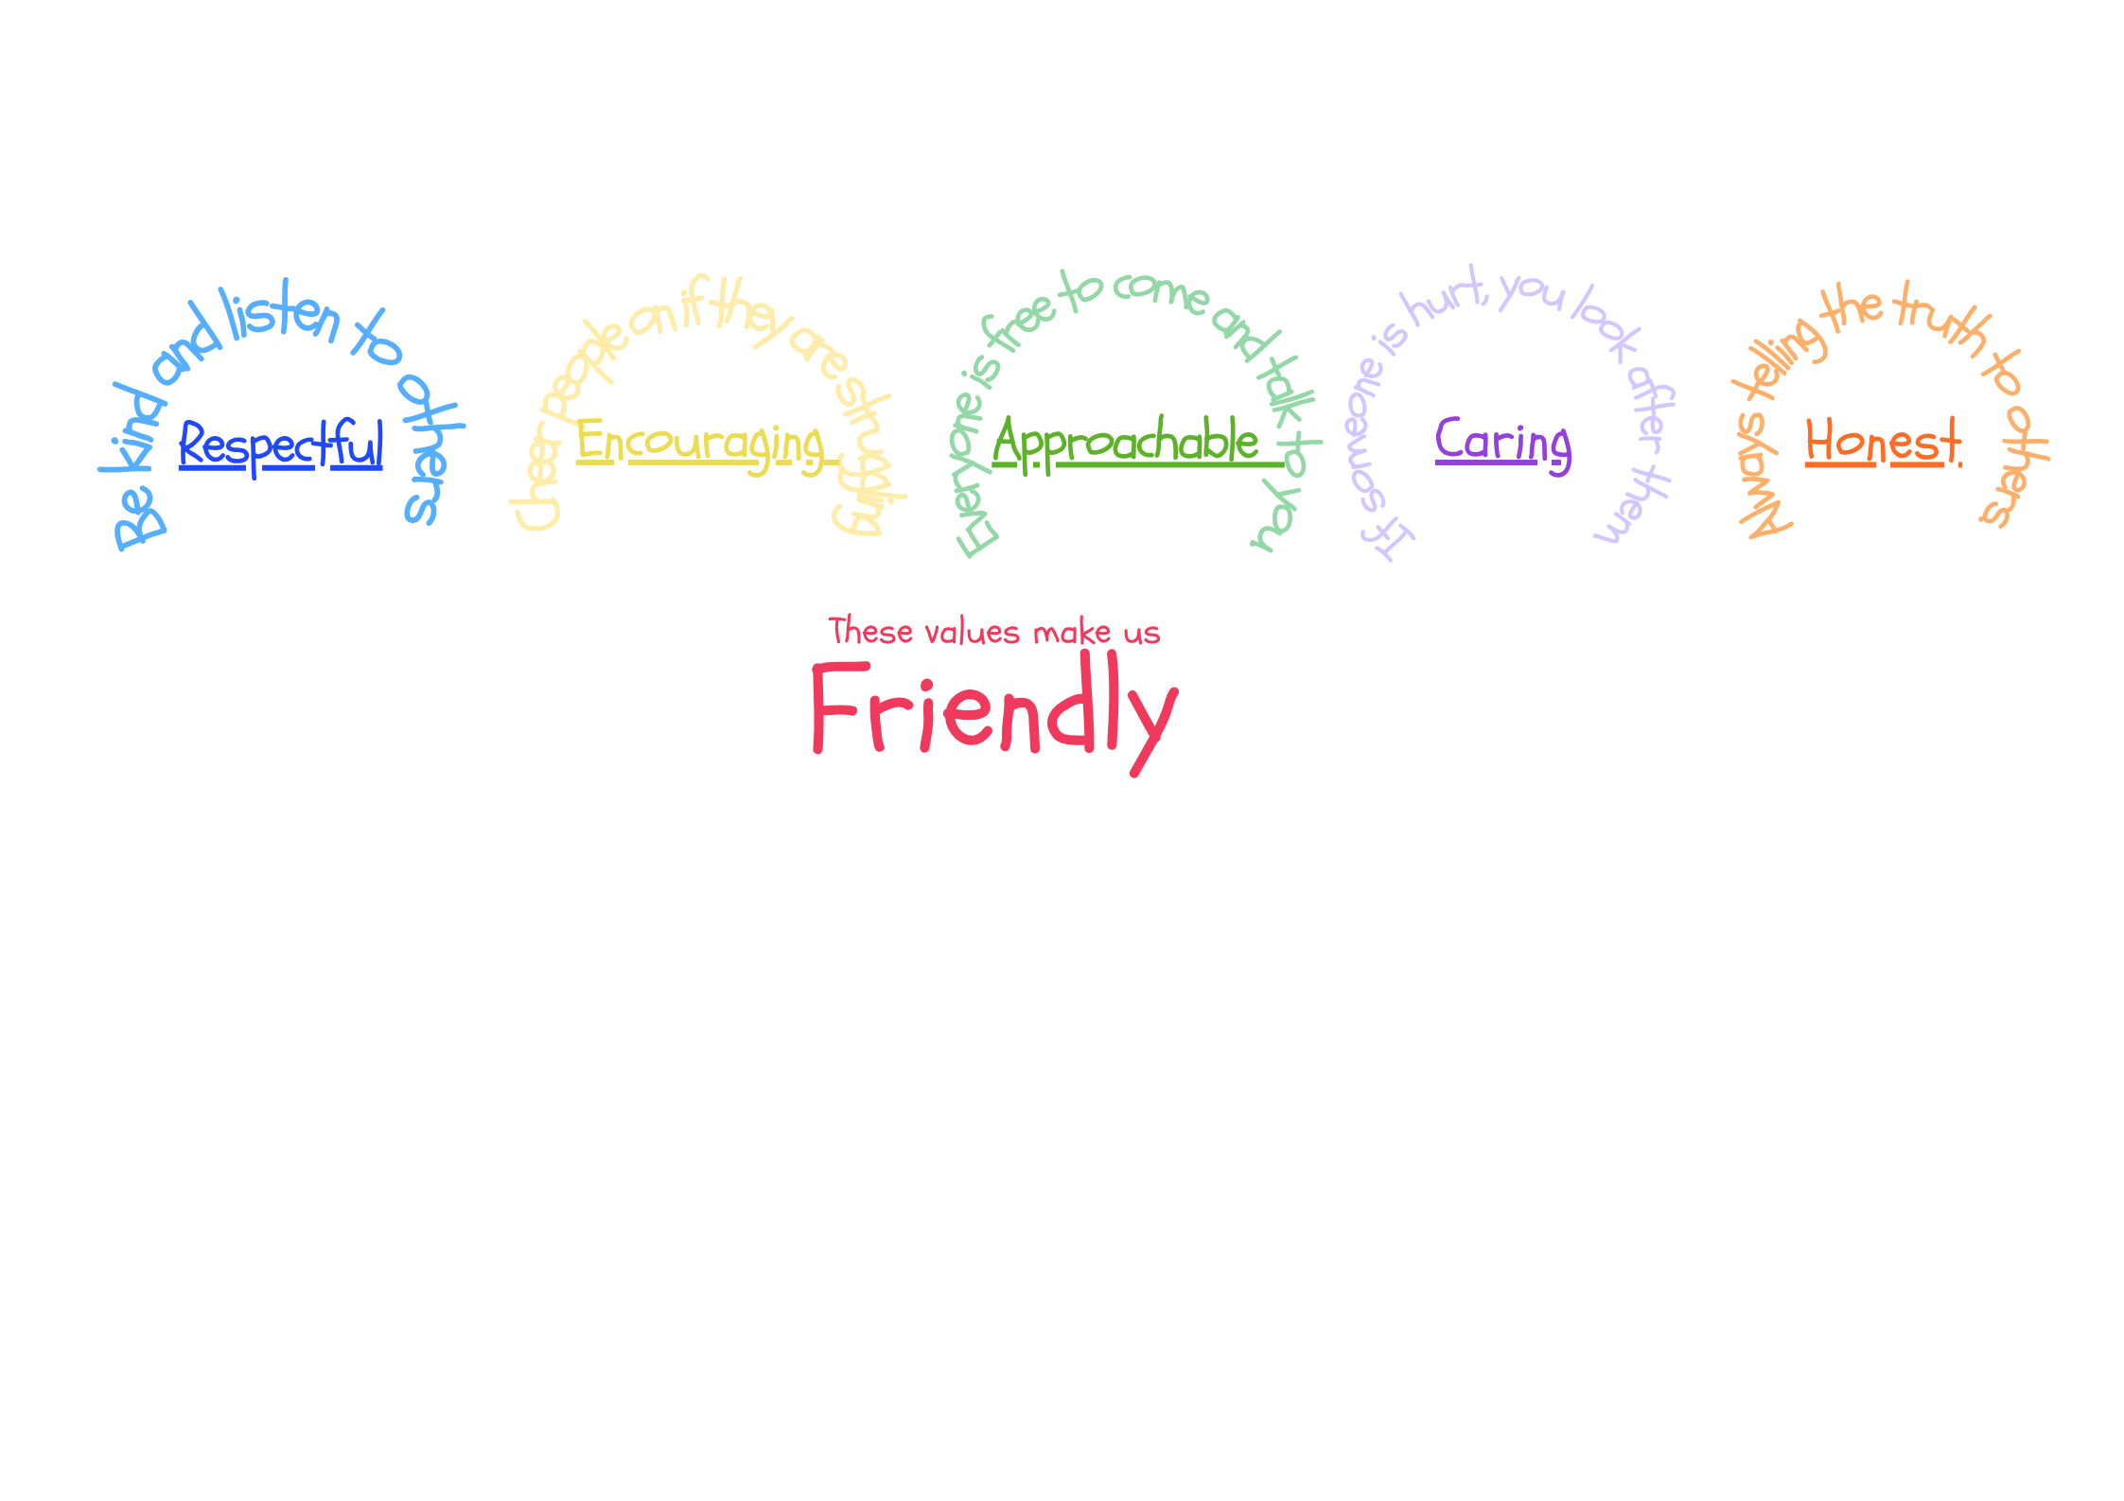
Our Vision
Dykesmains Primary is a welcoming and motivational school that nurtures and develops life skills. We work as a community to support pupils to learn transferable skills for life to enable pupils to achieve the best possible outcomes.

Our Aims
- To create a safe, healthy and welcoming school.
- To ensure our children feel happy and secure within our community.
- To support children and families educationally, emotionally and socially.
- To provide a wide variety of opportunities and experiences to enable us to maximise each child’s potential.
- To encourage our children to be independent and take responsibility for their own learning.
- To equip our children with the knowledge and skills to make healthy choices now and in the future.

Our Values
We strive for excellence and equality for all through our school values.
Friendly, Respectful, Encouraging, Approachable, Caring, Honest

Click here to View our Vision and Values video or use the QR code.


EDUCATION SERVICE: IMPROVEMENT PLAN SUMMARY 2026/7 – 2028/9

The Education Service Improvement Plan is organised under three main priorities. Individual establishments should create their own plan under these three priority areas, based on rigorous self-evaluation and analysis of performance evidence. Stakeholders should be fully engaged in the development of the plan. In the diagram below, the light blue show the thematic areas under each priority which the service intends to focus on in the year ahead.
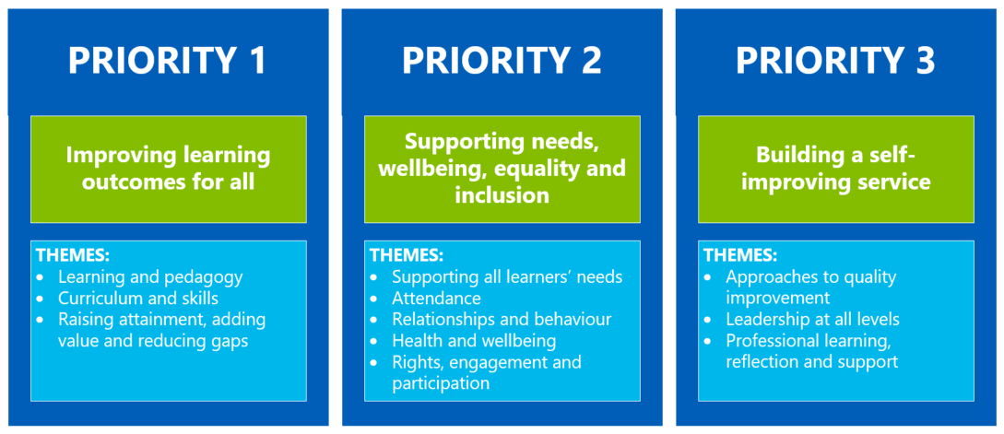

PRIORITY 1: Improving learning outcomes for all
Strategic Objective:
1. Maths - Through high quality professional learning and collaborative practice we will optimise learning outcomes for pupils through the introduction and development of research based pedagogical practices in Mathematics.
2. LFS – Further develop and embed Learning for Sustainability by fostering a learning environment that inspires and empowers every learner to lead positive change and develop sustainable thinking.

Select the KEY drivers for this improvement priority
National Improvement Framework  Please select the relevant NIF priority | NIF Drivers of Improvement  Please select up to three NIF drivers | How Good Is Our School 4  Please select up to three quality indicators for this priority | Quality Improvement Framework for ELC settings  Please select up to three quality indicators for this priority
1. Improvement in attainment, particularly literacy and numeracy  2. Closing the attainment gap between the most and least disadvantaged children and young people | 2. Teaching and practitioner professionalism  4. Curriculum and assessment  Choose an item. | 2.2 Curriculum  1.2 Leadership of Learning  2.3 Learning, teaching and assessment | Choose an item.  Choose an item.  Choose an item.
Rationale for Change

1.Mathematics - Analysis of data shows that learners would benefit from further opportunities to develop mathematical reasoning, particularly in problem-solving, visualisation and applying concepts across contexts. Self-evaluation evidence including observations, learner voice and moderation activities highlights limited opportunities for the development of higher-order skills and for developing spatial reasoning. Key barriers include challenges in engaging targeted learners to apply mathematical learning in unfamiliar contexts. Staff have highlighted that they would like the opportunity to develop further their understanding of effective approaches and have access to research informed strategies to develop their skills further in this area. The STEM SPACE project will strengthen pedagogy by developing spatial reasoning as a foundation for improved mathematical thinking. A PEF spend of £5000 is allocated to this.

2.LFS – Enable pupils to contribute to a sustainable future in line with UN Sustainable Goals and the Scottish Government Target 2030 - movement for people, planet and prosperity action plan. Analysis of data and self-evaluation activities have identified making better use of our outdoor learning environment as a next step to positively impact pupil experiences and encourage sustainable thinking. A PEF spend of £2500 is allocated to this.

PRIORITY 1: Action Plan
Pupil Outcomes | Implementation Plan | Timescales/  Responsibility | Measurement of Impact | Analysis & Evaluation of Progress | Cost  (PEF)
Specifically, what will change for our learners? | How will we achieve this?  What do we plan to do? | What are our timescales? Who will lead? | How will we know the change is an improvement? Can you quantify this?  What data will be collated and analysed to demonstrate progress? Consider baseline data. | How do we know that the experiences & outcomes for learners have improved? What does the data tell us which demonstrates impact? | Please enter the cost to the nearest £
1.  Learners will develop stronger spatial reasoning skills, enabling them to visualise, model and solve problems more effectively across different areas of mathematics.  Learners will experience more consistent, research-informed teaching approaches that strengthen higher-order thinking, leading to improved confidence, engagement and attainment in mathematical problem-solving.  Learners will benefit from improved identification of gaps in learning in mathematics through improved assessment data.  Learners will be able to reflect on how they learn and the tools and strategies they need to help them learn | Implement the 16 STEM SPACE Maths Burst lessons across P4-P7, embedding them within existing numeracy planning to explicitly develop learners’ spatial reasoning and mathematical thinking.  Use a range of manipulatives (some supplied by Glasgow University) and concrete materials to support progression from concrete to abstract understanding and strengthen visualisation skills.  Engage in professional learning and collaboration linked to the research project to build staff confidence and ensure consistent, evidence-informed pedagogy.  Monitor and evaluate impact through engaging fully with assessments provided by the UoG and the data that comes from it.  All teachers to have training in NA Maths Assessments with the data identifying gaps in mathematical knowledge allowing a very robust targeted approach to supporting learning.  All staff and pupils will engage with the NA Maths Framework and develop a ‘What makes a great maths lesson’ overview | HT Lead  Aug-Dec 2026  PLA STEM Space Twilights 25/8 & 1/9  All P4-P7 teachers will participate and lead the initiative in their own class. Pre assess August and post assess December  P1-3 staff will ensure a range of resources to support the early skills of spatial reasoning and mathematical thinking are available to pupils through planned play  PLA NAC Maths Assessment Training P1-7 staff INSET 19/8  PSA PLA – Grab and Go Numeracy boxes INSET Sept 26  Staff development of WMAGML – Sept INSET  October – Dec Pupil engagement | The University of Glasgow will provide comprehensive baseline and post-intervention data through pre- and post-assessments, measuring improvements in mathematical thinking, computational thinking and spatial reasoning.  Quantifiable progress will be evidenced through comparative analysis of assessment scores, demonstrating gains across participating cohorts.  Data will be analysed to identify improvements in attainment and to track reductions in gaps, including detailed insights into gender and SIMD quintile disparities.  Additional school-level evidence (e.g. class assessments, learner voice and observations) will triangulate findings and confirm increased confidence, engagement and application of mathematical reasoning.  Pre and post data input on NAC spreadsheet will evidence areas of target and progress achieved.  Feedback will show improved teacher confidence and improvement in identifying and targeting gaps.  ‘What makes a great maths lesson’ used alongside NA maths frameworks to ensure consistency in maths lessons.  Pupils will show understanding of this and improved mathematical engagement in focus groups with SLT |  | PEF spend of £5000
2.  Through the rich stimulus of outdoor learning pupils will have opportunities to further develop sustainable thinking and be empowered to lead change.  Learners will benefit from staff using skills from prior and planned CLPL ensuring learning is impactful and inspiring. | Newly developed LfS progression planners in use by staff and learning planned into weekly planning. Activities/learning in line with NA LfS Policy  Grab and go boxes created by staff will enable access to materials to ensure learning is impactful and inspiring.  Outdoor clothing purchased and set up for ease of accessibility to enable time outside for planned learning all year round.  Garden focus development enhanced by partnership working with Tim Dreyer.  Fire pit training for staff | All staff to use progression planners developed collegiately including pupil voice 2025/2026 session.  LTL and lead LFS in own classes  Term 3  Tim Dreyer  All Staff  Open afternoon SIP showcase Feb 2027 | Baseline from NA LFS policy section RAG – post RAG to be completed in March 2027  Pre and post questionnaires for teachers and pupils to measure impact of input on lessons. October 2026 & May 2027  Teacher to teacher observations to share good practice Term 2  Termly staff evaluations will evidence engagement and reflection on outdoor learning.  Community events will inform and involve parents and community partners. Open afternoon Feb 2027 & LFS end of term Assembly March 2027  Eco-Schools Scotland environmental review and draft action plan 2025-2027 will evidence improvements and actions for 11th Eco Flag. |  | PEF spend of £2500

PRIORITY 2: Supporting needs, wellbeing, equality and inclusion
Strategic Objective:
We will develop and embed New Authority as a universal, whole-school approach informed by the principles of Building Positive Relationships (BPR). This programme forms an important aspect of North Ayrshire’s Relationships and Behaviour Policy from 2026 onwards. This priority will support a consistent, relational response to behaviour across the establishment, with a focus on strengthening adult presence, reducing escalation, and promoting repair and connection.

Select the KEY drivers for this improvement priority
National Improvement Framework  Please select the relevant NIF priority | NIF Drivers of Improvement  Please select up to three NIF drivers | How Good Is Our School 4  Please select up to three quality indicators for this priority | Quality Improvement Framework for ELC settings  Please select up to three quality indicators for this priority
4. Improvement in children and young people's health and wellbeing  5. Placing human rights and needs of every child and young person at the centre of education | 2. Teaching and practitioner professionalism  5. School & ELC improvement  Choose an item. | 3.1 Ensuring wellbeing, equality and inclusion  Choose an item.  Choose an item. | Choose an item.  Choose an item.  Choose an item.
Rationale for Change

At Dykesmains, positive relationships and a nurturing ethos are central to our school community. New Authority provides an opportunity to reflect on and strengthen existing practice, developing a shared, consistent relational approach across all staff, including our four new PSAs.
Through the principles of resist, persist, unite and repair, we aim to strengthen adult self-regulation, calm presence and collective responsibility. This will support us to respond confidently and consistently to children's needs and behaviours, maintaining positive relationships and ensuring all learners feel safe, valued and supported.

PRIORITY 2: Action Plan
Pupil Outcomes | Implementation Plan | Timescales/  Responsibility | Measurement of Impact | Analysis & Evaluation of Progress | Cost  (PEF)
Specifically, what will change for our learners? | How will we achieve this?  What do we plan to do? | What are our timescales? Who will lead? | How will we know the change is an improvement? Can you quantify this?  What data will be collated and analysed to demonstrate progress? Consider baseline data. | How do we know that the experiences & outcomes for learners have improved? What does the data tell us which demonstrates impact? | Please enter the cost to the nearest £
Pupils feel safe, understood and  supported by adults across the school.  Pupils experience consistent  expectations and appropriate  relational and natural  consequences across the school.  Pupils are supported to repair relationships and resolve difficulties following incidents or conflict. | Attend NAC training and provide in school training on BPR and the principles of New Authority, focusing on calm adult presence, self-regulation, de-escalation, connection and repair.  Work in partnership with families and relevant professionals where appropriate to ensure support is responsive and consistent.  Utilise resources provided to support embedding New Authority, for example the Solution Orientated Planning Sheet and the Reflective Log.  Engage in professional dialogue as a team to support reflective discussion– utilising the NAC training resources provided  Embed consistent strategies for de-escalation, self-regulation, and repair. Using training materials | November 2026 Training  attended by DHT and TST  Action Plan created November 2026  All staff November to June collegiate dates TBC  Led by TST as trainer | Baseline and follow-up pupil voice, staff self-evaluation, observations and the New Authority. Aim for a minimum 90% of pupils to report feeling safe, listened to and supported by adults.  PASS, wellbeing and behaviour information will be analysed alongside qualitative evidence to evaluate impact.  Staff confidence and consistency in relational practice will also increase.  Pupil voice, staff observations and wellbeing data will demonstrate increased use of appropriate strategies to manage emotions and respond positively to difficulties.  Staff self-evaluation will measure increased confidence and consistency in using shared language and approaches to support regulation  More effective use of de-escalation and repair strategies.  Reduced incidents of escalation measured as above.  Positive feedback from staff, pupils, and families, gathered through questionnaires, professional dialogue, surveys  Use of rubric (see NAC resource)

PRIORITY 3: Building a self-improving service
Strategic Objective:
Establish consistency and improve pupil transitions through cluster and cross cluster moderation to align teacher judgements and achievement of a level learner journey in writing, taking cognisance of the CIC.

Select the KEY drivers for this improvement priority
National Improvement Framework  Please select the relevant NIF priority | NIF Drivers of Improvement  Please select up to three NIF drivers | How Good Is Our School 4  Please select up to three quality indicators for this priority | Quality Improvement Framework for ELC settings  Please select up to three quality indicators for this priority
1. Improvement in attainment, particularly literacy and numeracy  2. Closing the attainment gap between the most and least disadvantaged children and young people | 2. Teaching and practitioner professionalism  4. Curriculum and assessment  1. School & ELC leadership | 2.3 Learning, teaching and assessment  2.2 Curriculum  3.2 Raising attainment and achievement | Choose an item.  Choose an item.  Choose an item.
Rationale for Change
Self-evaluation activities across the cluster have identified variation in staff confidence when applying national benchmarks and making professional judgements relating to achievement of a level. While moderation takes place within individual establishments, there is a need to strengthen collaborative moderation across Dykesmains Primary School, Stanley Primary School, West Kilbride Primary School and Ardrossan Academy.
A more consistent approach to moderation will support staff to develop a shared understanding of standards, strengthen assessment in literacy and increase confidence in identifying learner progress through breadth, challenge and application. This work will also improve the robustness and reliability of ACEL data at P1, P4 and P7 and strengthen curriculum continuity as learners progress into the Broad General Education.

PRIORITY 3: Action Plan
Pupil Outcomes | Implementation Plan | Timescales/  Responsibility | Measurement of Impact | Analysis & Evaluation of Progress | Cost  (PEF)
Specifically, what will change for our learners? | How will we achieve this?  What do we plan to do? | What are our timescales? Who will lead? | How will we know the change is an improvement? Can you quantify this?  What data will be collated and analysed to demonstrate progress? Consider baseline data. | How do we know that the experiences & outcomes for learners have improved? What does the data tell us which demonstrates impact? | Please enter the cost to the nearest £
Learners will experience greater consistency in assessment approaches across the cluster.  Learners will be able to demonstrate progress, achievement and next steps more clearly  Transitions between stages and sectors are supported through a shared understanding of standards and expectations | Establish a cluster moderation calendar focused on writing at P1, P4 and P7.  Deliver termly online moderation meetings involving staff from all four schools  Develop agreed moderation protocols linked to Benchmarks and Achievement of a Level guidance.  Introduce anonymised writing moderation activities using evidence from each school.  Create a shared digital moderation portfolio containing annotated examples of achievement of a level.  Use moderation findings to inform professional learning and assessment practice.  Evaluate staff confidence and consistency through moderation evaluations and professional dialogue. | HT’s DHT’s August 2026  Cluster \DHT Lead  Throughout session  Cluster Working Group September 2026  Stage Leaders Termly  Cluster Staff  Throughout session  DHT’s Ongoing  HT/DHT Team  May 2027 | Increased confidence reported by staff through moderation evaluations. Professional dialogue demonstrates a stronger understanding of national standards and achievement of a level.  Moderation activities completed across the session with evidence available for P1, P4 and P7 writing in all schools.  Cluster moderation portfolio evidences agreed standards and expectations in writing across key stages.  Increased confidence and consistency in ACEL judgements across participating schools evidenced through quality assurance activities and professional dialogue.  Moderation discussions show greater consistency when evaluating learner evidence. Staff can clearly articulate how breadth, challenge and application inform professional judgements.

This should only be completed for aspects of your PEF spend not included within your Improvement Plan priorities.
PEF contact - HT or DHT with responsibility for the plan: |  |  | Elizabeth Gribben
Carry forward: | £5754 | Total Allocation: | £73440 | Total: | £79194
PEF Action Plan
Poverty Related Gap | Pupil Outcomes | Implementation Plan | Timescales/  Responsibility | Detail of Spend | Measures of Impact | Analysis & Evaluation of Progress
Provide details of the gap or barrier you wish to address. | Specifically, what will change for our learners? | What do we plan to do to achieve this outcome? | What are our timescales?  Who will lead? | Record cost & provide concise detail of what this entails. | How will we know the change is an improvement? Can you quantify this? What data will be collated and analysed to demonstrate progress? Consider baseline data. | What does the data tell us? How well is evidence from self-evaluation analysed to improve pupil outcomes? How is the spend contributing to narrowing our attainment gap?
Breakfast Club/Equality -  Promoting Healthy Lifestyles | All pupils will be able to access a healthy breakfast. Reduce food poverty. Reduce absence and latecomings by providing a soft start for those experiencing anxiety attending school. | Provide a breakfast club that all pupils can have access to free of charge. | Available term time until March 2027. Led by Healthy Start workers and supported by office staff. | Three Healthy Start workers  £13087.05  Food and resources  £2000 | Pupil voice will show readiness to learn.  Data will show an improvement in attendance and latecomings for some pupils. Pupils with separation anxiety/school based anxiety will benefit from a soft start.  Parent voice will show impact of support for food poverty, working families and school based anxiety.
Reducing the poverty related attainment gap | PSA time will support improvement in attainment. | Employ two PSA’s to | March 2026-March 2027 | One full time PSA 27.5 hours and one part time PSA 16.5 hours employed through PEF  Cost £42997.67 | Data from interventions, PASS survey, attainment data and pupil voice will evidence improvement in attainment, pupil confidence and self esteem.
Literacy Resources | Pupils will have access to literacy resources to improve attainment in reading. This will include a focus on comprehension and top up of decodable texts |  |  | £4000  Comprehension boxes P3-P7  Big Cat decodable texts P1-3 | Data including SNSA’s, GL’s and intervention data will show improved attainment and confidence in reading.
Digital | Software/licences | Enhance digital learning experiences for pupils. |  | £2500 spend on licences including Seesaw and Sumdog | Pupil skills improved and enhanced engagement of pupils.
PT enhancement conservation |  |  |  | £6808.26

