
Dykesmains
Primary School
Infant Handbook 2026 – 2027
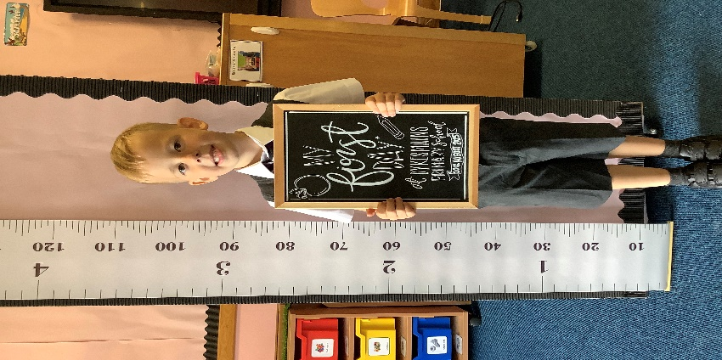
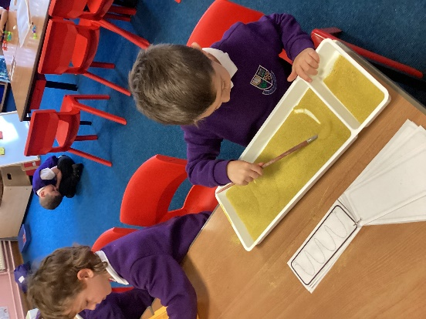
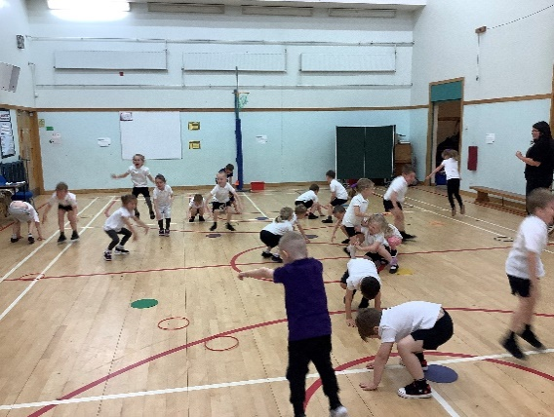
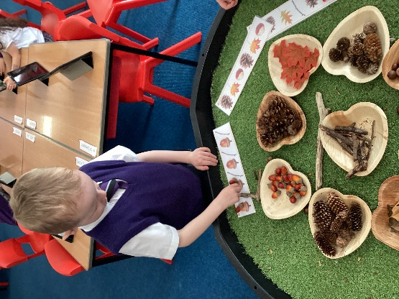
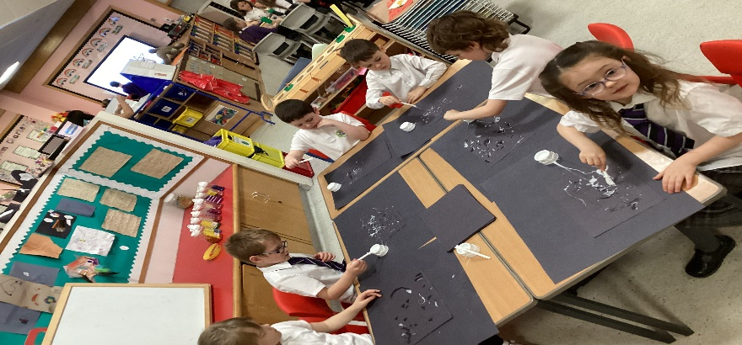
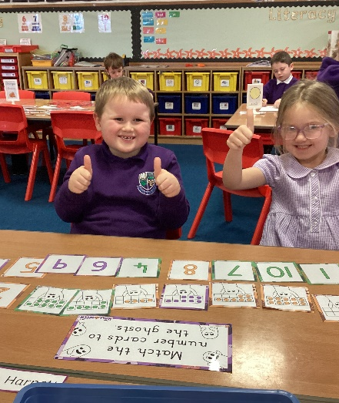

Our Vision
Dykesmains Primary School strives to conquer by being a welcoming and motivational school that nurtures and develops life skills. We work as a community to support pupils to learn transferable skills for life learning so that they can be as successful as they can be.
Our Values
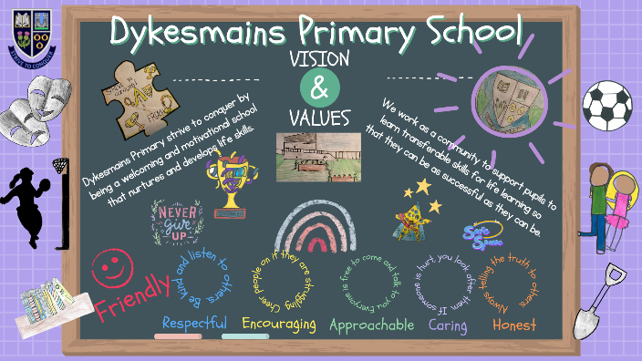
Friendly

Respectful
Encouraging
Approachable
Caring
Honest

Our Aims

1 To create a safe, healthy and welcoming school.
2 To ensure our children feel happy and secure within our community.
3 To support children and families educationally, emotionally and socially.
4 To provide a wide variety of opportunities and experiences to enable us to maximize each child’s potential.
5 To encourage our children to be independent & take responsibility for their own learning.
6 To equip our children with the knowledge and skills to make healthy choices now and in the future.
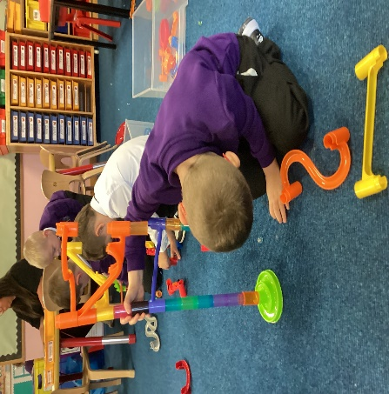
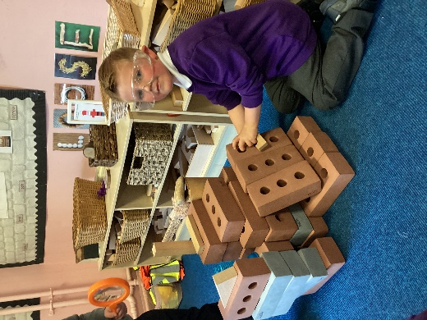
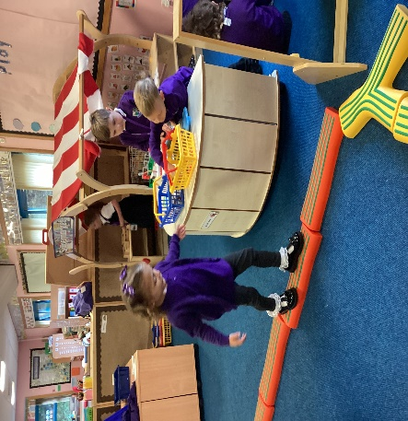

Welcome to Primary One
We would like to welcome you and your child to Dykesmains Primary School. Our staff will do everything possible to make the learning experiences for your child as interesting and motivating as possible and to ensure a smooth transition into primary 1.
This booklet provides information on the curriculum, routines within primary 1 and general information about the school. If you have any concerns or questions you would like to ask, please do not hesitate to contact us using the contact details below.

School Hours
School Hours
Morning Start | 9.00 am
Morning Break | 10.40 am - 10.55 am
Lunch Break | 12.30 pm – 1.15 pm
Afternoon Finish | 3.00 pm

Breakfast Club is provided for the children from 8:00 – 8:45 am. Information will be provided at induction days.
Contact Details
Address Dykesmains Primary School
Simpson Drive
Saltcoats
KA21 6EX
Website https://blogs.glowscotland.org.uk/na/dykesmainsprimary/
X @Dykesmainsps
Email dykesmains@ea.n-ayrshire.sch.uk
Telephone No 01294 461354

Head Teacher Ms Elizabeth Gribben
Depute Head Teacher Mrs Claire Smith


The Big Day
Starting school for the first time is a memorable experience and we hope to make this as pleasant and reassuring for your child as possible. We will set up activities very similar to your child’s Early Years class to support their transition to be as smooth as possible.
On the first day, Primary 1 children will start slightly later, at 9:15 am, to allow for a less overwhelming playground experience. Parents should accompany their child to the infant playground (at the back of the school) until the teacher escorts the class inside. On the first day, we invite up to 2 adults into the Primary 1 classroom to help settle children and take a picture of their first day. We politely ask adults to leave promptly to avoid children becoming upset, as the first day can be overwhelming.
Dismissal is at 3:00 pm at the same entrance. If your child will collected by different adults throughout the week, please inform the class teacher or the school office in advance. We ensure that children are collected by a known adult. If a parent is delayed, staff will supervise pupils at the primary 1 entrance until the rest of the class has been dismissed, they will then take your child to the school office for collection by a known adult. Where possible, please call the school in advance if you anticipate a delay.
Pupils will be supported for a soft start within the class but will line up at their class door with the 9am morning bell as of day two onwards. Should your child be upset, please alert a member of staff in the playground and they can be supported in coming in to class.
From 8.45am, staff supervise our playgrounds until the bell rings at 9.00am.

School Security
North Ayrshire Council has procedures to ensure the safety of children and staff within the school. These include a visitor’s book, secure entry system and closed circuit television. All external doors are locked during the school day. In the event of arriving late, please enter by the main entrance and report to the office to sign in.
Primary 1 children should enter the school from the infant playground (around the back of the school). Please do not drive into the school car park when dropping off or collecting your child nor take children out of the playground via the car access road. Disabled parking is provided for blue badge holders. There are several unmarked areas for parking on the roads beside the school. Please do not bring dogs into the playground, as some children may be frightened of them.

Absence
If your child is ill and unable to come to school please inform the office by before 9.20am. If we have not heard from you by then, we will contact you to ensure your child is safe.
Please avoid taking holidays during term time as this is disruptive to pupils’ learning. In most cases, the absence will be regarded as unauthorised.
Where possible, appointments should be made out with school hours.
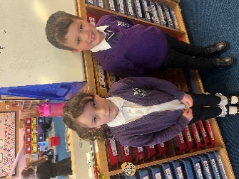
School Uniform
Non-uniform clothing is not encouraged and most parents at Dykesmains prefer their children to wear school uniform. This consists of grey or black skirt/trousers for girls, grey or black trousers for boys, school sweatshirt (purple) or white polo shirt, shirt or blouse and school tie. Branded school polo shirts, sweatshirts and fleeces can be bought through www.myclothing.com however, most supermarkets offer a wide range of low cost school uniform. In summer, both boys and girls may also like to wear short sleeved polo shirts and girls can choose to wear purple checked summer dresses.
It would be helpful if all clothing/shoes could be labelled with pupil names.
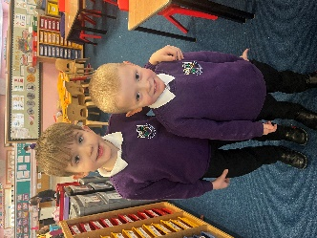
A gym kit should be provided and this includes shorts, t-shirts or polo shirts and gym shoes, which will be kept in school. Please have all items labelled with their names in case these get lost in class. We will be able to let you know at the beginning of the session which days your child will be having gym. It is advised in the interests of health and safety that no jewellery should be worn during P.E. lessons. Any new piercings must covered in micro-tape (which can be left in school for your child).
Pupils should also bring a water bottle with their name on it to school each day.

Curriculum for Excellence
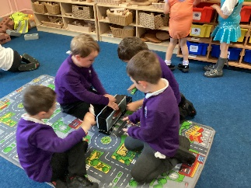
Curriculum for Excellence experiences and outcomes are used across Scotland for all 3-18 year olds. The aim of Curriculum for excellence is to raise standards, prepare children for the future and equip them for the jobs of tomorrow in a fast changing world.
We aim to engage and challenge children in motivating and interesting activities and to promote active learning which meets the needs of all children. We also aim to provide effective feedback to parents and children, so that children can progress in their own learning.
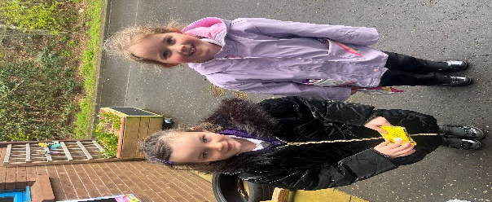
Effective transition information is of high priority to ensure progression and continuity. We encourage children to experience Curriculum for Excellence through integrated learning experiences, which they find fun and motivating. We create opportunities for personalisation and choice through responsive planning and by creating opportunities for children to be independent in their own learning. Children are encouraged to investigate, experience and to work collaboratively to encourage confident and successful learners. Children are encouraged to contribute to performances, whole school action days and projects to support them to be effective contributors and responsible citizens.
Break Time
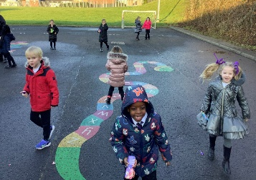
At break (10.40am – 10.55am) the children will play in the playground with the children in P1-3, supported by a group of Primary 7 buddies. Pupil Support Assistants will supervise the children in the playground at all times; they have walkie-talkies to enable regular communication and are all first-aid trained. If it is raining, the children will stay in their class areas and play with activities organised by their teacher, supervised by a Pupil Support Assistant and a group of Primary 7 buddies.
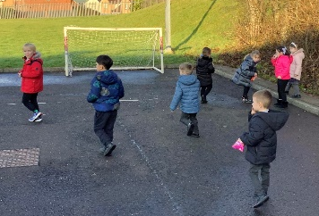
Children should bring a small healthy snack for break. Please choose no more than one or two small snacks that they can eat quickly to allow them time to play with their friends. The children are encouraged to bring bottled water into the class to allow them to drink when required. We advise water bottles with sports tops to minimise accidents. Please make sure names are on water bottles.
Health Promoting School
We are a health promoting school and promote fitness and health. As part of that process we promote healthy eating. Healthy and balanced meals are served in the lunch hall. Children have the option of taking a school lunch or if preferred you can provide a packed lunch. We would ask you to support our promotion of healthy eating, by providing healthy packed lunches and snacks
Mrs S McClymont (Catering Manager) can be contacted if your child has any dietary needs or you wish to discuss school meals. Menus are available on the NAC and Dykesmains website. North Ayrshire has started to use the iPay website (https://www.ipayimpact.co.uk) to order school lunches and pay for trips. Details will be given to you on how to set this up.
Lunchtime
All of the children stay at school during lunchtime and are not allowed to leave the school, unless we receive a written request from a child’s parent. If you wish your child to go home for lunch, please indicate this in writing and give the letter to your class teacher. Please collect your child from the office at 12.30pm.
Every Primary 1 to Primary 5 pupil are entitled to a free school meal. If however your child is having a packed lunch, please ensure their lunchbox is clearly marked, with your child’s name and class, as we have a number of lunch boxes that look the same.
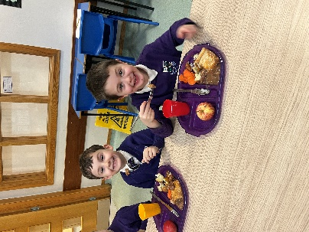
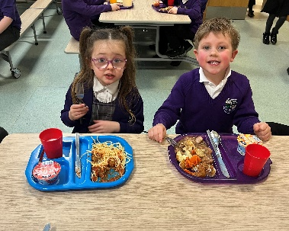
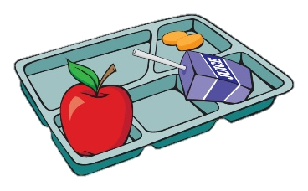


Homework
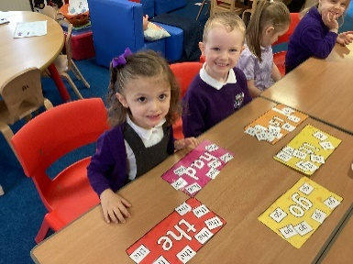
Each term, families receive a newsletter outlining their child's learning and suggesting ways to support it at home. Primary 1 offers homework to reinforce classroom learning, focusing on early numeracy and literacy skills, and activities related to Curriculum for Excellence. Seesaw, an online platform, is used for children and teachers to upload photographs and information about their learning. Login details will be provided in August once parental permissions are received. Once routines are established, weekly reading books and sound/number packs with suggested activities will be sent home. We aim to make home learning engaging and easily incorporated into family routines. We value parental support, recognizing families as children's most significant learning influence. We regularly send home letters about school events and completed work. Please check your child's bag and Eduspot regularly to avoid missing anything.
We are also linked to the Parent Portal app and you will receive information about setting this up.

Positive Behaviour
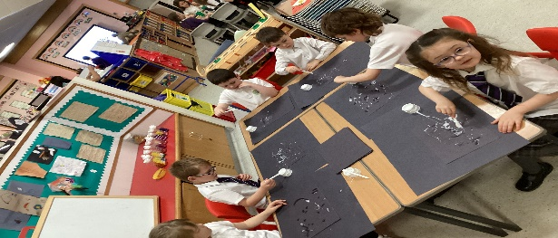
Teachers will work with the children to establish shared expectations for behaviour in the classroom, playground, and throughout the school. Maintaining high standards of positive behaviour is essential for every child's safety and well-being, as well as for the class to run smoothly and effective learning can take place. Clearly defined expectations are a key part of this process and reflect the school's values. Developing these expectations collaboratively with the children, and ensuring they are age-appropriate, increases the likelihood of adherence.
We promote positive behaviour through clear expectations, praise, and the removal of privileges for unacceptable behaviour. We then discuss the behaviour with the child through a restorative conversation and set agreed-upon targets for improvement. We work closely with our parents and carers to prevent any issues developing.
Parental Involvement
We are working hard to involve parents in the life of the school, in teaching and learning and in decision making. We will do this by keeping you informed through termly newsletters, parent workshops, reports, open days and the school website. We will seek your views through many opportunities such as parent evenings, after events such as workshops and online questionnaires.
We have a Parent Council who work hard to support the school though fund raising and by promoting partnership between the school, its pupils and its parents. You are very welcome to join the Parent Council once your child has joined the school.
We are always happy to discuss any concerns you may have and we try to resolve these as quickly and efficiently as possible. Please phone the office to make an appointment to speak to a member of the Senior Management Team in the first instance. Mrs Smith (Depute Head Teacher) is your first point of contact when arranging a meeting.
Emergency Arrangements
It is important the office has emergency contact details for your child and that your child knows who would be collecting them in this situation. If the school needs to be closed in an emergency situation, we will contact you by phone. It is important you keep us up to date with new contact names and telephone numbers.
Medical Conditions
Please keep us informed of all health issues affecting your child, so we can ensure their best interests. If your child requires to use an inhaler or take any other medications, the office will provide you with the necessary form to complete. Medication will be locked away but available when required.
We would advise that all medicines should be handed into the office. However, it is possible to make individual arrangements after discussion with the Head Teacher.
Inclement Weather
In inclement weather, all children will be admitted into the school fifteen minutes before the bell. Staff will supervise your child in the class area. Children arriving by taxi at fixed times will be allowed into the school on arrival.
