Curriculum for Excellence: What are we learning this term? |   Term 4-April - June
Context for Learning: Natural Disasters & Health Weeks | Mrs McDiarmid & Mrs Cairns: P7

Language and Literacy  Spelling- We are continuing to work through spelling words looking at prefixes and suffixes with root words, as well as subject specific vocabulary and common words.  Reading- We will be working through our appropriate levels on Bug Club. We will be revising all of the SHORS strategies and working on independent comprehension.  Writing- Our PM writing genres are: Explanation & Discussion  Grammar lessons will focus on:  Abstract Nouns, Hyphens, Auxiliary Verbs and Multi & Conditional Clauses.    Languages- French- Family Vocabulary and Mardi Gras.  Spanish- Town information. | Numeracy and Maths  This term, children will be focusing on:  - Fractions, Decimals & Percentages  - Expressions & Equations    As always, we will continue to build upon the skills required for the four numerical processes; learning a variety of mental numeracy strategies to help us solve problems with more ease and accuracy. We will also continue to use our Retrieval Practise booklets, as well as using Sumdog Fluency. This assists learners to strengthen their memory of key concepts across all areas  of numeracy  and maths. |  | Health and Wellbeing (HWB)    PE: In PE this term, our topics are Sports Champion events, Athletics & Rounders.  PE days: Monday & Thursday  Kit: Shorts, leggings or jogging bottoms and indoor PE shoes. All jewellery MUST be removed. Any new piercings can be covered.  HWB: All pupils will learn the theory behind the iCycle programme, keeping safe on and around roads. We will also learn to describe the physical and emotional changes to the body during puberty during our health weeks. |  | IDL (Interdisciplinary Learning)    This term we will be exploring Natural Disasters through a variety of written and active activities. We will investigate how the earth is formed and research how tectonic plates impact on Natural Disasters. We will also look at how climate change can impact upon these and look at sustainability as part of this.  Digital- We will continue to use technology to support and enhance our learning across the curriculum, and further develop our digital literacy skills. Some learners will use Nessy weekly to support their reading and spelling. We will continue to enjoy using the new technology in school.
Learning at home- Literacy |  | Learning at home- Numeracy
Spelling- Attached sheet & active spelling games  Online games: https://www.bbc.co.uk/bitesize/topics/zkbkf4j/articles/zbm8scw  Sumdog grammar & spelling challenges – https://www.sumdog.com/  Languages-https://www.spanish-games.net/  https://www.french-games.net/ |  | Times tables: https://www.topmarks.co.uk/maths-games/daily10  https://www.topmarks.co.uk/maths-games/hit-the-button  Fractions: https://www.topmarks.co.uk/maths-games/7-11-years/fractions-and-decimals  Decimals: as above  Percentages: https://maths-games.org/percentage-games/  Expressions & Equations: https://www.math-salamanders.com/algebra-math-games.html
At Dykesmains Primary School we are working to Get It Right For Every Child (GIRFEC). This means we are working to support our children to grow develop and reach their full potential. The children are currently looking at the SHANARRI indicators which are Safe, Healthy, Achieving, Nurtured, Active, Respected, Responsible and Included. For more information: http://www.girfecna.co.uk/
Term 3 Spelling Words – For Consolidation & Practise in Term 4 Active Spelling Ideas:
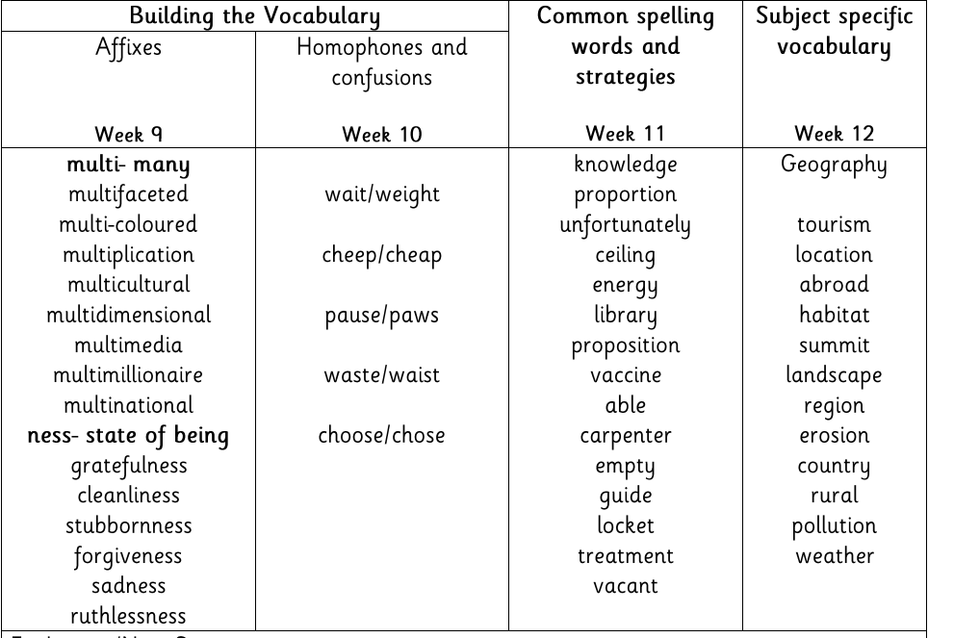
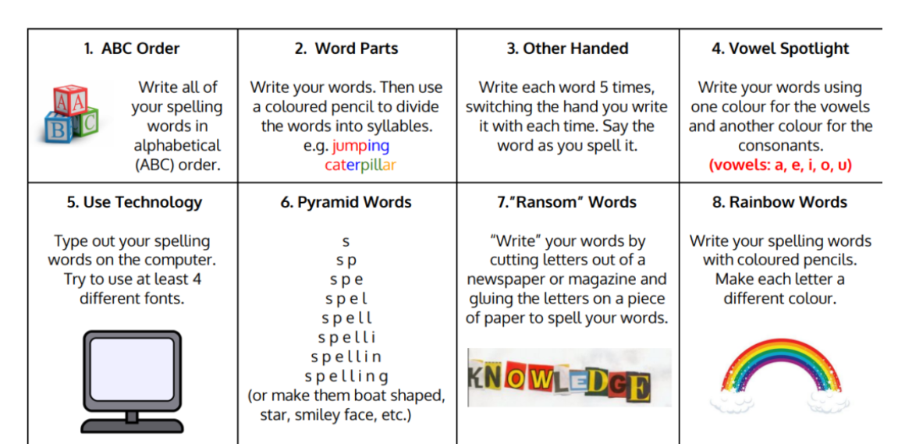
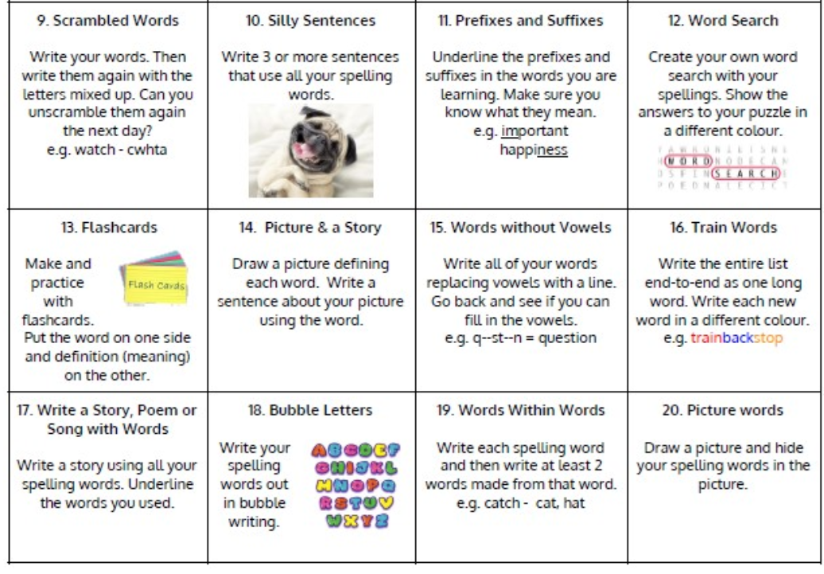

Jotters have been provided for your child to use if and when required when learning at home, there is no expectation for them to be handed in weekly. Children are always welcome to bring and share any work they are proud of.

