Curriculum for Excellence: What are we learning this term? | Term 4 - April-June 2025
Context for Learning: Food and Farming | Teacher: Mrs Weir & Mrs Wilson

Language and Literacy  Phonics/Spelling - Spelling patterns will continue to be taught through active and written spelling activities.  Grammar- We will be learning about Adverbs and commas and using these within our writing.  Reading - Children will continue to develop fluency and expression. We will be participating in activities to develop our written comprehension skills.  Writing – This term, children will create recounts and explanation writing. We will continue to incorporate features of VCOP in our writing and will be using personal dictionaries to help with spelling accuracy.    Spanish -. We will continue to develop our knowledge of Classroom instructions and using Spanish in everyday routines. | Numeracy and Maths  Within Numeracy and Maths, we will continue to develop our number knowledge with a focus on our times tables and division. (2,3,4,5 and 10). We will also be looking at-  Money- Children will identify coins and notes up to £10, read and write different values as well as understanding the decimal point in relation to money.  Angles- Within our angles topic we will be learning about different types of angles, estimating, and measuring angles.  .  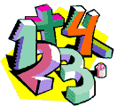 | Health and Wellbeing (HWB)    In PE this term we are focusing on:  - Rounders  - Athletics – running, jumping & throwing  - Preparation for sports day  PE days: Tuesday and Thursday  Kit: t-shirt, shorts, and pair of indoor gym shoes.  HWB: We will continue to investigate Healthy lifestyles and be taking part in a variety of different activities during health weeks in May. | IDL (Interdisciplinary Learning)  Our topic this term will be Food and Farming.  Social Subject- We will be learning about different types of farming, where our foods come from and how they are made. We will look at local sources of food and drink linking with our community topic.  Expressive Arts – We will be developing the use of the visual elements whilst using various media. There will be a focus on drawing and painting, as part of our Food and Farming topic.  Science- We will be learning about Living Things for Science and will be planting our own vegetables/plants. We will observe and measure the outcome when we grow plants in different conditions.  Technology- We will continue to develoip our Digital Skills across the curriculum. We will be using Scratch Junior on the IPADS and The Sphero Indies to develop our coding skills. We will also continue to work on our ICT Skills using the laptops.
Learning at home- Literacy |  | Learning at home - Numeracy
Phonics/Spelling-Spelling Patterns Taught this term and examples of words.  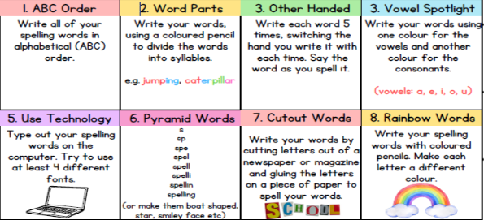 |  | Time- Continue to practice reading the time using o’clock, half past, quarter, and quarter to, using an analogue (clock with a face) and digital clock.  Times Tables- Recite the 2, 3,4, 5 or 10 times table.  Dice game- One player should roll two dice and multiply the two numbers together. For example, if they roll a 3 and a 4, they multiply 3 x 4. You can take turns, and each person tries to solve the problem as quickly as possible.  Times Table Art- Create a multiplication poster or chart, decorating it with fun colours, stickers, or drawings. This poster could be decorated with visual representations (like groups of objects).  Fractions- Identify half and quarter of a shape on items around the home e.g. pizza, clock, pictures.  Online Games:  Sumdog- https://play.sumdog.com  Topmark Games:  Hit the button- https://www.topmarks.co.uk/maths-games/hit-the-button  Mental maths- mental-maths-train  Fractions- https://www.topmarks.co.uk/search.aspx?q=fractions
  Soft c | Soft g/ge/dge | Le/el/al/il | Y/ey endings
  Price  Nice  Race  Centre  City  Cereal | Gentle  Urgent  Large  Tragic  Bridge  Hedge | Candle  Middle  Camel  Pedal  Signal  fossil | Merry  Sorry  Happy  Donkey  Monkey  chimney
  Ing words | Silent k & w | wa/qu | Suffixes
  Wagging  Begging  Sitting  Running  Patting  dropping | Kneel  Knew  Knife  Wrap  Write  Wrestle | Wand  Water  Watch  Want  Quantity  Squash | Painful  Careful  Fearless  Agreement  Happiness  Slowly
At Dykesmains Primary School, we are working to Get It Right For Every Child (GIRFEC). This means we are working to support our children to grow develop and reach their full potential. The children are currently looking at the SHANARRI indicators, which are Safe, Healthy, Achieving, Nurtured, Active, Respected, Responsible and Included. For more information: http://www.girfecna.co.uk/

