Curriculum for Excellence: What are we learning this term? | Term 3-January-April 2026
Context for Learning: Scot’s Language, Developing the Young Workforce, Book Study | Teacher name: Mrs Pike Primary 4
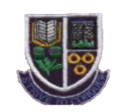
Language and Literacy  Spelling- All spelling patterns will continue to be taught through active and written spelling strategies.  Grammar- Our focus this term will be using and developing punctuation in all written tasks. Introducing contractions, speech marks and paragraphs.  Writing- We will be focusing on Narrative and Response ,learning about the purpose of these text types and their features. We will do some writing in Scots.    Spanish- We will be learning vocabulary for animals and classroom commands whilst reinforcing vocabulary learned during term 2. | Numeracy and Maths  This term, children will be focusing on:  Number and number processes  - The link between addition and subtraction, multiplication and division.  - Patterns and Relationships  Exploring repeating patterns and designs as well as recognising and continuing simple number sequences.  - Angles and Symmtery  Using signs, words and angles associated with direction and turning. Lines of symmetry, completing/creating symmetrical pictures.  - Time  Learning to tell the time in 5 minute intervals, past and to, am or pm and duration of time. |   Health and Wellbeing (HWB)  PE: In PE this term our focus is on gymnastics, fitness  orienteering and team building.  We are also taking part in Fit Fifteen.  PE Days: Thursday, Friday  HWB: We are continuing to reinforce our Rights Respecting School ethos and are adhering to our class charter.  We will be looking at ways in which we can build our resilience and develop a Growth Mindset.  We will take part in activities to reinforce the Zones of Regulation and embed Dykesmains Right Pathway. | IDL (Interdisciplinary Learning)  Our contexts for learning this term will be a focus on Scots Language,including learning our Scottish Poem . Developing the Young Workforce and March into Books.  Art & Design- We will be completing a variety of art activities linked to our topics and focussing on our book board.  Music – We will focus on learning and performing our songs for the school show.  Drama – Using Scots language contexts for drama activities.  Digital-Powerpoint Presentations. Developing our programming skills using Microbits.
Learning at home- Literacy |  | Learning at home- Numeracy
Phonics/Spelling- Taught phonemes ae,ee,ie,maths shape words, common words  Online games: English KS1 - reading, spelling and punctuation games plus stories (roythezebra.com) https://www.topmarks.co.uk/  Bug club- ActiveLearn: Login (activelearnprimary.co.uk)  Languages-https://www.spanish-games.net |  | The following websites have activities to reinforce numeracy concepts covered in class e.g. Number bonds/ Place Value/Addition & Subtraction/Tables/Time/Money/Shape: https://www.topmarks.co.uk/  https://www.sumdog.com/
Sumdog link : https://www.sumdog.com/
Purple mash : Purple Mash | Computing, Maths, English and more - 2simple.com
At Dykesmains Primary School we are working to Get It Right For Every Child (GIRFEC). This means we are working to support our children to grow develop and reach their full potential. The children are currently looking at the SHANARRI indicators which are Safe, Healthy, Achieving, Nurtured, Active, Respected, Responsible and Included. For more information: http://www.girfecna.co.uk/
Spelling covered in term 2
Common words, days of the week, months of the year, seasons, shape words,
contractions
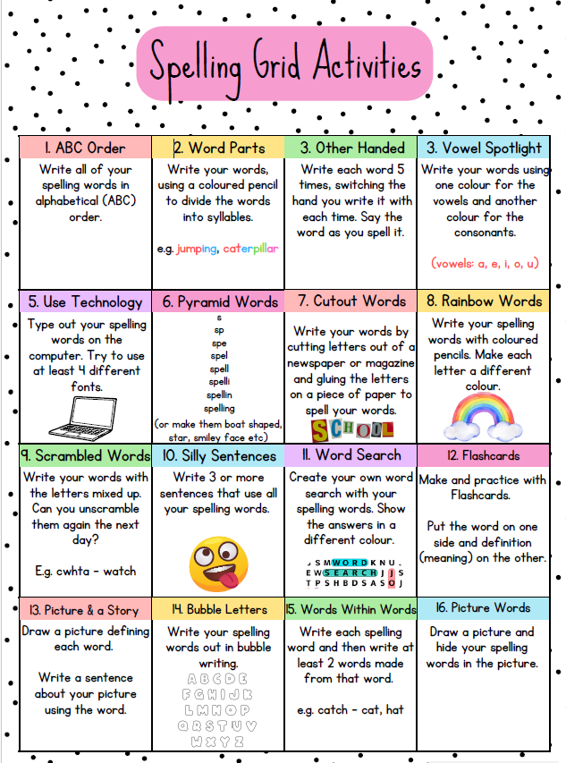
Spelling Phonemes covered in term 2/3
A phoneme is the “sound” letters make when put together.
It focusses on the “sound” not the letter pattern.
Here are examples, the children generate their own words.
Phonemes covered “ie”,”oe”,”oo” here are some examples of words

Unit 3 | i-e | ie |  | y |  | igh
“ie” | spine  smile | tie  lie |  | why  reply |  | right bright
Unit 4 | o-e |  | oa |  | ow |  | oe
“ oe” | whole  alone |  | road  coach |  | snow  follow |  | heroes  tomatoes
Unit 5 | oo |  | u-e |  | ew |  | ue |  | u
“oo” | shook  school |  | cute  flute |  | flew  threw |  | glue  rescue |  | pull  push

