Curriculum for Excellence: What are we learning this term? | Term 3 – January – April 2026
Context for Learning: Scots Language, Developing the Young Workforce, Book Study | Teacher name: Mrs Weir and Mrs Wilson P3

Language and Literacy  Phonics/Spelling- Spelling patterns will be taught through a variety of active spelling tasks.  Reading – Children will be developing their reading skills, focusing on Summarising a Story.  Writing- In writing we will be creating discussion and expository writing where we will follow a structured approach to creating a different style of text. We will continue to build upon existing knowledge, adding more detail to our writing.    Languages- Children will continue to use Spanish in everyday routines. We will be learning about animals, pets and different classroom instructions. | Numeracy and Maths  This term, the class will be focussing on:  - Fractions  - Equations  - Continuing to consolidate knowledge of Number and Number Processes.  The Circles and Squares maths groups will be introduced to division.  We will also continue to work on our Times Tables and will be learning the 4 and 6 times tables. |   Health and Wellbeing (HWB)  - We will continue to use the Zones of Regulation to explore different feelings and different strategies that we can use to regulate our emotions. Also, we will be learning about food and health. Within this topic we will be investigating what a balanced diet consists of and the different food groups within it.  PE Days- Tuesday and Thursday  - During P.E lessons, we will be developing our Gymnastics Skills and accessing some of the small apparatus. We will be improving our Target Skills through playing Bowls and Golf. We will also be developing our teamwork skills and participating in orienteering.  Participation in Fit 15 will continue this term. | IDL (Interdisciplinary Learning)  Our topic this term will be Scotland. We will be learning different Scottish words, songs and poems. We will also be researching different Scottish myths and legends. Additionally, we will create artwork inspired by famous Scottish artists.  We will be participating in different activities, which will focus on Developing the Young Workforce.  We will conduct a book study as part of our "March into Books" topic. Pupils will be involved in different activities in order to explore the text. We will create a final display of our learning.
At Dykesmains Primary School we are working to Get It Right For Every Child (GIRFEC). This means we are working to support our children to grow develop and reach their full potential. The children are currently looking at the SHANARRI indicators which are Safe, Healthy, Achieving, Nurtured, Active, Respected, Responsible and Included. For more information: http://www.girfecna.co.uk/

Learning at home- Literacy | Learning at home- Numeracy
Phonics sounds taught-  Examples of Activities-  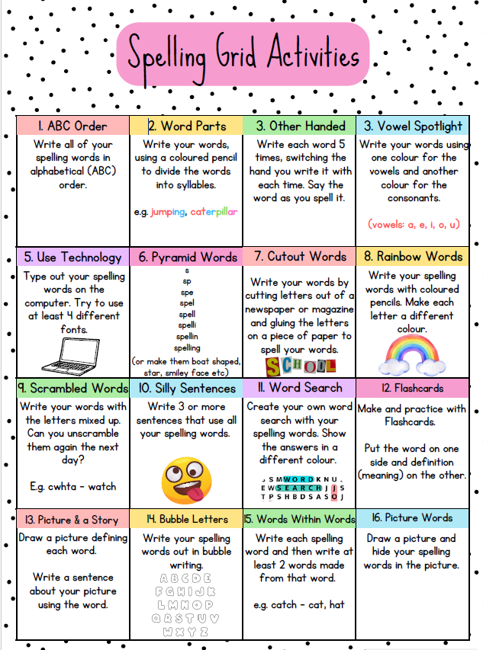  Bug club- ActiveLearn: Login  Languages-Online Spanish Games | Spanish Level  Spanish - BBC Bitesize | Times Tables activities-  Rock, Paper, Times Tables- Just like rock, paper, scissors except on the third lowering of your fist, you reveal a number with your fingers. For example, one player may hold up 7 fingers and the other may hold up 2. The calculation that needs to be solved is 7 x 2. The first player to get the correct answer wins.  Dice game- One player should roll two dice and multiply the two numbers together. For example, if they roll a 3 and a 4, they multiply 3 x 4. You can take turns, and each person tries to solve the problem as quickly as possible.  Times Table Art- Create a multiplication poster or chart, decorating it with fun colours, stickers, or drawings. This poster could be decorated with visual representations (like groups of objects).  Songs -  Number Blocks-Bing Videos  Twinkle Twinkle Little Songs- 5 Times Table Song (1-10) | Learn Math for Kids (X5 Multiplication Song)  Games-  Topmarks- Topmarks: teaching resources, interactive resources, worksheets, homework, exam and revision help  Time- Teaching Clock  Daily ten- Daily 10 - Mental Maths Challenge - Topmarks  Sumdog- Sumdog  Purple mash-Purple Mash | Computing, Maths, English and more - 2simple.com
  tch | wr | wa | th
  Witch  Match  Kitchen  Scratch  Snatch | Wrote  Wrong  Wrench  Wrap  Wren | Wander  Swallow  Wander  Watch  Warm | Them  Father  Mother  Rather  Gather
  ie | ve | g | ch
  Lied  Tried  Magpie  Cried  Lied | Believe  Starve  Retrieve  Leave  Have | Giant  Gentle  Stranger  Germs  Energy | Chorus  School  Christmas  Ache  Chord

