Curriculum for Excellence: What are we learning this term? | Term – 1 August- October
Context for Learning: The Vikings | Teacher name: Mrs Pike Primary 4
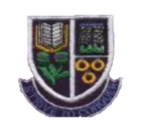
Language and Literacy  Spelling- Spelling patterns and rules will be taught through active and written spelling activities. We will focus on phonemes, common and topic words  Grammar- Our focus will be alphabetical order, a or an, extended sentences and V.C.O.P    Writing- We will learn about the purpose and features of a recount and an information report linking to our IDL topic The Vikings.  Spanish- We will be reinforcing vocabulary for the  calendar, classroom routines, greetings and feelings. | Numeracy and Maths  This term, children will be focusing on:  - Developing mental maths strategies.  - Place value involving 2, 3 and 4 digit numbers.  - Number and number processes: addition, subtraction and tables.  - Estimation and rounding.  Maths Topic-  - 3-D shape : names, properties  - Chance and uncertainty |   Health and Wellbeing (HWB)  PE: In PE this term, our focus is table Hockey and gymnastics.  We are also taking part in Fit Fifteen.  PE Days: Thursday am, Friday pm.  HWB: We are continuing to reinforce our Rights Respecting School ethos and are creating our class charter.  We will use the Zones of Regulation as a check in and revisit each zone to support ourselves to remain regulated.  Dykesmains Right Pathway will continue be central to our behaviour management. | IDL (Interdisciplinary Learning)  Topic :The Vikings We will be exploring where they came from, places that they settled in Scotland and how their lives were very different from ours. We will examine how they travelled, what they wore and play games that they would have played.  Art & Design- We will be engaging in a range of art activities linked to our topic e.g. designing Viking shields, helmets, jewellery, creating long boats.  Music – We will be playing games to develop our sense of rhythm, keeping the beat using different parts of our body. We will also be learning and performing songs.  Drama – We will be developing our use of improvisation through a variety of games and drama techniques.  Digital- Internet Safety, Word Processing Skills, research skills.
Learning at home- Literacy |  | Learning at home- Numeracy
Phonics/Spelling- Taught phonemes ae,ee,maths shape words, common words, topic words.  Online games: English KS1 - reading, spelling and punctuation games plus stories (roythezebra.com) https://www.topmarks.co.uk/  Bug club- ActiveLearn: Login (activelearnprimary.co.uk)  Languages-https://www.spanish-games.net |  | The following websites have activities to reinforce numeracy concepts covered in class e.g. Number bonds/ Place Value/Addition & Subtraction/Tables/Time/Money/Shapehttps://www.topmarks.co.uk/  https://www.sumdog.com/
Sumdog link : https://www.sumdog.com/
Purple mash : Purple Mash | Computing, Maths, English and more - 2simple.com
At Dykesmains Primary School we are working to Get It Right For Every Child (GIRFEC). This means we are working to support our children to grow develop and reach their full potential. The children are currently looking at the SHANARRI indicators which are Safe, Healthy, Achieving, Nurtured, Active, Respected, Responsible and Included. For more information: http://www.girfecna.co.uk/

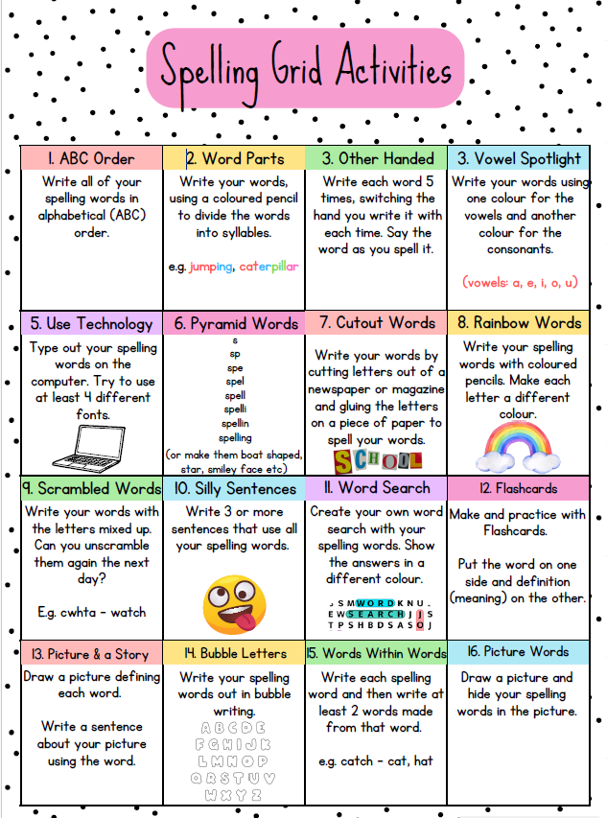

Spelling covered in term 1
Common words, days of the week, months of the year, seasons, shape words,
homophones : to,too,two
Spelling Phonemes covered in term 1
A phoneme is the “sound” letters make when put together.
It focusses on the “sound” not the letter pattern.
Here are examples , the children generate their own words.

Unit 1 ae
a-e | ay | ai | ey | ea
cage  plate | play  away | wait  railway | they  hockey | break  steak

ee | ea | e | ie | e-e
meet  street | teach  beach | she  he | thief  brief | these  complete
Unit 2 ee

Jotters have been provided for your child to use if
and when required when learning at home,
there is no expectation for them to be handed in weekly.
Children are always welcome to bring and share any work they are proud of.

