Curriculum for Excellence: What are we learning this term? | Term 1- August – October 2025
Context for Learning: The Victorians | Mrs McDiarmid / Mrs Cairns: Primary 7
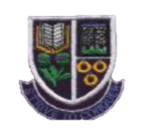
Language and Literacy  Spelling- North Lanarkshire spelling word lists learned through variety of written and active tasks  Reading- Predicting and Visualising reading strategies will be taught and consolidated through weekly guided reading sessions in groups as well as during comprehension activities    Writing- We are following PM Writing and covering the following genres this term: Recount, Information Report & Description. Writing contexts will include the Victorians and topical themes appropriate to the genre  Languages:  French- Introductions & Weather  Spanish- Personal information, adjectives to describe appearance, and numbers to 100 | Numeracy and Maths  This term, children will be focusing on:  Numeracy-  - Place Value beyond millions  - Estimation and Rounding to 10s, 100s & 1000s  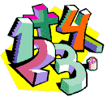  Maths-  - Multiples, Factors and Primes  - Chance and Probability  All maths groups will be working on mental maths strategies involving the four number processes. |   Health and Wellbeing (HWB)  PE: In PE this term our focus is Gymnastics and Netball  We are also taking part in Fit Fifteen each day.  PE days: Mondays & Thursdays  Kit: gym shorts, gym shoes/trainers, change of t-shirt (if wearing shirt/blouse or where pupil feels more comfortable changing for hygiene reasons)  HWB: ‘Social Values’ focussing on; being kind, friendly and including others, co-operating and treating others with respect  Growth Mindset activities  Rights Respecting Schools and SHANARRI activities.  Focus on our School Values: ‘FREACH’ | IDL (Interdisciplinary Learning)  The Victorians  Social Subject- We will be exploring ‘The Victorians’ through a variety of activities. Pupils will be investigating – Work, Clothing, Inventions, Famous Victorians, & Education  Science – Electricity & Light  Technologies-  Digital- Digital Literacy, Responsible use of digital platforms, e-Safety, accessing and using websites and games in a safe way.  Expressive Arts- Studying Victorian artists; exploring their techniques and recreating their works.  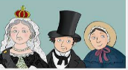  Drama & Music – We will be experimenting with movement and expression, using scenes from our class novel. We will look at Victorian music and compare to current trends.
Learning at home- Literacy |  | Learning at home- Numeracy
Spelling- Attached sheet & active spelling games  Victorians - https://www.bbc.co.uk/bitesize/articles/zkb6fdm  Sumdog grammar & spelling challenges – access through sumdog link below  Bug club- https://www.activelearnprimary.co.uk/login?c=0  Languages- https://www.spanish-games.net/ https://www.french-games.net/ |  | Timetables: https://www.topmarks.co.uk/maths-games/daily10  https://www.topmarks.co.uk/maths-games/hit-the-button  Place Value – https://www.topmarks.co.uk/maths-games/7-11-years/place-value  Multiples & Factors - https://www.topmarks.co.uk/maths-games/multiples-and-factors  Chance & Probability - https://www.scootle.edu.au/ec/viewing/L118/index.html#
Sumdog link - https://www.sumdog.com/ Purple mash link - https://www.purplemash.com/sch/dykesmains-primary-school
At Dykesmains Primary School we are working to Get It Right For Every Child (GIRFEC). This means we are working to support our children to grow develop and reach their full potential. The children are currently looking at the SHANARRI indicators which are Safe, Healthy, Achieving, Nurtured, Active, Respected, Responsible and Included. For more information: http://www.girfecna.co.uk/
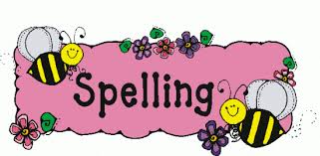
Spelling Words – For Consolidation & Practise in Term 1
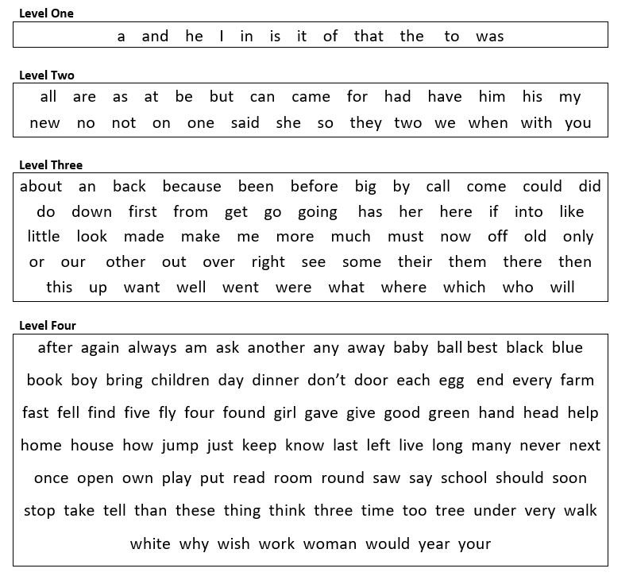
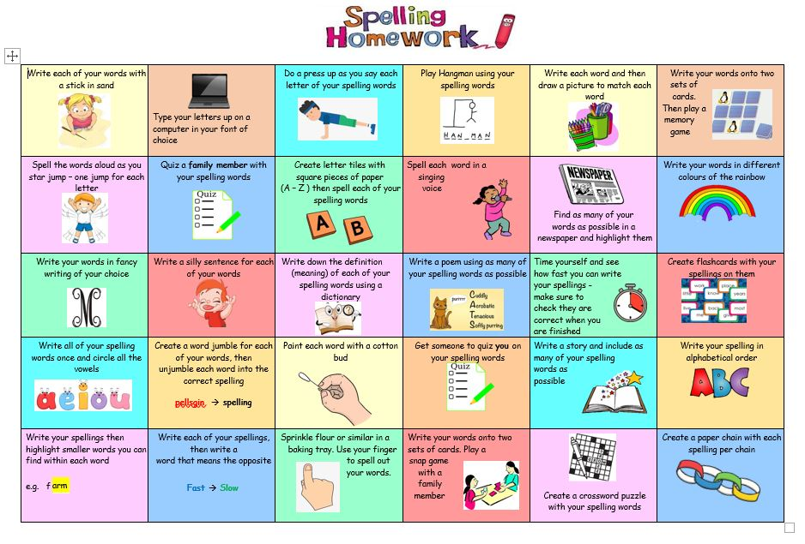

Active Spelling Ideas:
