Curriculum for Excellence: What are we learning this term? | Term 1 August - October 2025
Context for Learning: Medieval Scotland | Teacher: Mrs Drennan Primary 5

Language and Literacy  Spelling- Spelling phonemes will continue to be taught through a variety of active and written spelling activities.  Grammar- We will focus on different types of nouns and adjectives, revising the descriptive bubble. We will use VCOP to uplevel our sentences.    PM Writing- Our writing focus will be RECOUNT and NARRATIVE where we will follow a structured approach to creating texts.    Spanish- We will be revising feelings, personal details, the calendar including weather phrases. We will be introducing vocabulary for the home. |   Numeracy and Maths  - Pupils will be revising a selection of number processes and will be taught a variety of mental addition and subtraction strategies.  - Using their knowledge of rounding pupils will learn to estimate answers to problems.  - Pupils will further develop their knowledge of place value while exploring larger numbers.    - Pupils will learn to describe the chance or certainty of events happening. Real life scenarios will be used to teach this. |   Health and Wellbeing (HWB)  - We will be revising all of the SHANARRI indicators – pupils will share their thoughts and feelings with their peers.  - Pupils will create a class charter linking to Children’s Rights.  - P.E lessons will be on a Wednesday and Friday. The focus is on basketball and gymnastics  - Participation in Fit Fifteen and exploring mindfulness activities this term.    - Using the Bounce Back resource we will focus on social values of kindness, being friendly and respect. | IDL (Interdisciplinary Learning)  This term we will be exploring Medieval Scotland. Pupils will participate in a range of cross-curricular learning. Activities will include –    Social Subjects - Pupils will be investigating key figures and events –  - Alexander III  - Edward 1    - Battles of Stirling and Bannockburn  - Robert the Bruce  - William Wallace  We will compare Medieval lifestyles with modern times – Castles, soldiers & daily life.  Expressive Arts – design a Coats of Arms shield, soldiers uniforms, role play in drama. Digital – researching Key figures and events using search engines, creating word documents, powerpoint presentations to share their learning.
Learning at home- Literacy |  | Learning at home- Numeracy
Spelling- Phonemes k,j, common words, tricky words (see back)  Online games:  Spelling - https://spellingframe.co.uk/ (free games only)  Bug club- https://www.activelearnprimary.co.uk/login?c=0  Modern Languages- https://www.spanish-games.net/  https://www.french-games.net/ |  | Place Value, Mental maths, Times tables, Rounding:  Online activities -  https://www.topmarks.co.uk/maths-games/daily10.  https://www.topmarks.co.uk/maths-games/hit-the-button  https://mathsframe.co.uk/en/resources/resource/289/KS2_Maths_Invaders  https: https://www.topmarks.co.uk/place-value/place-value-charts
Sumdog link https://www.sumdog.com/user/sign_in
Purple mash link https://www.2simple.com/purple-mash/
At Dykesmains Primary School we are working to Get It Right For Every Child (GIRFEC). This means we are working to support our children to grow develop and reach their full potential. The children are currently looking at the SHANARRI indicators which are Safe, Healthy, Achieving, Nurtured, Active, Respected, Responsible and Included. For more information: http://www.girfecna.co.uk/
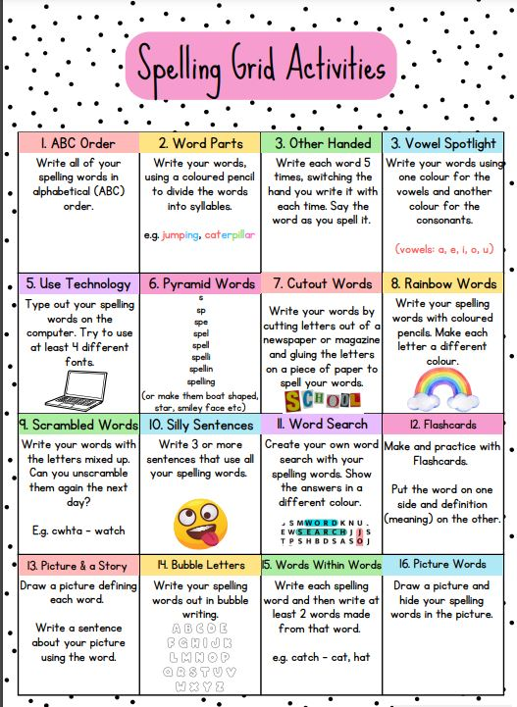
Phoneme Grids (to practise spelling words)
A phoneme is a sound letters make when you put them together.
It focuses on the sound not the letter pattern.
The children will generate the word lists.
Here are some examples.
c | k | ck | ch
cabin  calf | kangaroo  kilometre | crack  flock | school  echo

Phoneme – k

Phoneme – j
j | g | dge
jaws  jumping | danger  giraffe | bridge  hedge

Common/tricky words covered in term 1 – Set 1 & Set 2
above nine accident practising
breakfast nineteen below whispered
cupboard million cloudy emotion
eight surprise eleven knew
eighteen care football biscuit
experiment busy group I’m
first hear holiday I’ve
listen playtime

Jotters have been provided for your child to use if and when required when learning at home, there is no expectation for them to be handed in weekly. Children are always welcome to bring and share any work they are proud of.

