Curriculum for Excellence: What are we learning this term? | Term 2-October - December
Context for Learning: The Titanic | Mrs McDiarmid & Mrs Cairns: P7
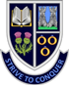
Language and Literacy  Spelling- We will work through spelling words looking at prefixes, suffixes with root words and subject specific vocabulary.  Reading- We will continue to work through appropriate levels on Bug Club and will also be learning the SHORS Comprehension strategies of Monitoring and Summarising.  Writing- We will be writing Book Reviews for the Rotary Club Competition and continuing with our PM Writing, focussing on Narrative Prose, Poetry and Procedural writing.    Languages- In French, we be learning weather vocabulary and in Spanish, we will be learning vocabulary associated with clothing and hobbies. | Numeracy and Maths  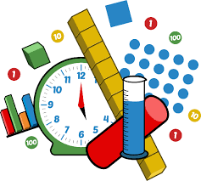  This term, children will be focusing on:  - Time  - Measurement  - Data & Analysis  - Number Patterns & Relationships  As always, we will continue to build upon the skills required for the four numerical processes; learning a variety of mental numeracy strategies to help us solve problems with more ease and accuracy. Pupils will also continue to use their Retrieval Practise booklets regularly to strengthen their memory of key concepts across all areas of numeracy and maths. | Health and Wellbeing (HWB)    PE: In PE this term, our topics will be table tennis and social dance.  We are also taking part in Fit Fifteen each day.  PE days: Monday & Thursday  Kit: Shorts and indoor PE shoes. Tape for any earrings that cannot be removed.  HWB: We will be continuing to look at Zones of Regulation this term, as well as areas of self-esteem, self-belief and growth mindset. We will also continue to further embed our knowledge of the UNCRC during the focus weeks and daily across the curriculum. | IDL (Interdisciplinary Learning)  Our IDL Topic this Term is the Ttianic and was voted for by the pupils. We will explore the story of the Titanic through history, literacy, numeracy, science, and the arts. We will investigate life in 1912, the ship’s engineering and voyage, and the social class differences. Pupils will analyse data, maps, and timelines, conduct science and STEM investigations on buoyancy and icebergs, and express understanding through art, drama, and presentation  Digital- We will be using our ICT skills to research and present our findings in various ways. We will also be continuing with coding on Purple Mash.
Learning at home- Literacy |  | Learning at home- Numeracy
Spelling- Attached sheet & active spelling games  Online games:  https://www.bbc.co.uk/bitesize/topics/zkbkf4j/articles/zbm8scw  Sumdog grammar & spelling challenges – access through sumdog link below  Bug club- https://www.activelearnprimary.co.uk/login?c=0  Languages-https://www.spanish-games.net/  https://www.french-games.net/ |  | Timetables: https://www.topmarks.co.uk/maths-games/daily10  https://www.topmarks.co.uk/maths-games/hit-the-button  Time: https://mathsframe.co.uk/en/resources/resource/116/telling-the-time  https://www.bbc.co.uk/bitesize/topics/zkfycdm/articles/zpxbydm#zkjfcxs  Measure:  https://www.transum.org/Maths/Activity/Reading_Scales/Default.asp?Level=1
https://www.sumdog.com/
https://www.purplemash.com/sch/dykesmains-primary-school
At Dykesmains Primary School we are working to Get It Right For Every Child (GIRFEC). This means we are working to support our children to grow develop and reach their full potential. The children are currently looking at the SHANARRI indicators which are Safe, Healthy, Achieving, Nurtured, Active, Respected, Responsible and Included. For more information: http://www.girfecna.co.uk/
Term 1 Spelling Words – For Consolidation & Practise in Term 2 Active Spelling Ideas:
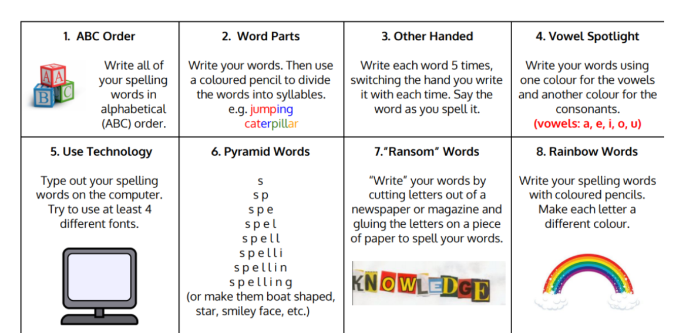
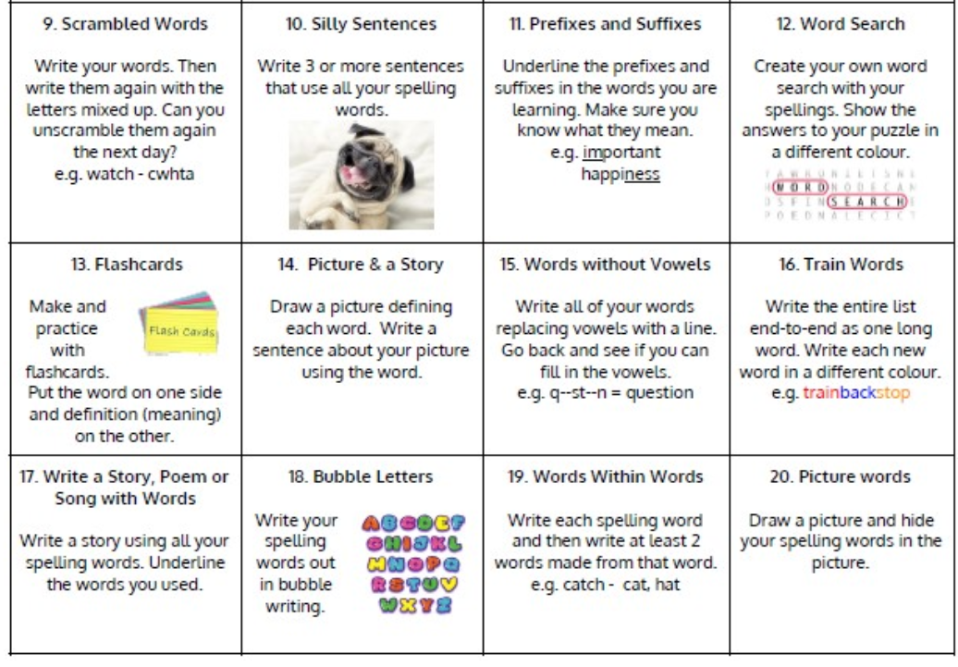
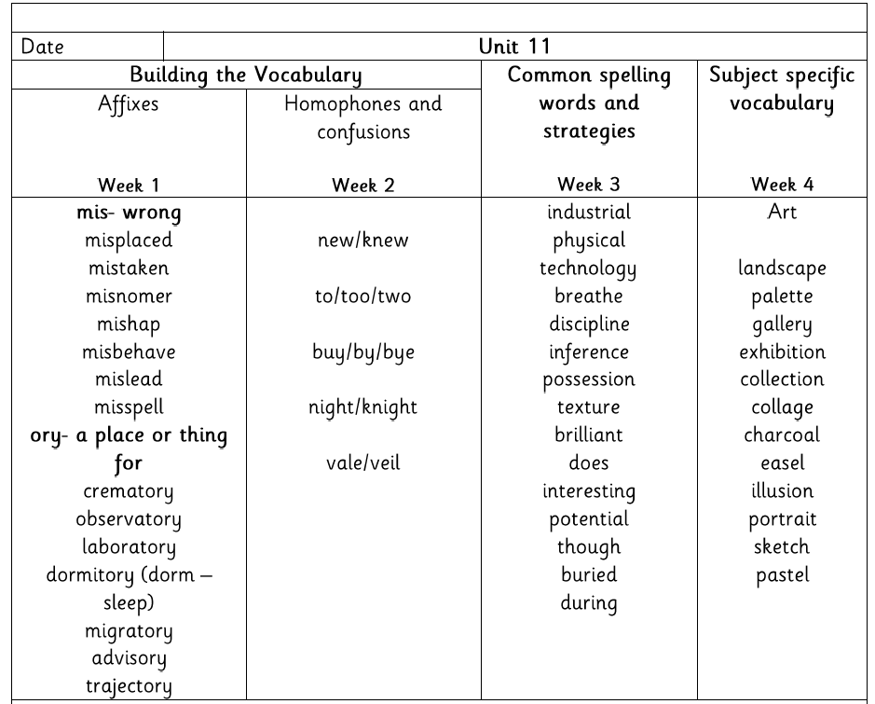

Jotters have been provided for your child to use if and when required when learning at home, there is no expectation for them to be handed in weekly. Children are always welcome to bring and share any work they are proud of.

