Curriculum for Excellence: What are we learning this term? | Term 4 April-June 2025
Context for Learning: Weather, Eco Week/ Outdoor Learning, Health and Wellbeing | Teacher : Mrs Pike Primary 4

Language and Literacy  Spelling- All spelling patterns, rules and common words will continue to be taught through active and written spelling strategies.  Talking and Listening- Create a weather report and present it to our peers.  Grammar- Our focus this term will be using adjectives, adverbs, correct tense verbs and revision of all punctuation and VCOP.  Writing- Our PM Writing topics for this term will be Discussion and Explanation. We will explore writing in paragraphs.  Spanish- Through games and activities we will continue build our knowledge of Spanish and Spanish customs. | Numeracy and Maths  This term, children will be focusing on:  Number and number processes  - Developing mental maths strategies.  - Reinforcing tables.  2D/3D Shape  - Exploring the properties of shapes.  - Investigating which shapes tile.  - Calculating the area of shapes in cm.  Patterns and Relationships  - Exploring repeating patterns and designs as well as recognising and continuing simple number sequences.  Angle and Symmtery  - Using signs, words and angles associated with direction and turning. Lines of symmetry, completing/creating symmetrical pictures. |   Health and Wellbeing (HWB)  PE: In PE this term our focus is on orienteering, softball and athletics.  We are also taking part in Fit Fifteen.  PE days: Monday, Thursday  HWB: Through our outdoor learning and our health and wellbeing topics we will explore ways of keeping ourselves healthy.  We will get the chance to take part in a range of activities.  We will continue our daily check-ins using our Zones of Regulation chart and accessing the boxes within our class to help us maintain a healthy mind. | IDL (Interdisciplinary Learning)  Our contexts for learning this term will be a focus on Weather, Eco Week/Outdoor Learning, Health & Wellbeing, Farming & Food  School Trip- Dumfries House, Festival of Farming and Food. The children will participate in a range of activities to increase their understanding of where the food they eat comes from, as well as their knowledge of other agricultural produce and practices.  Art & Design- We will be completing a variety of art activities linked to our topic. Music – Creating weather music using instruments, exploring weather songs.  Drama – Creating a weather report  Digital-Lego Spike, Purple Mash,Use of Promeathan board to create a weather report.
Learning at home- Literacy |  | Learning at home- Numeracy
Phonics/Spelling- Taught phonemes ae,ee,maths shape words, common words  Online games: English KS1 - reading, spelling and punctuation games plus stories (roythezebra.com) https://www.topmarks.co.uk/  Bug club- ActiveLearn: Login (activelearnprimary.co.uk)  Languages-https://www.spanish-games.net |  | The following websites have activities to reinforce numeracy concepts covered in class e.g. Number bonds/ Place Value/Addition & Subtraction/Tables/Time/Money/Shapehttps://www.topmarks.co.uk/  https://www.sumdog.com/
Sumdog link : https://www.sumdog.com/
Purple mash : Purple Mash | Computing, Maths, English and more - 2simple.com
At Dykesmains Primary School we are working to Get It Right For Every Child (GIRFEC). This means we are working to support our children to grow develop and reach their full potential. The children are currently looking at the SHANARRI indicators which are Safe, Healthy, Achieving, Nurtured, Active, Respected, Responsible and Included. For more information: http://www.girfecna.co.uk/

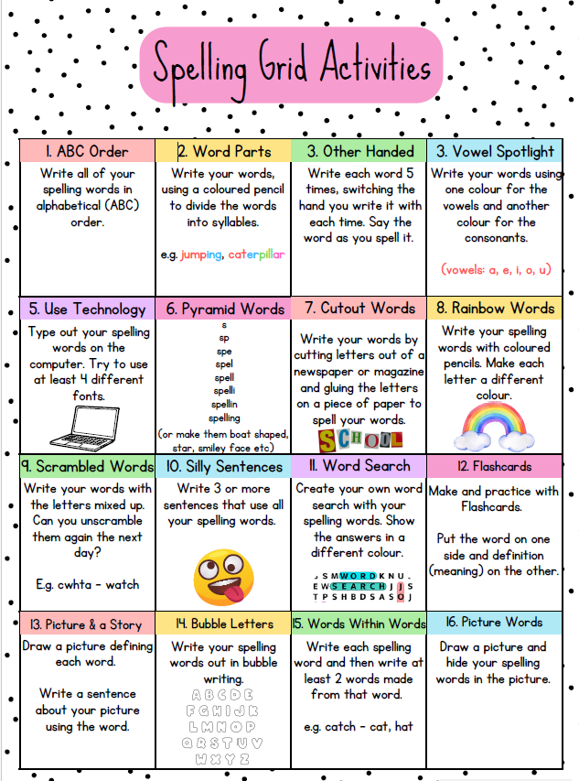

Spelling covered in term 3
- Common words, contractions,
- Homophones e.g. flower, flour,
- Time words e.g. minute, hour

Spelling Phonemes covered in term 3
A phoneme is the “sound” letters make when put together.
It focusses on the “sound” not the letter pattern.
Here are examples, the children generate their own words.
Phonemes covered “ow”,”oi”,”k” here are some examples of words

Unit 9 | c | k | ck | ch
“k” | cabin  cartoon  call | kangaroo  kind | crack  crackle  flock | school  character  chaos

Unit 8 | oy | oi
“ oi” | enjoy  annoy  employ | soil  choice  voice
Unit 7 | ou | ow
“ow” | ground  outside  found | allow  shower  growl

