Curriculum for Excellence: What are we learning this term? | Term 4 April-June 2025
Context for Learning: The Rainforest | Teacher: Mrs Drennan Primary 5

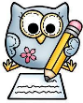  Language and Literacy  Spelling- Spelling patterns will continue to be taught through active and written spelling activities.  Literacy- Our Literacy work will further develop our skills in up-levelling sentences using VCOP. We will also work on adding more dialogue to our writing.  PM writing- Our writing focus will be NARRATIVE where we will follow a structured approach and create a range of texts.  Spanish- Vocabulary for the home & nationalities. Short written tasks.  French –Numbers and weather      Phrases. | Numeracy and Maths  Number – Revision of the 4 processes, multiplying decimals.  Money – continue to develop money sense and calculations.  Symmetry – identify and illustrate all lines of symmetry on a wide range of 2D shapes and complete symmetrical patterns.  Shape - describe 2D/3D shapes using specific vocabulary, regular/irregular, show an understanding of 3D shapes and nets.    Measure – perimeter, area, volume. | Health and Wellbeing (HWB)  P.E lessons will be on a Wednesday and Friday. The focus is on ATHLETICS where we will be working on different techniques for events – running, hurdles, long jump etc. and Outdoor Summer games eg. rounders, team games.  Participation in Fit Fifteen outdoors and our mindfulness activities will continue this term.      Our Health and Wellbeing focus weeks are also this term. We will take part in a variety of activities to improve our overall Health and Wellbeing. | IDL (Interdisciplinary Learning)  This term we will be exploring – The Rainforest - through a variety of activities. Pupils will be investigating the following: Where are the Rainforests, The Rainforest Climate, Layers of the Rainforest, Life in the Rainforest, the Amazon Jungle.    There will also be an Eco week where we will highlight and build upon the hard work that our Eco Council currently do.  Digital Technology – We will continue to develop our use of digital technologies. Activites will include – research, animation and coding.
Learning at home- Literacy |  | Learning at home- Numeracy
Spelling- Phonemes common words, tricky words (see back)  Online games:  Spelling - https://spellingframe.co.uk/ (free games only)  Bug club- https://www.activelearnprimary.co.uk/login?c=0  Modern Languages- https://www.spanish-games.net/  https://www.french-games.net/ |  | Mental maths, shape, area, symmetry, measure, tables: Online activities -  https://www.topmarks.co.uk/maths-games/daily10.  https://www.topmarks.co.uk/maths-games/hit-the-button  https://mathsframe.co.uk/en/resources/resource/289/KS2_Maths_Invaders  https://www.topmarks.co.uk/maths-games/7-11-years/shape-position-and-movement  https://www.topmarks.co.uk/search.aspx?q=symmetry
Sumdog link https://www.sumdog.com/user/sign_in
Purple mash link https://www.2simple.com/purple-mash/
At Dykesmains Primary School we are working to Get It Right For Every Child (GIRFEC). This means we are working to support our children to grow develop and reach their full potential. The children are currently looking at the SHANARRI indicators which are Safe, Healthy, Achieving, Nurtured, Active, Respected, Responsible and Included. For more information: http://www.girfecna.co.uk/
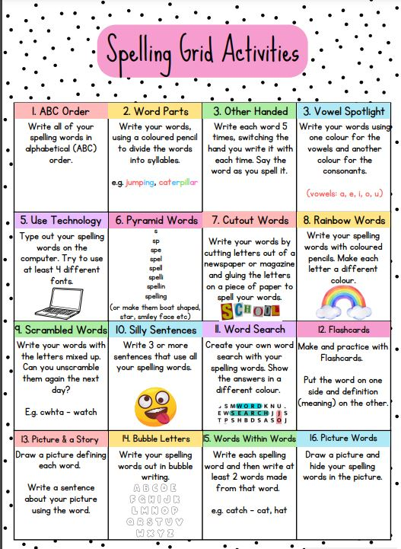
Phoneme Grids (to practise spelling words)
A phoneme is a sound letters make when you put them together.
It focuses on the sound not the letter pattern.
The children will generate the word lists.
Here are some examples.
s | ss | c | se | ce
sack  scream | address  actress | saucer  city | sense  cease | peace  service

Phoneme – s

Phoneme – au
a | o | au | aw
ball  fall | oxygen  orange | because  pause | awful  crawl

Common/tricky words
seven, seventeen, clothes, garden, yesterday, swimming, sure, before, never, fruit, believe, decided, another, quiet, quite

Jotters have been provided for your child to use if and when required when learning at home, there is no expectation for them to be handed in weekly. Children are always welcome to share any work they are proud of. Work can be uploaded onto the SEESAW platform.

