Curriculum for Excellence: What are we learning this term? | Term 4-April - June
Context for Learning: Natural Disasters, Sustainability & Health Weeks | Mrs Moran & Mrs Cairns: P7

Language and Literacy  Spelling- We are continuing to work through spelling words looking at prefixes and suffixes with root words, as well as subject specific vocabulary.  Reading- We will be working through our appropriate levels on Bug Club. We will be revising all of the SHORS strategies and working on independent comprehension.  Writing- Our PM writing genres are: Procedure & Narrative Prose. Grammar lessons will focus on:  Abstract Nouns, Hyphens, and Multi & Conditional Clauses.  Languages-    French- Family Vocabulary and Mardi Gras.  Spanish- Town information. | Numeracy and Maths  This term, children will be focusing on:  - Fractions, Decimals & Percentages  - Expressions & Equations  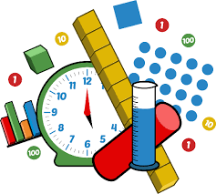  As always, we will continue to build upon the skills required for the four numerical processes; learning a variety of mental numeracy strategies to help us solve problems with more ease and accuracy. We will also continue to use our Retrieval Practise booklets daily, as well as using Sumdog Fluency. This assists learners to strengthen their memory of key concepts across all areas of numeracy and maths. |  | Health and Wellbeing (HWB)    PE: In PE this term, our topics are Sports Champion events, Athletics & Rounders.  We will also take part in Fit Fifteen daily.  PE days: Monday & Thursday  Kit: Shorts, leggings or jogging bottoms and indoor PE shoes. All jewellery MUST be removed. Any new piercings can be covered.  HWB: All pupils will learn the theory behind the iCycle programme, keeping safe on and around roads. We will also learn to describe the physical and emotional changes to the body during puberty during our health weeks. |  | IDL (Interdisciplinary Learning)  This term we will be exploring The Natural Disasters through a variety of written and active activities. We will investigate how the earth is formed and research how tectonic plates impact on Natural Disasters. We will also look at how climate change can impact upon these and look at sustainability as part of this.  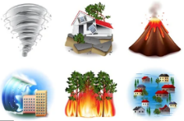    Digital- We will be using our ICT skills to research and present our findings in various ways. We will also be learning about spreadsheets and blogging on Purple Mash.
Learning at home- Literacy |  | Learning at home- Numeracy
Spelling- Attached sheet & active spelling games  Online games: https://www.bbc.co.uk/bitesize/topics/zkbkf4j/articles/zbm8scw  Sumdog grammar & spelling challenges – https://www.sumdog.com/  Bug club- https://www.activelearnprimary.co.uk/login?c=0  Languages-https://www.spanish-games.net/  https://www.french-games.net/ |  | Times tables: https://www.topmarks.co.uk/maths-games/daily10  https://www.topmarks.co.uk/maths-games/hit-the-button  Fractions: https://www.topmarks.co.uk/maths-games/7-11-years/fractions-and-decimals  Decimals: as above  Percentages: https://maths-games.org/percentage-games/  Expressions & Equations: https://www.math-salamanders.com/algebra-math-games.html
https://www.purplemash.com/sch/dykesmains-primary-school
At Dykesmains Primary School we are working to Get It Right For Every Child (GIRFEC). This means we are working to support our children to grow develop and reach their full potential. The children are currently looking at the SHANARRI indicators which are Safe, Healthy, Achieving, Nurtured, Active, Respected, Responsible and Included. For more information: http://www.girfecna.co.uk/
Term 3 Spelling Words – For Consolidation & Practise in Term 4 Active Spelling Ideas:
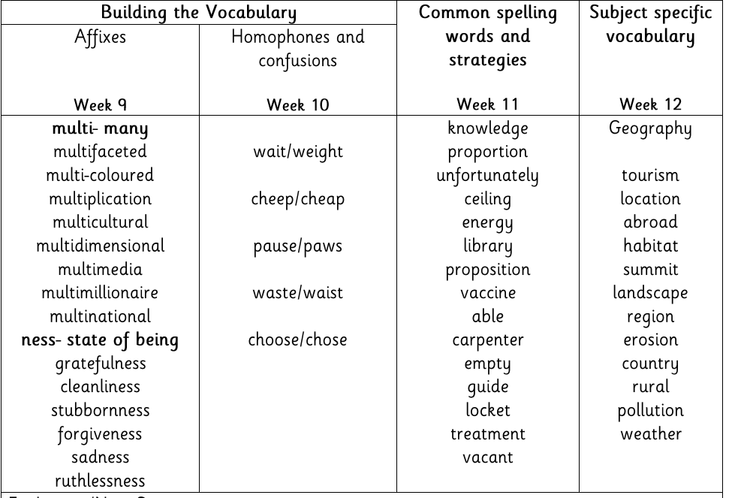
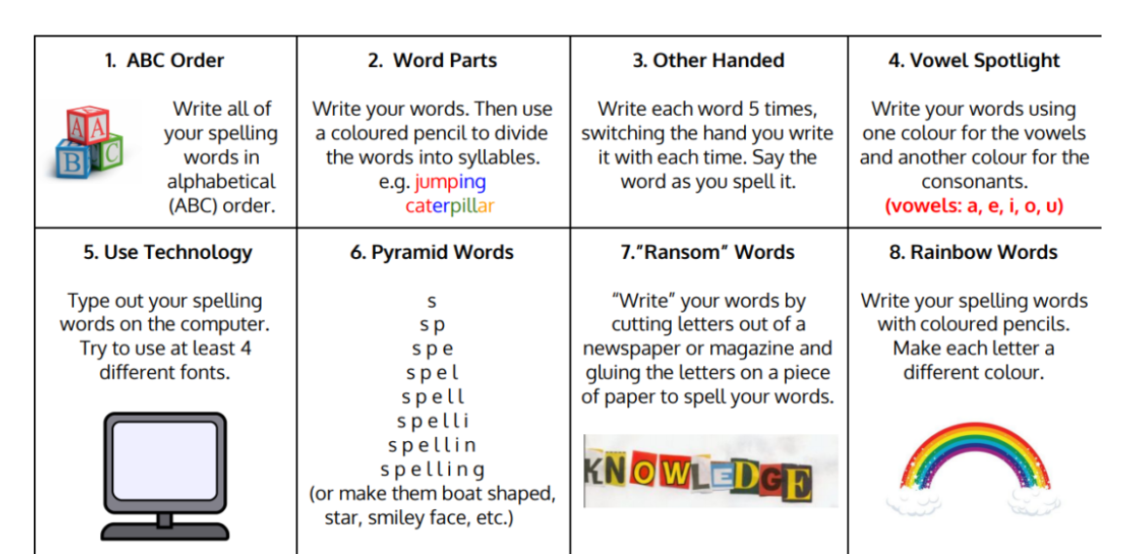
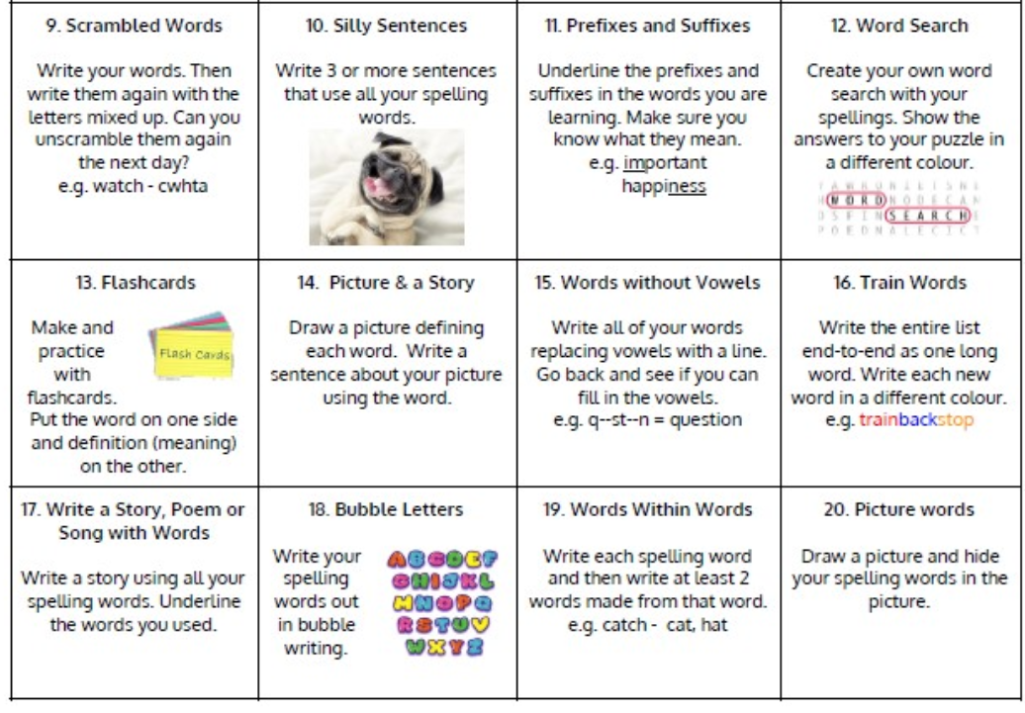

Jotters have been provided for your child to use if and when required when learning at home, there is no expectation for them to be handed in weekly. Children are always welcome to bring and share any work they are proud of.

