Curriculum for Excellence: What are we learning this term? | Term 3-January - April
Context for Learning: Scots Language, Scottish Parliament & March into Books | Mrs Moran & Mrs Cairns: P7

Language and Literacy  Spelling- We are continuing to work through spelling words looking at prefixes and suffixes with root words, as well as subject specific vocabulary.  Reading- We will be working through our appropriate levels on Bug Club. We will be looking at the SHORS Comprehension strategies of Prediction and Monitoring.  Writing- We will be continuing with our PM Writing and looking at the genres of explanation and response.    Languages- In French, we are learning vocabulary associated with animals and pets. In Spanish, we will be learning vocabulary associated with directions. | Numeracy and Maths  This term, children will be focusing on:  - Money  - Angles  - Symmetry  - 2D & 3D Shapes  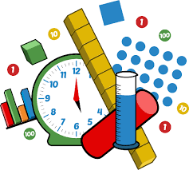  As always, we will continue to build upon the skills required for the four numerical processes; learning a variety of mental numeracy strategies to help us solve problems with more ease and accuracy. We will also continue to use our Retrieval Practise booklets daily. This assists learners to strengthen their memory of key concepts across all areas of numeracy and maths. |  | Health and Wellbeing (HWB)    PE: In PE this term, our topics will be large apparatus gymnastics, target games such as golf and bowls, and orienteering.  We will also take part in Fit Fifteen daily.  PE days: Monday & Thursday  Kit: Shorts, leggings or jogging bottoms and indoor PE shoes. All jewellery MUST be removed. Any new piercings can be covered.  HWB: We will be continuing to look at Zones of Regulation this term, as well as areas of self-esteem, self-belief and growth mindset. We will also continue to further embed our knowledge of the UNCRC. |  | IDL (Interdisciplinary Learning)    We are developing our skills in Self-Directed Learning this term and will be choosing our own individual topics to explore.  Scottish Parliament  We will be looking at the principles of democracy, how the parliament makes decisions as well as key individuals and links to the UNCRC. They will be covering outcomes on social studies, expressive arts, science and rme.  Digital- We will be using our ICT skills to research and present our findings in various ways. We will also be continuing with coding on Purple Mash.
Learning at home- Literacy |  | Learning at home- Numeracy
Spelling- Attached sheet & active spelling games  Online games: https://www.bbc.co.uk/bitesize/topics/zkbkf4j/articles/zbm8scw  Sumdog grammar & spelling challenges – https://www.sumdog.com/  Bug club- https://www.activelearnprimary.co.uk/login?c=0  Languages-https://www.spanish-games.net/  https://www.french-games.net/ |  | Times tables: https://www.topmarks.co.uk/maths-games/daily10  https://www.topmarks.co.uk/maths-games/hit-the-button  Money: https://natwest.mymoneysense.com/students/students-8-12/space-trader/  Angles: https://firstlook.educationcity.com/content/Learnscreen/index/22408  Symmetry: https://www.topmarks.co.uk/symmetry/symmetry-matching  https://mathsframe.co.uk/en/resources/resource/82/itp-symmetry  Shape: https://mathsframe.co.uk/en/resources/resource/115/sorting_3d_shapes_on_a_venn_diagram#
https://www.purplemash.com/sch/dykesmains-primary-school
At Dykesmains Primary School we are working to Get It Right For Every Child (GIRFEC). This means we are working to support our children to grow develop and reach their full potential. The children are currently looking at the SHANARRI indicators which are Safe, Healthy, Achieving, Nurtured, Active, Respected, Responsible and Included. For more information: http://www.girfecna.co.uk/
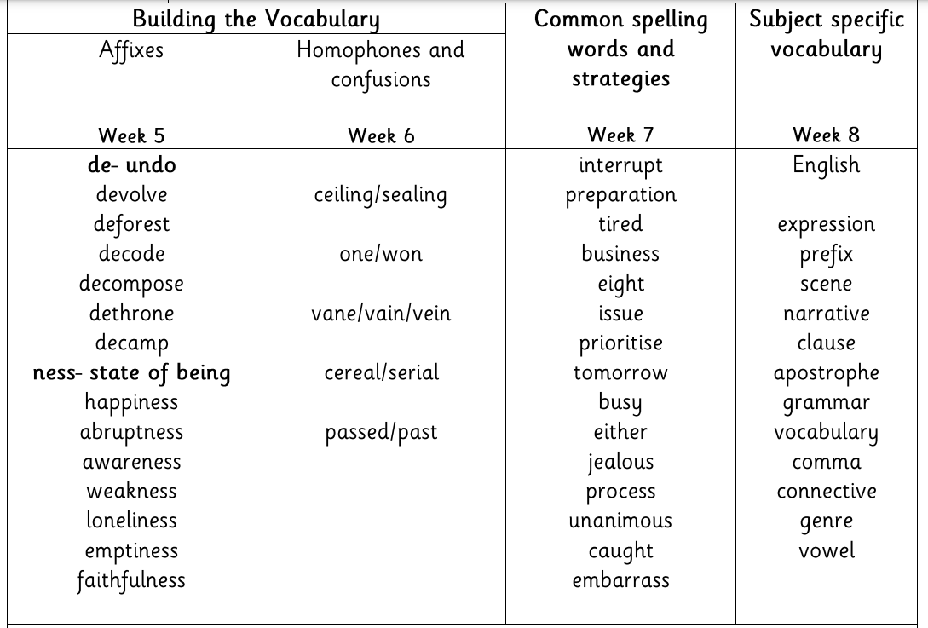
Term 2 Spelling Words – For Consolidation & Practise in Term 3 Active Spelling Ideas:
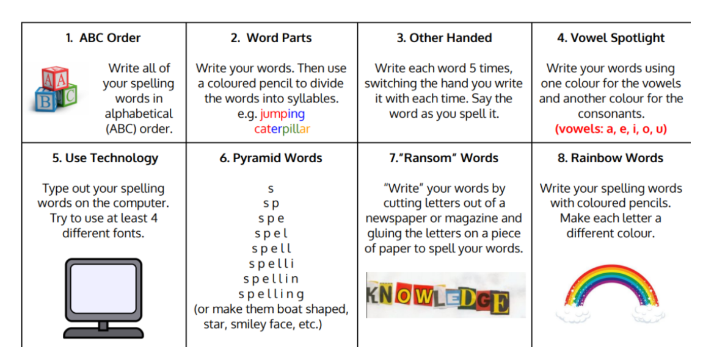
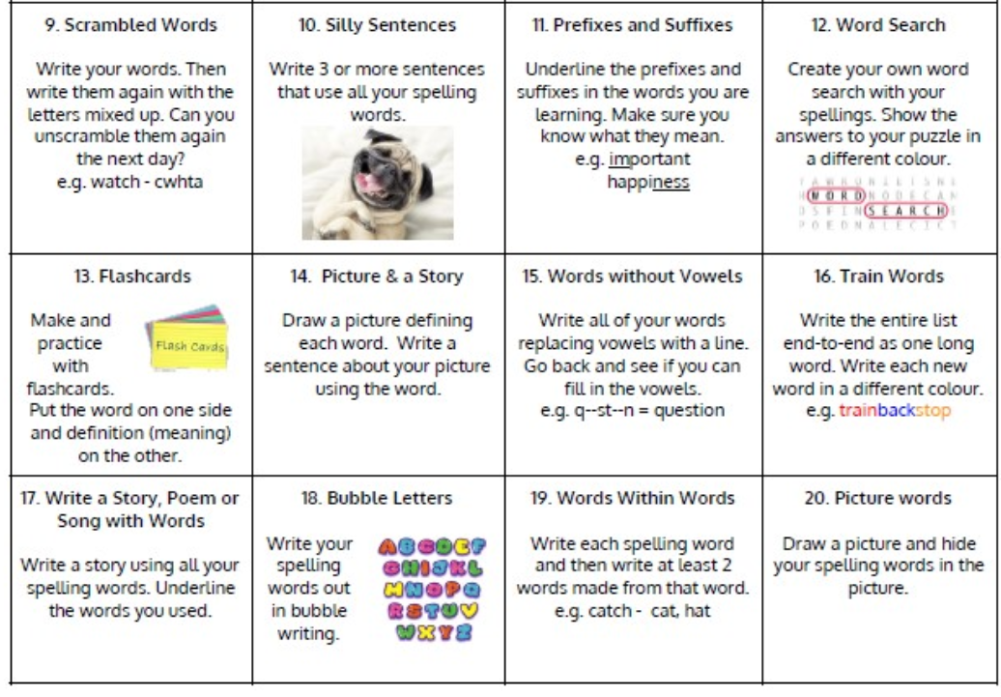

Jotters have been provided for your child to use if and when required when learning at home, there is no expectation for them to be handed in weekly. Children are always welcome to bring and share any work they are proud of.

