Curriculum for Excellence: What are we learning this term? | Term 3 January – April 2025
Context for Learning: Scots Language,World of Work, Novel Study | Teacher: Mrs Drennan Primary 5

  Language and Literacy  Spelling- Spelling patterns will continue to be taught through active and written spelling activities using NL spelling.  Grammar- The focus is on ADVERBS, using PUNCTUATION marks & FIGURATIVE Language – Alliteration, Similes & Metaphors.  PM Writing- Our writing focus will be Narrative & Information where we will follow a structured approach to creating texts.    Listening/Talking – different activities will be used to focus on specific skills in this area.  Spanish- Vocabulary for PETS & FOODS will be learned through games and songs.  French – We will learn days, months and seasons through fun tasks. | Numeracy and Maths  Place value – continuing to develop mental maths skills, x10, x100, x1000, uses multiplication and division facts with 2, 3, 4, 5, 6, 7 and 10 tables.  Fractions – revision, simple fractions, fractions of quantity, ordering and simplifying, introduction to decimal numbers.  Measurement – We will look at:  Length – km, m, cm, mm / Weight – Kg, g & Capacity – l, ml. We will learn to calculate the perimeter/area and volume of shapes.  Data Handling – We will be collecting, organising, displaying and analysing data accurately in a variety    of ways. | Health and Wellbeing (HWB)  PE lessons will be on a Wednesday and Friday. The focus is on FITNESS activities, where we will be working on stamina/strength and TARGET games. We will also continue to further develop gymnastic skills on larger apparatus. Participation in Fit Fifteen outdoors and our mindfulness activities will continue this term.    In BOUNCE BACK we will focus on EMOTIONS: Feelings are important; Knowing how you are feeling and naming feelings; Boosting positive feelings and managing our own feelings. This ties in well with our work on the ZONES of REGULATION. Here we will continue to develop our awareness of the different zones. | IDL (Interdisciplinary Learning)    Pupils will be exploring the use of Scots Language through a variety of Literacy and cross-curricular activities. They will learn a Scots poem and will be given an opportunity to perform in front of their peers.    Later in the term will be our March into Books topic - a cross curricular novel study. Pupils will be involved in different activities in order to explore the text. We will create a final DISPLAY of our learning.  Digital Technology – We will continue to develop our use of digital technologies. Activites will include – research, animation and powerpoints.
Learning at home- Literacy |  | Learning at home- Numeracy
Spelling- Phonemes common words, tricky words (see back)  Online games:  Spelling - https://spellingframe.co.uk/ (free games only)  Bug club- https://www.activelearnprimary.co.uk/login?c=0  Modern Languages- https://www.spanish-games.net/  https://www.french-games.net/ |  | Place Value, Mental maths, Fractions, Measure,Times tables:  Online activities -  https://www.topmarks.co.uk/maths-games/daily10.  https://www.topmarks.co.uk/maths-games/hit-the-button  https://mathsframe.co.uk/en/resources/resource/289/KS2_Maths_Invaders  https://www.topmarks.co.uk/Search.aspx?q=Fractions  https://www.topmarks.co.uk/Search.aspx?q=Measure
Sumdog link https://www.sumdog.com/user/sign_in
Purple mash link https://www.2simple.com/purple-mash/
At Dykesmains Primary School we are working to Get It Right For Every Child (GIRFEC). This means we are working to support our children to grow develop and reach their full potential. The children are currently looking at the SHANARRI indicators which are Safe, Healthy, Achieving, Nurtured, Active, Respected, Responsible and Included. For more information: http://www.girfecna.co.uk/
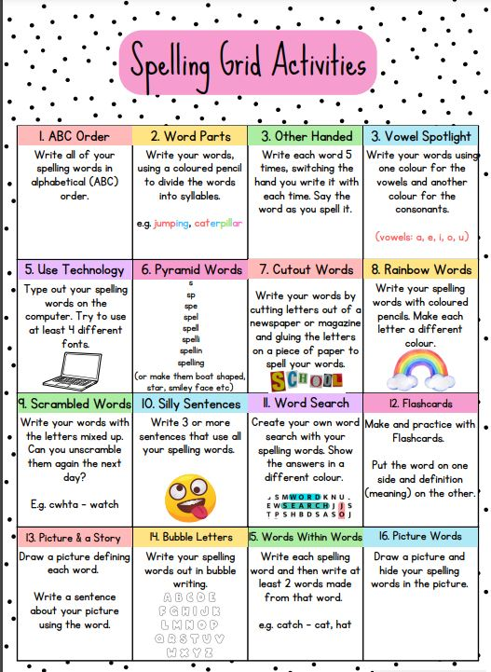
Phoneme Grids (to practise spelling words)
A phoneme is a sound letters make when you put them together.
It focuses on the sound not the letter pattern.
The children will generate the word lists.
Here are some examples.
sh | ti | ch
should  shoe | nation  collection | chef  chalet

Phoneme – sh

Phoneme – ch
ch | tch | ch
chair  chance | kitchen  catch | picture  creature

Common/tricky words
Accident, below, cloudy, eleven, football, group, holiday, I’m, I’ve, playtime, practising, whispered, emotion, knew, biscuit

Jotters have been provided for your child to use if and when required when learning at home, there is no expectation for them to be handed in weekly. Children are always welcome to share any work they are proud of. Work can be uploaded onto the SEESAW platform.

