|  |  |
| --- | --- |
| **Curriculum for Excellence: What are we learning this term?** | **Term 2-October - December** |
| **Context for Learning: Significant People** | **Mrs Moran & Mrs Cairns: P7** |



|  |  |  |  |
| --- | --- | --- | --- |
| **Language and Literacy**  **Spelling-** We are working through spelling words looking at prefixes and suffixes with root words, as well as subject specific vocabulary.  **Reading-** We will be working through our appropriate levels on Bug. We will be looking at the SHORS Comprehension strategies of Inference and Questioning.  **Writing-** We will be continuing with our PM Writing and looking at the genres of exposition and description.  C:\Users\lgibson\AppData\Local\Microsoft\Windows\Temporary Internet Files\Content.IE5\QGZH8EEO\Spain-flag-map-plus-ultra[1].png**Languages-** In French, we are looking at France as a country and weather. In Spanish, we will be learning vocabulary associated with clothing and hobbies. | **Numeracy and Maths**  Early Years Free Resources - Master The ...  This term, children will be focusing on:   * Time * Measurement * Data & Analysis * Number Patterns & Relationships   As always, we will continue to build upon the skills required for the four numerical processes; learning a variety of mental numeracy strategies to help us solve problems with more ease and accuracy. We will also continue to use our Retrieval Practise booklets daily. This assists learners to strengthen their memory of key concepts across all areas of numeracy and maths. | **Health and Wellbeing (HWB)**    **PE:** In PE this term, our topics will be table tennis and social dance.  We are also taking part in Fit Fifteen each day and will have Rugby input from Ardrossan Accies.  **PE days:** Monday & Thursday  **Kit:** Shorts and indoor PE shoes. Tape for any earrings that cannot be removed.  **HWB**: We will be continuing to look at Zones of Regulation this term, as well as areas of self-esteem, self-belief and growth mindset. We will also continue to further embed our knowledge of the UNCRC. | **IDL (Interdisciplinary Learning)**  We are developing our skills in Self-Directed Learning this term and will be doing this through our IDL topic of:  **Significant People**  Pupils will choose signifcant people from the past and present to research and present about. They will be covering outcomes on social studies, expressive arts, science and rme.  C:\Users\nschofield\AppData\Local\Microsoft\Windows\INetCache\Content.MSO\CF7A64B6.tmp**Digital-** We will be using our ICT skills to research and present our findings in various ways. We will also be continuing with coding on Purple Mash. |
| Learning at home- Literacy | | Learning at home- Numeracy |  |
| **Spelling-** Attached sheet & active spelling games  **Online games:**  [**https://www.bbc.co.uk/bitesize/topics/zkbkf4j/articles/zbm8scw**](https://www.bbc.co.uk/bitesize/topics/zkbkf4j/articles/zbm8scw)  **Sumdog grammar & spelling challenges – access through sumdog link below**  **Bug club-** https://www.activelearnprimary.co.uk/login?c=0  **Languages-**https://www.spanish-games.net/  <https://www.french-games.net/> | | **Timetables:** [**https://www.topmarks.co.uk/maths-games/daily10**](https://www.topmarks.co.uk/maths-games/daily10)  [**https://www.topmarks.co.uk/maths-games/hit-the-button**](https://www.topmarks.co.uk/maths-games/hit-the-button)  **Time:** [**https://mathsframe.co.uk/en/resources/resource/116/telling-the-time**](https://mathsframe.co.uk/en/resources/resource/116/telling-the-time)  [**https://www.bbc.co.uk/bitesize/topics/zkfycdm/articles/zpxbydm#zkjfcxs**](https://www.bbc.co.uk/bitesize/topics/zkfycdm/articles/zpxbydm#zkjfcxs)  **Measure:**  [**https://www.transum.org/Maths/Activity/Reading_Scales/Default.asp?Level=1**](https://www.transum.org/Maths/Activity/Reading_Scales/Default.asp?Level=1) | |
| [**https://www.sumdog.com/**](https://www.sumdog.com/)  **https://www.purplemash.com/sch/dykesmains-primary-school** | | | |

At Dykesmains Primary School we are working to Get It Right For Every Child (GIRFEC). This means we are working to support our children to grow develop and reach their full potential. The children are currently looking at the SHANARRI indicators which are Safe, Healthy, Achieving, Nurtured, Active, Respected, Responsible and Included. For more information: <http://www.girfecna.co.uk/>

Term 1 Spelling Words – For Consolidation & Practise in Term 2 Active Spelling Ideas:

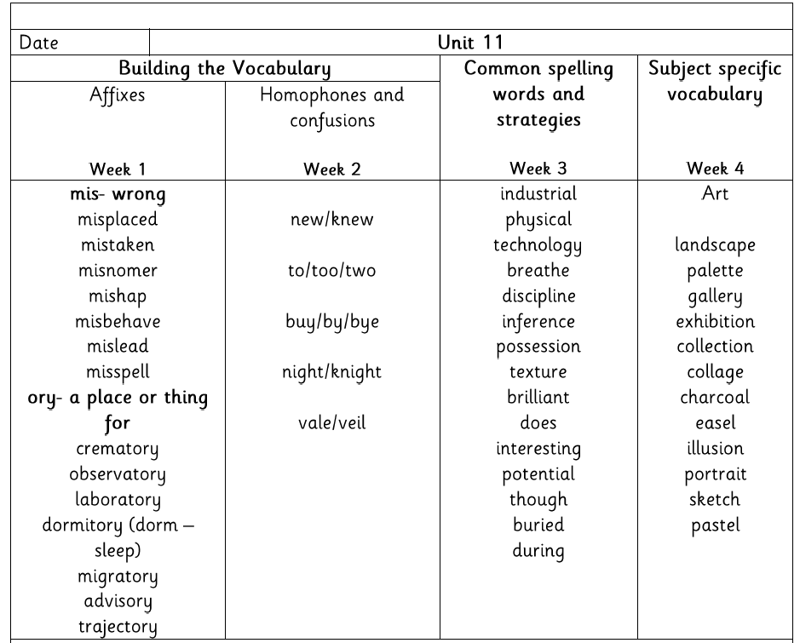

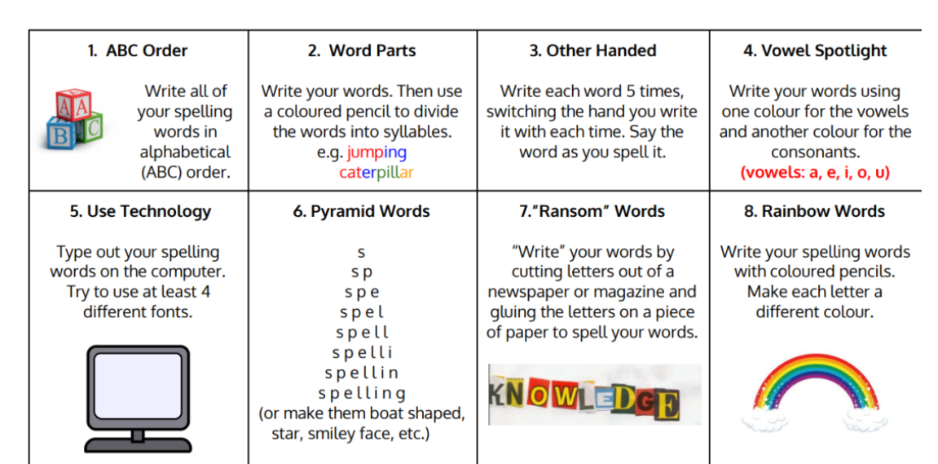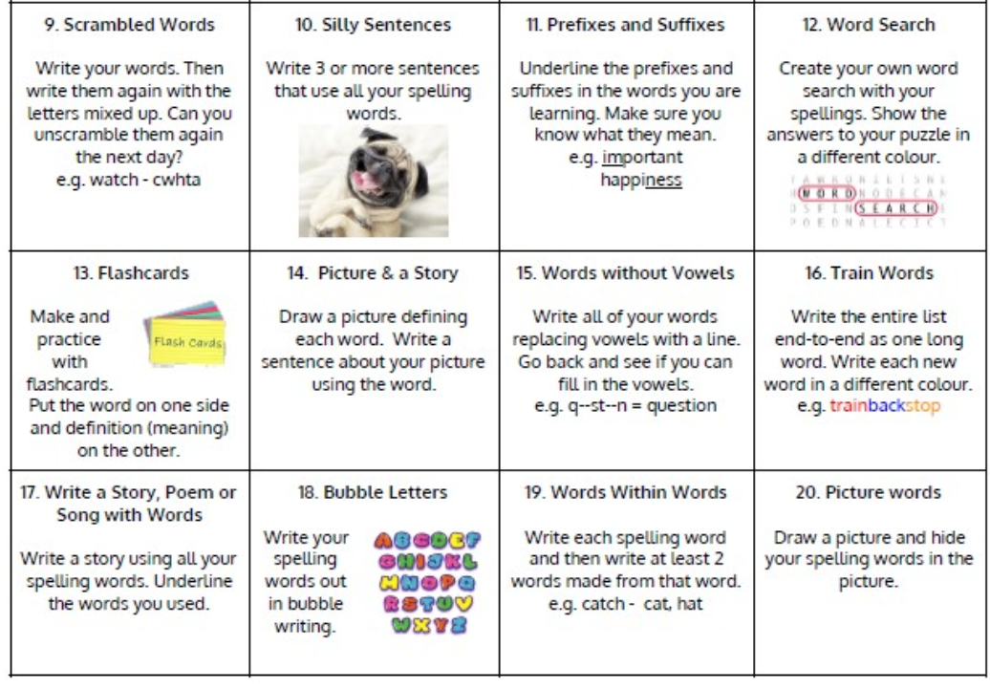

Jotters have been provided for your child to use if and when required when learning at home, there is no expectation for them to be handed in weekly. Children are always welcome to bring and share any work they are proud of.