|  |  |
| --- | --- |
| **Curriculum for Excellence: What are we learning this term?** | **Term 2 October - December 2024** |
| **Context for Learning: Oceans and Seas** | **Teacher: Mrs Drennan Primary 5** |



|  |  |  |  |
| --- | --- | --- | --- |
| **Language and Literacy**  **Spelling-** Spelling phonemes will continue to be taught through a variety of active and written spelling activities.  **Grammar-**We will focus on extending sentences using connectives and continue to develop our use of different PUNCTUATION marks – commas, speech marks.  **PM Writing-** Our writing focus will be INFORMATION and PROCEDURE where we will follow a structured approach to creating texts.  C:\Users\lgibson\AppData\Local\Microsoft\Windows\Temporary Internet Files\Content.IE5\QGZH8EEO\Spain-flag-map-plus-ultra[1].png**Spanish-** We will introduce new vocabulary for food and drink. We will read and write short sentences. **French –** We will look at greetings, feelings and numbers to 30 through games. | **Numeracy and Maths**  All maths groups will continue to develop different mental maths strategies through interactive activities.  **Number Processes** – includes tables practice, multiplying and dividing larger numbers by a single digit.  **Angles –** Identifying, classifying and measuring a range of angles, compass points and related angles.  **Expressions and Equations –** solving simple algebraic equations.  **Finance week** – We will look at aspects of money with a focus on budgeting.  **Time –** Looking at both 12 hour clock – analogue, digital times, durations of time. | **Health and Wellbeing (HWB)**  P.E lessons will be on a Monday and Thursday. The focus is on small ball skills – tennis and fitness activities. We will also further develop our Social Dancing skills by learning different Scottish Country Dances.  Participation in Fit Fifteen and our mindfulness activities will continue this term.  We will revise GROWTH MINDSET through a range of animations, stories and short activities.  We will also explore positivity by “Looking at the Bright Side” with Bounce Back. | **IDL (Interdisciplinary Learning)**  This term we will be exploring **Oceans and Seas**. Pupils will participate in a range of cross-curricular learning. **Activities will include –**  **Social Subjects** -Locating Oceans and Seas on a world map, exploring climate change issues affecting oceans/seas, investigating layers of the Ocean, Ocean/sea creatures, Plastic Pollution problems.  **Expressive Arts -** sea silhouttes, foil fish, 3D paper models, pastel pictures.  **Science -** research, water pollution experiments.  **Digital –** researching sea creatures using search engines, creating word documents, powerpoint presentations to share their learning. |
| Learning at home- Literacy | | Learning at home- Numeracy |  |
| **Spelling- Phonemes k,j, common words, tricky words (see back)**  **Online games:**  **Spelling -** [**https://spellingframe.co.uk/**](https://spellingframe.co.uk/) **(free games only)**  **Bug club-** [**https://www.activelearnprimary.co.uk/login?c=0**](https://www.activelearnprimary.co.uk/login?c=0)  **Modern Languages-** [**https://www.spanish-games.net/**](https://www.spanish-games.net/)  [**https://www.french-games.net/**](https://www.french-games.net/) | | **Place Value, Mental maths, Rounding,Times tables:**  **Online activities -**  [**https://www.topmarks.co.uk/maths-games/daily10**](https://www.topmarks.co.uk/maths-games/daily10)**.**  [**https://www.topmarks.co.uk/maths-games/hit-the-button**](https://www.topmarks.co.uk/maths-games/hit-the-button)  [**https://mathsframe.co.uk/en/resources/resource/289/KS2_Maths_Invaders**](https://mathsframe.co.uk/en/resources/resource/289/KS2_Maths_Invaders)  [**https://www.topmarks.co.uk/maths-games/rocket-rounding**](https://www.topmarks.co.uk/maths-games/rocket-rounding) | |
| **Sumdog link** [**https://www.sumdog.com/user/sign_in**](https://www.sumdog.com/user/sign_in)  **Purple mash link** [**https://www.2simple.com/purple-mash/**](https://www.2simple.com/purple-mash/) | | | |

At Dykesmains Primary School we are working to Get It Right For Every Child (GIRFEC). This means we are working to support our children to grow develop and reach their full potential. The children are currently looking at the SHANARRI indicators which are Safe, Healthy, Achieving, Nurtured, Active, Respected, Responsible and Included. For more information: <http://www.girfecna.co.uk/>

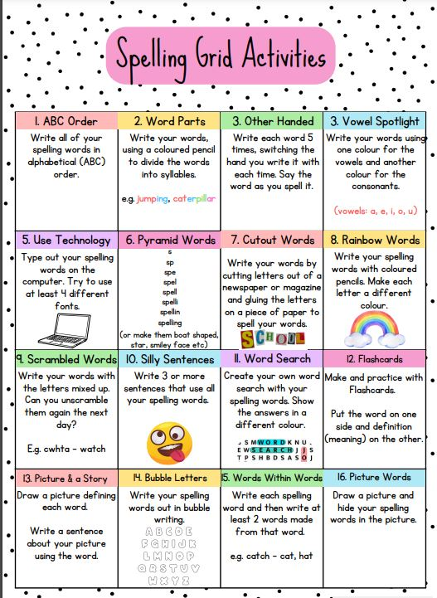Phoneme Grids (to practise spelling words)

A phoneme is a sound letters make when you put them together.

It focuses on the sound not the letter pattern.

The children will generate the word lists.

Here are some examples.

|  |  |  |  |
| --- | --- | --- | --- |
| c | k | ck | ch |
| cabin | kangaroo | crack | school |

Phoneme – k

Phoneme – j

|  |  |  |
| --- | --- | --- |
| j | g | dge |
| jaws | danger | bridge |

Common/tricky words covered in term 1

above nine

breakfast nineteen

cupboard million

eight surprise

eighteen care

experiment busy

first hear

listen

Jotters have been provided for your child to use if and when required when learning at home, there is no expectation for them to be handed in weekly. Children are always welcome to bring and share any work they are proud of.