|  |  |
| --- | --- |
| **Curriculum for Excellence: What are we learning this term?** | **Term 2- October-December 2024** |
| **Context for Learning: Spain & Enterprise (Christmas Fayre)** | **Teacher name: Mrs Pike Primary 4** |



|  |  |  |  |
| --- | --- | --- | --- |
| **Language and Literacy**    **Spelling-** All spelling patterns will continue to be taught through active and written spelling strategies.  **Grammar-** We will identify different parts of speech within a text and up-level our sentences to create complex sentences which include time and sequence words, connectives, nouns, adjectives, verbs and adverbs.  C:\Users\lgibson\AppData\Local\Microsoft\Windows\Temporary Internet Files\Content.IE5\QGZH8EEO\Spain-flag-map-plus-ultra[1].png**Writing-** We will learn about the purpose and features of a recount, narrative and procedure, developing the skills required to write this type of text independently.  **Spanish-** We will be learning vocabulary for family and classroom objects whilst reinforcing vocabulary learned during term 1. | **Numeracy and Maths**  This term, children will be focusing on:   * Continuing to develop mental maths strategies. * Number and number processes (addition, subtraction, multiplication and division). * Fractions (finding fractions of numbers, calculating simple fractions using division and learning to recognise simple equivalent fractions). * Expressions and Equations (comparing and describing number relationships and finding the value of missing numbers).   **Maths Topic-** We will be learning about the importance of mathematics and number in the world, researching number systems that have been used in the past. | **Health and Wellbeing (HWB)**  **PE:** In PE this term our focus is table tennis skills and dance.  We are also taking part in Fit Fifteen.  **PE days:** Monday, Thursday  **HWB**: We are continuing to reinforce our Rights Respecting School ethos and are adhering to our class charter.  We will be looking at ways in which we can build our resilience and develop a Growth Mindset.  We will continue to look at the **Zones of Regulation** and embed **Dykesmains Right Pathway** | **IDL (Interdisciplinary Learning)**  **Topic: Spain**  This term is our pupil choice topic. The class voted for **Spain** to be their class topic. The children will be involved in the planning of this topic and will be encouraged to suggest activities to complete as part of their learning.  **Art & Design-** We will be completing a variety of art activities linked to our topic e.g. exploring Cubism as well as Christmas crafts for our enterprise work.  **Music –** We will be playing games to develop our sense of rhythm, keeping the beat using different parts of our body. We will also be learning and performing songs.  **Drama –** We will be developing our use of improvisation through a variety of games and drama techniques.  **Digital-** Coding, Word Processing Skills |
| Learning at home- Literacy | | Learning at home- Numeracy |  |
| **Phonics/Spelling-** Taught phonemes **ae,ee,maths shape words, common words**  **Online games:** [English KS1 - reading, spelling and punctuation games plus stories (roythezebra.com)](https://www.roythezebra.com/) <https://www.topmarks.co.uk/>  **Bug club-** [ActiveLearn: Login (activelearnprimary.co.uk)](https://www.activelearnprimary.co.uk/login?c=0)  **Languages-https://www.spanish-games.net** | | **The following websites have activities to reinforce numeracy concepts covered in class e.g. Number bonds/ Place Value/Addition & Subtraction/Tables/Time/Money/Shape**<https://www.topmarks.co.uk/>  <https://www.sumdog.com/> | |
| **Sumdog link :** <https://www.sumdog.com/>  **Purple mash :** [Purple Mash | Computing, Maths, English and more - 2simple.com](https://www.2simple.com/purple-mash/) | | | |

At Dykesmains Primary School we are working to Get It Right For Every Child (GIRFEC). This means we are working to support our children to grow develop and reach their full potential. The children are currently looking at the SHANARRI indicators which are Safe, Healthy, Achieving, Nurtured, Active, Respected, Responsible and Included. For more information: <http://www.girfecna.co.uk/>

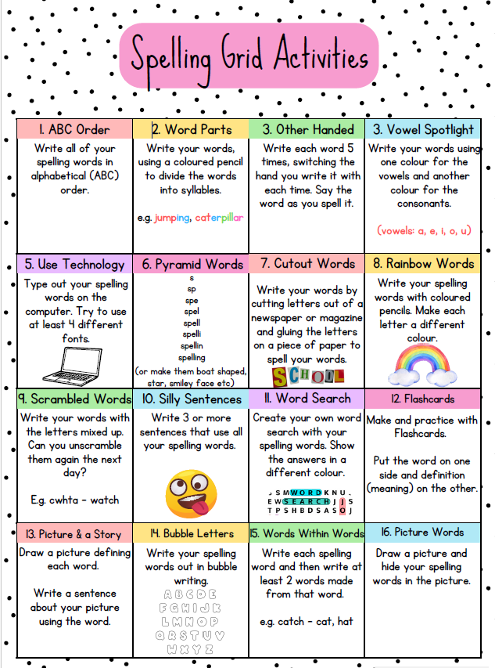

Spelling covered in term 1

Common words, days of the week, months of the year, seasons, shape words,

homophones :they’re, their, there, to,too,two

Spelling Phonemes covered in term 1

A phoneme is the “sound” letters make when put together.

It focusses on the “sound” not the letter pattern.

Here are examples; the children generate their own words.

**Unit 1 ae**

|  |  |  |  |  |
| --- | --- | --- | --- | --- |
| a-e | ay | ai | ey | ea |
| cage  plate | play  away | wait  railway | they  hockey | break  steak |

|  |  |  |  |  |
| --- | --- | --- | --- | --- |
| ee | ea | e | ie | e-e |
| meet  street | teach  beach | she  he | thief  brief | these  complete |

**Unit 2 ee**

**Jotters have been provided for your child to use if and when required**

**when learning at home, there is no expectation for them to be handed in**

**weekly. Children are always welcome to bring and share any work they**

**are proud of.**