Dykesmains Primary School

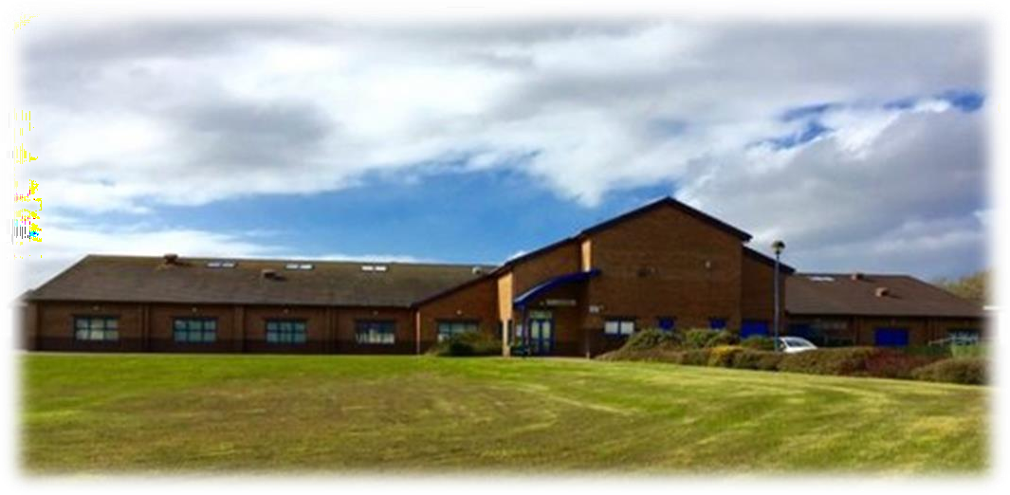

Starting school is a very important time in your child’s life. This booklet aims to help you support your child with this transition through offering advice and activities that you can do as a family if you wish to take part, as we understand that all children’s development needs are different.
In May, there will be transition videos on our school website https://blogs.glowscotland.org.uk/na/dykesmainsprimary/ and up to date information on our twitter page @DykesmainsPS
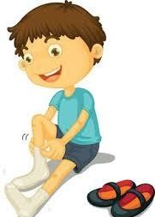
Help your child to develop some basic skills
- Try to encourage your child to dress himself/herself, including zipping a jacket and fastening shoes.
- It is very important to label clothing for school in case jumpers/shoes are taken off. Help your child to identify where they will find their name.
- Help your child to recognise their name.
- Ensure your child can go to the toilet and wash their hands by themselves.
- Remind your child about the importance of tidying up and of being well mannered, to other children as well as to adults.
- Allow you child to develop fine motor skills using pencils, crayons, playdough, scissors and paints as this is part of their hand development before writing.
- Play games with your child encourage listening skills, colour identity, counting and letter sounds.
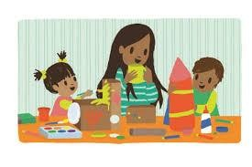
- Encourage your child to use a fork and knife and to remove their own plate and cup from the dinner table as this is expected in the lunch hall.

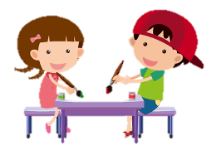
Play is a vital part of a child’s development and should be encourage throughout the day. Play activities in school are carefully structured to develop physical and social skills as well as skills in literacy, numeracy and other curricular areas. Play helps children to learn in a more relaxed and friendly way.
Games to play at home that you may already do
These are only suggestions, spending time, even just talking to your child, is the best thing you can do. Remember not to worry if your child has difficulty with any or all of the activities. It is NOT intended at as a development checklist and does not reflect your child’s readiness for school.
Matching game
Show your child a coloured item, identify the colour, and then ask them to find something else of the same colour. As your child’s colour awareness develops, you can give instructions such as ‘Find something red’ without first showing the colour.
Sing songs
Sing nursery rhyme songs that develops counting such as 5 Little Speckled Frogs, 10 in a Bed or 10 Green Bottles.
Playdough
This is a fun creative activity to do with children. You can make your own playdough with 2 cups of flour, 1 cup of water, 2 tablespoons of oil and a teaspoon of salt. You can add food colour to give it colour if you wish.
Cutting skills
Let your child create interesting pictures by cutting up different colours and images to create their own image. Children do find cutting skills difficult but this develops through practice. Remember to stay with your child when they are using scissors.
Junk Modelling
Being creative is good for brain development. Using junk, allow your child take the lead with what and how they want to create theirs.

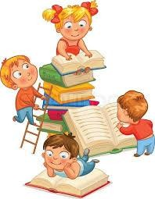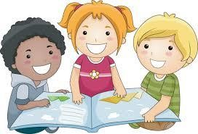
There are many things you can do as a family to encourage the love of books which will develop an interest in sounds and written language in children.
- As part of your child’s bed routine, read a book of their choice.
- Try to find books with pictures so you can talk about what is in the picture and the characters.
- Point to the pictures as your read.
- Ask questions, including “What do you think will happen next?” “What is your favourite part and why?”

Reading in school
Children develop at different stages from their peers and as a result reading books will not be sent home until your child is ready to cope with it. Giving a child a reading book to ready independently will cause stress to the child and a sense of failure as they will be aware that it is too hard for them.

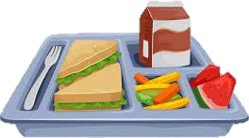

Children are often worried about the toilets in school. The toilets are beside the classroom and will be shown to them. An Early Years Practitioner supports in Primary 1 and is always there to take a child to the toilet area.
The cloakrooms for hanging jackets are as you come into school via the P1 entrance and the toilets are there too.
During break time and lunch time P1 children enter and exit the school via the same door and there are always adults in the playground to support and supervise all children. P1 children go for lunch slightly earlier to give them more time in the lunch hall and again there are familiar adults in the lunch hall to help children with things like routines and cutting of food.
For snack we suggest that children bring a healthy snack.
If a child feels ill or is hurt in the playground they will be taken to the main office where a trained first aider will look after your child.
In the mornings some children may struggle coming into school. Please be rest assured that if your child does not settle quickly with a member of staff you will receive a phone call.

- Have appropriate jacket and footwear for the weather.
- Label everything your child takes to school – clothes, jackets, shoes, water bottle and bag.
- Pencils and rubbers will be supplied so no need for a pencil case.
- Encourage children not to bring toys into school as these may get lost throughout the day.
- Use Velcro fastening shoes for school or gym shoes if your child cannot yet tie shoe laces.

