Dykesmains
Primary School
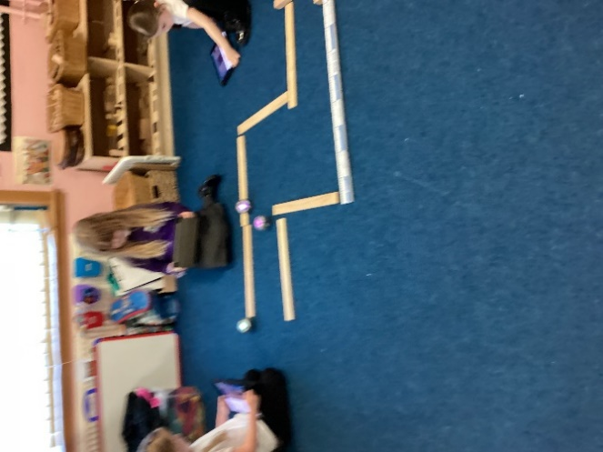
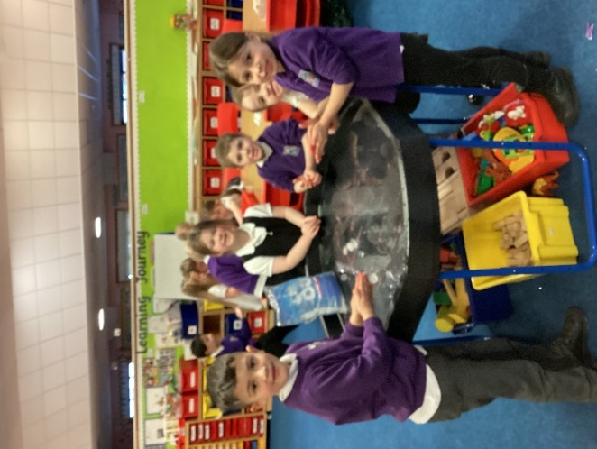

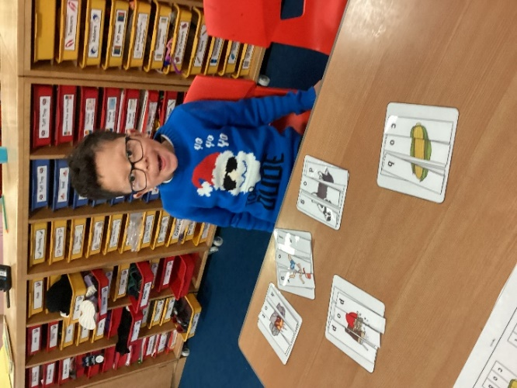
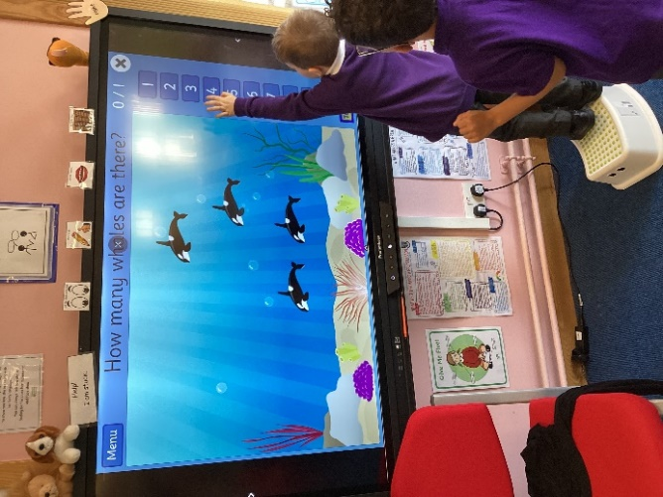

Infant Handbook 2024 – 2025
Welcome to Primary One
We would like to welcome you and your child to Dykesmains Primary. The staff will do everything possible to make the learning experiences for your child as interesting and motivating as possible and to ensure a smooth transition into P1.
This booklet is designed to give you information on the curriculum, routines within P1 and the Infant Department and general information about the school.
If you have any concerns or questions you would like to ask, please do not hesitate to contact us.

School Hours
School Hours
Morning Start | 9.00am
Morning Break | 10.40 am - 10.55 am
Lunch Break | 12.30 pm – 1.15 pm
Afternoon Finish | 3.00 pm

Contact Details
Address Dykesmains Primary School
Simpson Drive
Saltcoats
KA21 6EX
Website https://blogs.glowscotland.org.uk/na/dykesmainsprimary/
Twitter @Dykesmainsps
Email dykesmains@ea.n-ayrshire.sch.uk
Telephone No 01294 461354
Head Teacher Ms Elizabeth Gribben
Depute Head Teacher Mrs Claire Smith
Principal Teacher Mrs Catriona Moran

Our Vision
Dykesmains Primary School strives to conquer by being a welcoming and motivational school that nurtures and develops life skills. We work as a community to support pupils to learn transferable skills for life learning so that they can be as successful as they can be.
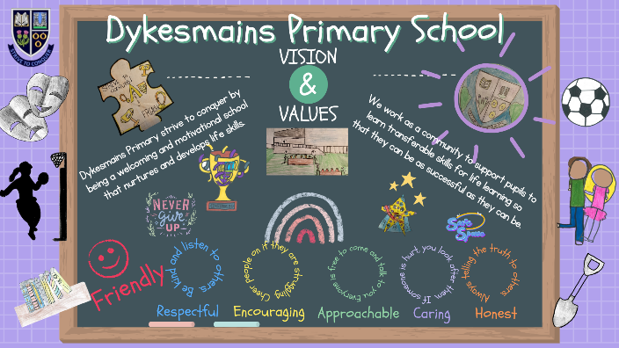
Our Values
Friendly
Respectful
Encouraging
Approachable
Caring
Honest
Our Aims

1 To create a safe, healthy and welcoming school.
2 To ensure our children feel happy and secure within our community.
3 To support children and families educationally, emotionally and socially.
4 To provide a wide variety of opportunities and experiences to enable us to maximize each child’s potential.
5 To encourage our children to be independent & take responsibility for their own learning.
6 To equip our children with the knowledge and skills to make healthy choices now and in the future.

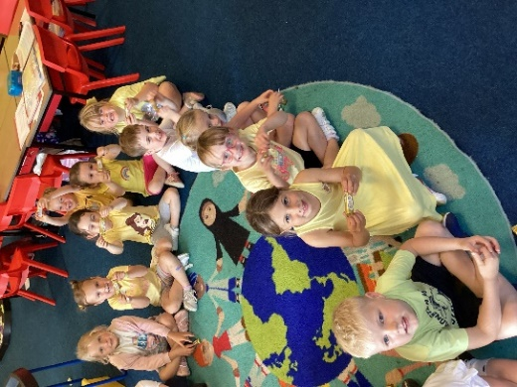
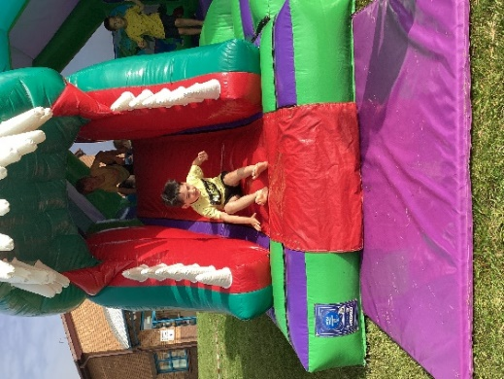
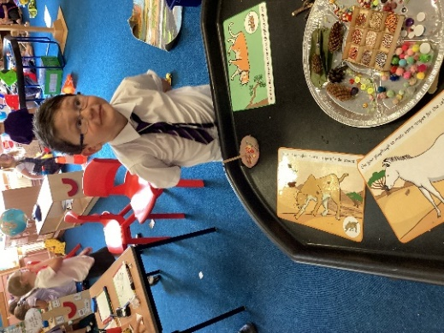

The Big Day
Starting school for the first time is a memorable experience and we hope to make this as pleasant and reassuring for your child as possible. We will set up activities very similar to your child’s Early Years class. This will make the transition as smooth as possible and give the staff every opportunity to interact fully with your child, in order to get to know them as quickly as possible.
On the first day, please wait with your child in the infant playground (at the back of the school) until the teacher comes out to help the children line up into their classes. It would be helpful, if you could stand well back from the lines in order for the children to see what is happening. However, if your child is upset please stand in the line with them and we will help you. Children should be collected from the infant department door at the arranged time. If for any reason, you or whoever is picking up your child is delayed, they will be supervised by a member of staff until they are collected. If you know you will be delayed please phone the school in advance.
In the interest of health and safety please do not drive into the school car park when dropping off or collecting children nor take children out of the playground via the car access road. Please do not bring dogs into the playground, as some children may be frightened of them.
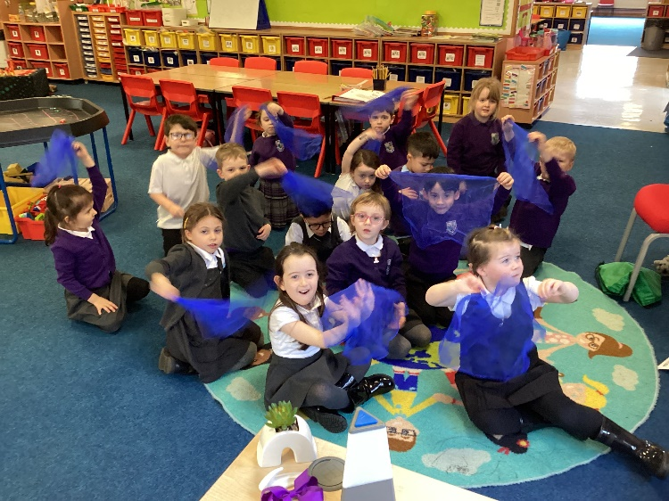
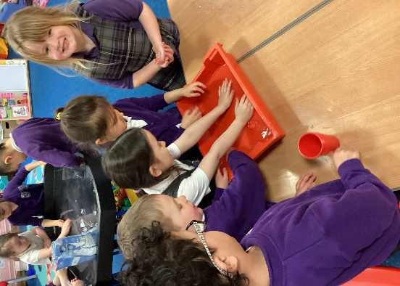

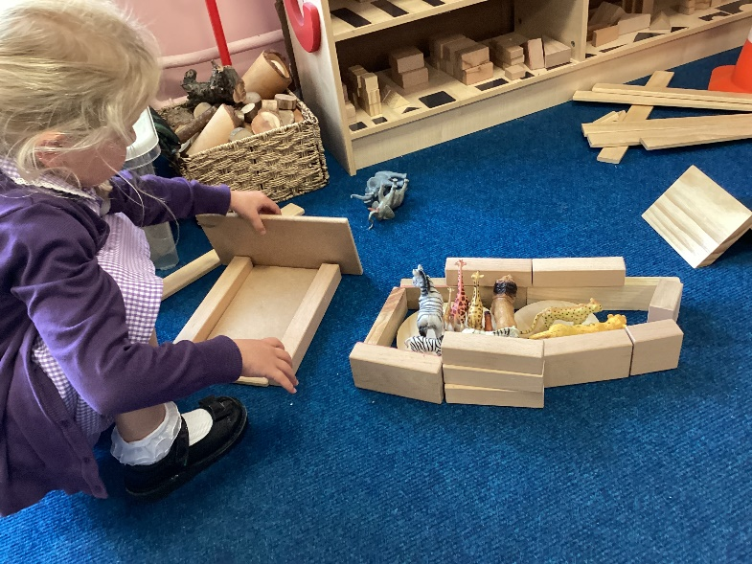
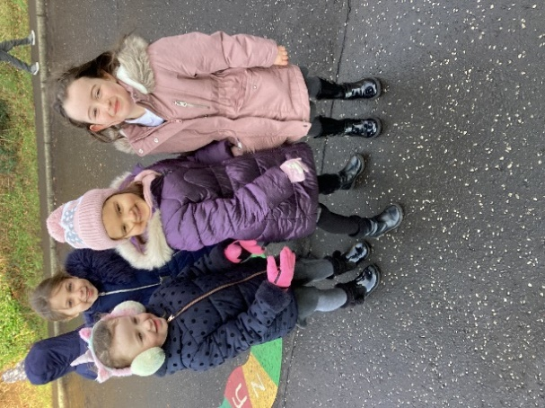

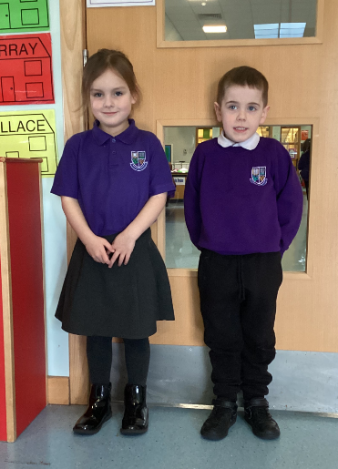
School Uniform
Most parents at Dykesmains prefer their children to wear school uniform.
This consists of grey or black skirt/ trousers for girls, grey or black
trousers for boys, school sweatshirt (purple) or white polo shirt,
shirt or blouse and school tie. ”Designer Wear” is strongly discouraged
as this can lead, so easily, to bullying. School polo shirts, sweatshirts and fleeces can be bought through My Clothing (www.myclothing.com).
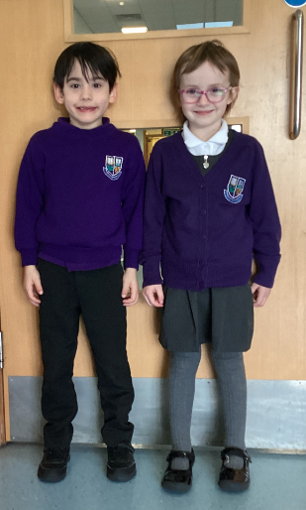
In summer girls generally prefer to wear a purple and white checked dress.
Both boys and girls may also like to wear short sleeved polo shirts.
The gym kit includes shorts, t-shirts or polo shirts and gym shoes,
which will be kept in school. Please have all items labelled with their
names in case these get lost in class. We will be able to let you know at
the beginning of the session which days your child will be having gym.
It is advised in the interests of health and safety that no jewellery should
be worn during P.E. lessons.

Homework
We offer a range of homework tasks to consolidate learning already carried out within the class. In P1 many of the activities will support the development of numeracy and literacy skills and will also include activities related to the curricular areas of the Curriculum for Excellence. Homework will be issued on Seesaw, which is an online learning platform. You will be given log in details when your child starts school in August. Children will also be given reading books home weekly along with sound and number bags with suggested activities that you can do at home with them. It is our aim to make these tasks as engaging and motivating as possible, to demonstrate from an early age that time spent on homework is both worthwhile and enjoyable. We hope you will work with your child to complete homework tasks. The most significant source of support for children’s continued learning is parents and carers.
We regularly send home letters informing you of events within the school and completed work. We would be grateful, if you could check your child’s bag nightly, in case anything is missed.
We send out class information about learning each term in the form of a class newsletter.

Positive Behaviour
Discipline is necessary for a child’s safety and well-being and allows the school to run smoothly, so that effective learning can take place. Rules are an effective part of this process. Rules which are formed in conjunction with the child and appropriate to the age and stage of that child are more likely to be adhered to. These rules reflect the values of our school.
We promote positive behaviour through clear expectations and use of praise and show disapproval of unacceptable behaviour by removing privileges and then conferencing with children to set agreed targets for improvement. We assume that you would wish to know, if your child was misbehaving and we would contact you accordingly, should the need arise.
Break Time
At break (10.40am – 10.55am) the children will play in the playground with the children in P1-3. School personnel will supervise the children in the playground at all times; they have walkie-talkies to enable regular communication. If it is raining, the children will stay in their class areas and play with activities organised by their teacher. They will be supervised by school personnel.
The children are encouraged to bring bottled water into the class to allow them to drink when required. We advise water bottles with sports tops to minimise accidents. Please make sure names are on water bottles.
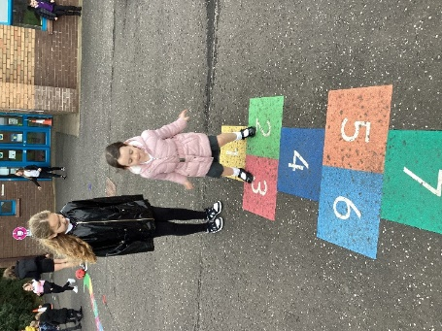
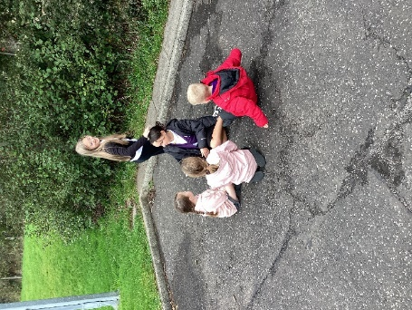

Lunchtime
All of the children stay at school during lunchtime and are not allowed to leave the school, unless we receive a written request from a child’s parent. If you wish your child to go home for lunch, please indicate this in writing and give the letter to your class teacher. Please collect your child from the office at 12.30pm.
Every Primary 1 to Primary 5 pupil are entitled to a free school meal. If however your child is having a packed lunch, please ensure their lunchbox is clearly marked, with your child’s name and class, as we have a number of lunch boxes that look the same.
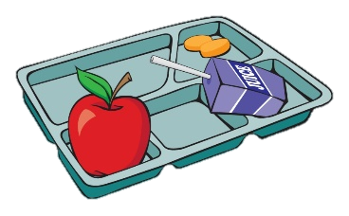
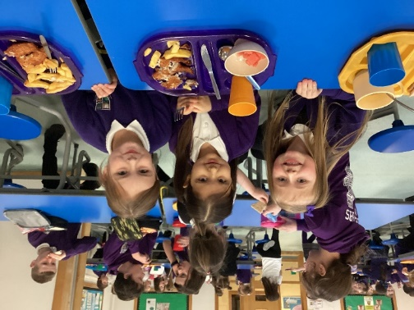

Mrs S McClymont (catering manager) can be contacted if your child has any dietary needs or you wish to discuss school meals. Menus are available on the NAC and Dykesmains website. North Ayrshire has started to use the iPay website (https://www.ipayimpact.co.uk) to order school lunches and pay for trips. Details will be given to you on how to set this up.
School Security
North Ayrshire Council has procedures to ensure the safety of children and staff within the school. These include a visitor’s book, secure entry system and closed circuit television.
All external doors are locked during the school day. In the event of arriving late, please enter by the main entrance and report to the office to sign in.
P1 children should enter the school from the infant playground (around the back of the school). Please do not drop off or collect children from the car park. There are several unmarked areas for parking on the roads beside the school.

Absence
If your child is ill and unable to come to school please inform the office daily either by letter or telephone before 9.20am. If we have not heard from you by then, we will contact you to ensure your child is safe. Please send in a letter explaining the reason for your child’s absence once he or she returns.
Please avoid taking holidays during term time as this is disruptive to pupils’ learning. In most cases the absence will be regarded as unauthorised.

Emergency Arrangements
It is important the office has emergency contact details for your child and that your child knows who would be collecting them in this situation. If the school needs to be closed in an emergency situation, we will contact you by phone. It is important you keep us up to date with new contact names and telephone numbers.

Medical Conditions
Please keep us informed of all health issues affecting your child, so we can ensure their best interests.
If your child requires to use an inhaler or take any other medications, the office will provide you with the necessary form to complete. Medication will be locked away but available when required.
We would advise that all medicines should be handed into the office. However, it is possible to make individual arrangements after discussion with the Head Teacher.

Inclement Weather
In inclement weather, all children will be admitted into the school fifteen minutes before the bell. Staff will supervise your child in the class area. Children arriving by taxi at fixed times will be allowed into the school on arrival.

Health Promoting School
We are a Health promoting School and promote fitness and health. As part of that process we promote healthy eating. Healthy and balanced meals are served in the lunch hall.
Children have the option of taking a school lunch or if preferred you can provide a packed lunch.
We would ask you to support our promotion of healthy eating, by providing healthy packed lunches and snacks

Parental Involvement
We are working hard to involve parents in the life of the school, in teaching and learning and in decision making. We will do this by keeping you informed through termly newsletters, parent workshops, reports, open days, the school website and Twitter. We will seek your views through many opportunities such as parent evenings, after events such as workshops and online questionnaires.
We have a Parent Council who work hard to support the school though fund raising and by promoting partnership between the school, its pupils and its parents. You are very welcome to join the Parent Council once your child has joined the school.
We are always happy to discuss any concerns you may have and we try to resolve these as quickly and efficiently as possible. Please phone the office to make an appointment to speak to a member of the Senior Management Team in the first instance. Mrs Smith (Depute Head Teacher) is your first point of contact when arranging a meeting.

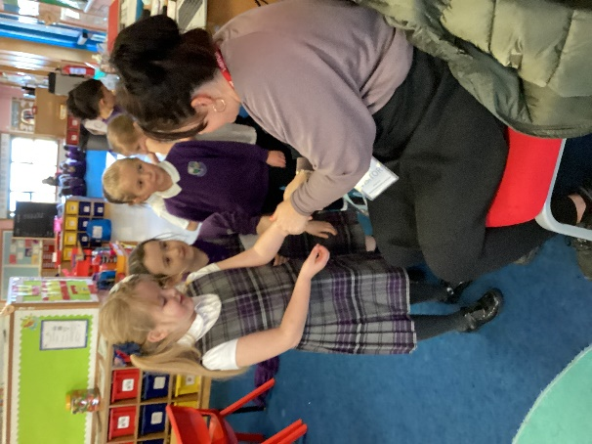

Curriculum for Excellence
Curriculum for Excellence experiences and outcomes are used across Scotland for all 3-18 year olds. The aim of Curriculum for excellence is to raise standards, prepare children for the future and equip them for the jobs of tomorrow in a fast changing world.
We aim to engage and challenge children in motivating and interesting activities and to promote active learning which meets the needs of all children. We also aim to provide effective feedback to parents and children, so that children can progress in their own learning.
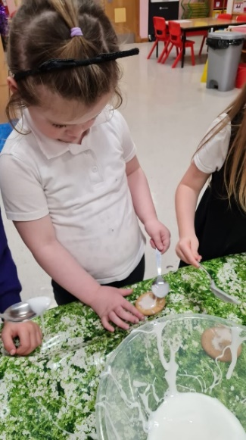
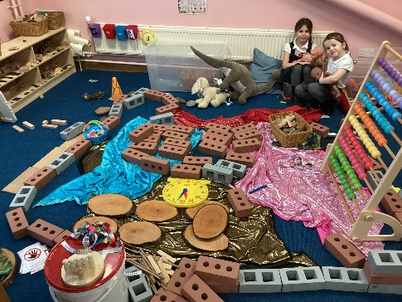
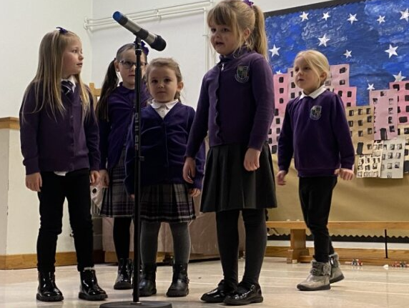

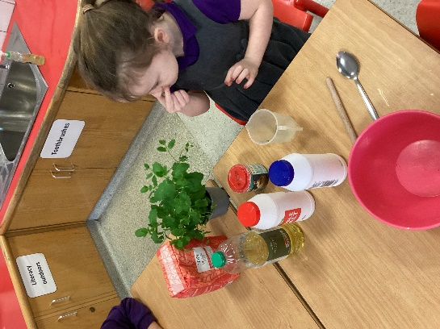

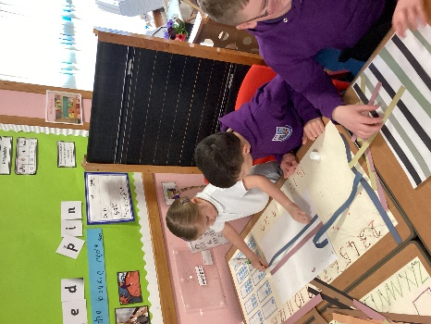
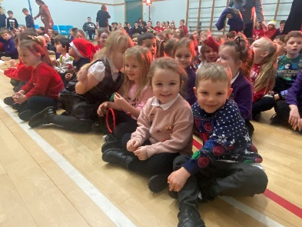

Effective transition information is of high priority to ensure progression and continuity. We encourage children to experience Curriculum for Excellence through integrated learning experiences which they find fun and motivating. We create opportunities for personalisation and choice through responsive planning and by creating opportunities for children to be independent in their own learning. Children are encouraged to investigate, experience and to work collaboratively to encourage confident and successful learners. Children are encouraged to contribute to performances, whole school action days and projects to support them to be effective contributors and responsible citizens.

