
Dreghorn Primary ESR Homework Grid
Class | ESR | Date | January

Makaton Sign | Top Tip | Emotion
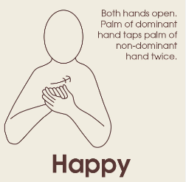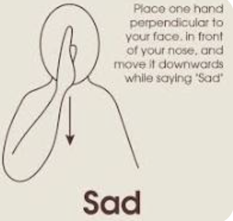https://www.youtube.com/watch?v=euN6G6NMJMM | In school, we use very little spoken language when speaking to the children. Choose one instruction to focus on. Remember to use their name and a simple instruction. Then take show them, hand over hand to carry out an instruction  “Molly rubbish in the bin.”  “Molly, jacket up.” | 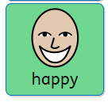  Try asking your child if they are ‘happy’ or ‘sad’. Remember to use the name and then the word ‘happy’.  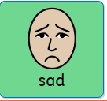 “Teddy happy or sad”?
How you can help my communication at home | Colourful Semantics | Skills for Independence
We are working on asking for help. Try placing something that they like inside a clear container. Be nearby and available for them to come to you for help. Ask them “What do you need“? Then model saying “Open” or “Help please”?   “Open” or “Help please” | We are learning about ‘Who?’ in Colourful Semantics. Look over the page and see if your child can identify ‘Who’ is in the picture.  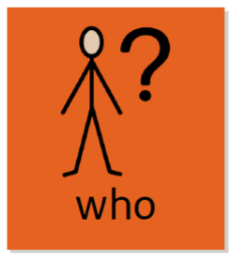 | We want to be able to look after our belongings and hanging up their own coat and bag. You will need to be vigilant and consistent to catch them when they arrive home.  Can you practice the following steps with your child:  - When they arrive home, remind them to put “Molly, coat up”.  - Hand over hand, hold the coat and take them to hang their coat up, saying “Molly, coat up”.

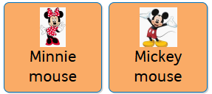 |   