
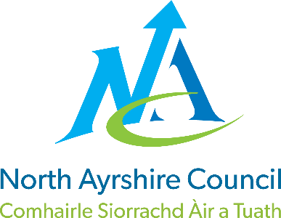

Dalry Primary School

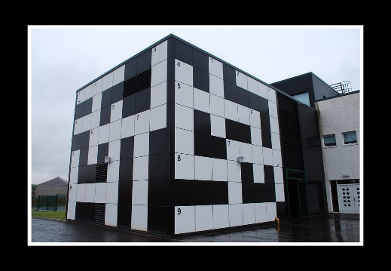

STANDARDS AND QUALITY REPORT
June 2025
This report will inform you of the school’s progress and achievements in the last session and let you know about our plans for 2025-2026.
I hope that you find it helpful and informative.

Louise Syme

Head Teacher

OUR SCHOOL
Dalry Primary is a non-denominational school with a roll of 278 pupils, split into 11 classes from P1 to P7.
The classroom areas are semi-open plan. The school building is 16 years old and has many facilities which offer excellent learning opportunities for all of our pupils, which develop creativity, digital literacy and promote an active lifestyle. There is a library, sensory room, gym hall, Art and Design room, fitness suite, dining hall and outdoor play areas. K.A. Leisure is part of the School Campus. The associated secondary school is Garnock Community Campus. We are proud of our relationships with children, parents, carers and families, as well as our links with the local community. We hope that you find our school a nurturing place where your child can reach their full potential.



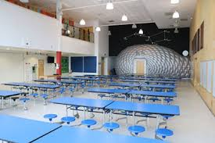

OUR VISION, VALUES AND AIMS
Values: Ambition Kindness Resilience Respect
Vision: Our Vision for Dalry Primary school is to create an inclusive community learning environment where pupils feel safe, respected and nurtured. We will endeavour to motivate all pupils to achieve their full potential in all aspects of the curriculum and enhance life skills for their future ambitions.
Aims:
- We aim to provide a creative curriculum where learners will be inspired and motivated to develop skills for life, learning and work.
- We aim to encourage individuals to be ambitious, passionate and courageous throughout their learning journey.
- We aim to enable our learners to become effective contributors within their community and beyond.
- We aim to build a community which values the uniqueness of all and promotes kindness and empathy.


Our Path To Success – The path symbolises the journey of learning, it is vibrant and creative!

ATTAINMENT & ACHIEVEMENT
- Most pupils continue to achieve the expected levels by the end of Primary 1, Primary 4 and Primary 7.

- The following details the percentage of pupils in P1, P4 and P7 who have achieved that National expectations within the Curriculum for Excellence for the session 24-25 and are therefore on track with their learning.
 | Primary 1 | Primary 4 | Primary 7
Reading | 79% | 86% | 85%
Writing | 79% | 81% | 73%
Numeracy | 77% | 83% | 73%

- Our Standardised Assessment data also showed us that at Primary 1 performed higher than the National average for Literacy and Numeracy. Primary 4 performed above National average for Numeracy and are in line with the National average for Reading and Writing. Primary 7 are in line with the National picture for our Primary 7 learners within Literacy however sitting slightly below the National average for Numeracy. This is an area identified within our School Improvement Plan.

- We are pleased with the progress our pupils are making each year across all curricular areas. There has been an increase in our Reading and Writing attainment across the school due to this being a focus in our School Improvement Plan. We are continuing to track and monitor the progress of all pupils and identify support needs in a timely manner.

- There continues to be a slight increase in our attendance from an average of 93% to 93.7%. This will continue to be monitored on a 4 week cycle and support and guidance offered to pupils who are finding attendance a challenge.

- We have had two exclusions during session 2024-2025. This is an increase compared to zero exclusions the previous year.

WIDER ACHIEVEMENT
Please use the QR code below to see an overview of our wider achievements over the past year, which we are very proud of.

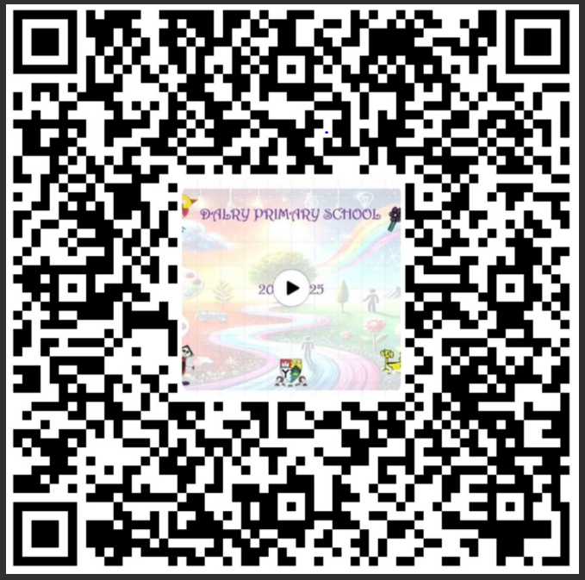

This session we have continued to build our relationships within our local community and have created very valuable and successful links. We continue to have great community support for the school and have had many visitors within the school to support our Learning and Teaching. We have looked at the Ayrshire Growth Deal and linked our learning from P1-P7 with the World of Work and the skills required for this. We will continue to develop this next session. We are very pleased with all the achievements of our pupils at Dalry Primary.

HOW SUCCESSFUL HAVE WE BEEN IN IMPROVING OUR ESTABLISHMENT?
Over the past session we have refreshed our new Curriculum Rationale and Vision, Values and Aims with all of our stake holders. We feel that our rationale is evident to see and feel as you walk through Dalry Primary School. We have also invited other schools out to provide us with feedback on our changes to the curriculum and pedagogy within our school. The feedback given was very positive.

Priority 1
To enrich the quality of learning experiences and raise attainment through enhanced pedagogy and identified curricular areas (Literacy, IDL and skills for learning, life and work).
- Staff engaged in well planned professional learning in Reading and Writing and we have created a whole school consistency guide for the teaching of Reading and Writing, including challenge and support.
- Staff engaged in cluster moderation of Writing this has ensured a consistent standard of level of achievement across the cluster.
- Pupil Support Assistants engaged in professional learning for Literacy strategies and targeted interventions to sure they all felt confident supporting our learners.
- Staff took part in professional learning around Interdisciplinary Learning and Meta- Skills. We then created an IDL progression from P1-P7 which incorporates Developing the Young Workforce, Scotland, Financial Education, Diversity and Equality, Digital Technologies, STEAM, Economy and Business and Social Studies.

Priority 2
To promote the Wellbeing of all children and young people through Rights based learning and a Whole School Nurture approach.
- Parent and Carer workshops were planned for and held within the school on Promoting Positive Relationships and supporting and understanding neurodiverse learners.
- Targeted Nurture Support was implemented this session, with a positive impact on our pupils with all pupils showing an improvement in social skills and interactions with peers.
- Staff took part in well planned professional learning on Whole School Nurture as well as CALM training. This has enriched staff knowledge and assisted us in supporting pupils and meeting their needs as best we can.
- This session we finalised our refreshed Curriculum Rationale and Vision Values and Aims. All staff now feel that this reflects our current curriculum and environment within the school, families have also been consulted and feedback around this has been very positive, particularly around the digital learning, skills for life and outdoor learning.
- We were successful for a second time securing our Rights Respecting Schools Gold Award. Our whole school community is very proud of this achievement and recognition.

QUALITY INDICATORS
How Good is Our School
QI 1.3 Leadership of Change | Evaluation 4 - Good
- Staff have consistently high expectations of all Learners.
- Pupils, parents, partners and staff are all involved in the creation and ongoing review of the vision, aims and values of the school.
- All staff have a very clear understanding of the social, economic and cultural context of the local community of current educational policy. They use this knowledge well to shape the vision for the school.
- All staff are committed to change which results in improvements for learners.
- All staff are involved in the process of change and in evaluating the impact of improvements. This is supported by carefully planned individual and collective career-long professional learning.
QI 2.3 Learning, Teaching & Assessment | Evaluation 4 - Good
- The ethos and culture of our school reflects a commitment to children’s rights and positive relationships.
- All pupils are part of school committee groups some of which link with the wider community.
- Pupil voice is sought and evident in planning for learning and teaching.
- Pupils can confidently talk about how their views are sought.
- We are using a wide variety of learning environments in particular the development of our Outdoor Learning.
- Our assessment evidence is valuable, reliable and confidently discussed and used to inform next steps in Learning and Teaching.
QI 3.1 Ensuring Wellbeing, Equality & Inclusion | Evaluation 4 –Good
- We use a large amount of PEF to provide Health and Wellbeing support for children.
- Relationships across our school community are positive and supportive.
- We ensure through pupil voice that children are active participants in discussions which affect them.
- We strive to ensure that inclusion and equality leads to improved outcomes for all learners.
QI 3.2 Raising Attainment & Achievement | Evaluation 4 - Good
- We are able to track attainment of our learners over time and most of our learners make good progress from their previous levels of learning.
- Attainment levels in Literacy and Numeracy continue to be a central feature of the school’s priorities for improvement.
- Confident teacher judgements together with benchmarking and an appropriate range of assessments are leading to positive outcomes for pupils.
- Targeted interventions are implemented to identify and close the attainment gap for pupils.

PUPIL EQUITY FUNDING
Last session we allocated our £95,000 PEF money to:

- An Area Inclusion Worker for 14 hours per week was directed to support identified pupils to develop their emotional literacy, social skills, self –esteem, confidence, peer relationships and to build a toolkit for supporting them with emotional regulation. Our Area Inclusion worker also worked to develop community links and to highlight supports within the community for our families.
- Class teacher to focus on targeted support to raise attainment specifically in Literacy within P2 -P4 - Reading and Writing.
- A Principal Teacher to specifically target our attainment in Reading and Writing and oversee the interventions. Our Principal Teacher was also allocated to provide targeted Nurture Support 3 mornings per week to support our identified pupils in building resilience, self-esteem, regulation strategies and social skills.

The results from the interventions were very positive showing that all pupils made progress from their prior levels of learning.

For Session 24-25 our PEF money will be allocated in the following way:
- Area Inclusion Worker 26 hours per week to continue our priorities from last session and to provide further support to a wider group of pupils and families. This is as a result of us identifying a greater need to provide targeted Health and Wellbeing support.
- Principal Teacher enhancement – To run the targeted interventions for Literacy and Numeracy and to oversee the targeted interventions run by Pupil Support Assistants and report to the Senior Management Team.
- 2 full time Pupils Support Assistants to provide additional support to identified pupils within the school with Literacy, Numeracy and Health and Wellbeing.
- 1 part time

IMPROVEMENT PLAN PRIORITIES 2025-2026
Priority 1

- To enrich the quality of learning experiences and raise attainment through enhanced pedagogy and identified curricular areas (Numeracy, Maths, meta-skills and Digital Technologies).
Priority 2
- To promote positive mental, emotional, social and physical wellbeing for all pupils, ensuring that wellbeing is central to learning, attainment and school life.

We are confident that we will be able to achieve these priorities and aim to reduce the attainment gap, particularly in P3 while placing the rights and needs of every child at the centre of the education we provide.

