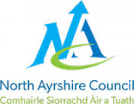
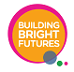
ii


Article 7.

I have the right to a name.
(Insert a photo of your child or a drawing.)

Look inside and see what I can do at home
Welcome to
Early Years
My first name is
________________________________
This booklet is all about me before I started at my early years setting.
My learning is blended with
______________________________

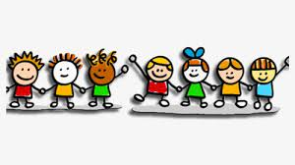

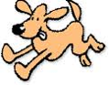
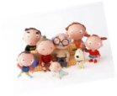
v
What I have learned so far: Health and Wellbeing
My favourite T.V. programmes are
____________________________________________
_____________________________________________
I help to care for my pets they are called
___________________________________
____________________________________________

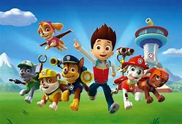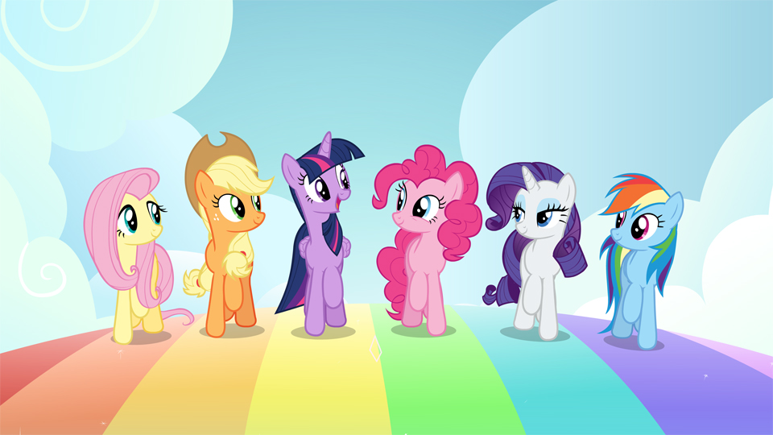

I have a special friend called __________________________________________
Other important people in my life are __________________________________________________________________________________________

Article 9.

I have the right to live with a
family who cares for me.

I know I live in (town/country) ____________________________________
with my family, who are ______________________________
____________________________________________________________________________________________

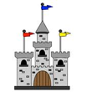
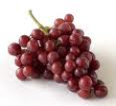
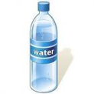
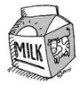
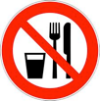
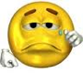
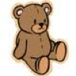
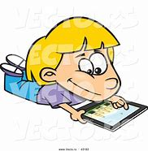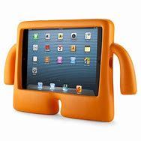
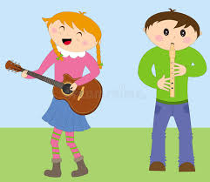 The things I like to play with/at are __________________________________________________________________________________________
Favourite places I like to go/have been are ________________________________________________________________________________

Article 24.

I have the right to clean water
and healthy food.
My favourite foods are ________________________________________________________________________________________
My favourite drinks are
______________________________________________

Foods I know I am not allowed to eat are __________________________________________________________________________________
Things that make me sad are __________________ ________________________________________
When I am upset I need _________________________________________
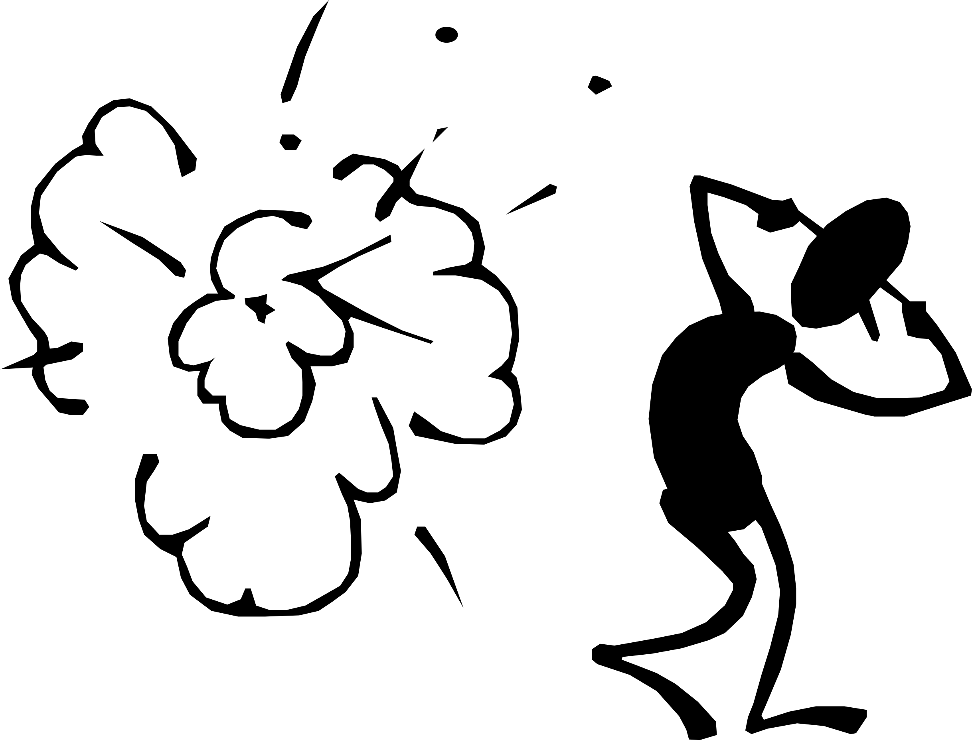

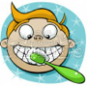
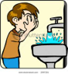
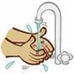
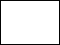
Things that make me frightened are
____________________________
Things that make me happy are
______________________________________
I look after myself by:
Brushing my teeth
Washing my face
Washing my hands
When I need the toilet I say
__________________

I go by myself
Yes
Not yet
Yes
Not yet
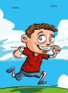
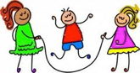
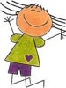
I am able to:

Article 31.

I have the right to play and rest.

Not yet
Yes
Run
Skip
Hop
Jump
What kind of person am I? (Please circle)

Shy Confident Mischievous Curious Friendly
Independent Talkative

Any other information that just makes me, me.
______________________________________________________________________________________________________________________________

My feelings about starting early years are:
____________________________________________________________________________________
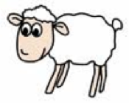
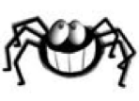
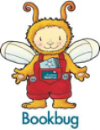

Literacy and English
I like reciting my favourite nursery rhyme, which is
____________________________________

Article 28.

I have the right to a good education.

When I am speaking, people understand what I am saying
Always
Sometimes
Not really
I am becoming aware of letters, signs and words when I am out and about.
Yes
Not yet
I like singing my favourite song, which is
_________________________________
I enjoy looking at books, my favourite is ________________________________
I talk about the pictures in a book.
Yes
Not yet
When mark making I prefer to use my:
Left hand Right hand Both hands
Can you use a pencil/black pen to draw
a picture of yourself?
Can you name some parts of your body?
Numeracy and Mathematics
I am able to match to 2 objects e.g. 2 socks.
Thank you for telling us all this information about what you have been learning at home.
Please bring this booklet back to your keyworker.
I know the difference between big and small.
Yes
Not yet
I am able to sort objects into groups e.g. cutlery (spoons, knives and forks).
I recognise and name some shapes.
I recognise and name
these colours (Please tick)
I recognise and name other colours
If yes tell me what you know
I am becoming aware of numbers and counting.
If yes tell me what you know

