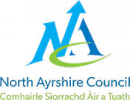




Article 7.

I have the right to a name.
Welcome to
Dalry Early Years Centre
Home to Early Years (Transition Pack)
I can say my name, it is

________________________________
and this pack is all about me before I started my
early years class.
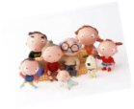
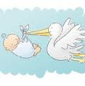
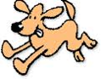
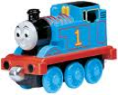
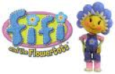
v
I know I live at ______________________________________ with my family, who are ______________________________
____________________________________________________________________________________________

Article 9.

I have the right to live with a
family who cares for me.

What I have learned so far: Health and Wellbeing

I was born on ___________________
Other important people in my life are __________________________________________________________________________________________
I have a special friend called __________________________________________
I help to care for my pets they are called
___________________________________
_____________________________________________
My favourite T.V. programmes are ______________________________________________
______________________________________________
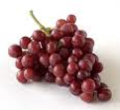
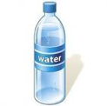
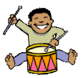

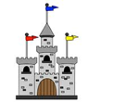
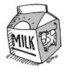
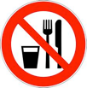
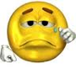
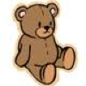

Article 24.

I have the right to clean water
and healthy food.
My favourite foods are ________________________________________________________________________________________
My favourite drinks are
______________________________________________
The things I like to play with/at are __________________________________________________________________________________________
Favourite places I like to go/have been are ________________________________________________________________________________
Foods I know I am not allowed to eat are __________________________________________________________________________________
Things that make me sad are __________________ ________________________________________
When I am upset I need _________________________________________
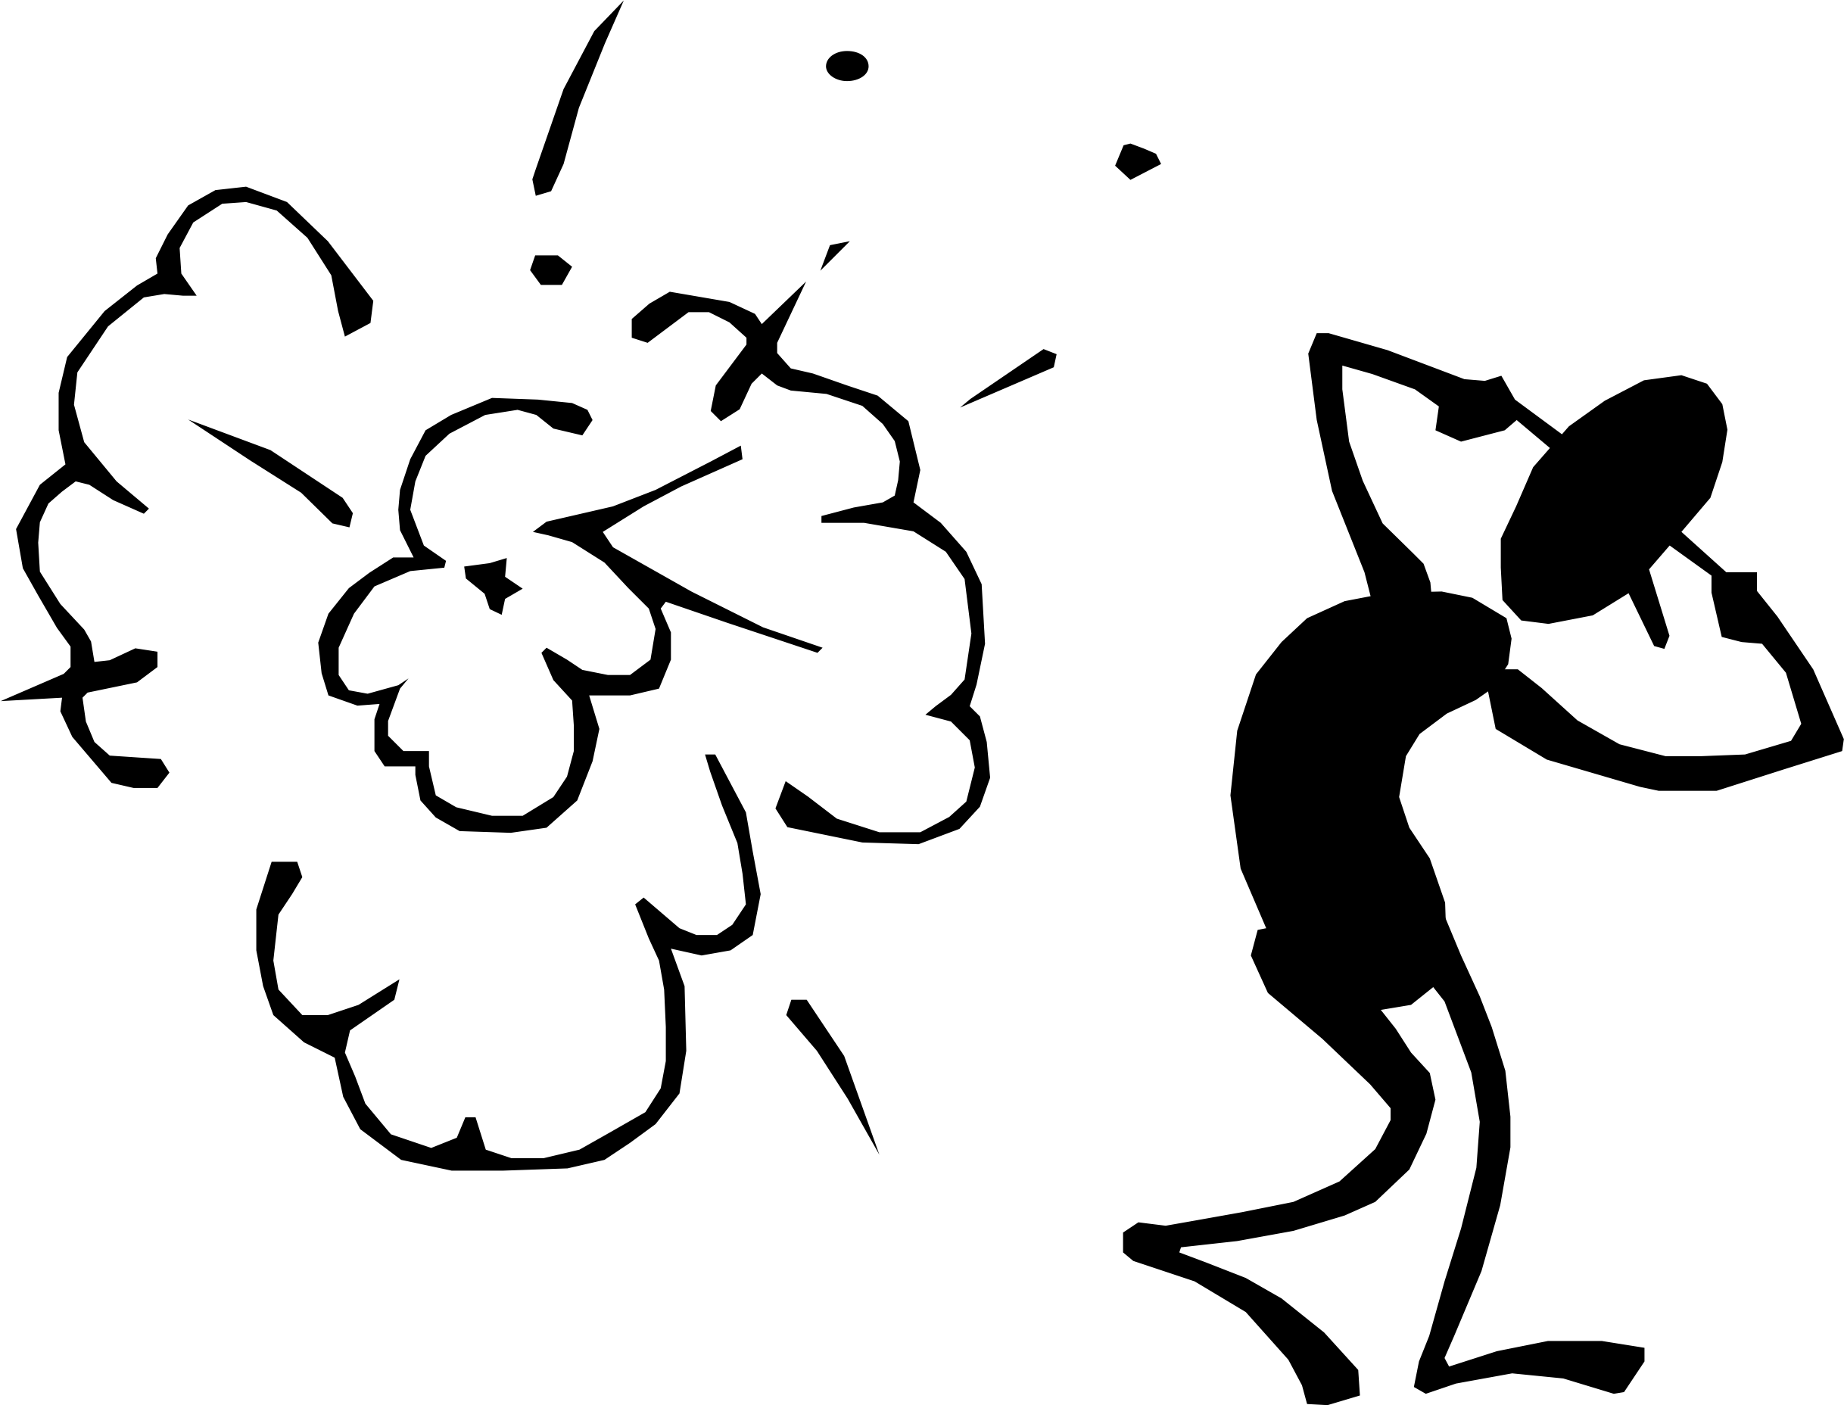

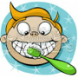
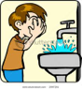
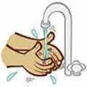
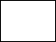
Things that make me frightened are
____________________________
Things that make me happy are
____________________________________
I can look after myself by:
Brushing my teeth
Washing my face
Washing my hands
When I need the toilet I say
__________________

I can go by myself
yes
not yet
yes
not yet
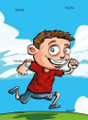
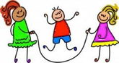
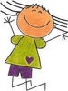

Article 31.

I have the right to play and rest.

Run
Skip
Hop
Jump
What kind of person am I? (Please circle)

Shy Confident Mischievous Curious Friendly
Independent Talkative

Any other information that just makes me, me.
______________________________________________________________________________________________________________________________

My thoughts about starting early years
____________________________________________________________________________________
not yet
yes
I can:
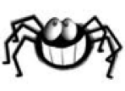
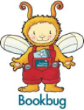
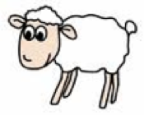

I am becoming aware of letters, signs and words when I am out and about.
yes
not yet
I can sing my favourite song, which is
_________________________________
I enjoy looking at books, my favourite is ________________________________
I can recite my favourite nursery rhyme, which is
____________________________________
When I am speaking, people understand what I am saying
always
sometimes
not really
I can talk about the pictures in a book
yes
not yet

Article 28.

I have the right to a good education.

Literacy and English
When mark making I prefer to use my:
Left hand Right hand Both hands
Can you use a pencil/black pen to draw
a picture of yourself?
Can you name some parts of your body?
I know the difference between big and small
Numeracy and Maths
I can match 2 objects e.g. 2 socks
yes
not yet
I can sort objects into groups e.g. cutlery
(spoons, knives and forks).
I can recognise and name some shapes.
I can recognise and name
these colours (Please tick)
I can recognise and name other colours.
If yes tell me what you know
I am becoming aware of numbers and counting.
If yes tell me what you know
Thank you for telling us all this information about what you have been learning at home.
Please bring this booklet back to your keyworker

