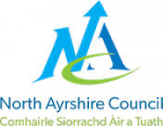


A guide to using our
‘All About Me Booklet’

The aim of our ‘All About Me’ booklet is for you to sit and chat to your child about the things they have learned before starting at our Early Learning and Childcare setting.

As parents/carers you know your child best and know what they can and cannot do. Please do not worry if there are some areas they have not yet achieved as it is far more important that the information is accurate.

Once you return the ‘All About Me’ Booklet, we will begin to plan experiences around your child’s interests and developmental needs. Every term we will meet together to discuss your child’s progress and their next steps in learning.

Thank you for taking the time to give us this information and we look forward to working in partnership with you and your child.


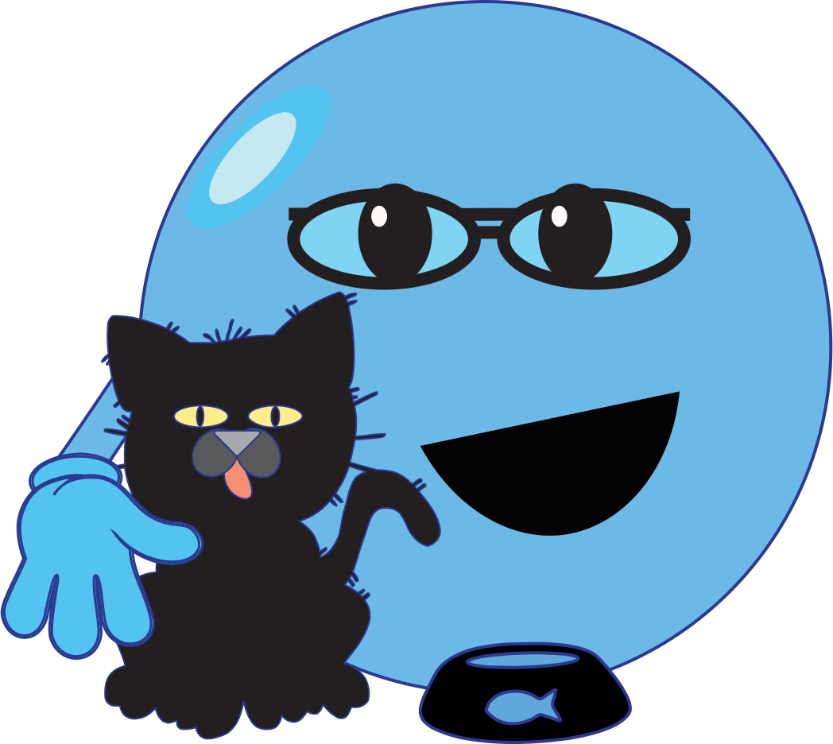
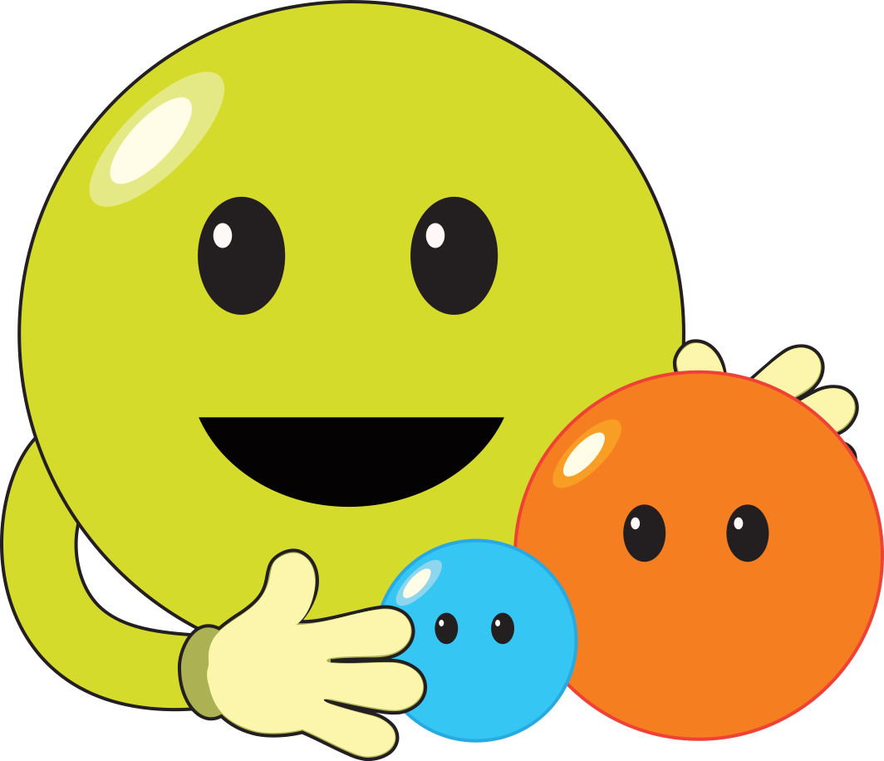
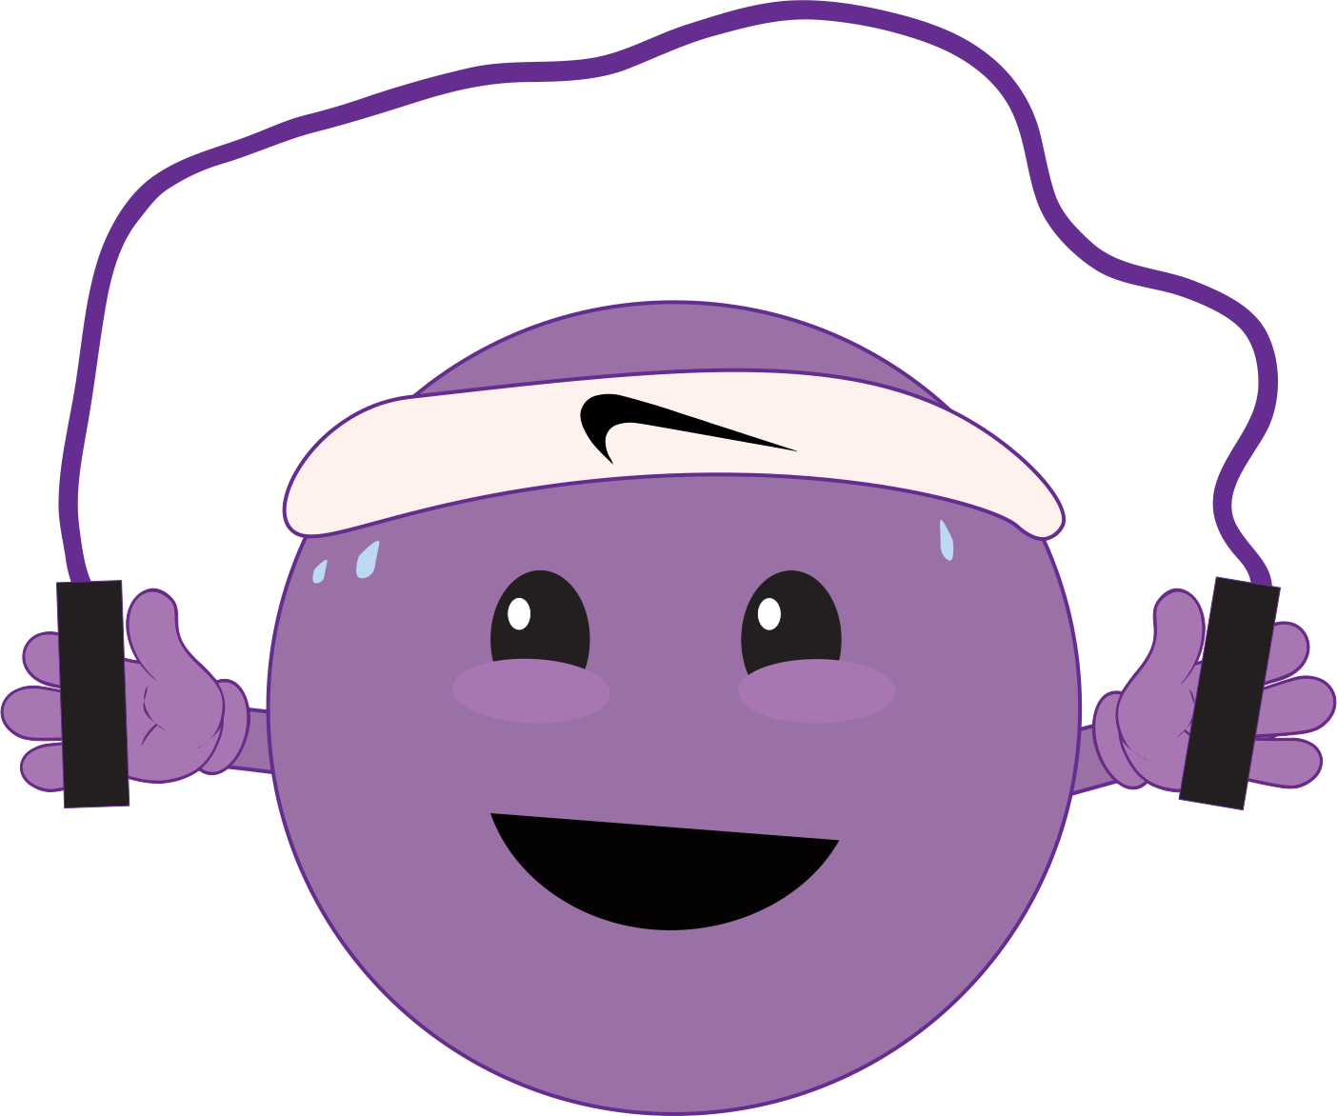

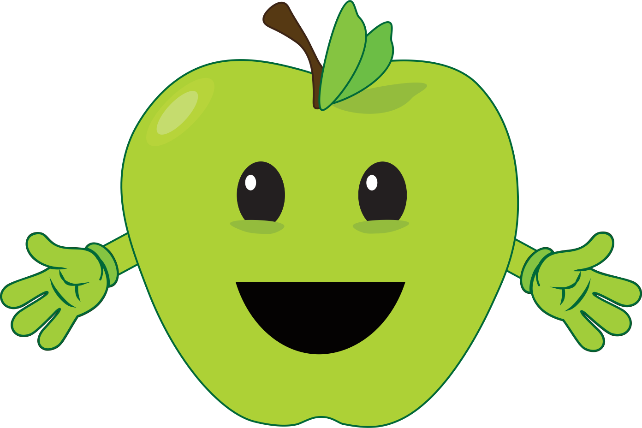
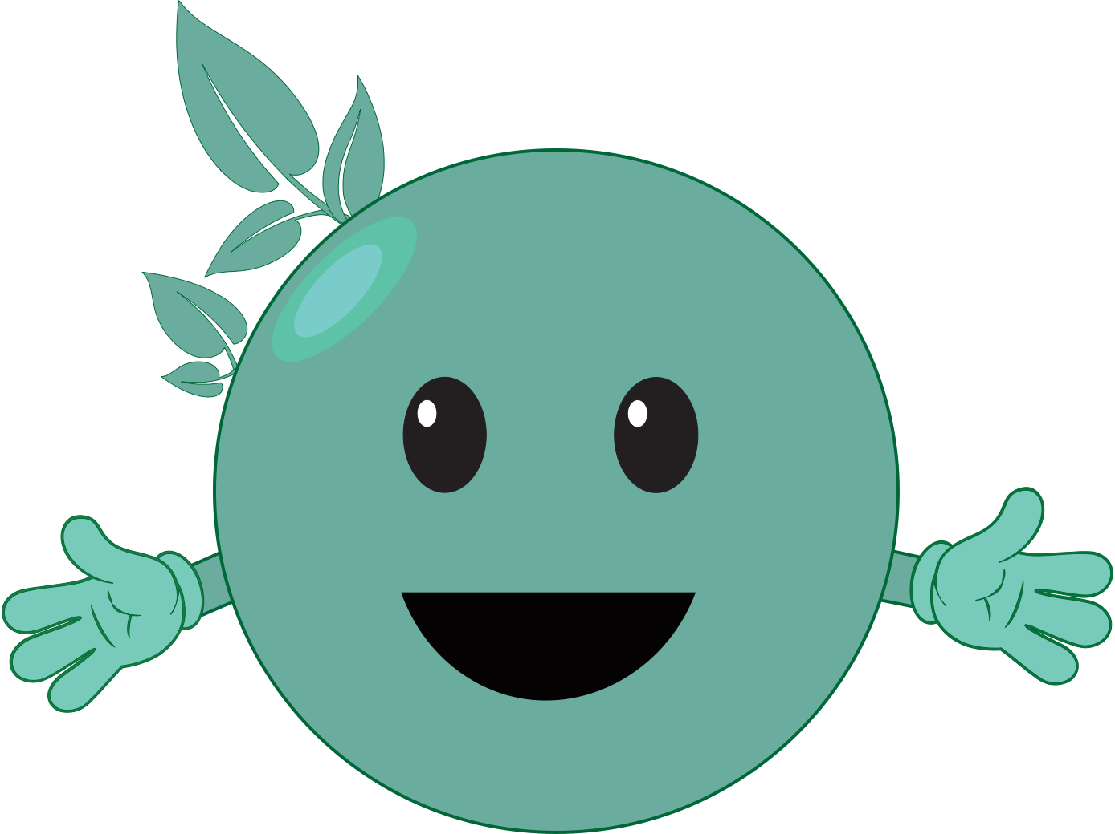
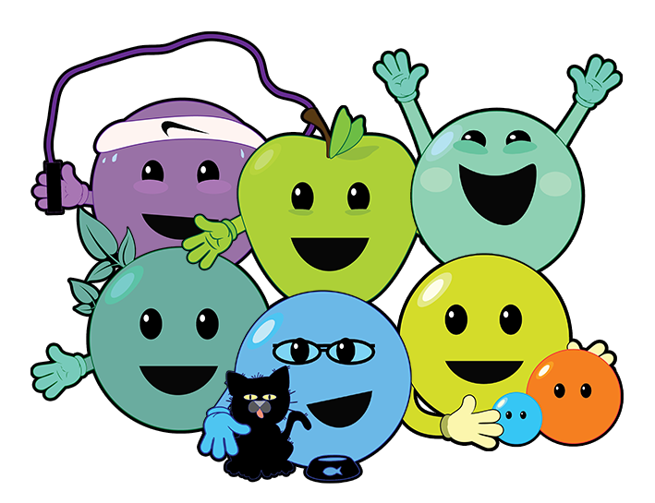


“Rights” are things every child should have or be able to do. All children have the same rights. These rights are listed in the UN Convention on the Rights of the Child. We have made reference to some of these rights throughout the booklet.

