
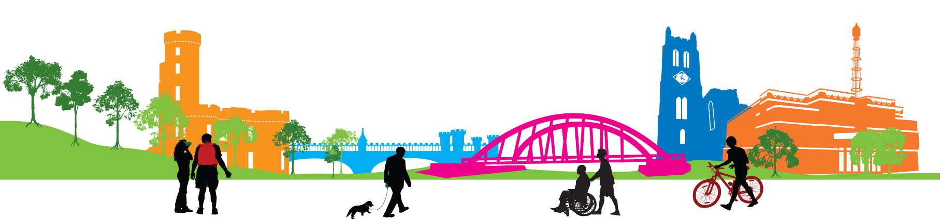
Education Directorate
Cumbrae Primary & EYC
Improvement Plan
2024-2025


Vision, Values and Aims
Our school vision is that staff, families and our community work actively together to ensure children receive a rich, inspiring and engaging education enabling each child to become a lifelong learner, aspiring to high standards of achievement in all areas of their life.

OUR AIMS
Working within a safe, secure and caring school, we aim to
- provide all pupils with a challenging and varied learning experience, promoting respect and consideration and encouraging a high level of success and achievement. This will lead to excellence and quality in their education.
- provide all staff with a supportive and rewarding working environment, maintaining a positive ethos and attitude to all.
- value and encourage an excellent partnership with parents, carers and members of the community, promoting high aspirations and a ‘can-do’ attitude.

OUR VALUES
- Teamwork
- Respect
- Ambition
- Inclusion & Equality
- Nurture

EDUCATION SERVICE: IMPROVEMENT PLAN SUMMARY 2023/4 – 2025/6

The Education Service Improvement Plan is aligned to the 5 priorities of the National Improvement Framework. Individual establishments should create their own plan under these 5 priorities, based on rigorous self-evaluation and analysis of performance evidence. Stakeholders should be fully engaged in the development of the plan. In the diagram below, the orange boxes show the thematic areas under each priority which the service intends to focus on in the year ahead.
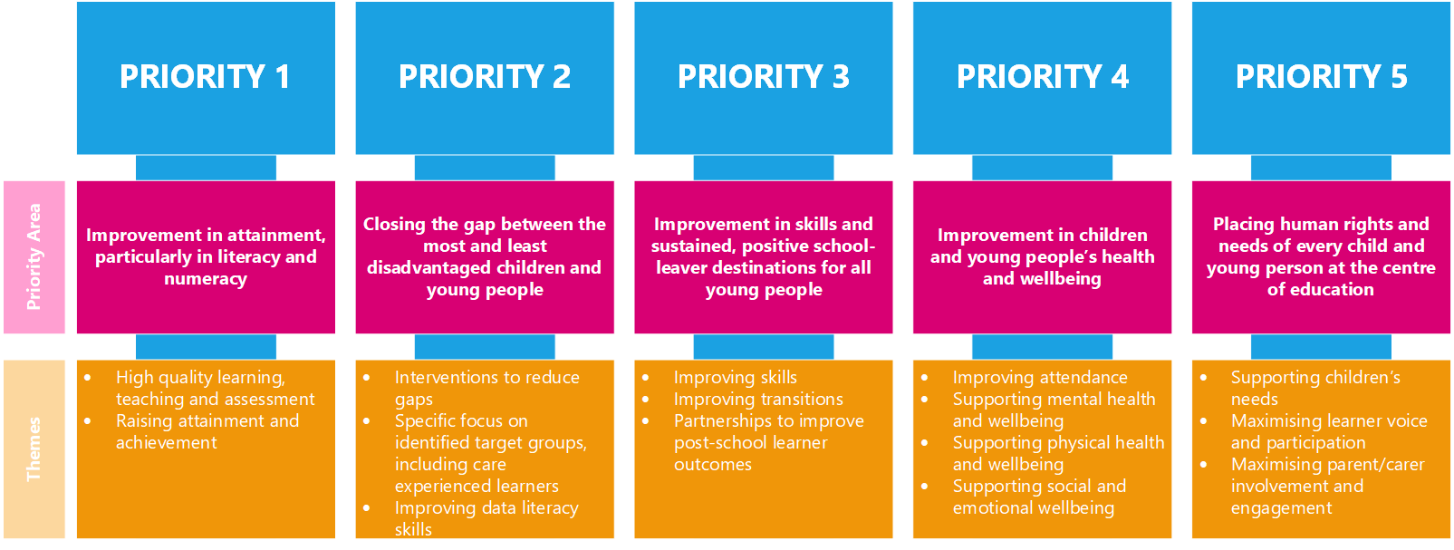

PRIORITY 1
Strategic Objective:
To develop joy in learning through enhancing pedagogy and improving skills across the curriculum.

Highlight your KEY drivers for this improvement priority
Service Priorities  - Improvement in attainment, particularly in literacy and numeracy  - Closing the attainment gap between the most and least disadvantaged children and young people  - Improvement in skills & sustained, positive school-leaver destinations for all young people.  - Improvement in children & young people’s health & wellbeing  - Placing human rights & needs of every child & young person at the centre of education | HGIOS□ & HGIOS ELC  Language specific to HIGIOELC is in green
 | 1.1 Self-evaluation for self-improvement  1.2 Leadership for learning  1.3 Leadership of change  1.4 Leadership & management of staff  (practitioners)  1.5 Management of resources to promote equity |  | 2.1 Safeguarding & Child Protection  2.2 Curriculum  2.3 Learning, teaching & assessment  2.4 Personalised Support  2.5 Family Learning  2.6 Transitions  2.7 Partnerships |  | 3.1 Ensuring wellbeing equality and inclusion  3.2 Raising attainment & achievement  (Securing children’s progress)  3.3 Increasing creativity and employability  (Developing creativity and skills for life and learning)
NIF Drivers of Improvement  - School & ELC Leadership  - Teaching & Practitioner Professionalism  - Parent/carer involvement & engagement  - Curriculum & Assessment  - School & ELC Improvement  - Performance Information | Care Standards - Care Inspectorate Quality Indicators  Applicable within all early years settings
 | - Nurturing care and support  - 1.2 Children are safe and protected  - Play and learning  - Family engagement  - Effective transitions | 2.1 Quality of the session for care, play and learning  2.2 Children’s experience high quality facilities |  | 3.1 Quality assurance and improvement are led well  3.2 Leadership of play and learning  3.3 Leadership and management of staff and resources |  | 4.1 Staff skills, knowledge and values  4.2 Staff recruitment  4.3 Staff deployment
Rationale for Change
OECD ‘The Future of Education & Skills 2030’ offers a vision that schools must equip students with skills, attitudes and values to contribute to and benefit from an inclusive and sustainable future.
Observations of learning & teaching and monitoring of timetables illustrate the need for an increase in opportunities for creativity and active learning to be embedded to develop all children’s intrinsic motivation to learn.
EYC observations noted that 82% of children (all boys) require regular opportunities for activity and curiosity to support progressive development.
Parent focus groups and questionnaires support the use of varied outdoor learning environments and the need for promoting skills based learning.
Data showed that all learners in target group improved in Leuven scale scores. All children made improvements in PASS with boys increasing the most, as much as 44% in perceived learning capability, 49.6% in self regard as a learner and 55.2% in general work ethic. These approaches therefore needed embedded and sustained.
£4,000 of PEF will be allocated to purchasing resources to improve environments and develop play and curiosity.
£3,000 of PEF will be allocated to off site activities eg. Dumfries House, Science Centre, Heads of Ayr, FSC depending on interests
HMIE inspection report April 2024 identified that school should provide children with further opportunities to lead their learning and recognise the skills they are developing through learning experiences.

PRIORITY 1: Action Plan
Pupil Outcomes | Implementation Plan | Timescales/  Responsibility | Measurement of Impact | Analysis & Evaluation of Progress | Cost  (PEF)
Specifically, what will change for our learners? | How will we achieve this?  What do we plan to do? | What are our timescales? Who will lead? | How will we know the change is an improvement? Can you quantify this?  What data will be collated and analysed to demonstrate progress? Consider baseline data. | How do we know that the experiences & outcomes for learners have improved? What does the data tell us which demonstrates impact? | Please enter the cost to the nearest £
Children will have increased opportunities to enjoy and choose from a wide variety of experiences, through play and outdoor learning.  Learner motivation and learner self regard will improve  Children will have more opportunities to develop gross motor skills and metaskills through relevant a IDL curriculum  Children will have fun and demonstrate increased curiosity, independence and love for learning  Children will have improved physical fitness, mental health and self-esteem.  Children will become self- motivated, happy, confident and active learners  Children’s digital literacy skills and understanding of digital wellbeing will improve | School environments will offer creative and engaging spaces to suit the needs of individual learners.  Having been accepted as a Climate 180 school, staff will engage in Learning Through Landscapes professional learning to embed quality oudoor learning and play experiences for our children  Use Skills Development Scotland materials to build staff confidence in implementing metaskills into curriculum  Implement the Think, puzzle, explore approach to promote inquiry based learning across all curricular areas.  Implement digital technology planners to ensure progression and deliver challenging and creative digital learning experiences. Staff will attend digital learning CLPL and raise own professional understanding of digital wellbeing in the curriculum. | Term 1  All staff led by Mrs Neilson  Begin Climate 180 November in-service led by Mrs Harvey  Ongoing  All staff led by HT  Ongoing  All staff  Ongoing  Mrs Kelso | Floorbook recording of environments development will demonstrate children’s engagement in active learning and improved creativity across all stages.  Records of audits, points for action and photos will evidence improvement  Milestones baseline data improvement  Early years 28 days observations  Learning & Teaching observations will feature more engaged and creative learners  Monitoring of plans will show varied activities and use of different environments  Pupil feedback will show improved confidence and ability to talk about their learning.  Target folders will demonstrate progression and challenge in learning.  Monthly evaluations and tracking meetings will be focussed and comment specifically on developing skills, opportunities for creativity and children’s engagement and achievement.  PASS results will show improved feedback from previous year.  Classroom observations and discussions will show increased confidence in teaching digital learning and it being used creatively across all stages.  Self evaluation of 2.3 Learning, Teaching & Assessment in EYC will improve from Good to Very Good. |  | £3000 for outdoor learning resources

PRIORITY 2
Strategic Objective:
To raise attainment and achievement for all ensuring children are well supported, included and engaged in their personal learning pathway.

Highlight your KEY drivers for this improvement priority
Service Priorities  - Improvement in attainment, particularly in literacy and numeracy  - Closing the attainment gap between the most and least disadvantaged children and young people  - Improvement in skills & sustained, positive school-leaver destinations for all young people.  - Improvement in children & young people’s health & wellbeing  - Placing human rights & needs of every child & young person at the centre of education | HGIOS□ & HGIOS ELC  Language specific to HIGIOELC is in green
 | 1.1 Self-evaluation for self-improvement  1.2 Leadership for learning  1.3 Leadership of change  1.4 Leadership & management of staff  (practitioners)  1.5 Management of resources to promote equity |  | 2.1 Safeguarding & Child Protection  2.2 Curriculum  2.3 Learning, teaching & assessment  2.4 Personalised Support  2.5 Family Learning  2.6 Transitions  2.7 Partnerships |  | 3.1 Ensuring wellbeing, equality and inclusion  3.2 Raising attainment & achievement  (Securing children’s progress)  3.3 Increasing creativity and employability  (Developing creativity and skills for life and learning)
NIF Drivers of Improvement  - School & ELC Leadership  - Teaching & Practitioner Professionalism  - Parent/carer involvement & engagement  - Curriculum & Assessment  - School & ELC Improvement  - Performance Information | Care Standards - Care Inspectorate Quality Indicators  Applicable within all early years settings
 | - Nurturing care and support  - 1.2 Children are safe and protected  - Play and learning  - Family engagement  - Effective transitions | 2.1 Quality of the session for care, play and learning  2.2 Children’s experience high quality facilities |  | 3.1 Quality assurance and improvement are led well  3.2 Leadership of play and learning  3.3 Leadership and management of staff and resources |  | 4.1 Staff skills, knowledge and values  4.2 Staff recruitment  4.3 Staff deployment
Rationale for Change
PASS test P4 – 7 2023 showed that 27% children were lower than average in preparedness for learning. In 2024 this had increased to 89.9% with high satisfaction. Therefore the approaches need sustained and further embedded.
PASS test P4 – 7 showed 25% learners (8/32) had low confidence in learning. In 2024 this had increased to 79.1% highly satisfied. Approaches need to be continued and developed for further gain.
EYC milestone data tracker shows that a continued focus is required in identifying numerals to 10 through play, counting forward/ backwards to 5 and identifying single sounds.
P6 Progress Test in English shows 86% of children performed higher than expected. Strategies used in P6/7 now need embedded in P4/5.
Pupil focus group conversations showed that children have loved the curriculum experiences this year and would like them to continue.
GL Assessment data for individual pupils identified gaps in specific areas which could be addressed through targeted interventions and clear goals shared with children.
Parent questionnaires identified a need in sharing understanding of curriculum pathways throughout the school and how they can help support learning at home.
A rise in children with identified needs eg. dyslexia, ASD requires clear strategies to support and develop independent learning for feelings of success

PRIORITY 2: Action Plan
Pupil Outcomes | Implementation Plan | Timescales/  Responsibility | Measurement of Impact | Analysis & Evaluation of Progress | Cost  (PEF)
Specifically, what will change for our learners? | How will we achieve this?  What do we plan to do? | What are our timescales? Who will lead? | How will we know the change is an improvement? Can you quantify this?  What data will be collated and analysed to demonstrate progress? Consider baseline data. | How do we know that the experiences & outcomes for learners have improved? What does the data tell us which demonstrates impact? | Please enter the cost to the nearest £
Children will demonstrate improved learner engagement  Children will be able to confidently verbalise their achievements in learning and next steps  Learner self-regard will further improve  Children will experience differentiated learning activities suited to their individual needs and make progress from prior levels of attainment  Children will feel emotionally secure and nurtured and personal planning will take account of their wellbeing indicators.  Children will feel success and achievement as environments, pedagogies and experiences are suited to their needs eg. dyslexia friendly classroom | Use NAC Learning & teaching guide and Numeracy & Literacy framework to self-evaluate and moderate our provision of learning and teaching activities. Increase moderation opportunities and visits to other establishments for class teachers to share practice.  Pedagogy will ensure children are prepared for learning with clear LIs, co-constructed SC and SMART goals linked to their personal targets in target folders  Use Ed Scot Practitioner Improvement videos for CLPL to moderate practice to ensure relevant high quality teaching and learning experiences  Embed NAC Nurture framework across EYC and school and use benchmarks to audit provision.  Identify children requiring support particularly in nurture and develop appropriate learning plans to support their needs eg. Metacognition and life skills development | Ongoing  All staff led by HT  Ongoing  All staff  Ongoing led by  Head Teacher  Ongoing  All staff led by PT  Ongoing  All staff led by PT | Learning & teaching observations and termly tracking meetings will evidence that all children are engaged in their learning and making progress.  ACEL data will show improved attainment over time in Literacy and Numeracy for individual children.  Improved PASS and Leauven scale results  Children will be able to discuss progress towards learning goals using their target folders.  CLPL discussions and moderation activities within school will lead to higher quality learning experiences evident in oservations and teachers’ plans  HQAs will be a key feature in termly plans and will contribute to teachers’ confidence in bundling experiences and delivering professional judgement.  Identified children will show improved engagement, learner participation using Leuven scale.  GL Dyslexia portfolio will be used as a baseline for some.  Parental/ pupil feedback & questionnaires will evidence greater understanding of our curriculum and learning pathways |  | £4,000 will be allocated for trips/ resources/ visitors which will be identified through learner consultations.  £1,000 for Dyslexia friendly resources  £2,000 for CA to support identified child with ASD with transition

PRIORITY 3
Strategic Objective:
To maximise learner participation and voice to create positive outcomes and changes.
Highlight your KEY drivers for this improvement priority
Service Priorities  - Improvement in attainment, particularly in literacy and numeracy  - Closing the attainment gap between the most and least disadvantaged children and young people  - Improvement in skills & sustained, positive school-leaver destinations for all young people.  - Improvement in children & young people’s health & wellbeing  - Placing human rights & needs of every child & young person at the centre of education | HGIOS□ & HGIOS ELC  Language specific to HIGIOELC is in green
 | 1.1 Self-evaluation for self-improvement  1.2 Leadership for learning  1.3 Leadership of change  1.4 Leadership & management of staff  (practitioners)  1.5 Management of resources to promote equity |  | 2.1 Safeguarding & Child Protection  2.2 Curriculum  2.3 Learning, teaching & assessment  2.4 Personalised Support  2.5 Family Learning  2.6 Transitions  2.7 Partnerships |  | 3.1 Ensuring wellbeing, equality and inclusion  3.2 Raising attainment & achievement  (Securing children’s progress)  3.3 Increasing creativity and employability  (Developing creativity and skills for life and learning)
NIF Drivers of Improvement  - School & ELC Leadership  - Teaching & Practitioner Professionalism  - Parent/carer involvement & engagement  - Curriculum & Assessment  - School & ELC Improvement  - Performance Information | Care Standards - Care Inspectorate Quality Indicators  Applicable within all early years settings
 | - Nurturing care and support  - 1.2 Children are safe and protected  - Play and learning  - Family engagement  - Effective transitions | 2.1 Quality of the session for care, play and learning  2.2 Children’s experience high quality facilities |  | 3.1 Quality assurance and improvement are led well  3.2 Leadership of play and learning  3.3 Leadership and management of staff and resources |  | 4.1 Staff skills, knowledge and values  4.2 Staff recruitment  4.3 Staff deployment
Rationale for Change
UNCRC Scotland Act comes into force July 2024
Education Scotland documentation details the importance and benefit of learner participation to the whole school community as well as individual children - ES website
UNCRC, Scottish Government and Education Scotland recognise that schools and EYCs play a critical role in helping children understand and experience their rights Recognising and Realising Children;s Rights HMIE inspection report April 2024 identified that there is scope for children to be more involved in leading their learning.
Feedback from assemblies and pupil questionnaires identified that children are keen to action change and have many ideas. Observations of children in EYC identify the need to respond to children’s interests and follow their lead in learning to ensure engagement and positive wellbeing in children

PRIORITY 3: Action Plan
Pupil Outcomes | Implementation Plan | Timescales/  Responsibility | Measurement of Impact | Analysis & Evaluation of Progress | Cost  (PEF)
Specifically, what will change for our learners? | How will we achieve this?  What do we plan to do? | What are our timescales? Who will lead? | How will we know the change is an improvement? Can you quantify this?  What data will be collated and analysed to demonstrate progress? Consider baseline data. | How do we know that the experiences & outcomes for learners have improved? What does the data tell us which demonstrates impact? | Please enter the cost to the nearest £
Children will participate in learning underpinned by the UNCRC, notably Articles 12 & 13  Children will show improved engagement, empowerment and commitment to learning.  Children will develop effective communication skills, teamwork, problem-solving and citizenship skills.  Children will see the impact of their participation in school and local and global community.  Children will feel valued, trusted and respected. | Work towards gold.RRS award  Implement NAC Learner participation policy – use self evaluation activities, HGIOURs, learner participation readiness checklist and establish priorities within the 4 arenas  Fortnightly dedicated time for leadership groups with clear purpose – pupil council, digital leaders, LFS, RRS, Community development  Establish cross stage activity times for skills development through 4 arenas  Use floorbooks and Seesaw to evidence pupil learning and record development of participation | Achieve gold by October 25 and begin Gold.  Mrs Joyce  Head Teacher  Self eval & plan by Oct 24  Revisit termly all staff  Fortnightly – all staff  On-going all staff led by Mrs Neilson  On-going all staff | Evaluations and achievement of award.  Learner Participation Readiness checklist will evidence improvement  Improved PASS results from previous years  Weekly plans will detail activities and experiences and teacher’s monthly evaluations will comment on progress  Pupils will be able to talk about the changes they are leading within the school and the benefits  Improved Leuven scale scores for targeted children  Significant observations in EYC will evidence impact of participation |  | £1,000 for skills development resources in consultation with children  £1,000 to support P7 residential financial constraints for families

This should only be completed for aspects of your PEF spend not included within your Improvement Plan priorities.
PEF contact - HT or DHT with responsibility for the plan:
Carry forward: |  | Total Allocation: |  | Total:
PEF Action Plan
Poverty Related Gap | Pupil Outcomes | Implementation Plan | Timescales/  Responsibility | Detail of Spend | Measures of Impact | Analysis & Evaluation of Progress
Provide details of the gap or barrier you wish to address. | Specifically, what will change for our learners? | What do we plan to do to achieve this outcome? | What are our timescales?  Who will lead? | Record cost & provide concise detail of what this entails. | How will we know the change is an improvement? Can you quantify this? What data will be collated and analysed to demonstrate progress? Consider baseline data. | What does the data tell us? How well is evidence from self-evaluation analysed to improve pupil outcomes? How is the spend contributing to narrowing our attainment gap?
All 24/25 PEF is in our improvement plan

