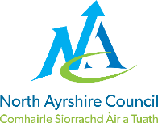
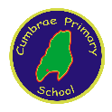
CUMBRAE PRIMARY SCHOOL

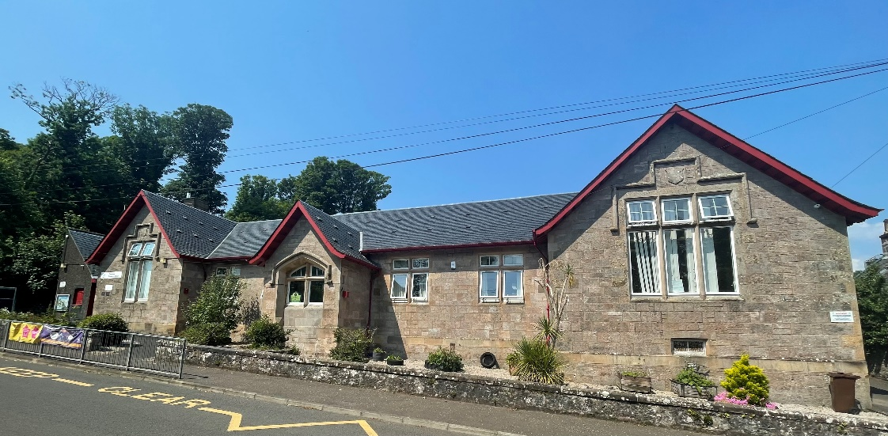

STANDARDS AND QUALITY REPORT
June 2024
This report will inform you of the school’s progress and achievements in the last session and let you know about our plans for 2024-25.
I hope that you find it helpful and informative.
Julie McAleese
Head Teacher

Our School
Cumbrae Primary School is situated in Millport on the Isle of Cumbrae, a short ferry ride from Largs. We are very lucky to live on such a beautiful island and we use this environment and very supportive community to enhance our learning experiences.
We are a non-denominational school with a roll of 42 children in three classes across Primaries 1 to 7. This is composed of a P1/2/3, a P4/5 and a P6/7. We have 11 children in the Early Years Class who attend 9am to 3pm. We are very proud of our nurturing ethos and our experienced staff team who strive to provide the best learning experiences for our children with every activity underpinned by our shared values and very positive ethos.
Our staffing structure consists of one Head Teacher and one Principal Teacher. We have three further class teachers, one support for learning teacher one day a week and an English as additional language teacher three days a week. We have one full time and two part time classroom assistants. In the early years class we have a Senior practitioner, an early years practitioner and an early years assistant.
Our office is staffed by one education business assistant and our building and grounds are cared for by our janitor. We have two catering assistants who bring our lunches over from Largs Academy.
We also work closely with our community partners, Educational Psychologist, Area Inclusion worker, percussion instructor and staff from Largs Academy. Together, we all provide a warm, supportive, nurturing and caring environment for learning where children are supported to reach their full potential.
This year, 12% of children on our roll have English as an additional language.

Our Vision, Values and Aims
Our school vision is that staff, families and our community work actively together to ensure children receive a rich, inspiring and engaging education enabling each child to become a lifelong learner, aspiring to high standards of achievement in all areas of their life.
Our values permeate our every action and activity and these are
Teamwork Respect Ambition Inclusion Nurture
Working within a safe, secure and caring school, we aim to
- provide all pupils with a challenging and varied learning experience, promoting respect and consideration and encouraging a high level of success and achievement. This will lead to excellence and quality in their education.
- provide all staff with a supportive and rewarding working environment, maintaining a positive ethos and attitude to all.
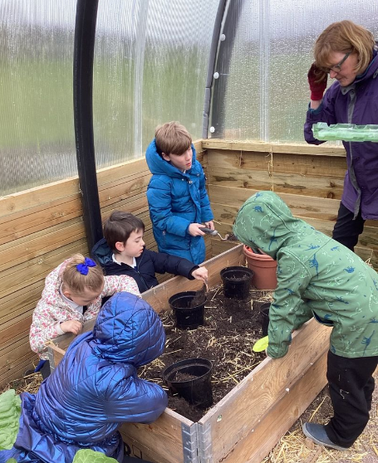
- value and encourage an excellent partnership with parents, carers and members of the community, promoting high aspirations and a ‘can-do’ attitude.

ATTAINMENT & ACHIEVEMENT
Attainment and Achievement
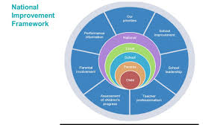
Every year we gather lots of information on how our children are progressing in their learning. To monitor their attainment and achievement we observe children working through tasks, listen to what they say, ask important questions, set challenges and use a variety of standardised assessments. We gather as a team and analyse our collection of data and observations to plan targeted learning activities for children to ensure they are making appropriate progress.
North Ayrshire Council and The Scottish Government also ask us to summarise our children’s progress in Reading, Writing, Listening and Talking and Numeracy.

We are very proud of how our children in Cumbrae are progressing and the well rounded, kind and responsible citizens they are becoming.
In the Early Years almost all preschool children achieved their expected milestones. In Primary 1, all children achieved their expected levels in Literacy & Numeracy. In Primary 4 almost all children achieved first level in Literacy & Numeracy and in Primary 7 almost all children achieved second level across all four areas, Reading, Writing, Listening & Talking and Numeracy.
Children with English as an additional language have received extra support from North Ayrshire EAL service and we are delighted that all our EAL children have made very good progress in English from their prior levels.
These successes have been due to the high quality learning and teaching experiences taking place within Cumbrae Primary and the shared vision that all children can achieve. All children are making progress across the curriculum because of the carefully planned programmes meeting their needs.
Our attendance overall is 92%. This is higher than the North Ayrshire average. We have had no exclusions.

WIDER ACHIEVEMENT
In 2023/24 we achieved many high level features of success
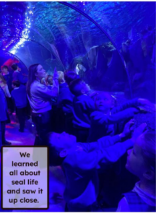
- Primary 6/7 experienced a trip of a lifetime on the Waverley. The children had previously won a modelling competition if the Waverley before the holidays and were crowned the national champions entitling them to a trip on the renowned ship around the west coast of Scotland.
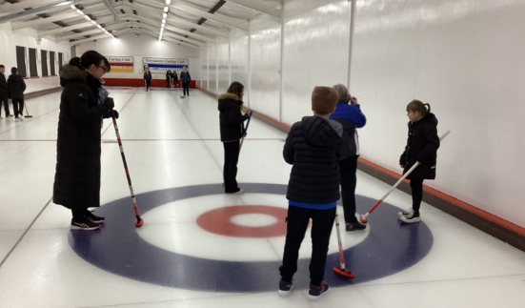
- We aim to give children experience of as many off site educational experiences as possible. This year the whole school enjoyed a trips to Loch Lomond Sea life Centre which was kindly donated to the school by one of our long standing partners, The Cumbrae Forum. We also enjoyed a trip to the pantomime at the Beacon Arts Centre, Greenock funded by the Masonic Lodge and Parent Council and Greenacres curling rink funded by the Paticipatory budget..
- Across the school we have had a focus on improving reading for enjoyment. All classes have experienced virtual author visits and in person visits from local writers and illustrators, Marie Herbert-Liew, Alan Dapre,Maura McRobbie and Alison Page. We also set a fun home reading challenge of ‘reading as an act of kindness’ and ‘reading in an unusual place’. We had some amazing photos sent in! All our reading activities were gathered together by Mrs Neilson and resulted in us achieving our Reading Schools Silver award.
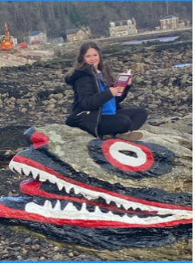
- Developing Digital Technology skills across the school has been a priority this year. Our coding club has been very successful and we used funding to purchase a variety of robots which the children have enjoyed playing with and coding them to carry out various tasks. Our work in this area was nationally recognised when we were awarded the Digital schools award.
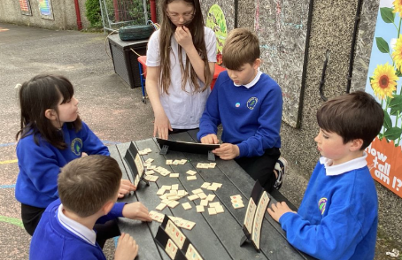
- All P6/7 children received training as Playground leaders to develop skills in involving the younger children in fun playground games at breaks and lunch. We are proud that our learning continues in our children’s free time and we provide a variety of traditional group games, sports and creative play such as art and construction at playtimes outside.
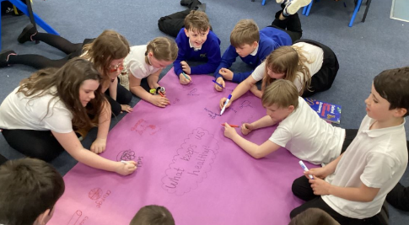
- Throughout the year we ensure that children’s rights are recognised and celebrated. We promote learner choice, participation and leadership, involving children in all aspects of their learner journey and encouraging awareness sustainability actions in our local environment and beyond. Because of our commitment to children’s rights we were recently awarded our Rights Respecting Schools Silver Award. We will now aim for gold!
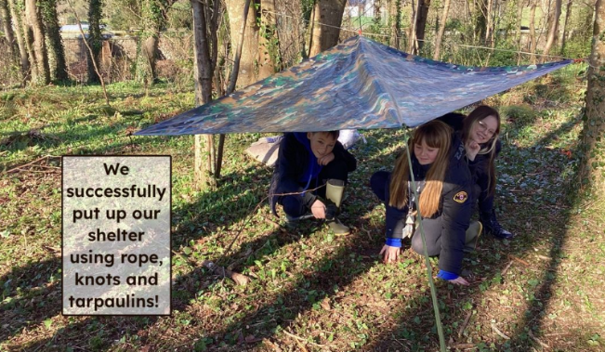
- We are passionate about ensuring children enjoy learning and school experiences. This session we increased our offering of outdoor learning opportunities and children across the school were involved in learning about survival, nature, den building and much more. This developed teamwork, leadership skills and improved children’s engagement and communication.
- Our partnerships with Active Schools gave children access to school clubs such as athletics, football, dance and multisports.
- All Primary 5 children successfully completed a block of six swimming lessons at Vikingar funded by the Cumbrae Forum.
- Groups of children regularly attended Warm Wednesday afternoons to promote intergenerational relationships through playing board games with the retired to singing nursery rhymes with toddlers. It’s a very popular activity benefitting all involved.
- Primay 7 pupils enjoyed a 3 night residential at Dumfries House along with P7 children from Fairlie and Skelmorlie Primaries. This was a great experience and allowed all children to develop friendships before they move on to Largs Academy in August.
- Another highlight of our year was our production of Matilda Jnr in June 2024. All children across the Primary School were involved and spectacularly performed 3 shows to the whole community.
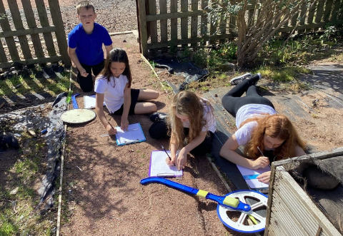

HOW SUCCESSFUL HAVE WE BEEN IN IMPROVING OUR ESTABLISHMENT?
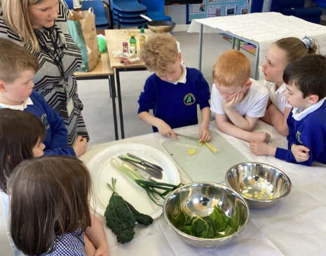
Priority 1 - To develop a love for learning through enhancing environments, pedagogy and providing relevant and exciting learning experiences across the school, indoors and outdoors. One teacher took responsibility for developing outdoor learning across the school and all children benefitted from exctiting and engaging experiences developing skills across the curriculum. Children had fun and demonstrated increased curiosity, independence and a love for learning. Environments were improved to ensure inclusivity and development of play pedagogy.
Priority 2 - To ensure all children are engaged in their learning pathway and making progress from prior levels of achievement. Staff and children developed a guide and standards for excellent learning and teaching in Cumbrae Primary to which all activities are centred around ensuring consistency and high quality experiences. Quality learning conversations and sharing of targets has resulted in children confidently discussing their achievements in learning and next steps
Priority 3 - To increase learner participation and empowerment to create positive outcomes and changes We successfully achieved our Silver Rights Respecting School award and all pupil leadership groups contributed to school improvement through expressing their ideas and working together towards common goals – sustainability, sports awards, reading awards and digital schools awards.

QUALITY INDICATORS
QI 1.3 Leadership of Change | Evaluation Very Good
Our shared school vision, values and aims are reviewed annually with pupils, parents and staff. Our school values of Teamwork, Respect, Ambition, Inclusion and Nurture are well understood by all staff and children and are highly visible in all aspects of school life. We have strong partnerships with community groups and ensure children value island life and experience a rich and varied curriculum. Our improvement priorities are influenced by our local context, our self-evaluation activities and have a clear rationale for change. We have high aspirations for our children.
QI 2.3 Learning, Teaching & Assessment | Evaluation – Very 6Good
Children experience high quality nurturing relationships. There are positive relationships and high quality learning experiences throughout the school which helps children to be enthusiastic about learning. Our priorities this session to develop play and outdoor learning have been very successful and resulted in improved engagement and achievement. Our use of the local area beyond our school grounds and developing a love for nature has helped children understand their importance in sustaining their natural environment for the future.
QI 3.1 Ensuring Wellbeing, Equality & Inclusion | Evaluation - Very Good
All children are included and involved in the life of the school and participate in pupil leadership groups. Our children experience high quality outdoor learning, supporting them to be more resilient, work together and deepen classroom learning in a new environment. Teachers meet the needs of all children very well through carefully planned learning experiences and children requiring support have bespoke, well considered plans in place.
QI 3.2 Raising Attainment & Achievement | Evaluation Very Good
Overall our quality of children’s attainment is very good and we swiftly identify children who require targeted interventions to ensure they remain on track. All children benefit from a wide variety of rich learning experiences including well planned sporting, cultural and community events. We aim to help children look outwards and recognise the opportunities there are both on the Isle of Cumbrae and more widely. Our children recognise these experiences are helping to prepare them for an ever changing future.

PUPIL EQUITY FUNDING
Our Pupil Equity Fund (PEF), monies allocated by the Scottish Government to help schools close the attainment gap, enabling us to focus on Getting It Right For Every Child. We pride ourselves in knowing our children very well and using our pupil equity fund to ensure children are able to make progress in a nurturing learning environment.
In 2023/24 we used PEF for the following
- Purchasing software licences to provide exciting and engaging activities for children to improve Literacy and Numeracy skills, to develop our provision of science and to ensure our health and wellbeing programme meets the needs of our pupils eg. Spellzone, Sumdog, Twig, TigTag and the Tree of Knowledge.
- We purchased a range of robots and coding toys to enhance our digital technology curriculum. This improved children’s skills in digital literacy.
- A priority in 23/24 was to develop outdoor learning across the school. We purchased resources to enhance these activities and waterproofs and wellies for all children so that they can access outdoors in all weathers with no additional cost to parents. Consistent outdoor learning and improved children’s teamwork skills, communications skills and wellbeing. Children regularly comment with excitement how much fun they have learning outdoors.
- We have also used some of our PEF to provide transport and off site trips for our children such as outdoor learning, sports festivals, class trips, science based trips and residential trips. This has an overall benefit for health and wellbeing and ensures all children have the opportunity to experience exciting learning opportunities.
- To further promote literacy across the school we invited various authors and illustrators to work with the children to help develop a love for reading and writing with purpose.
In 24/25 we intend to
- Further develop our outdoor learning provision by developing a skills based curriculum
- Improve attainment and achievement by ensuring children are motivated by relevant learning experiences tailored to their individual needs and also through learning for sustainability
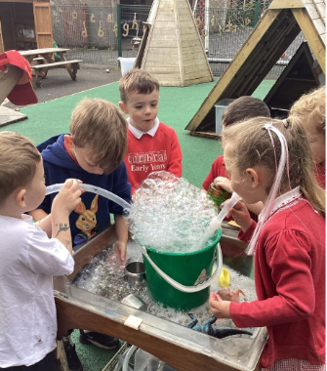
- Continue to seek opportunities for off site learning and also partners to bring interesting learning activities to Cumbrae to enhance children’s learning experiences in our island context.

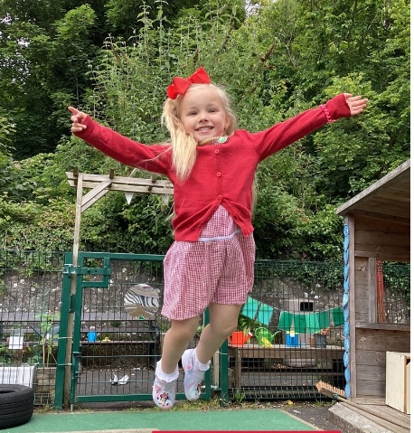

Education Scotland Inspection
In January 2024, a team of inspectors from Education Scotland visited Cumbrae Primary School and Nursery Class. During their visit, they talked to parents/carers and children and worked closely with the headteacher and staff.

The inspection team found the following strengths in the school’s work:
The positive nurturing relationships between all staff and children in the school and nursery. Children are confident, secure and engage very well in learning.
The highly respected and aspirational headteacher who is driving school improvement. She is supported very well by an effective and resilient staff team. Together they are successfully improving children’s attainment, experiences and outcomes.
The high-quality experiences, including outdoor learning, community projects and learning through play. Learning is well planned and effectively supported by a range of partners. This is leading to positive outcomes for children.

IMPROVEMENT PLAN PRIORITIES 2024-25
Priority 1 To develop joy in learning through enhancing pedagogy and improving skills across the curriculum.
Priority 2 To raise attainment and achievement for all ensuring children are well supported, included and engaged in their personal learning pathway.
Priority 3 To maximise learner participation and voice to create positive outcomes and changes.

