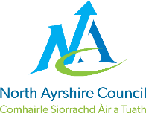
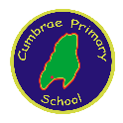
CUMBRAE PRIMARY SCHOOL

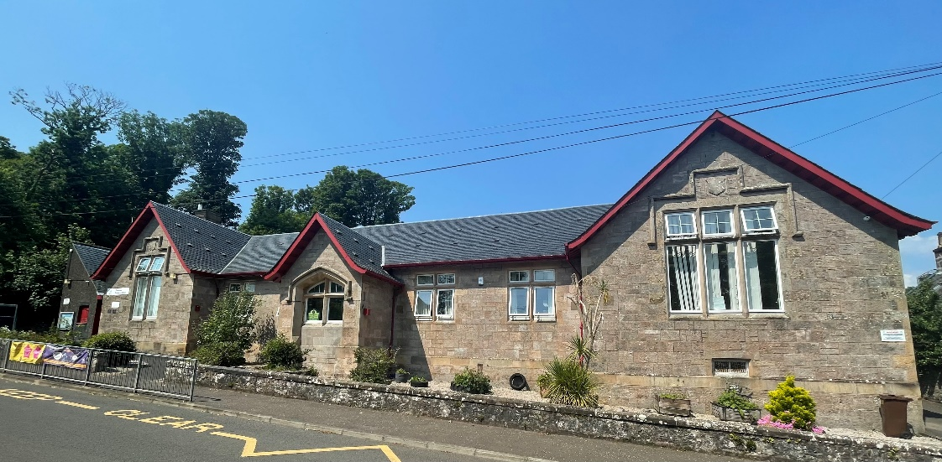

STANDARDS AND QUALITY REPORT
June 2025
This report will inform you of the school’s progress and achievements in the last session and let you know about our plans for 2025-26.
I hope that you find it helpful and informative.
Julie McAleese
Head Teacher

Our School
Cumbrae Primary School is situated in Millport on the Isle of Cumbrae, a short ferry ride from Largs. We are very lucky to live on such a beautiful island and we use this environment and very supportive community to enhance our learning experiences.
We are a non-denominational school with a roll of 44 children in three classes across Primaries 1 to 7. This is composed of a P1/2/3, a P4/5 and a P6/7. We have 10 children in the Early Years Class who attend 9am to 3pm. We are very proud of our nurturing ethos and our experienced staff team who strive to provide the best learning experiences for our children with every activity underpinned by our shared values and very positive ethos.
Our staffing structure consists of one Head Teacher and one Principal Teacher. We have three further class teachers, one support for learning teacher one day a week and an English as additional language teacher one morning a week. We have one full time and one part time classroom assistants. In the early years class we have a Senior practitioner, an early years practitioner and two part time early years assistants.
Our office is staffed by one education business assistant and our building and grounds are cared for by our janitor. We have two catering assistants who bring our lunches over from Largs Academy.
We also work closely with our community partners, Educational Psychologist, Area Inclusion worker, percussion instructor and staff from Largs Academy. Together, we all provide a warm, supportive, nurturing and caring environment for learning where children are supported to reach their full potential.
This year, 9% of children on our roll have English as an additional language.

Our Vision, Values and Aims
Our school vision is that staff, families and our community work actively together to ensure children receive a rich, inspiring and engaging education enabling each child to become a lifelong learner, aspiring to high standards of achievement in all areas of their life.
Our values permeate our every action and activity and these are
Teamwork Respect Ambition Inclusion Nurture
Working within a safe, secure and caring school, we aim to
- provide all pupils with a challenging and varied learning experience, promoting respect and consideration and encouraging a high level of success and achievement. This will lead to excellence and quality in their education.
- provide all staff with a supportive and rewarding working environment, maintaining a positive ethos and attitude to all.
- value and encourage an excellent partnership with parents, carers and members of the community, promoting high aspirations and a ‘can-do’ attitude.

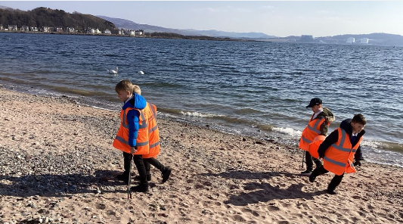

ATTAINMENT & ACHIEVEMENT
Attainment and Achievement
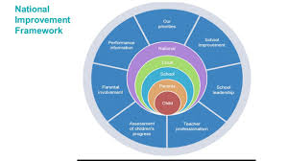
Every year we gather lots of information on how our children are progressing in their learning. To monitor their attainment and achievement we observe children working through tasks, listen to what they say, ask important questions, set challenges and use a variety of standardised assessments. We gather as a team and analyse our collection of data and observations to plan targeted learning activities for children to ensure they are making appropriate progress.
North Ayrshire Council and The Scottish Government also ask us to summarise our children’s progress in Reading, Writing, Listening and Talking and Numeracy.

We are very proud of how our children in Cumbrae are progressing and the well rounded, kind and responsible citizens they are becoming.
In the Early Years almost all preschool children achieved their expected milestones. In Primary 1, almost all children achieved their expected levels in Numeracy, Listening & Talking and Reading and most in Writing. In Primary 4 almost all children achieved first level in Literacy & Numeracy and in Primary 7 almost all children achieved second level across all four areas, Reading, Writing, Listening & Talking and Numeracy.
Children with English as an additional language have received extra support from North Ayrshire EAL service and we are delighted that all our EAL children have made very good progress in English from their prior levels, with a few reaching national expectations.
These successes have been due to the high quality learning and teaching experiences taking place within Cumbrae Primary and the shared vision that all children can achieve. All children are making progress across the curriculum because of the carefully planned programmes meeting their needs.
Our attendance overall is 93.27%. This is higher than the North Ayrshire average of 92.35%. We have had no exclusions.

WIDER ACHIEVEMENT
In 2024/25 we achieved many high level features of success
- We aim to give children experience of as many off site educational experiences as possible. This year children across the school enjoyed trips to the pantomime at the Beacon Arts Centre, Greenock funded by the Masonic Lodge and Parent Council, Greenacres curling rink funded by the Participatory budget, Lime Tree Larder for chocolate making, the Field Studies Centre for science activities and outdoor learning and a whole school trip to Glasgow Science Centre.

- Primary 6/ 7 experienced a number of transition visits to Largs Academy and Inverclyde sports centre enabling them to establish early positive relationships with children from other schools and staff from Largs Academy.
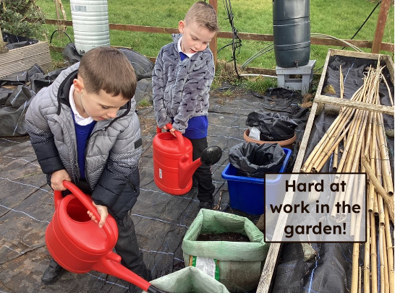
- P1/2/3 have worked very closely with the Cumbrae Forum and have participated in weekly gardening sessions, cultivating produce which they have then used in creating healthy meals, at home and in school.

- Our curriculum is varied and relevant to our children’s interests and local issues. We regularly make use of our local environment and this session the children have enjoyed learning in the cathedral grounds, at the beach or in our school garden. We made close links with Mackley construction who visited the school to help our children understand the process and purpose of the newly constructed flood defence system in Millport.

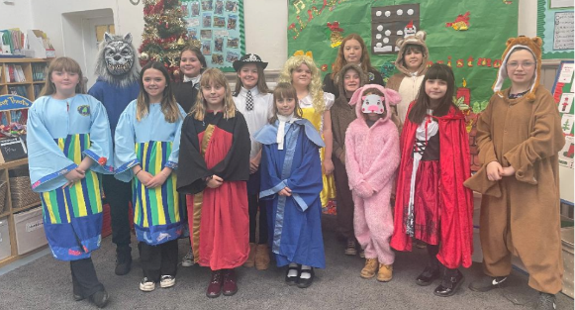
- We are committed to ensuring children learn about nature and learn through nature. All children experience outdoor learning across the curriculum and participate in events such as beach clean ups and the big garden birdwatch.

- As part of our Literacy curriculum our P6/7 class wrote and produced a very lively ‘trial’ around whether Goldilocks should be held accountable for trashing the three bears home. Parents and friends of the school very much enjoyed the performance and ultimately found Goldilocks guilty. This gave the children a wonderful opportunity for script writing, learning about the legal system and developing performing skills.
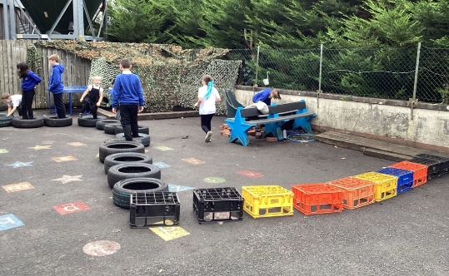
- All P6/7 children received training as Playground leaders to develop skills in involving the younger children in fun playground games at breaks and lunch. We are proud that our learning continues in our children’s free time and we provide a variety of traditional group games, sports and creative play such as art and construction at playtimes outside.

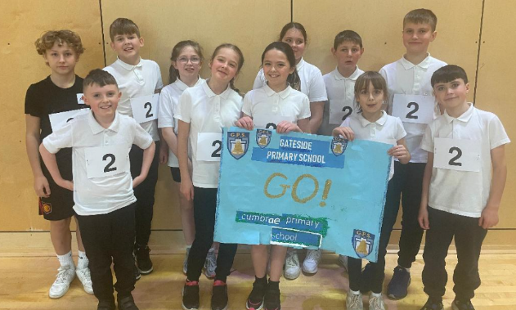
- Our partnerships with Active Schools gave children access to school clubs such as athletics, football, dance and multisports. To increase competitive opportunities in sport we established a virtual athletics competition with other small schools across the authority. The P4 – 7 children participated in weekly activities such as long jump, hurdles, high jump, running and Cumbrae pupils regularly featured in the top ten.

- Our commitment to sport for all earned us our Gold School Sport Award this session.

- In November 2024 our athletics team travelled to Irvine Portal to participate in regional heats against other North Ayrshire Schools. This was our first time competing in such an event and it was such a success it will now be a regular feature of our sporting calendar.

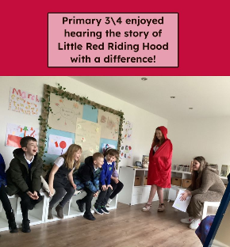
- All Primary 5 children successfully completed a block of six swimming lessons at Vikingar funded by the Cumbrae Forum.

- Our Early Years children regularly attended Warm Wednesday afternoons to promote intergenerational relationships through playing board games with the retired to singing nursery rhymes with toddlers. It’s a very popular activity benefitting all involved.

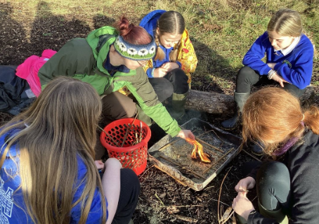
- Primary 7 pupils enjoyed a 3 night residential at Dumfries House along with P7 children from Fairlie and Skelmorlie Primaries. This was a great experience and allowed all children to develop friendships before they move on to Largs Academy in August. They enjoyed activities such as den building, fire lighting, archery, rock climbing and a tour of the house.

- We were visited by His Majesty’s Inspectors of Education in May 2025 for a national thematic inspection in Literacy which highlighted our commitment to ensuring children receive a balance of activities and experiences to promote Literacy skills across our curriculum.

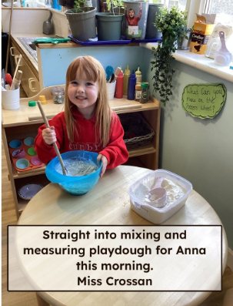
- For a period of eight weeks we made very good use of a teacher from North Ayrshire’s Professional Learning Academy to support staff in delivering engaging maths lessons and also increasing the reading and Numeracy attainment of individual children.

HOW SUCCESSFUL HAVE WE BEEN IN IMPROVING OUR ESTABLISHMENT?
Priority 1 - To develop joy in learning through enhancing pedagogy and improving skills across the curriculum.
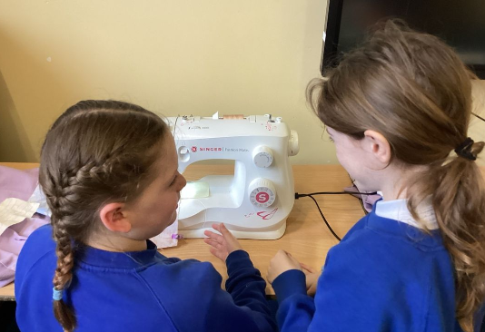
Children have demonstrated increased curiosity, independence and love for learning through our Puzzle, Think, Explore approach which promotes inquiry based personal learning across the curriculum. Staff engaged in professional learning to develop skills in delivering outdoor learning and creating engaging spaces to suit the needs of all learners. This increased opportunities for children to learn in a variety of spaces.
Priority 2 - To raise attainment and achievement in Literacy and Numeracy for all, ensuring children are well supported, included and engaged in their personal learning pathway.
All children have made progress from prior levels of attainment. Staff use nurturing and creative approaches to meet the needs of all learners and celebrate their achievements. A number of children make good use of digital technologies to improve their reading, writing and make the curriculum more accessible. Staff carefully plan learning activities so that children understand what they are learning, why it matters, and how they can succeed at their own level. Through effective target setting, children are supported with clear steps to help them make progress and achieve success.
Priority 3 - To maximise learner participation and voice to create positive outcomes and changes.
Our children experienced fortnightly dedicated time for leadership groups which enabled them to have a voice in school life and make positive changes which enhanced their school experiences. The pupil council have requested new football nets and playground games and are currently working towards our Rights Respecting School award. The sustainability group have had responsibility of leading our Plant to Plate project. The digital leaders established a lunchtime coding club. The book ambassadors have revamped our school library, led story sessions for our younger children and chosen new books for the library. And finally our sports committee have all been trained as play leaders to encourage all children to be active at playtime and they successfully delivered a presentation of our achievements in sport, leading to our Sport Scotland Gold Award.

QUALITY INDICATORS
QI 1.3 Leadership of Change | Evaluation Very Good
Our shared school vision, values, and aims are collaboratively reviewed each year with input from pupils, parents, and staff. Our core values—Teamwork, Respect, Ambition, Inclusion, and Nurture—are deeply embedded in our school culture and are clearly reflected in all aspects of school life.
We are committed to creating dynamic and inclusive learning environments. Our learning spaces are regularly refreshed and thoughtfully designed to be creative, engaging, and responsive to the diverse needs of individual children.
We maintain strong partnerships with local community groups, ensuring that our children develop a deep appreciation for island life and local environment while benefiting from a rich and varied curriculum. Our improvement priorities are shaped by our unique local context and informed by ongoing self-evaluation. Each priority is underpinned by a clear and purposeful rationale for change. We hold high aspirations for all our learners and are dedicated to supporting them to achieve their full potential.
QI 2.3 Learning, Teaching & Assessment | Evaluation – Very Good
Children across our school benefit from high-quality, nurturing relationships that support their wellbeing and learning. Positive interactions and engaging learning experiences are evident throughout the school, fostering a strong sense of enthusiasm and curiosity among our learners.
This session, we prioritised the development of play and creative thinking through our 'Think, Puzzle, Explore' approach, which encourages inquiry and deeper understanding. Outdoor learning continues to be a strength of our practice, with children demonstrating increased engagement and achievement as a result.
We make full use of our local environment beyond the school grounds, helping children to develop a love for nature and a strong sense of responsibility for sustaining the natural world. All teaching staff have participated in professional learning through Learning Through Landscapes, which has supported the embedding of high-quality outdoor learning and play experiences. We are proud to be recognised as a Climate 180 school, reflecting our commitment to environmental education and sustainability.

QI 3.1 Ensuring Wellbeing, Equality & Inclusion | Evaluation - Very Good
All children are actively included in the life of the school and have meaningful opportunities to lead and contribute through a range of pupil leadership groups, including the Pupil Council, Digital Leaders, Learning for Sustainability (LFS), Rights Respecting Schools (RRS), and Community Development. These roles help develop confidence, responsibility, and a sense of agency in our learners.
Children benefit from high-quality learning experiences in a variety of settings—both on and off the island—which enhance resilience, collaboration, and the ability to apply classroom learning in real-world contexts. These experiences are carefully designed to deepen understanding and broaden horizons.
Teachers plan learning experiences that are responsive to the needs of all learners, ensuring that every child is challenged and supported appropriately. Children who require additional support have individualised, well-considered plans in place, which are regularly reviewed to ensure progress.
Our curriculum is underpinned by the United Nations Convention on the Rights of the Child (UNCRC), ensuring that children’s rights are central to all aspects of school life. We work closely with a range of partners to provide holistic support for children and families, ensuring that every child is equipped to thrive both academically and personally.

QI 3.2 Raising Attainment & Achievement | Evaluation Very Good
Children across our school demonstrate strong attainment, with overall outcomes judged to be very good. We have robust systems in place to swiftly identify learners who require targeted support, ensuring timely interventions that help all children stay on track and make measurable progress.
All learners benefit from a broad and enriching curriculum that includes well-planned sporting, cultural, and community-based experiences. These opportunities not only enhance academic learning but also develop confidence, teamwork, and a sense of belonging.
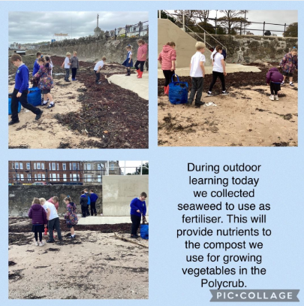
We actively encourage children to look beyond their immediate environment, helping them to recognise the diverse opportunities available both on the Isle of Cumbrae and beyond. As a result, our pupils are developing the skills, knowledge, and mindset needed to thrive in an ever-changing world.
Children who require additional support have personalised, well-structured plans in place, ensuring they experience success and feel a strong sense of achievement. Progress is closely monitored, and interventions are adapted to meet evolving needs.
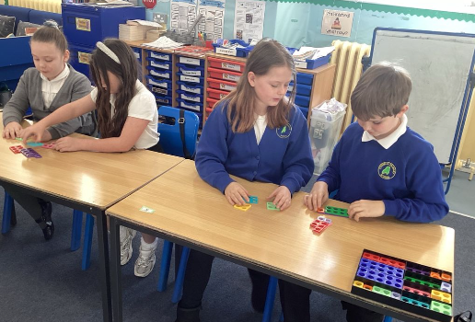
Achievement is celebrated regularly and meaningfully—both within and beyond the classroom—helping to build self-esteem, motivation, and a culture of success for all.

PUPIL EQUITY FUNDING
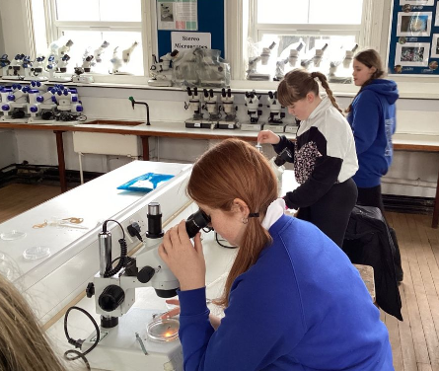
Our Pupil Equity Fund (PEF), monies allocated by the Scottish Government to help schools close the attainment gap, enables us to focus on Getting It Right For Every Child. We pride ourselves in knowing our children very well and using our pupil equity fund to ensure children are able to make progress in a nurturing learning environment.
In 2024/25 we used PEF for the following
- Purchasing resources for play to enhance children’s engagement in learning and enhance our learning for sustainability curriculum.
- To ensure all pupils had full access to the maths curriculum, we invested in a variety of games and practical resources, including Numicon. These materials were used to stimulate children’s interest in numeracy and to support their understanding of mathematical concepts through hands-on activities and manipulatives.
- Much of our PEF to provide transport and off site trips for our children such as outdoor learning, sports festivals, class trips and science based trips. This ensures our children have the same opportunities as mainland children to attend events and experience exciting learning activities without having families impacted by financial constraints because of their island locality. These experiences have a huge benefit to the overall wellbeing and happiness of our children.
- To enhance pupils’ engagement with science and engineering, we utilised Pupil Equity Funding to invite Generation Science to deliver interactive sessions on climate change and renewable energy to all students.
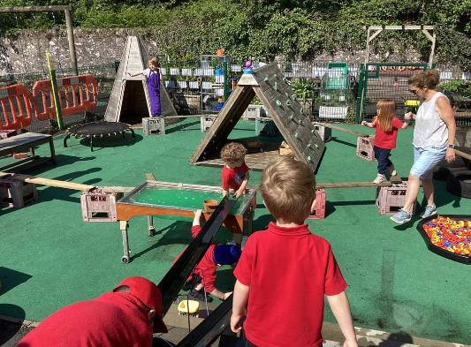
In 25/26 we intend to
- Further improve our outdoor learning provision by developing a skills based curriculum and employing a pupil support assistant to develop play
- Improve attainment and achievement by ensuring children are motivated by relevant learning experiences tailored to their individual needs and also through learning for sustainability
- Continue to seek opportunities for off site learning and also partners to bring interesting learning activities to Cumbrae to enhance children’s learning experiences in our island context.

IMPROVEMENT PLAN PRIORITIES 2025-26
Priority 1 - To improve attainment in Literacy (Writing) for all, ensuring all children are well supported, included and engaged in their personal learning pathway.
Priority 2 – To enrich the quality of learning experiences and raise attainment in Mathematics through enhanced pedagogy and curriculum development.
Priority 3 - To cultivate skills development and engaged learners through a holistic learning for sustainability curriculum.

