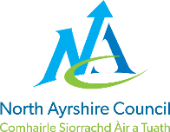
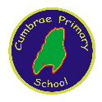
CUMBRAE PRIMARY SCHOOL

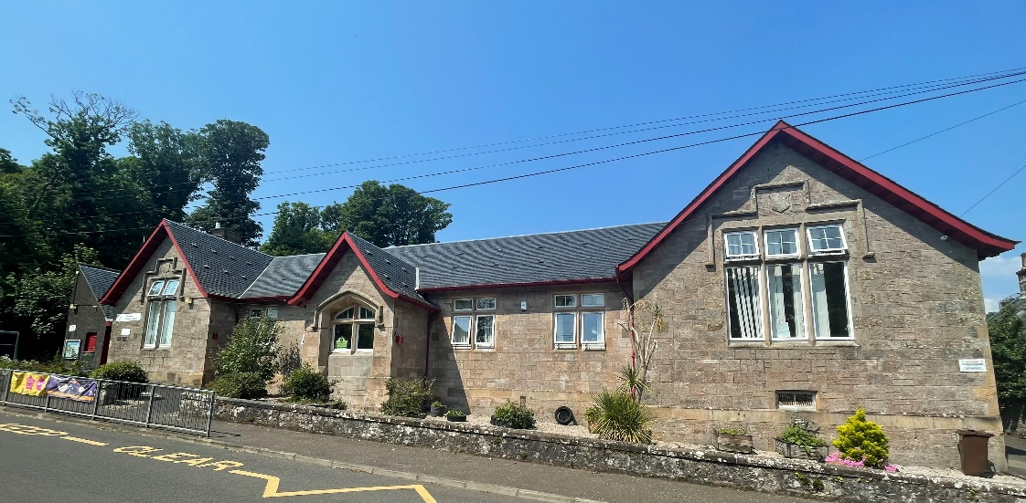

STANDARDS AND QUALITY REPORT
June 2023
This report will inform you of the school’s progress and achievements in the last session and let you know about our plans for 2023-2024.
I hope that you find it helpful and informative.
Julie McAleese
Head Teacher

Our School
Cumbrae Primary School is situated in Millport on the Isle of Cumbrae, a short ferry ride from Largs. We are very lucky to live on such a beautiful island and we use this environment and very supportive community to enhance our learning experiences.
We are a non-denominational school with a roll of 53 children in three classes across Primaries 1 to 7. This is composed of a P1/2/3, a P4/5 and a P6/7. We have 9 children in the Early Years Class who attend 9am to 3pm. We are very proud of our nurturing ethos and our experienced staff team who strive to provide the best learning experiences for our children with every activity underpinned by our shared values and very positive ethos.
Our staffing structure consists of one Head Teacher and one Principal Teacher. We have three further class teachers, one support for learning teacher one day a week and an English as additional language teacher three days a week. We have one full time and two part time classroom assistants. In the early years class we have a Senior practitioner, an early years practitioner and a classroom assistant.
Our office is staffed by one education business assistant and our building and grounds are cared for by our janitor. We have two catering assistants who bring our lunches over from Largs Academy.
We also work closely with our Educational Psychologist, Family Learning Team, Area Inclusion worker, percussion instructor and staff from our counselling service The Exchange, Aberlour and Largs Academy. Together, we all provide a warm, supportive, nurturing and caring environment for learning where children are supported to reach their full potential.
This year we have welcomed a number of new families to our community which has resulted in 17% of children on our roll having English as an additional language.

Our Vision, Values and Aims
Our school vision is that staff, families and our community work actively together to ensure children receive a rich, inspiring and engaging education enabling each child to become a lifelong learner, aspiring to high standards of achievement in all areas of their life.
Our values permeate our every action and activity and these are
Teamwork Respect Ambition Inclusion Nurture
Working within a safe, secure and caring school, we aim to
- provide all pupils with a challenging and varied learning experience, promoting respect and consideration and encouraging a high level of success and achievement. This will lead to excellence and quality in their education.
- provide all staff with a supportive and rewarding working environment, maintaining a positive ethos and attitude to all.
- value and encourage an excellent partnership with parents, carers and members of the community, promoting high aspirations and a ‘can-do’ attitude.
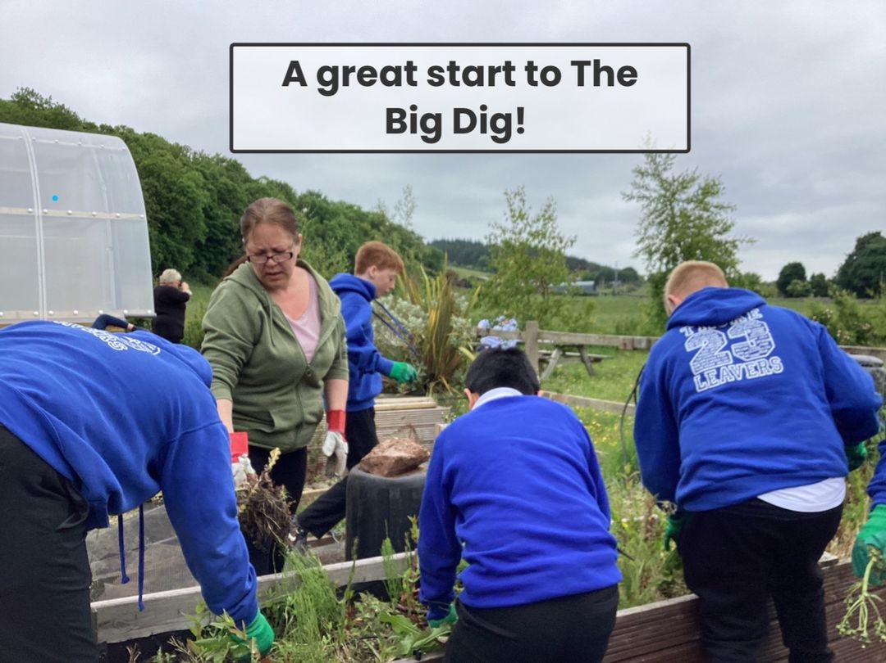

ATTAINMENT & ACHIEVEMENT
Attainment and Achievement
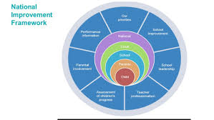
Every year we gather lots of information on how our children are progressing in their learning. To monitor their attainment and achievement we observe children working through tasks, listen to what they say, ask important questions, set challenges and use a variety of standardised assessments. We gather as a team and analyse our collection of data and observations to plan targeted learning activities for children to ensure they are making appropriate progress.
North Ayrshire Council and The Scottish Government also ask us to summarise our children’s progress in Reading, Writing, Listening and Talking and Numeracy.
We are very proud of how our children in Cumbrae are progressing and the well rounded, kind and responsible citizens they are becoming.
In the Early Years most preschool children achieved their expected milestones. In Primary 1, almost all children achieved their expected levels in Literacy & Numeracy. In Primary 4 most children achieved first level in Literacy & Numeracy and in Primary 7 almost all children achieved second level across all four areas, Reading, Writing, Listening & Talking and Numeracy.
Children with English as an additional language have received extra support from North Ayrshire EAL service on a daily basis. We are delighted that all our EAL children have made very good progress in English from their prior levels.
These successes have been due to the high quality learning and teaching experiences taking place within Cumbrae Primary and the shared vision that all children can achieve. All children are making progress across the curriculum because of the carefully planned programmes meeting their needs.
Our attendance overall is 92.63%. This is higher than the North Ayrshire average. We have had no exclusions.

WIDER ACHIEVEMENT
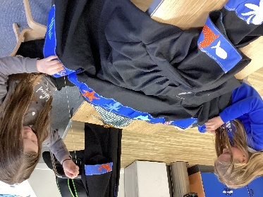
In 2022/23 our high level features of success were
- Primary 6/7 once again smashed the Ayr region of the Scottish Mock Court challenge. This experience involves the children in debating a court case with other schools across the region while developing skills in Literacy, Art, Sewing and Performing. The children produced a portfolio of work and ‘performed’ the case in front of a real Sheriff at Ayr Town Hall. We won Top Pursuer Team, Top Defender Witness and Best journalism Teams.
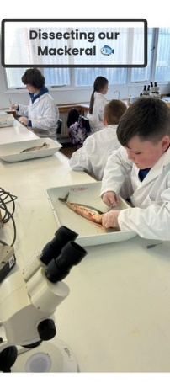
- We aim to give children experience of as many off site educational experiences as possible. This year the whole school enjoyed a trip to Glasgow Science Centre which was a huge success. This was kindly donated to the school by one of our long standing partners, The Cumbrae Forum.
- From this trip, Primary 6/7 expressed a great interest in science and we then arranged a 10 week experience of science activities to explore our island at the Field Studies Centre. They developed a great range of maths and science skills in real life contexts – and some very smelly experiments!
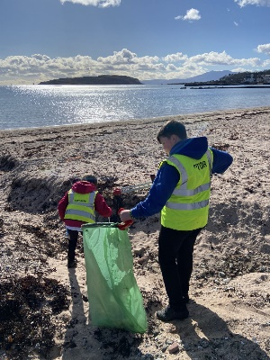
- We are passionate about developing the children’s leadership skills across the school, encouraging responsibility for improving our environments. Our learning for sustainability group spent time developing the school garden and organised a whole school beach clean.
- Improving digital skills across the school this session has been a priority and 20% of children joined our coding club and worked alongside our digital leaders to deliver workshops to other classes and parents.
- In response to our children’s interest and in partnership with Active Schools, we have offered a variety of clubs this year which have been well attended eg. Glee club, handball, athletics, football and multisports
- All Primary 5 children successfully completed a block of six swimming lessons at Vikingar.
- All children from EYC to P7 were involved in the summer term in a series of outdoor learning experiences with local company LOOC (Let’s Learn Outside Of the Classroom). The children had a wonderful time learning about nature and all achieved their RSPB Wild Challenge Silver Award.
- Primary 7 pupils all successfully passed their bikeability assessments.
- Groups of children regularly attend the forum group on a Wednesday afternoon to promote intergenerational relationships through playing board games with the retired to singing nursery rhymes with toddlers.
- Partnership working is essential to support the health and wellbeing of our pupils and this session we have developed strong relationships with Aberlour Charity, Exchange Counselling and our Area Inclusion Worker to improve outcomes for our children across the school and particularly those in Primary 7 to support transition to Largs Academy.

HOW SUCCESSFUL HAVE WE BEEN IN IMPROVING OUR ESTABLISHMENT?
Priority 1 - To Improve attainment, particularly in Literacy and Numeracy. All children have made progress from their prior levels of attainment. Staff received training in the teaching of writing to develop a more consistent focus across the school and this is showing improvement in children’s approaches to writing.Digital technology development has enabled teachers to support learners more effectively and overcome any barriers to learning which may have impacted on progress.
Priority 2 - To close the gap between the most and least disadvantaged children. Effective targeted support for our EAL children has resulted in good progress in learning English. Nurturing activities across the school have ensured groups of children maintain engagement in learning while developing fundamental life skills.
Priority 3 - To improve children and young people’s health and wellbeing and develop skills for life, learning and work. Offering a variety of outdoor learning experiences and offsite activities has increased children’s joy in learning and improved attendance for some.
Priority 4 - To place human rights and needs of every child at the centre of education. An increase in leadership groups across the school has meant that all children feel they can have a positive impact of change within school eg. book club, reading ambassadors, pupil council, digital leaders, learning for sustainability group

QUALITY INDICATORS
QI 1.3 Leadership of Change | Evaluation Very Good
Our shared school vision, values and aims are reviewed annually with pupils, parents and staff. These are very relevant to our unique setting. Our improvement priorities are centred around what our children need to make progress in their learning and health and wellbeing. All staff are committed to evaluating the impact of improvements to ensure positive outcomes for our learners.
QI 2.3 Learning, Teaching & Assessment | Evaluation - Good
Our learning environment is very nurturing and positive relationships are fostered across our community. We encourage learner participation through our assemblies, rights respecting school work and pupil leadership groups to ensure a culture of equality and so that everyone feels valued. We make good use of our local community to enhance learning and make it relevant for our children. The use of digital technologies is improving and we intend to build on this in 23/24.
QI 3.1 Ensuring Wellbeing, Equality & Inclusion | Evaluation - Very Good
Relationships across our school are very positive. Children’s rights are embedded in our curriculum and we strive to ensure all learners and families feel well supported. We realise the benefit of outdoor learning, using green spaces and risky play,regularly implementing these in to children’s daily experiences.
QI 3.2 Raising Attainment & Achievement | Evaluation Very Good
Almost all children across the school are achieving appropriate levels. We use robust tracking systems to ensure our pupils’ needs are being met and they are being constantly challenged to further their love for learning. Children’s personal achievements are recognised across the school and we use a wide variety of personnel, technologies and varied activities to ensure that all children feel a sense of achievement across all stages of development.

PUPIL EQUITY FUNDING
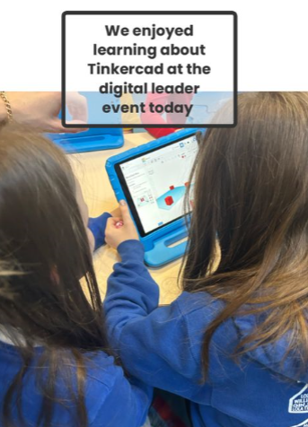
Our Pupil Equity Fund (PEF), monies allocated by the Scottish Government to help schools close the attainment gap, enabling us to focus on Getting It Right For Every Child. We pride ourselves in knowing our children very well and using our pupil equity fund to ensure children are able to make progress in a nurturing learning environment.
In 2022/23 we used PEF for the following
- Purchasing software licences to provide exciting and engaging activities for children to improve Literacy and Numeracy skills, to develop our provision of science and to ensure our health and wellbeing programme meets the needs of our pupils eg. Nessy Spelling, Sumdog, Twig, TigTag and the Tree of Knowledge.
- We purchased Promethean Boards so that all classes were suitably resourced to deliver good learning and teaching. We purchased a number of ipads to ensure all children had access to technology to support and progress their learning. This resulted in children with EAL being able to access the curriculum with ease and children with dyslexia using speech to text technology so that their ideas and stories are communicated without the barrier of worrying about spelling.
- A priority in 22/23 was to develop consistency in the teaching of writing across the school to improve the quality of children’s writing. Therefore, we invested in PM Writing resources and training from world expert, Stephen Graham. The impact of this writing approach is already evident in the quality of children’s writing and we will see further year on year progression.
- We have also used some of our PEF to provide transport and off site trips for our children such as outdoor learning, sports festivals, class trips, science based trips and residential trips. This has an overall benefit for health and wellbeing and ensures all children have the opportunity to experience exciting learning opportunities.
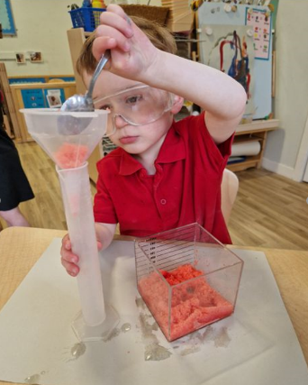
In 23/24 we intend to
- Further develop our environments inside and outside to provide opportunities for engaging learning activities through play and skills based experiences
- Continue to seek opportunities for off site learning and also partners to bring interesting learning activities to Cumbrae to develop an excitement for learning in our children.

IMPROVEMENT PLAN PRIORITIES 2023-2024
Priority 1 To develop a love for learning through enhancing environments, pedagogy and providing relevant and exciting learning experiences across the school, indoors and outdoors
Priority 2 To ensure all children are engaged in their learning pathway and making progress from prior levels of achievement.
Priority 3 To increase learner participation and empowerment to create positive outcomes and changes.

