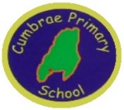
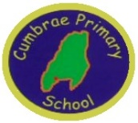
CUMBRAE PRIMARY & EARLY YEARS CLASS
HT Update Term 3
January 2023
Dear Parents and Families,

Welcome back to our third term of the session!

LEARNING & TEACHING in TERM 3

You will shortly receive your class newsletter outlining the core learning and teaching for each class.
All classes begin the term with our Scottish focused learning. This is a much loved part of our annual curriculum where children learn about the rich heritage, culture and history of our own country. Each class will also learn a Scottish poem to share aloud and if the children wish they can be considered for our annual Scottish recital competition in February. We will also be inviting parents to our Scottish concert on Wednesday 8th February in the afternoon.

During December and January P6/7 have been involved in the Mock Court project. They have been studying the case of Apple Byte and working as prosecutors, defenders, artists and writers to present their case to a real life Sherriff! A group of children travelled to the old Ayr Town Court to present their case in front of the Sherriff and against Heathfield Primary from Ayr. The children were absolutely fantastic and an absolute credit to the school. We will find out the results later in the year but some photos of the day are below.
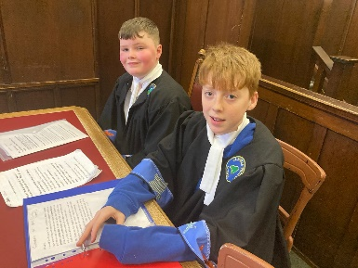
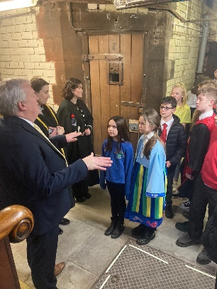
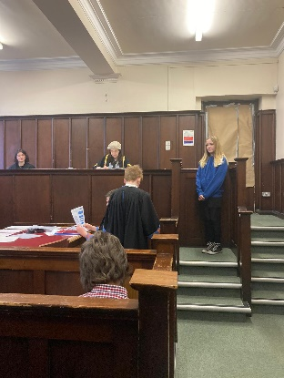
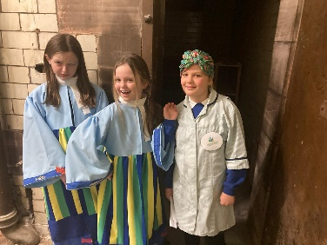

This term P6/7 will also experience a series of science afternoons with Jack Lock from the Field Studies Centre. They will be involved in fish dissection, plankton investigations, beach art, vegetation analysis, rocky shore explorations and classification and identification of local species.

Our outdoor classroom is now complete beside the garden in the church grounds. We have applied for further grants to build a path to the classroom so that it is accessible by all. The children will be involved in furnishing the room and we look forward to using it shortly. Many thanks to the Cumbrae Forum for contributing a substantial amount to this build.

P4/5 will be working in the garden in the spring time to plant and harvest crops so that we will hopefully be able to host a community café in the summer term.

At the end of January a covered bike shelter will be built at side wall entrance to the school which will hopefully encourage more children to cycle or scoot to school.

PARENT MEETINGS
Parents appointments will be scheduled for March and parents will have the choice of a face to face meeting on Wednesday 22nd March or a telephone appointment. Further details will be issued nearer the time. However, if you have any concern or question regarding your child’s learning or wellbeing prior to these meetings please contact the school to speak to myself or your class teacher. Also, that week we will have the Scholastic Book Fair in school.

PUPIL LEADERSHIP

Our pupil voice groups have been established and each will have a clear focus for school improvement. Our groups allow the children to share their opinions, views and drive change across the school community.
Our Pupil Council will focus on evaluating our learning and teaching experiences and work on developing our school playground by introducing some new games and more exciting areas in which the children can play.
Our Greenfingers group will ensure we are learning about sustainability and lead the development of our garden.
The Digital Leaders will be involved in ensuring our technology is all up to date, that we are cyber safety aware and will work towards the school achieving our Digital Schools Award.
And finally our Rights Respecting School ensure that we are living and breathing the United Nations articles across the school to achieve our silver award.

PARENT SURVEY
During February I will issue all families with our annual survey to evaluate our school and learning provision. As always, if you have any issues or ideas for improvement please let me know through the usual channels – phone or email.

CAN YOU HELP?
We would very much like to tidy the strip of overgrown bushes behind the main school building. It is full of large bushes, brambles and ivy. It is too big a job for us to tackle alone and P1/2/3 would like to plant some wild flowers here to develop a butterfly and bee area. If anyone or knows of anyone who is able to come and do some heavy clearing out we would very much appreciate it. This could be done during school time or evenings or weekends but we are pleading for some help! Please contact the school if you are able or have any ideas.

Mrs J McAleese

DATES FOR YOUR DIARY

Wed 8th Feb | Scottish Concert 1.45pm
Fri 10th Feb | Holiday
Mon 13th Feb | Holiday
Tues 14th Feb | In-service for teachers. Children off.
Wed 15th Feb | Back to school  P6/7 FSC – Beach Art
Thurs 16th Feb | P6/7 FSC – Rocky Shore
Wed 22nd Feb | P6/7 FSC – Vegetation Analysis
Wed 1st March | P6/7 FSC – Classification & Identification
Thurs 2nd March | P1 & P7 Dental Inspections  P6/7 FSC – Sandy Shore Exploration
Fri 3rd March | Glasgow Science Centre on Tour visiting Cumbrae – Body Vision Workshop for whole school
Wed 22nd March | Parent Appointments & Book Fair
Mon 27th March | Easter Egg Dioramas
Fri 31st March | School closes for 2 weeks
Mon 17th April | Children return to school
Thurs 27th April | P7 to Largs Academy
Mon 1st May | May Day Holiday
Wed 3rd May | Generation Science visiting Cumbrae whole school workshop
Mon 8th May | Coronation Holiday
Wed 24th May | School Sports Day
Mon 29th May | May Holiday
Tues 30th May | School in-service. Children off
Tues 6th June | P7 parents Largs Academy information evening
Thurs 8th June | P7 Largs Academy visit all day
Fri 9th June | P7 Largs Academy visit all day
Mon 19th – Fri 23rd June | P7 to Arran residential
Wed 28th June | School closes 1pm

