CUMBRAE PRIMARY & EARLY YEARS CLASS
HT Update Term 3
MARCH 2023
Dear Parents and Families,

LEARNING & TEACHING in TERM 3

Term 3 is going by very quickly and it is hard to believe we are heading towards the Easter holidays.

This term we held a very successful Scottish Concert and were treated to some amazing performance from our children. Many thanks to the Burns Club for supporting us. We were overwhelmed with the number of people who came to watch and support our children. It was lovely to have such a big audience. Because of the large numbers, we intend next year to either hold the concert in the school gym hall or perhaps the new town hall.

Some of our pupil equity fund this year has been spent on raising attainment in writing through the PM writing scheme. These lessons focus on developing consistent teaching of writing throughout the primary stages. We are already seeing improvements in children’s approaches to their writing and look forward to seeing further advancements in the years to come.

In numeracy, all classes continue to focus on learning the basic operations following our numeracy pathways. Children are involved in play and active tasks to display their understanding in the early stages moving on to some complicated challenges in the upper primary. All children are given daily opportunities to strengthen their mental agility and weekly problem solving activities to enable them to deepen mathematical knowledge through group work. We aim to always give learning purpose and relate activities to everyday life. This term, children have been working with simple money activities in the early years and learning about banking, interest rates and hire purchase in Primary 6/7.

Primaries 1 to 5 will travel to Finlaystone Country Park on Friday 17th March to work with wildlife rangers to further their investigations of animals and habitats which they have been learning about in school.

Primaries 1 to 7 had a super experience on Friday 3rd March when Glasgow Science Centre on tour visited the school. They participated in fun activities and learned about how our bodies work and found out lots of interesting facts about our bodily functions! In Lyle’s own words, “Mrs McAleese, that was awesome!”

P6/7 continue their visits to the FSC where they learn about and investigate habitats of plants and animals on Cumbrae. They also had a fun afternoon of a CSI science challenge led by Mr Rosa from Largs Academy and some S6 students. At the end of March Primary 7 will head to Largs Academy for the day to meet the rest of the cluster Primary 7 children and participate in a scavenger hunt around the campus.

After Easter Primary 5 will receive a number of swimming lessons at Vikingar – dates to be confirmed. Primary 7 will also receive their bikeability sessions in term 4 – dates still to be confirmed. Primaries 4 to 7 will also be receiving golf lessons and hopefully some tennis tuition too!

The early years children have been focussing on keeping active outside and you may have noticed their new climbing frame which they absolutely love! They are also busy planting seeds to grow, in their new inside greenhouse, for their annual plant sale which is a highlight of the year and raises funds for the early years children. We will keep you posted when a date for the sale is set.

FAMILY LEARNING

This term, Scott Hindmarsh, our family learning worker is running a series of healthy eating and fitness sessions on a Monday afternoon. There are still three sessions left this term. If you’d like to participate just phone the school to book in.
On Monday 13th March, PC Pollard from Largs Academy delivered a very informative internet safety session to parents. There was a lot of valuable discussion regarding mobile phones, apps and how to try and keep our children safe online. A brief guidance note is being issued to all parents by email with some very good advice and links for video clips to watch.
Primary 6/7 and Primary 4/5 will also receive an internet safety talk before the Easter holidays. An outline of the presentation will also be shared with you through Groupcall email.

After Easter our family learning sessions will focus on outdoor learning and hopefully make use of our new polycrub and outdoor classroom.

PARENT SURVEY

Many thanks to everyone who completed the parental survey in February. Your comments were much appreciated as it helps us reflect and design our curriculum taking into account the needs and ideas of our whole school community. On the whole, the responses were very positive.
Key strengths were that most parents agreed their child is happy and safe at school, making progress and they are happy with the quality of teaching and leadership. Another major strength was that parents feel they are encouraged to be involved in the work of the parent council and are kept informed of the work they do. It was also very pleasing to read that almost all parents agreed that the school encourages children to treat everyone with respect.

Some parents are unclear about how we assess children in school and how best to support their child at home. In order to share more information about teaching and learning within our school we would like to invite all parents from the EYC to P7 to an information afternoon on Friday 24th March at 1.30pm in the school library. I will lead a short presentation about our curriculum within Cumbrae Primary and our plans for the future. As always, your input will be very much valued too. After the presentation, you will be able to visit your child’s class to join in some activities. A Microsoft form will be sent out for you to register your interest in attending.

We will also be reissuing our Curriculum guidance leaflets in Term 4 so that all parents have a clearer understanding of our values, how we challenge and support our children across the curriculum and how we try to improve their health and wellbeing.

GRANTS & IMPROVEMENTS

This term we were successful in securing a £6,800 grant from the Scottish Government Island Skills fund. This fund aims to support skills development in rural communities and develop the workforce for the 21st century. We have decided to spend this on coding equipment and a class set of sphero robots to improve the children’s technology skills.

We were also awarded £2,000 from the Calmac fund to improve wellbeing in the community. We will use this to construct a path from the carpark to the outdoor classroom and also connect it directly to the garden. This will make the classroom more easily accessible to all.

You may have noticed that we have also installed a covered bike shelter at the front of the school. This was requested by the pupil council so it is great that the children can see their ideas come to fruition and hopefully it will encourage more children to cycle or scoot to school.

One of our school traditions in the approach to the Easter holidays is the Easter egg decoration challenge. Each child from the EYC to Primary 7 is invited to create a themed egg decoration. Sometimes people create a scene in a box and others simply decorate eggs. There is a winner for each stage so feel free to get involved. Entries can be brought in during the last week of term on the Wednesday/ Thursday with judging taking place on Thursday 30th April. See examples below.

Kind regards

Mrs J McAleese

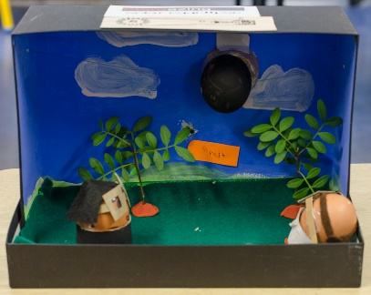
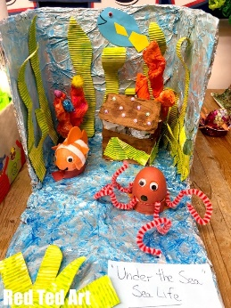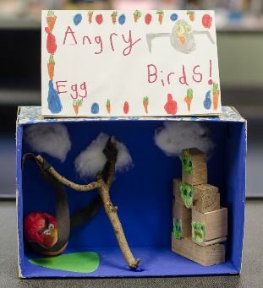

DATES FOR YOUR DIARY

Thursday 16th March | Parent appointments issued
Friday 17th March | P1 – 5 visit to Finlaystone. 8.30am at school with packed lunch and appropriate outdoor clothing
Wed 22nd March | Parent Appointments & Book Fair  P6/7 FSC – ponds and bugs
Thurs 23rd March | P7 to Largs Academy. 8.30am at school
Fri 24th March | Parent information afternoon 1.30pm in school library
Tues 28th March | P6/7 Curling experience at Greenacres, Howood. 8.30am at school with packed lunch
Wed 29th March | Easter Egg Dioramas can come in for judging on Thursday 30th
Fri 31st March | School closes for 2 weeks
Mon 17th April | Children return to school
Tues 18th April | P5/6/7 – Royal Air Force Stem challenge in school to raise awareness of the variety of careers in the RAF from chef to nurse to pilot
Wed 19th April | P5/6/7 – Champions for Change – PE lesson from KA Leisure to promote fitness and deter smoking for 4 weeks
Tues 25th April | Family outdoor learning session
Mon 1st May | May Day Holiday
Wed 3rd May | Generation Science visiting Cumbrae whole school workshop  Fizz, boom, bang P5/6/7  Ready, Teddy, Go P1/2/3/4
Mon 8th May | Coronation Holiday
Fri 19th May | P7 Parents Arran residential info 1.30pm school library
Wed 24th May | School Sports Day
Mon 29th May | May Holiday
Tues 30th May | School in-service. Children off
Tues 6th June | P7 parents Largs Academy information evening
Thurs 8th June | P7 Largs Academy visit all day
Fri 9th June | P7 Largs Academy visit all day
Mon 19th – Fri 23rd June | P7 to Arran residential
Wed 28th June | School closes 1pm

