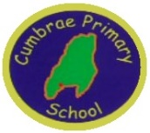
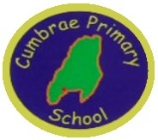
CUMBRAE PRIMARY & EARLY YEARS CLASS
HT Update March 2022
Dear Parent/ Carer,

It is lovely to feel that spring air and a touch of warmth in the sunshine. We have much to look forward to in school this term.
Photographs
The photographer will be visiting the school and EYC on Friday 18th March. All children will have an individual photograph, sibling photograph if applicable and a class photograph. Proofs will be sent home with your child but you are under no obligation to purchase.

New Staff
I am delighted to announce that we have two new classroom assistants starting with us while Miss McDavid is on maternity leave. Mrs Helen Letham will be with us on a Monday, Wednesday and Thursday and Mrs Sharon Armstrong on a Tuesday and Wednesday.

Jobs Within School
There are also two vacancies within the catering department of our school. There is a 7.5 hours catering assistant vacancy which is 1.5 hours per day to support the EYC in serving their lunch and tidying up. We also have 10 hours available in the kitchen, 2 hours per day helping to serve lunches and clearning up. These posts can either be filled individually or combined. They would suit a variety of people, parents, grandparents who quite simply enjoy working around children and would like to be part of our fantastic team. Please spread the word! If anyone is interested in the positions they should be advertised on My Job Scotland but if they are tricky to find please contact me directly.

Garrison Display
The art work the children produced for our Scottish art competition is now displayed in the Garrison so please pop in and see our fantastic art work.

The winners of our Scottish Poetry Competition were P3 – Lilly Rose, P4 – Zoe, P5 – Matilda, P6 – Emma and P7 – Enzo, who was also the overall poetry winner.
Winners of the art competition were Antepre – Grace, Pre – Ella, P1 – William, P2 – Charlie, P3 – Ethan, P4 – Myla & overall winner, P5 – Matilda, P6 – Lola, P7 – Enzo.
The musical award went to Mark in P7 on the chanter and the singing award to Jack in P6.

Well done everyone for your efforts!

Poetry Week
We will be kicking of our poetry week with a whole school visit and P6/7 workshop from poet Simon Lamb. Simon is a writer and performer who enjoys delighting and igniting his audience with his distinctive voice and infectious enthusiasm.
P6/7 Authors

P6/7 have been working with Lindsay Littleson to create their own stories of adventures on Cumbrae. They have produced some amazing pieces of work.
We are going to display these in the Garrison over the Easter break for everyone to read. There will also be a display of art work and photography too. We intend to have all the stories published into a glossy brochure as a keepsake for years to come. This has been a very worthwhile experience and I am sure you will be very impressed with the final results.

Parents Nights
Thank you for your responses regarding face to face meetings. Unfortunately, I have been advised by the authority that we are not allowed to hold these until Term 4. Therefore all parents will receive a telephone appointment time in the week beginning 21st March and we will invite parents into class in Term 4 when we get the go ahead. Children will also receive their annual written report towards the end of Term 4.

Easter
The children will receive a visit from Gus, the minister, on the last day of term to celebrate Easter. We had hoped to hold our traditional Easter service but restrictions are still in place for large gatherings so fingers crossed we can have an amazing summer service!

The Easter Egg Shoe box diorama competition will be judged on the last day of term – Friday 1st April. Entries can be brought in to school from Wednesday 30th March.
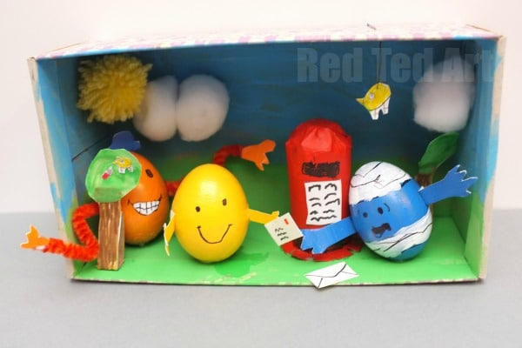
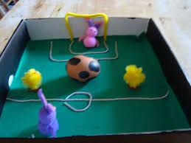

Kind regards

Mrs J McAleese

gw09mcaleesejulie01@glow.sch.uk

Tues 8th March | P5/6/7 Swimming Week 2
Mon 14th March | Poet Simon Lamb visiting
Tues 15th March | P5/6/7 Swimming Week 3
Fri 18th March | School photographs – individual & class
Mon 21st March | Parent appointments TBC
Tues 22nd March | Swimming Week 4
Fri 25th March | P7 to Largs Ac - orienteering
Tues 29th March | P5/6/7 Swimming Week 5
Wed 30th March | Egg competition can come in
Fri 1st April | Egg competition judging  Minister Gus visiting school  P7 enhanced transition parents to Largs Ac  School closes 2.30pm
Term 3 Calendar

Term 4 Calendar

Tues 19th March | Return to school
Fri 29th April | P7 to Largs Academy Fun Activity
Mon 2nd May | Holiday
Wed 11th May | Let’s LOOC Outdoor learning P1/2/3
Thurs 12th May | Let’s LOOC Outdoor Learning P4/5
Fri 13th May | Let’s LOOC Outdoor Learning P6/7
Sat 14th May | Cumbrae Queen Crowning
Wed 18th May | Island Art Experience P6/7
Thurs 19th May | Island Art Experience P6/7
Wed 25th May | Island Art Experience P6/7
Thurs 26th May | Island Art Experience P6/7
Fri 27th May | In-service
Thurs 2nd June | Holiday
Fri 3rd June | Holiday
Mon 7th June | Holiday
Thurs 9th June | P7 Largs Academy follow timetable
Fri 10th June | P7 Largs Academy follow timetable
Wed 15th June | Sports Day
Thurs 30th June | Summer service  School closes 1pm

