CUMBRAE PRIMARY SCHOOL & Early Years Class

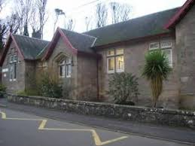

Standards & Quality Report
Session 2020/2021
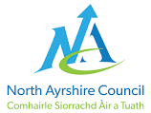
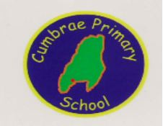
Believe and Achieve

Our School

Cumbrae Primary School is situated in Millport on the Isle of Cumbrae, a short ferry ride from Largs. This session we had 50 children in three classes across Primaries 1 to 7 and 10 children in the Early Years Class. We are very proud of our nurturing ethos and our experienced staff team who are fully committed to helping every child reach their potential. We make best use of our local community and outdoor environment. Together, we strive for the best learning experiences for our children with every activity underpinned by our shared values of Teamwork, Respect, Ambition, Inclusion and Nurture.

Our school improvement priorities in 2020/2021 were

- To create conditions for our children to access high quality learning experiences from age 3 to 12.
- To ensure self-evaluation and performance improvement were embedded throughout the school in order for children to become effective contributors, successful learners, confident individuals and responsible citizens.
- To engage families and offer opportunities to play a more active role in school life to secure better outcomes for children.
- To work with children, staff and families to build their resilience, supporting their mental health and physical wellbeing.

This past year has been incredibly challenging for schools across Scotland and we were required to implement remote learning in Term 3 but our well organised plan for remote learning and use of Seesaw across all stages ensured that learning was continuous and that communication channels remained very open between families and the school. In fact, it is without doubt, as evidenced in our parental survey that almost all parents were satisfied with the experience of remote learning in 2021 and this is a result of the very strong home/ school partnerships which are embedded within Cumbrae Primary and EYC.

Attainment

As in every year we gather lots of information how our children are progressing in their learning and this has been no different in 2020/21. To monitor their progress we watch children working through tasks, listen to what they say, ask important questions, set challenges and use a variety of standardised assessments. We gather as a team and analyse our collection of data and observations to plan targeted learning activities for children to ensure they are making appropriate progress.

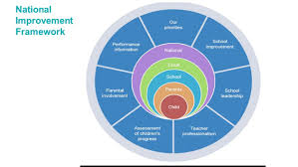
North Ayrshire Council and The Scottish Government also ask us to summarise our children’s progress in Reading, Writing, Listening and Talking and Numeracy. We are required to make professional judgements regarding children’s progress towards the Early, First and Second Levels: P1, P4 and P7. We come to these judgements using a variety of evidence such as performance in lessons, progress in class work and results from standardised assessments.

We are very proud of how our children in Cumbrae are progressing and the well rounded responsible citizens they are becoming. Through our robust monitoring systems we have identified desired improvements in specific areas such as spelling and grammar but on the whole our attainment is good.
In the Early Years all children achieved their expected preschool milestones. In Primary 1, all children achieved their expected levels in Literacy & Numeracy. In Primary 4 almost all children achieved first level in Literacy & Numeracy and in Primary 7 most children achieved second level across all four areas, Reading, Writing, Listening & Talking and Numeracy.

These successes have been due to the high quality learning and teaching experiences taking place within Cumbrae Primary and the shared vision that all children can achieve. All children are making progress across the curriculum because of the carefully planned programmes meeting their needs.

Successes and Achievements

Health & Wellbeing
Ensuring our children are mentally healthy in a nurturing environment is always our key priority. Success in this area is fundamental to ensuring their readiness to learn and ability to progress in other curricular areas.

In 2020/21 our high level features of success were
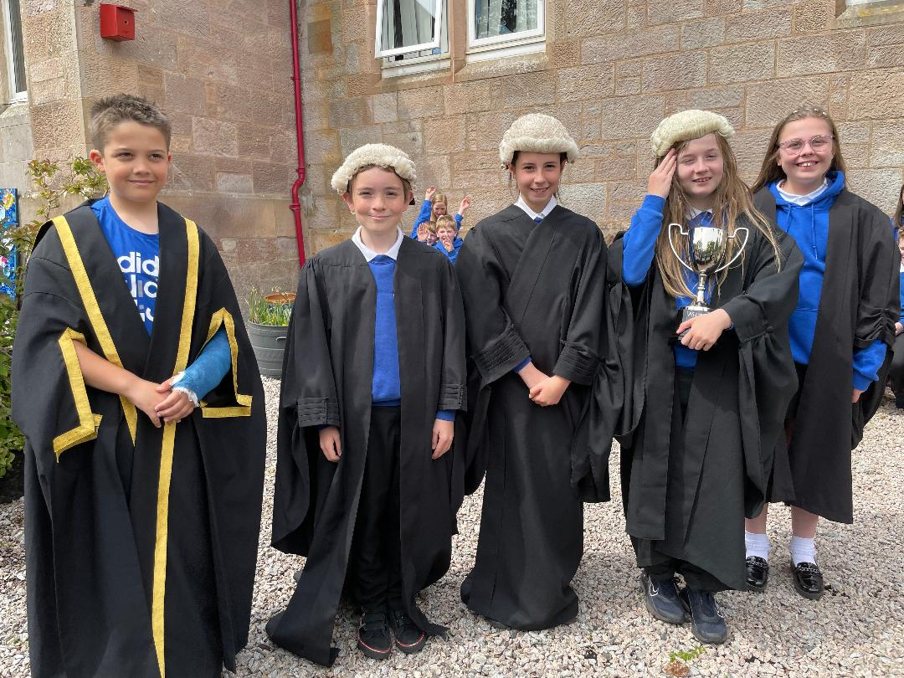
- Building on our previous year’s achievements, Primary 6/7 were crowned overall winners of the Scottish Mock Court challenge – the top award. This experience involves the children in debating a court case with other schools across the region while developing skills in Literacy, Art and Performing. The children produce a portfolio of work and ‘perform’ the case. They are then assessed by lawyers and judges of the Court. This was an outstanding and well deserved achievement. The children were presented their trophy by founder Gerald Murphy on a beautifully sunny day in Millport. Gerald was then subjected to a very intensive career interview by our children. More info on the project here https://www.mockcourt.org.uk/background.php
- Despite experiencing remote learning our children managed to participate in our Scottish fortnight in January and were presented with prizes from the Cumbrae Burns Club in recitation, art and musical performance.
- Across the school a love of reading is continually encouraged and this year, although face to face school visits were not allowed, we invited a number of authors in to our classrooms virtually to inspire the children eg. Michael Rosen, Tanya Robert, Jion Shoibani and Michelle Robinson who sent P1/2 signed copies of her books as she was so impressed with their enthusiasm and the stories they wrote after their session with her.
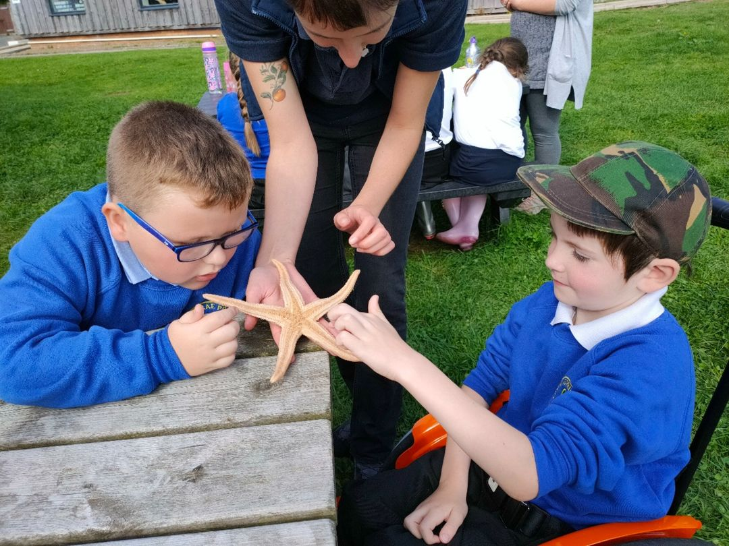
- Throughout remote learning we encouraged regular outdoor activities across the school and we worked in partnership with the Field Studies Council to enable many children to achieve their Hi5 award which is a nationally recognised SQA award.
- A major success this year was providing a continuous provision of teaching and learning throughout the remote learning period. Almost all children engaged daily in a variety of tasks provided by their teachers and staff were able to make phone and virtual contact with children and families to teach directly or offer pastoral support. We also staffed a successful hub for the essential keyworker children who were entitled to the provision. Thanks goes to everyone in the community who supported each other during that period.
- During Term 4 when all children were returning to school full time we wanted to make the experience of returning to in school learning as inspiring and exciting as possible. New playground games were painted in the lower playground and lots of new games were purchased to encourage outdoor play and exercise. The children who accessed the hub and pupil council were instrumental in determining the resources we bought.
- All children from EYC to P7 were involved in the summer term in a series of outdoor learning experiences with local company LOOC (Let’s Learn Outside Of the Classroom). The children had a wonderful time learning about nature and all achieved their RSPB Wild Challenge Bronze Award.
- Primary 6/7 had a very exciting Term 4 as they were involved in working with students from the University of Abertay who had developed a Minecraft game based on the Isle of Cumbrae. Our pupils worked their way through ten activities giving constructive feedback to the game developers before they rolled the project out to the rest of Scottish schools. This was a great experience and our children learned a lot about game development and opportunities for learning beyond school. The whole project was developed in partnership with Millport Conservation and Regeneration Scheme.
- Primary 7 pupils also all successfully passed their cycling proficiency assessments.
- Our EYC moved to 1140 hours and we now provide a service all day 9am to 3pm. Our EYC will be refurbished in the near future to further develop the provision available.

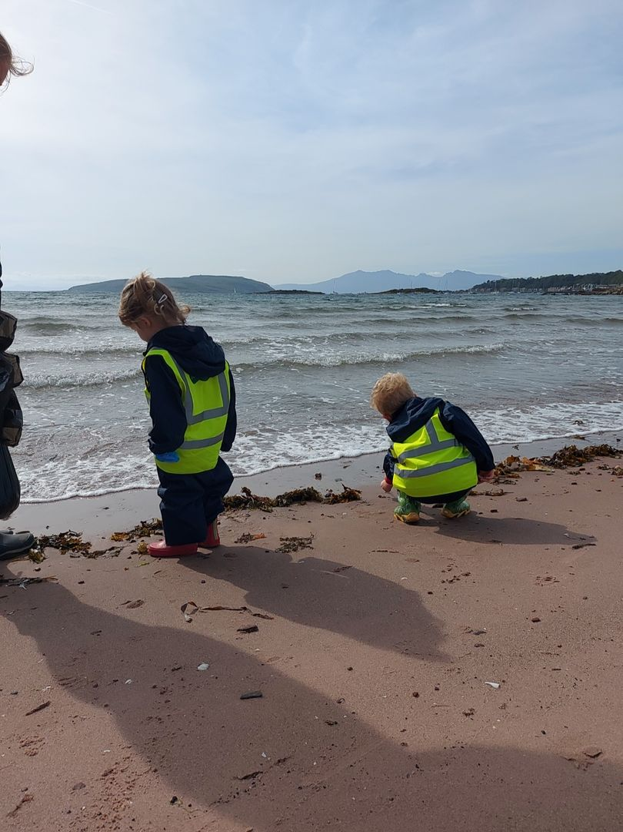

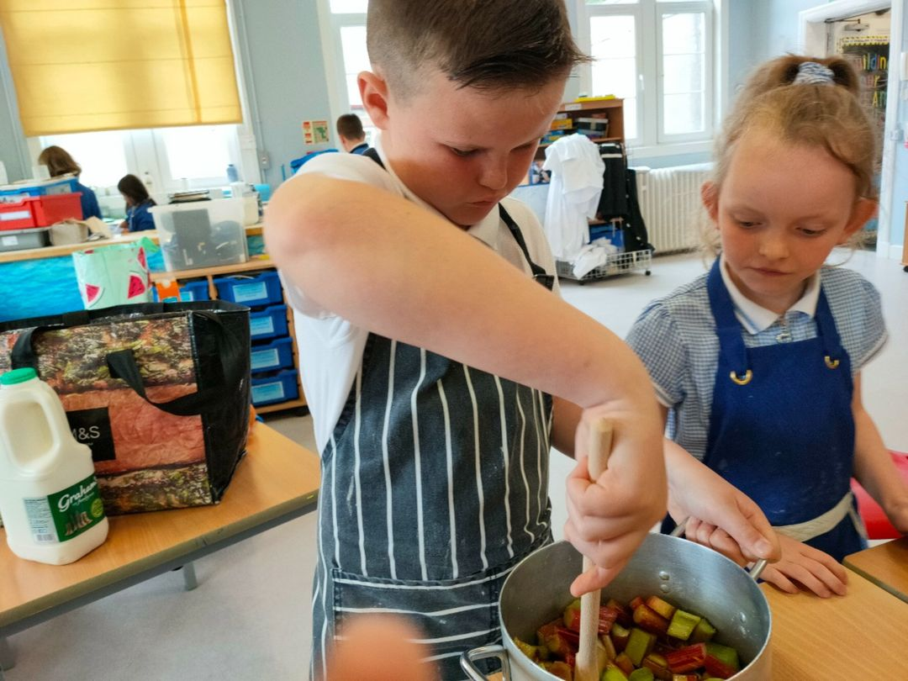
Looking Forward

Our priorities for 2021/22 continue to be influenced by the National Improvement Framework while taking recognition of our own context and children’s needs. We will continue to raise attainment in Literacy and Numeracy and enhance children’s Health & Wellbeing by

- We will further develop Numeracy skills and strategies by promoting problem solving challenges across the school. While most of our children achieve expected levels in Numeracy we are keen to provide challenge and breadth across mathematics allowing them to deepen their skills and think more creatively.
- Our Family Learning Team will be promoting problem solving challenges and inviting families to join in family maths circle events.
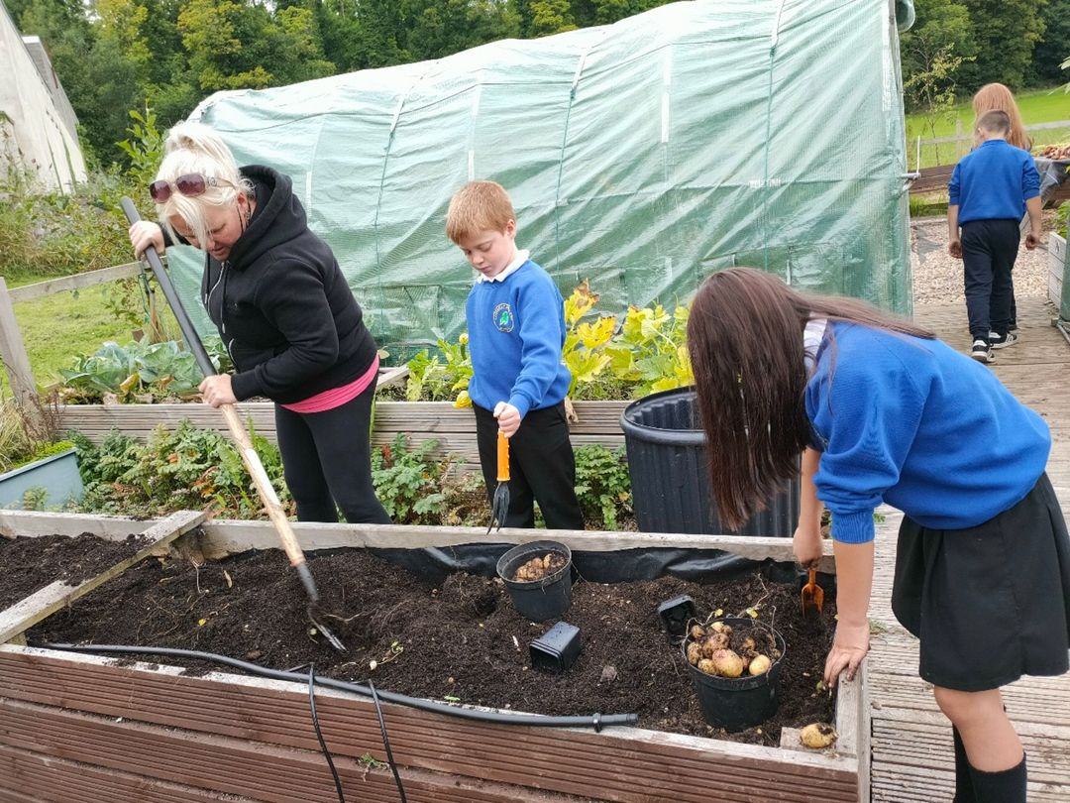
- Our Plant 2 Plate project will continue with children planting and harvesting the produce in close partnership with our community gardeners. We are applying for a number of grants which will hopefully enable us to expand our venture to keep chickens and develop a sheltered area near the garden to produce and serve food outdoors.
- All children will experience a half day outdoor learning programme for 15 weeks in partnership with the FSC based upon the sustainable goals for Scotland.
- We made a successful bid to the Scottish Book Trust to win a 10 week programme for P6/7 to work closely with author Lindsay Littleson. Lindsay has written books based on her experiences of Millport and will work with our children to write their own adventure stories based on Cumbrae which will be displayed in the Garrison.

Pupil Equity Fund

Our Pupil Equity Fund (PEF), monies allocated by the Scottish Government to help schools close the attainment gap enable us to focus on Getting It Right For Every Child. We pride ourselves in knowing our children very well and providing a nurturing environment in which they can learn.

Our PEF money in 2020 was spent in working towards improving children’s Health and Wellbeing and Attainment through
- Nessy Spelling/ Reading resources for specific children which has resulted in all who participated in this activity significantly raising their spelling ages.
- We purchased a range of reading books to target specific readers who would respond to adventure literature to improve their reading.
- The Pupil Council worked as a team and identified some playground games they would like painted in the lower playground. They had a specific budget and range of suppliers to choose from. The playground was measured and the games were painted for the children returning to school in March. The Pupil Council task now is to continue to develop area where the sandpit was into a house/ kitchen or to whatever their imagination creates!
- Much of our planned spending for PEF was curtailed by Covid as we were prevented from travelling off site or inviting people in. However, what we did not spend we have been able to carry over to this session and
  - Invest in a grammar and spelling resource from P1 to 7 to improve Literacy skills and develop continuity and structure across school.
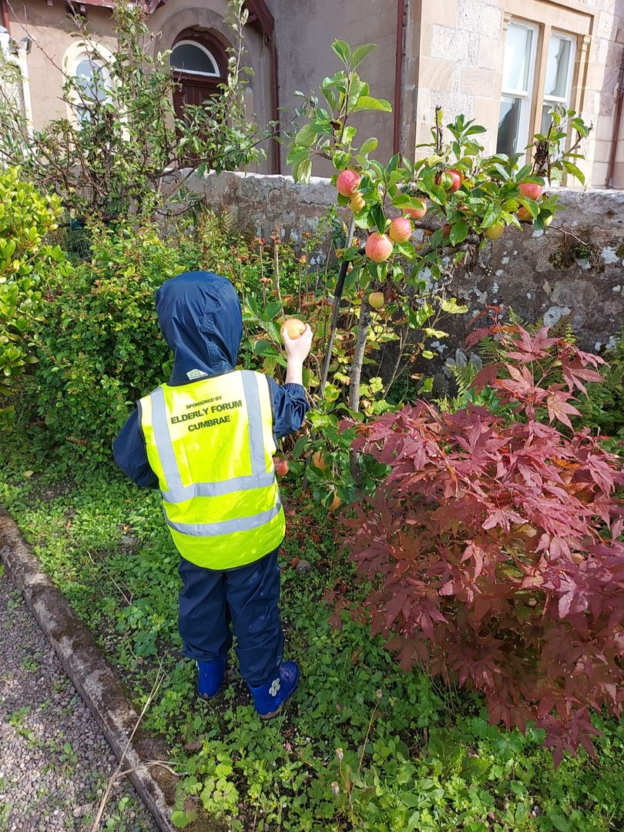
  - Further develop our outdoor spaces coordinated by the Pupil Council.
  - Invest in improving mathematical minds by introducing family maths circles and strategy games.
  - Introduce the Junior Dukes Scheme from P2 to P7. This is a home/ school partnership scheme which helps children develop a ‘can do’ attitude and encourages them to experience valuable life skills. It is a prequel to the Duke of Edinburgh scheme which some children may work towards in their teenage years.

Parental Involvement
Providing opportunities for active collaboration with parents and family learning underpins our ethos in Cumbrae.

- Our Seesaw app is our main platform for sharing the learning between home and school. All families are proactive in using this app and we are creating extensive journeys of learning for all our children. The children are excited to share their learning with their parents throughout the day. Seesaw was also a great resource during remote learning when teachers were able to send video messages or teaching clips to families. Likewise children were able to video message or send photos securely to staff so that engagement could be monitored.
- Although were not able to meet in person this year, all parents received phone call meetings with teachers to discuss learning and individual children’s targets. This has worked well but we look forward to the time when we can welcome our community safely back through our doors.
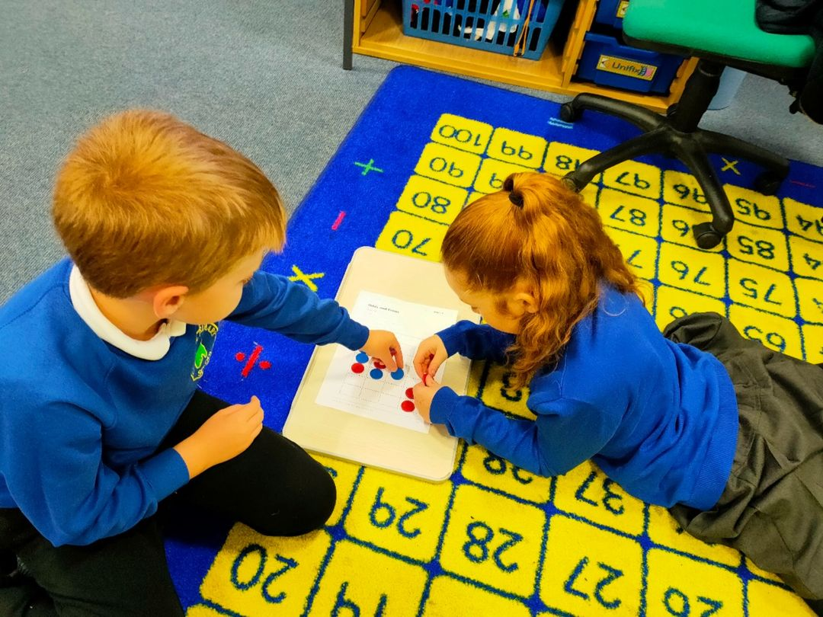
- Our Family Learning Worker worked closely supporting a few families in a variety of situations throughout this past year and will engage families this session in group events as restrictions allow.
- All parents were invited to participate in our Parent Consultation via Survey Monkey questionnaire and the feedback provided was very positive.
- Our Parent Council continues to be active and is a vital group within our school community to help support our children’s learning. It is well established but new members are always welcome and at present the meetings are held virtually.

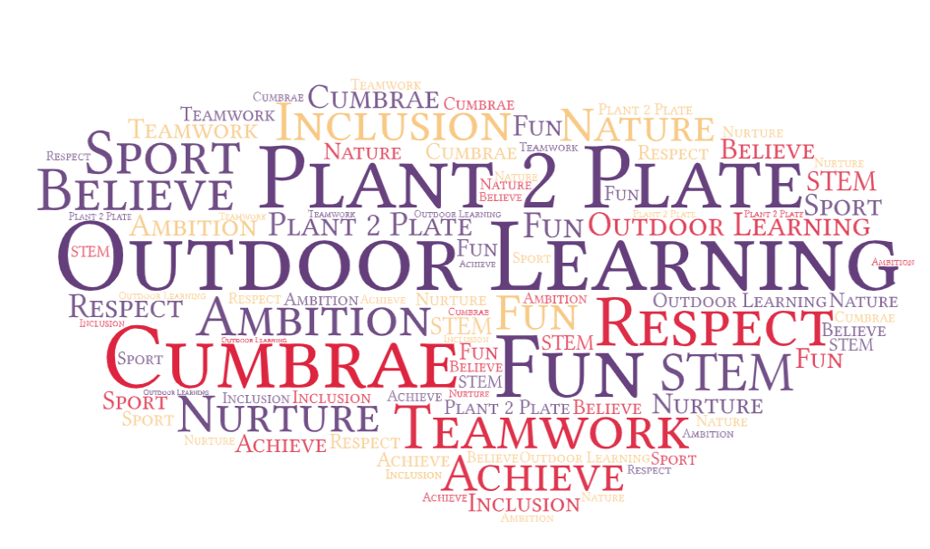
In conclusion it should be emphasised that education should be an enlightening experience both in and beyond the classroom. At Cumbrae Primary we strive to achieve this through great teaching and providing exciting learning activities across the curriculum in a variety of environments. Throughout this past challenging year we, as a whole school community, have all very successfully worked together to provide an education through which our children have continued to grow and thrive.

