Cumbrae Primary School

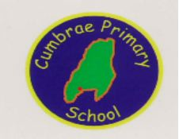

Curriculum Rationale 2022

7 Principles Challenge & Enjoyment, Breadth, Progression, Depth, Personalisation & Choice, Coherence, Relevance
Pupil Council Pupil Voice Playground Improvement RSS Health Committee Global Citizenship Community Development Eco School
Cumbrae Primary & EYC
Curriculum Design
Values

Learning Journeys Assessment Professional Judgement Breadth SNSA Summative Assessments Challenge AiFL
Aims

Contexts For Learning
Ethos & Life of the School The starting point for learning Curricular Areas & Subjects Organisers for the Es & Os Interdisiplinary Learning Skills & knowledge for learning beyond subject boundaries Opportunities for Personal Achievement Achievements in the classroom and beyond
Learning & Teaching
Active Learning & Play, Bloom’s Taxonomy, Peer collaboration, Cross Stage Learning, Outdoor Learning, Assessment is For Learning, Teacher directed learning, Nurturing curriculum, Healthy lifestyles, Working with partners eg, FSC, Cumbrae forum

Our Values
intrinsic to the ethos and life of the school Teamwork Respect Ambition Inclusion Nurture
Curricular Areas
Health & Wellbeing Literacy & English Numeracy & Maths Social Sciences Sciences Expressive Arts Technologies RME 1 + 2 Langages French/ SpanishReligious & Moral Education
Achievements
Playground leaders JRSOs, Football club, Assemblies School Shows, School Garden, Community involvement, Choir, Country Dancing, Recorders, Chanter, Sailing, Committees, Mock Court, Outdoor learning, Residential Activities Religious & Moral Education
Interdisciplinary Learning Skills
Growth Mindset, Creativity, Scientific, Transferable, Resilience, Problem Solving, Flexibility, Healthy Attitudes, Positive Mindset, Responsibility to self-development, Moral Values, Core Literacy & Numeracy skills, Plant2 Plate, Community cafe, Cumbrae Chickens, Learning for Sustainability
4 Capacities
Successful Learners, Confident Individuals, Effective Contributors, Responsible Citizens
Our Children
& families
CUMBRAE PRIMARY SCHOOL
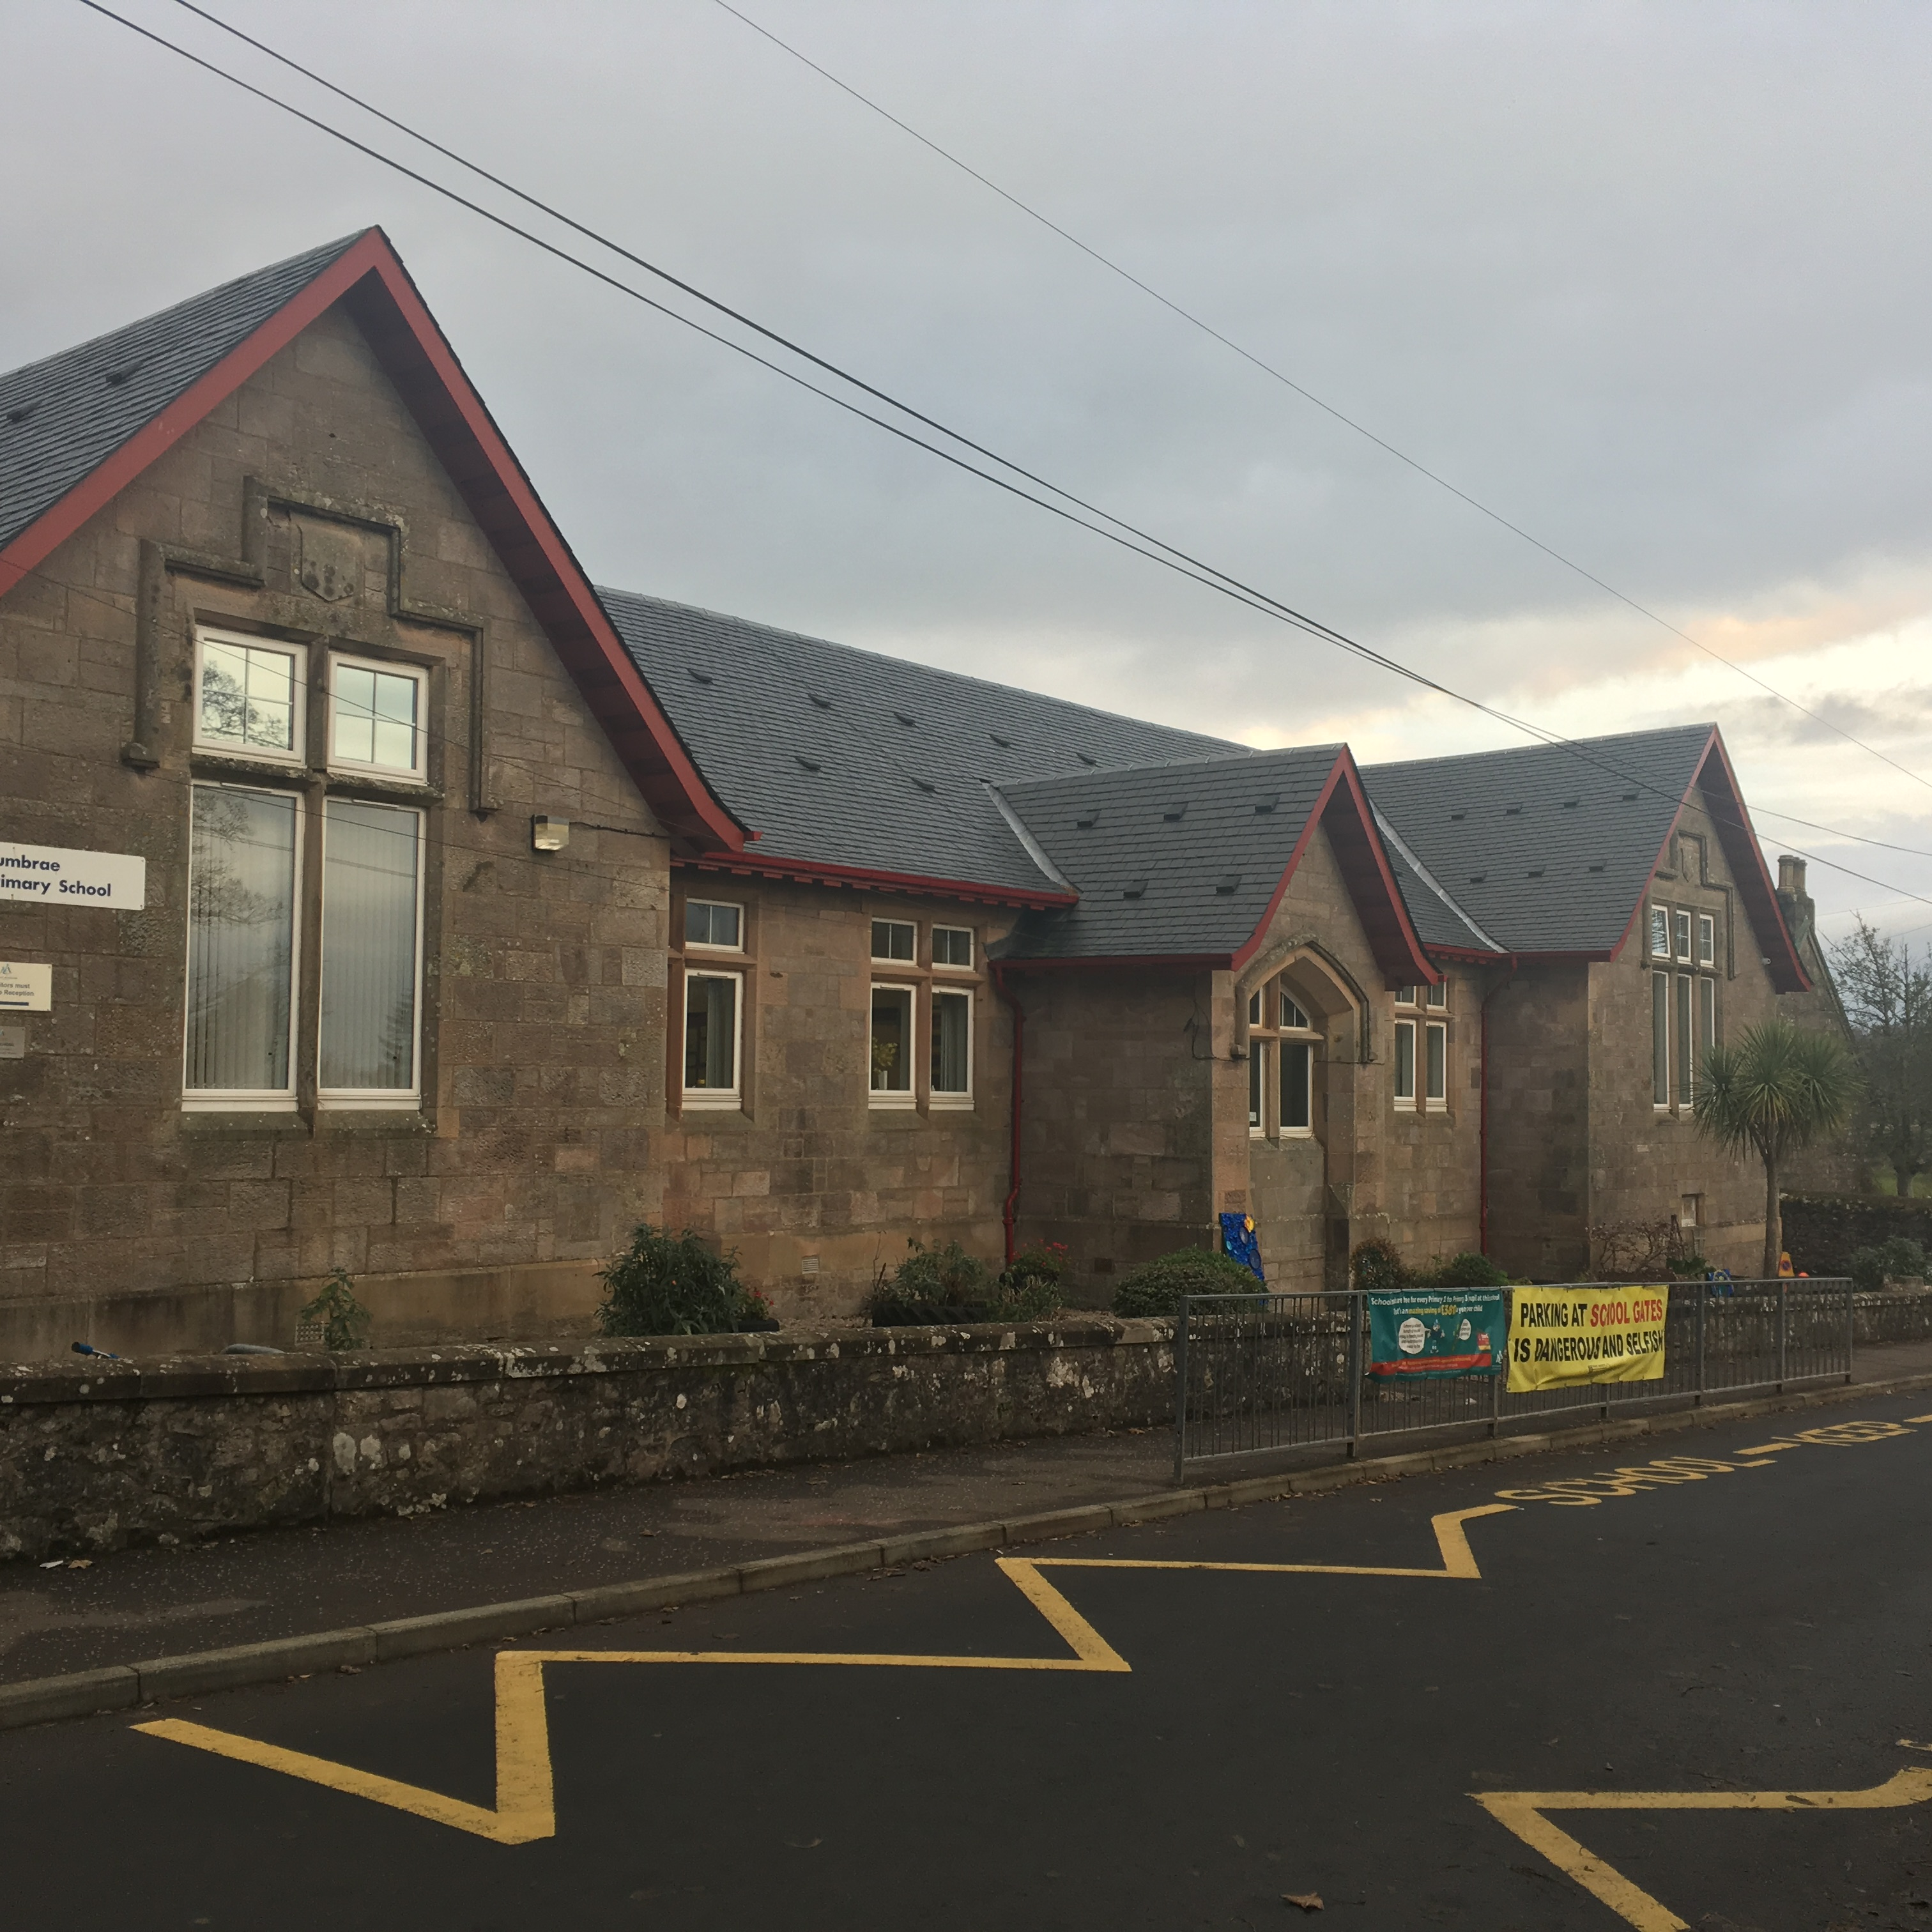

Cumbrae Primary is a rural primary school based on the Isle of Cumbrae an eight minute ferry ride from Largs. Cumbrae Primary is a central part of the island community.At Cumbrae Primary, we aim to ensure that all children achieve their potential in every area of our wide curriculum. We are very proud of our local unique community and use every opportunity possible to learn outdoors using local resources and supporting community events in all weathers. Every member of staff does their utmost to promote a nurturing ethos that is happy and industrious, where children are challenged and supported to become independent, confident and responsible individuals who are able to carry out their tasks in a spirit of cooperation, courtesy and respect.
At present there are currently four classes, a nurture group and an Early Years morning class. The current school role is 60 and the school is staffed by a Head Teacher, Principal Teacher, 3 Class Teachers, 1 Support for Learning teacher, visiting EAL teachers, 2 Early Years Practitioners, 4 Classroom Assistants, 1 Education Business Assistant and 1 Janitor.
Vision, Values & Aims Revisited with Staff, Parents & Pupils June 2022
Our school vision is that staff, families and our community work actively together to ensure children receive a rich, inspiring and engaging education enabling each child to become a lifelong learner, aspiring to high standards of achievement in all areas of their life.
OUR AIMS
Working within a safe, secure and caring school, we aim to
- provide all pupils with a challenging and varied learning experience, promoting respect and consideration and encouraging a high level of success and achievement. This will lead to excellence and quality in their education.
- provide all staff with a supportive and rewarding working environment, maintaining a positive ethos and attitude to all.
- value and encourage an excellent partnership with parents, carers and members of the community, promoting high aspirations and a ‘can-do’ attitude.
OUR VALUES
Teamwork Respect Ambition Inclusion & Equality Nurture
Curriculum Rationale
When designing our curriculum we took account of a number of key factors
* Our attainment results * What our families and children wanted in our unique island setting * The needs of our local context – Know Our School * What we wanted our learners to look like to be successful in the 21st century
Based on this we decided to
- Organise our Curriculum Experiences under the four contexts of learning
  - Curriculum areas and subjects
  - Interdisciplinary learning
  - Ethos & life of the school
  - Opportunities for personal achievement 2. Ensure that Health & Wellbeing was a top priority as we wanted to support our children to be nurtured, resilient, sociable and confident learners who developed healthy attitudes. 3. Prioritise Literacy and Numeracy as core areas permeating all curricular areas with Modern Languages, Music, RME and PE having a standalone progressive framework.
4. Bundle the remaining 4 areas of the curriculum in an interdisciplinary way to include Social Studies, Science, Technologies and Expressive Arts and develop a curriculum to ensure a variety of experiences and progression across the school. .
5. Provide opportunities to work together as a school community. Our children have many opportunities at class and whole school level for this.
6. Provide opportunities throughout the curriculum to develop creativity and employability skills.
Our curriculum will:
- Allow pupils to contribute to the ethos and life of the school community
- Provide opportunities for personal achievement and support all learners in developing skills for life, learning & work
- Have a continuous focus on Literacy, Numeracy and Health & Wellbeing with all staff having a responsibility to develop, reinforce and extend learning in these areas
- Ensure opportunities for mixed stage learning which is interest based, coherent and relevant
- Provide a broad general education including all the experiences and outcomes which is progressive and takes accounts of prior learning
- Allow opportunities to capitalize on the outdoor learning environment on Cumbrae
- Take account of the Nurture principles

