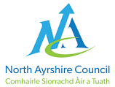
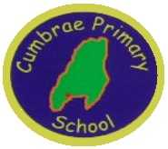 Standards & Quality Report 2019-2020
Cumbrae Primary School
& Early Years Class

Our School
Cumbrae Primary School is situated in Millport on the Isle of Cumbrae, a short ferry ride from Largs. This session we had 59 children in four classes across Primaries 1 to 7 and 9 children in the Early Years Class which runs morning only sessions. We are very proud of our nurturing ethos and our experienced staff team who are fully committed to helping every child reach their potential. We make best use of our local community and outdoor environment. Together, we strive for the best learning experiences for our children with every activity underpinned by our shared values of Teamwork, Respect, Ambition, Inclusion and Nurture.
2020 has certainly been a year to remember! We had a very different end to our academic year and a very different start to this year. Lockdown, despite its challenges, was an opportunity to make lots of memories & learn in unique and creative ways. Children shared those memories on SeeSaw with the staff and talked to staff on the phone. We grew, we believed and we achieved! We have put together some pictures taken from SeeSaw which encapsulated the journey we went on together.
We are delighted to report that since returning to school, our children across all stages, have settled well and are thriving being back in school. Children, staff and families have taken the changes in policies and procedures in their stride and we are on track for another fantastic year of learning at Cumbrae Primary School & Early Years Class.
Our school improvement priorities in 2019/2020 were
- To create conditions for our children to access high quality learning experiences from age 3 to 12.
- To ensure self-evaluation and performance improvement were embedded throughout the school.
- To engage families and offer opportunities to play a more active role in school life to secure better outcomes for children.
- To work with children, staff and families to build their resilience, supporting their mental health and physical wellbeing.
Attainment
Throughout the year we gather lots of information on how our children are progressing in their learning. To monitor their progress we watch children working through tasks, listen to what they say, ask important questions, set challenges and use a variety of standardised assessments. We gather as a team and analyse our collection of data and observations to plan targeted learning activities for children to ensure they are making appropriate progress.
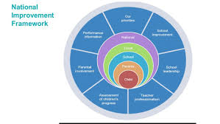
North Ayrshire Council and The Scottish Government also ask us to summarise our children’s progress in Reading, Writing, Listening and Talking and Numeracy. We are required to make professional judgements regarding children’s progress towards the Early, First and Second Levels: P1, P4 and P7. We come to these judgements using a variety of evidence such as performance in lessons, progress in class work and results from standardised assessments.
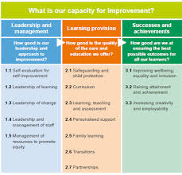
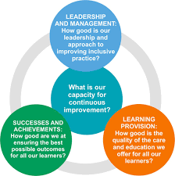
As part of this process we self-evaluate how well our school is performing using a range of quality indicators set out in the framework ‘How Good Is Our School’. These support us to take a closer look at specific aspects of our work and are applied at classroom, whole-school, cluster and local authority level. There is a set of quality indicators within three categories; Leadership and Management, Learning Provision and Success and Achievements.

We self-evaluate using a 6 point scale for grading the quality indicators. 1=unsatisfactory, 2=weak, 3=satisfactory, 4=good, 5=very good, 6=excellent.
At Cumbrae Primary School & Early Years Class we self-evaluated where we currently are on our journey to excellence:
Q Quality Indicator 1.3 | Quality Indicator 2.3 | Quality Indicator 3.2 | Quality Indicator 3.1
Leadership of Change | Learning, Teaching & Assessment | Raising Attainment & Achievement | Ensuring wellbeing, equality & Inclusion
5 | 4 | 4 | 5

Successes and Achievements
Health & Wellbeing
Ensuring our children are healthy with a positive outlook is our key priority and success in this area is fundamental to ensuring their readiness to learn and ability to progress in other curricular areas.
In 2019/2020 our high level successes were
- Working in partnership with Cumbrae Community Radio building our own radio station in school providing the children with the opportunity to write, read, produce and present shows.
- Continuing the ‘Fitnut’ programme has further increased children’s knowledge of the positive effects foods have on our bodies and the importance of regular exercise.
- Continuing and developing our Skills Academy which incorporated staff and parents being trained as Cycle Leaders by Brian Salvona of Cycling Scotland to enable us to access more remote areas of the island in groups to further engage in outdoor learning. The children were then trained as Cycle Leaders and planned routes, completed risk assessments and led groups.
- We increased the opportunity for school clubs and sports this year with children experiencing badminton, multi sports, zumba, country dancing, and rugby.
- Using our local environment to provide creative learning experiences for our children continues to be a top priority. Our children, across the school have benefitted from a range of outdoor learning experiences such as science on the beach, forest schools in the cathedral grounds, developing the community garden and running the daily mile and of course hosting our hugely popular Cumbrae Community Café.
- The promotion of reading for enjoyment across the school and into the community by having inspirational visits from authors including A H Proctor author of the Thumble Tumble series.
- Successfully achieving our Bronze Award for Rights Respecting Schools.
- As part of their World Book Day celebrations Cumbrae Primary worked with North Ayrshire’s Library Development Officer Helen Stewart to host a virtual Book Blether. Pupils had the chance to talk to Glebe Primary pupils over the airwaves about the books they were reading and had an opportunity to hear and ask questions about the books being read at Glebe Primary.
- Developing our delivery of expressive arts through the introduction of Charanga – a new innovative resource to help enhance children’s appreciation of music, performance skills and knowledge of music theory. The children were given the opportunity to listen to a wide variety of music styles. They were encouraged to move to the beat, play instrumental accompaniments and talk about how the music made them feel. The children were taught to recognise genres, dynamics, structure, sounds of instruments, tempo, mood etc. It has been proven that regular music lessons help raise achievement in other areas and aid positive mental health & wellbeing.

Pupil Equity Fund
Our Pupil Equity Fund (PEF), monies allocated by the Scottish Government to help schools close the attainment gap enabled us to focus on Getting It Right For Every Child. We pride ourselves in knowing our children very well and providing a nurturing environment in which to learn.
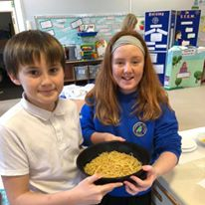
Our PEF money in 2019 was spent in working towards improving children’s Health and Wellbeing and Attainment through
- Nessy Spelling/ Reading resources for specific children which has resulted in all who participated in this activity significantly raising their spelling ages.
- Purchasing Clicker software tool to support literacy at Cumbrae Primary School.
- Increased Classroom assistant support to develop STEM and Food Technology across the school.
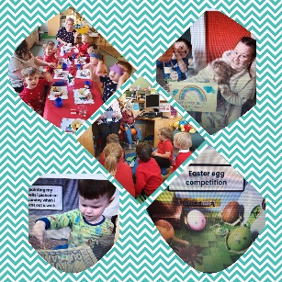
- The organisation of a motivational and inspiring Tree of Knowledge cluster workshop event to upskill staff in promoting the Health and Wellbeing of their staff, children and families.
- Participating in the Live Literature Programme run by the Scottish Book Trust by having an Author in Residency promoting the art of poetry. This culminated in the production of a publication of works by the children!
- Purchasing homework diaries & target boards to enable learning targets to be shared at home and displayed for the children.
- Purchasing a range of resources to support coding skills including Coding Bugs & Turing Tumbles which teaches coding strategy as well as abstract concepts like binary, binary operations, and logic gates in a fun, tangible way.
- Purchasing Phonics Readers, decodable books which consolidate the phonics taught with step-by-step progression to support children to become confident, fluent readers.
- Developing our young workforce and raising awareness of employability skills and opportunities remains a high priority to ensure our children have high aspirations and see purpose and value in their learning. We have achieved this through working with partners to deliver lessons or talks to the children eg. Royal Bank of Scotland, Police Scotland, local solicitors and quantity surveyors, Mock Court, handiwives group and our skills development through Plant 2 Plate.
- Thumble Tumble Author Visit to inspire budding young authors within our school.
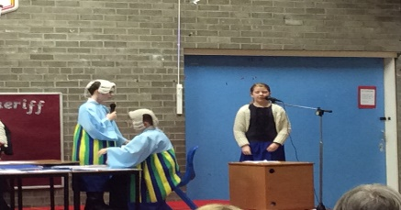
Across The Curriculum
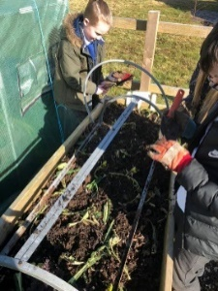
- Primary 6/7 again participated in the national ‘Mock Court’ challenge, a valuable cross-curricular project which simulates the development, debate and role play of a real of court case. For the fourth year running we were prize winners with Cumbrae Primary Defender & Pursuer teams winning a top place in the Ayrshire region!
- Primary 4/5 used their digital technology skills to produce a Cumbrae Community Café radio advertisement. The children also demonstrated how to use the equipment to a team from Caledonian MacBrayne.
- The whole school has benefitted hugely from our Plant2Plate initiative which has involved us in developing various partnerships with groups across the island, and indeed world, as we designed and developed our garden in the grounds of Cumbrae Parish Church. All children have been involved in learning across the curriculum through this project which has literally grown from seed to providing a termly community cafe. The successes of this project will continue as we strive to ensure our children appreciate sustainability and learn how to cook meals from the plant to the plate.
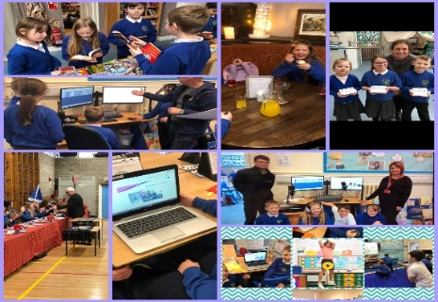
- Developing Science, Technology, Engineering and Mathematics skills within Cumbrae has been a success this year as we have turned our middle building into a STEAM room. The children regularly use this room for science, cooking, developing digital technology and we have held successful parental events in this room to showcase the work.
- Pupil leadership in learning continues to be a key strength in Cumbrae and our committees and Skills Academy are well established. Our pupil voice is strong in Cumbrae and has driven forward improvements in outdoor learning, the playground, working with the community and the development of our new STEAM room.
- Primary 1-3 had a wonderful visit to the Beacon Arts Centre in Greenock to see Scottish Ballet’s ‘Wee Hansel and Gretel’. It was an excellent opportunity for the children to see professional dancers and allowed them to take their class work on Fairy Tales beyond the classroom.

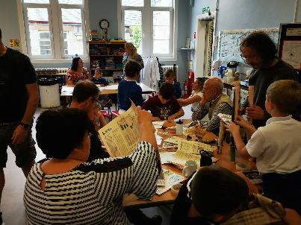
Parental Involvement
Providing opportunities for active collaboration with parents and family learning underpins our ethos in Cumbrae.
- Our curricular showcases gave parents an opportunity to gain more knowledge of our curriculum within Cumbrae Primary and how children can be supported at home.
- All parents were invited to our Community Café which featured information sessions delivered by the children on food dehydration processes.
- Our Family Learning Worker held a number of well attended cooking classes for families across the school and EYC.
- All parents were invited to participate in our Parent Consultation via questionnaire and the feedback provided was very positive.
- Within the Early Years parents are regularly invited in to share learning experiences with their children.
- The Seesaw app was introduced across the school this session to develop communication with parents and to allow children to report their learning experiences directly and immediately to parents through the use of digital technology. This received very successful feedback from staff, pupils and parents who all appreciated the value of sharing the learning and progress with one another. It was a particularly useful tool in maintaining contact with children & families throughout the period of home learning.
Looking Forward
Our priorities for 2020/21 continue to be influenced by the National Improvement Framework while taking recognition of our own context and children’s needs. We will continue to raise attainment in Literacy and Numeracy and enhance children’s Health & Wellbeing by
- Continuing to promote reading for enjoyment across the school and into the community along with our Family Learning Team we will offer parental opportunities and intergenerational activities through our community project ‘Cumbrae Loves to Read’.
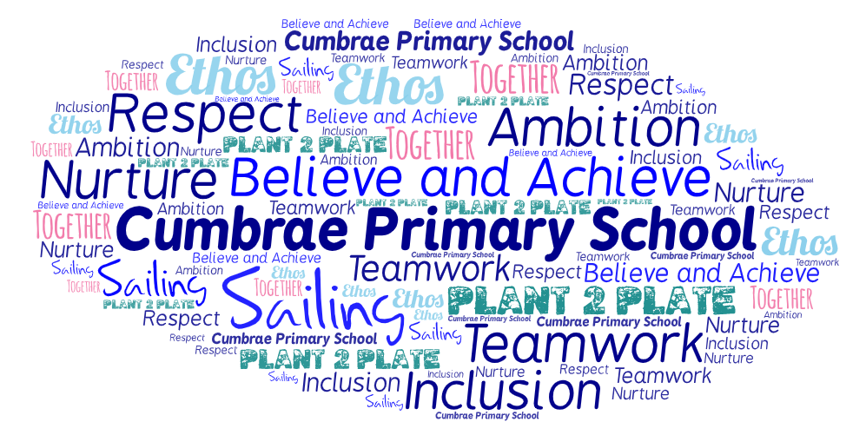
- In partnership with Cumbrae Community Radio station we will give all the children the opportunity to write, read, produce and present shows and music on a regular basis, using this as a way to involve the community and reduce loneliness during the isolation related to COVID-19.
- Our Plant 2 Plate project will continue with children planning and harvesting the produce. Instead of hosting our termly community cafe, the children have adapted plans to offer recipe boxes to provide to members of our community. We will continue to investigate the possibility of dehydrating harvested veg to provide regular healthy snacks for children.
- The upper primary will work collaboratively with Millport Conservation and Regeneration Scheme (CARS) to help the children appreciate our local heritage and engage in various activities to develop understanding of traditional building methods, architecture, graphic design, computing and photography.
- Teachers will use their professional judgements and assessment information to provide targeted interventions for specific groups of children to support and challenge their learning.
- The Seesaw app will continue to be used across the EYC and school to develop children’s profiles and evidence learning and progress.
- Plan and implement a Growth Mindset in Numeracy Project through Mindset Matters.

