North Ayrshire Council: Education Services

Cumbrae Primary School
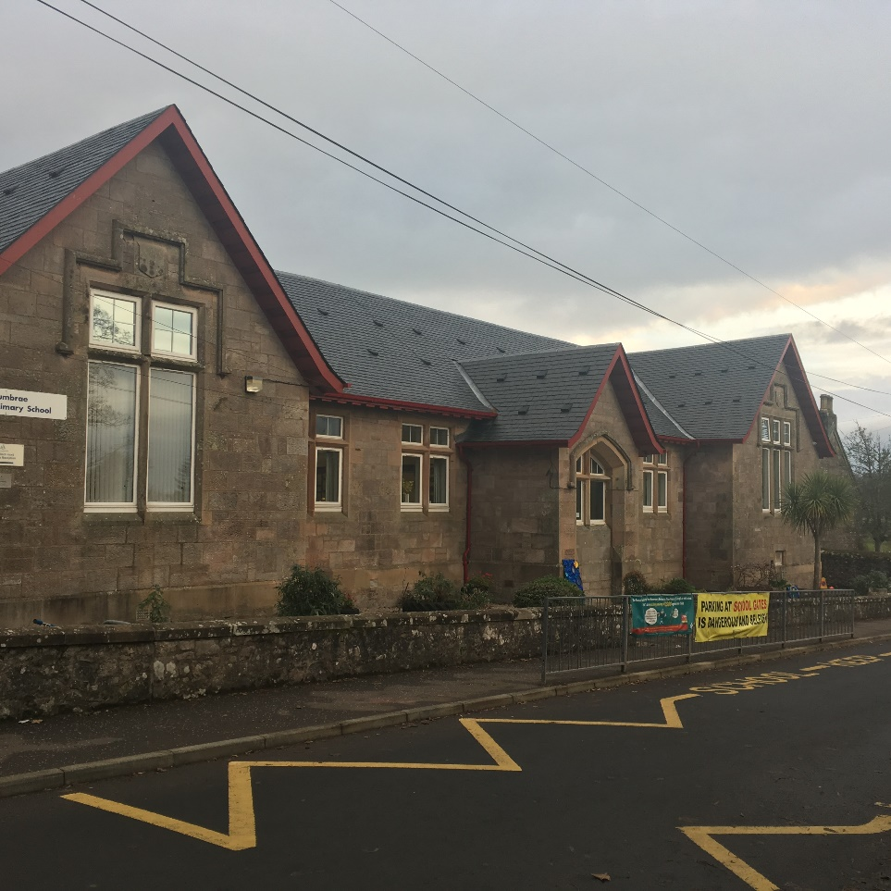

School Handbook

Session: 2021-2022

Contents

Head Teacher Introduction

Communities Directorate (Education Services) ………………………………………

- Directorate Aims and Priorities

Section 1: School Information …………………………………………………………

- School Aims, Values, Ethos
- School Contact Details (Address, Telephone, Email, Fax)
- School Staff
- School Calendar/Holidays

Section 2: School Procedures …………………………………………………………

- School Security
- Positive Relationships
- Playground Supervision
- Absence from School Premises at Breaks
- School Dress Code
- Dress Code for PE
- Personal Belongings
- Mobile Phones
- Information in Emergencies
- Listening and Learning

Section 3: Footwear, Clothing, Free School Meals and Transport………………

- Footwear and Clothing Grants
- Free School Meals
- School Transport Policy

Section 4: School Registration, Enrolment and Attendance……………………..

- Registration and Enrolment
- Attendance at School
- Structure of Classes
- Transfer to Secondary School

Section 5: Curriculum for Excellence....................................................................

- Curriculum for Excellence
- The Capacities
- Extra-Curricular Activities
- Assessment and Reporting
- Homework

Section 6: School Improvement ………………………………………………………

- S&Q Report/Improvement Plan

Section 7: Support for your Child……………………………………………………..

- Additional Support for Learning
- Dispute Resolution Procedures
- Further Support
- Equalities
- Equality Act 2010
- Child Protection
- Inclusion
- GIRFEC
- Psychological Services
- Data Protection
- Medical and Health Care

Section 8: Parental Involvement ……………………………………………………..

- Parent Council
- Home School Links
- Reports to Parents
- Homework
- School Committees

Section 9: Pupil Data Collection and Protection Policies…………………………

Appendix 1: Important Contacts

Head Teacher Introduction

Dear Parents / Carers,
Welcome to Cumbrae Primary School!
Starting school is a very exciting time for you and your child and I am delighted that you have chosen our school for your child’s education. At Cumbrae Primary School we have a very caring team of staff who will help your child to settle quickly into school.
In our school, we offer a wide variety of experiences and opportunities for your child to learn many new skills and to develop their talents not only through the curriculum but also through events such as school shows, outdoor learning experiences, close community links, choirs and clubs.
We aim to ‘get it right for every child’, to make them feel special and to play an active leading part in our learning community. We also encourage our pupils to show respect to everyone in the school living our values of Teamwork, Respect, Ambition, Inclusion and Nurture.
I look forward to working in partnership with you as your child learns and grows at Cumbrae Primary School. With your encouragement, help and co-operation, our school will do the best we can to ensure that your child benefits fully from the experiences offered and becomes a valuable member of the community. Children do better and achieve more when their parents are involved and we value the support that you as parents can bring to our partnership. Please take every opportunity to become involved in the life and community of our school.
We have an open door policy at Cumbrae Primary, therefore please do not hesitate to contact me regarding any issue and together we can try to find a solution. I hope that you find this handbook useful and if there is anything that you don’t understand or about which you require more information, please do not hesitate to contact me. We are always here to offer support and advice. Please feel free to come to school to discuss any queries or worries.
Yours faithfully,
Julie McAleese
Head Teacher

Communities Directorate (Education Services)

What we want to achieve

Our Overall Aim

Ensuring our children and young people experience the best start in life.

Our Priorities

- We will create the conditions for our children and young people to access the highest quality learning experiences from ages 3-18.

- We will support our children and young people to become successful learners, confident individuals, effective contributors and responsible citizens.

- We will offer opportunities to our young people and their families to play a more active role in school life and encourage more participation in learning.

- We will work with all young people to build their resilience, supporting their mental health and physical well-being.

Section 1: School Information

School Contact Details

Cumbrae Primary School

Bute Terrace
Millport
Isle of Cumbrae
KA28 0BB

Telephone 01475 530343
Fax 01475 530519
E mail cumbrae@ea.n-ayshire.sch.uk
Website https://blogs.glowscotland.org.uk/na/cumbraeprimary/

OUR AIMS
Working within a safe, secure and caring school, we aim to
- provide all pupils with a challenging and varied learning experience, promoting respect and consideration and encouraging a high level of success and achievement. This will lead to excellence and quality in their education.
- provide all staff with a supportive and rewarding working environment, maintaining a positive ethos and attitude to all.
- value and encourage an excellent partnership with parents, carers and members of the community, promoting high aspirations and a ‘can-do’ attitude.
OUR VALUES
- Teamwork
- Respect
- Ambition
- Inclusion & Equality
- Nurture
OUR ETHOS
We are very proud of our ethos and positive relationships in Cumbrae Primary and all our visitors comment positively with regard to how welcome they feel in our school. Throughout our every experience and action our vision is to Believe and Achieve.

School Staff

Head Teacher Mrs J McAleese

Principal Teacher Mrs L Cathcart

Early Years Class Miss J Armstrong (Senior Early Years Practitioner)
Miss L Crossan ( Early Years Practitioner)
Miss L Patrick (Classroom Assistant)

P1/2 Mrs J Neilson

P3/4/5 Mrs S Young/ Mrs L Cathcart

P6/7 Mr J Joyce

Non class contact time Miss A Roper

School Office Miss D Smilie

Classroom Assistant Miss L Wylie & Mrs E McDavid

Pupil Support Mrs S Buchanan (0.2)

Janitor Mr A McKinnie

Catering Manager Mr A Conaghan

Cleaning Staff Miss A Healy, Miss M Borg

NORTH AYRSHIRE COUNCIL - EDUCATION SERVICE
School Holiday and In-Service Dates 2021/2022 (Mainland Schools)
Term | Dates of Attendance | Day | Date | Cumulative Holiday/ Closure Total | Cumulative Working Days
Term 1 | Teacher (In-Service) | Tuesday | 17-Aug-21
 | Pupils Return | Wednesday | 18-Aug-21
 | Teacher (In-Service) | Monday | 20-Sep-21
 | Close | Friday | 08-Oct-21 |  | 39
Term 2 | Pupils Return | Monday | 18-Oct-21 | 5
 | Teacher (In-Service) | Thursday | 18-Nov-21
 | Local Holiday | Friday | 19-Nov-21
 | Local Holiday | Monday | 22-Nov-21 | 7
 | Close | Wednesday | 22-Dec-21 |  | 85
Term 3 | Re-open | Thursday | 06-Jan-22 | 17
 | Local Holiday | Friday | 11-Feb-22
 | Local Holiday | Monday | 14-Feb-22
 | Teacher (In-Service) | Tuesday | 15-Feb-22
 | Pupils Return | Wednesday | 16-Feb-22 | 19
 | Close | Friday | 01-Apr-22 |  | 145
Term 4 | Re-open | Tuesday | 19-Apr-22 | 30
 | May Day | Monday | 02-May-22 | 31
 | Teacher (In-Service) | Friday | 27-May-22
 | Local Holiday | Monday | 30-May-22 | 32
 | Pupils Return | Tuesday | 31-May-22
 | Close | Wednesday | 29-Jun-22 | 66 | 195
22/23 | Pupils Return | Thursday | 18-Aug-22

Pupils attendance will be 190 days after deducting 5 in-service days

Section 2: School Procedures
School Security
North Ayrshire Council has introduced procedures to ensure the safety and security of children and staff when attending or working in a school. A number of security measures are used including the use of a visitors’ book, badges and escorts while visitors are within the school building. Any parent/carer or visitor at a school for any reason will be asked to report to the school office. The school staff will then make any necessary arrangements in connection with the visit to the school.

It is the policy of the school that any member of staff will approach a visitor and ask for verification of identity. This measure ensures that children work in a safe and protected environment. We appreciate your support in carrying out all of the above measures.

Positive Relationships
The school is committed to developing a nurturing approach and promoting positive relationships. Like every community, our school is built on the relationships within it, across it and its connections with others. Every member of staff is responsible for establishing and maintaining positive relationships with each other, with parents and with partners and most importantly with the young people in their care.

Our expectations of behaviour for children and young people are high. Some children may require additional support in relation to their behaviour, and the school will work positively with the young person and the parents, and other partners, as appropriate, to ensure positive outcomes are achieved.

North Ayrshire Council is committed to the principles of restorative practices. This is a solution-focused approach to managing behaviour and resolving difficulties and which promotes healthy relationships that enable better behaviour and better learning.

The school has a code of conduct to ensure the safety and well-being of all and parents are asked to support the school fully in this matter.

Playground Supervision
The Council meets the terms of the legal requirement that pupils be supervised in the playground by at least one adult during the interval or lunchtime if there are fifty or more pupils at the school. Our policy reflects that of North Ayrshire Council in terms of the Schools (Safety and Supervision of Pupils) (Scotland) Regulations 1990.

An adult presence is provided in playgrounds at break times. Pupils who travel by contracted school transport and arrive at school more than ten minutes before the start of the school day have accommodation allocated to them within the school during inclement weather.

Absence from school premises at breaks
Schools have a duty to look after the welfare of their pupils. This means that the staff should take the same care of pupils as a sensible parent would take, and this includes taking reasonable care of pupils' safety during intervals and lunchtimes.

It is the policy of North Ayrshire Council that pupils should not leave the school grounds at intervals. Primary pupils should only leave school grounds at lunchtimes when they are going home for lunch with their parents' agreement. Parents should put this request in writing to the Head Teacher. Pupils will leave and return through main entrance door of the school.

Parents should encourage their children to follow these rules in the interests of safety.
School Dress Code
It is the policy of North Ayrshire Council to support the introduction of a reasonable and flexible dress code in schools in its area. The Council encourages each school to adopt its own code, after consultation with parents and pupils.
The Council believes that establishing a school dress code has many benefits. These include improvements in safety, security, positive behaviour and community spirit and a decrease in bullying and in expense for parents.
The Council will support schools in encouraging and helping pupils to conform to the chosen dress code. Some types of clothing will not be allowed at school in any circumstances, for reasons of safety, decency or wellbeing.
Types of clothing which will not be allowed include:
- Clothes which are a health or safety risk
- Clothes which may damage the school building
- Clothes which may provoke other pupils
- Clothes which are offensive or indecent
- Clothes which encourage the use of alcohol or tobacco

All items of clothing should be clearly labelled with the child's name in case of loss. It is appreciated that parents and pupils are distressed over the occasional loss of pupils' clothing and/or personal belongings. Parents are asked to assist in this area by ensuring that valuable items of clothing or personal belongings are not brought to school.

Personal Belongings
It is appreciated that parents and pupils may be distressed over the occasional loss of pupil’s clothing and/or personal belongings. Parents are asked to assist by ensuring that valuable items of clothing or personal belongings are NOT brought to school.
Parents should note that the authority does not carry insurance to cover the loss of such items.

Dress Code for PE
For health and safety reasons all children must wear suitable clothing for PE. This consists of shorts and t-shirts with soft shoes for indoor activities.

We adhere strictly to health and safety guidelines and pupils must remove any item that may cause danger, i.e. metal buckles, jewellery. These items are the responsibility of the pupil. Long hair should be tied back.

School Meals
Meals are served daily from the multi-choice cafeteria. The meals are planned to offer a healthy diet for the children. Please inform us if your child has any specific allergies. Parents of children who require a special diet can arrange this by contacting the school or Early Years Class.

There are arrangements in place for children who would prefer to eat a packed lunch.

Mobile Phones
While the benefits of mobile phones are recognised, they can be a serious distraction to work. If a child brings a mobile phone to school they should hand it in to the school office and it will be kept safe till collected at the end of the day.

Inappropriate use of text messages and/or photographs/recordings (video and audio) whilst in school may be treated as a breach of the school’s code of conduct or a serious incident, which could be referred to the police.

Information in Emergencies
We make every effort to maintain a full educational service but on some occasions circumstances arise which lead to disruption. Schools may be affected by, for example, severe weather, and temporary interruption of transport, power failures or difficulties of fuel supply. In such cases, we shall do all we can to let you know about the details of closure or re-opening. We will keep you in touch by using letters, texts, NAC website, notices in local shops and community centres, announcements in the press and West FM.

Should you have doubts about deteriorating conditions during the day, it may be advisable to contact the school. Parents should ensure that the school is aware of the emergency arrangements made for their child and have responsibility to update us with contact numbers.

Listening and Learning
It is the policy of North Ayrshire Council to try to encourage feedback on the education service from parents and pupils. This is part of our overall commitment to giving the best possible service and to working in partnership.

We are therefore very interested in feedback of all kinds, whether it is compliments, suggestions or complaints. If you wish to register a comment of any type about the school you can do this by writing, telephoning or making an appointment to see someone. All feedback is welcome and helps us keep in touch.

If, in particular, you have a complaint about the school please let us know. It is better that these things are shared openly and resolved fairly, rather than being allowed to damage the home/school relationship. There will be no negative consequences arising from making a complaint and we will deal with the issue as confidentially as possible. If we have made a mistake we will apologise quickly and clearly and try to put things right.

There are some things which you should take note of in relation to making a complaint:

- The Council has a Two Stage Policy when dealing with complaints from parents.

- It is helpful if complaints are made initially to the Head Teacher. This makes sure that the school knows what is going on and has an opportunity to respond and resolve the issue.

- We will try to respond as quickly as possible, but often issues are complex and need time to investigate. It is therefore helpful if you can give some details of the issue and ask for an early appointment to discuss it.

- If you are not satisfied with our response then you still have the right to request that your complaint is raised as a Stage 2 Complaint. Should you wish to request this you should contact Education Services at Cunninghame House, Irvine, KA12 8EE, Telephone (01294 324400).

- If, after receiving our final decision on your complaint, you remain dissatisfied with our decision or the way we have handled your complaint, you can ask the SPSO to consider it. We’ll tell you how to do this when we send you our final decision.

- You should also note that you have the right to raise unresolved concerns with your local Councillor, MSP or MP.

- Parent Councils have an important role in developing links between the school and the wider parent body and can often be helpful in helping to deal with issues of general concern. However, parents are advised that individual, more personal complaints are not appropriate for raising via Parent Councils due to the need for appropriate confidentiality.

Section 3: Educational Grants: Footwear, Clothing, Free School Meals and Transport

Footwear and Clothing Grants
Parents receiving Universal Credit will normally be entitled to grants for footwear and clothing for their children. Universal Credit claimants monthly income must not exceed £610.00, however, some parents earning more than this may still be eligible. Parents who receive Income Support, Income based Job Seeker’s Allowance, any income related element of Employment and Support Allowance, Support under part V1 of the Immigration and Asylum Act 1999, Child Tax Credit only (with income under £16,105), both Working Tax Credit and Child Tax Credit (with an income up to £7,330) may also still be entitled to grants for footwear and clothing for their children.

Parents who may be unsure whether they can apply should contact the Council Contact Centre on 01294 310000 or the Council’s Welfare Reform Team on 0300 99 4606 for further advice. Information and application forms may be obtained from schools.

Free School Meals
Children of parents receiving Universal Credit (claimants monthly income must not exceed £610.00), Income Support, Income based Job Seeker’s Allowance, any income related element of Employment and Support Allowance, Support under part V1 of the Immigration and Asylum Act 1999, both Working Tax Credit and Child Tax Credit (with an income up to £7,330) are entitled to a free midday meal and free milk. Parents and Carers should contact 01294 310000 for further information.

Please Note: ALL pupils in P1-3 are entitled to a free school meal, which includes milk.

Other than P1-P3 pupils, only those children whose parents receive job seeker's allowance or income support will be entitled to free milk. Milk may however be available for purchase in the school during the lunch period.

School Transport Policy
North Ayrshire Council has a policy of providing free transport to all primary pupils who live more than two miles from their catchment area school by the recognised shortest suitable walking route or through this link: https://www.north-ayrshire.gov.uk/Forms/EducationalServices/free-school-transport.docx

These forms should be completed and returned before the end of February for those pupils beginning school in August to enable the appropriate arrangements to be made.

Applications may be submitted at other times throughout the year but may be subject to delay while arrangements are made. The appropriate officer has discretion in special circumstances to grant permission for pupils to travel in transport provided by the authority, where places are available and no additional costs are incurred.

Where free transport is provided it may be necessary for pupils to walk a certain distance to the vehicle pick-up point. Walking distance in total, including the distance from home to the pick-up point and from the drop-off point to the school in any one direction, will not exceed the Council's limits (see above section). It is the parents’ responsibility to ensure that their child arrives at the pick-up point on time. It is also the parents’ responsibility to ensure that their child behaves in a safe and acceptable manner while boarding, travelling in and leaving the vehicle. Misbehavior can result in children losing the right to free transport.

Please see attached link to the Council’s School Transport Policy:

https://www.north-ayrshire.gov.uk/Documents/EducationalServices/school-transport-policy.pdf
Section 4: School Registration, Enrolment and Attendance

Registration and Enrolment
The date for registration of school beginners is advertised in the local press and is normally in January each year. Pupils will be registered in the school for their catchment area.

Parents are provided with information about the school and procedures for making placing requests, if required. Arrangements for meetings with parents and induction days for pupils will be notified during the spring and summer terms.

Parents of pupils who have moved to the area or who wish their child to transfer to the school should contact the school office for information about appropriate procedures and to arrange a visit to the school.

Parents are welcome to contact the Head Teacher at any time by visiting or telephoning the school.

Attendance at School/Lateness
It is the responsibility of parents of children of school age to educate their child(ren). Most do this by ensuring that their child(ren) attend(s) school regularly.

Attendance is recorded twice a day, morning and afternoon. Absence from school is recorded as authorised, unauthorised or temporarily excluded.

Parents are asked to inform the school by letter or telephone if their child is likely to be absent for some time, and to give the child a note on his or her return to school, confirming the reason for absence. If there is no explanation from a child’s parents, the absence will be regarded as unauthorised.

Every effort should be made to avoid family holidays during term time as this both disrupts the child’s education and reduces learning time. Parents should inform the school by letter, before going on holiday, of the dates. Such absence will be authorised only where certain and very specific family circumstances exist. The majority of family holidays taken during term time will be categorised as unauthorised absence.

Parents may request that their children be permitted to be absent from school to make an extended visit to relatives. Only written requests detailing the destination, the duration and the provision that will be made for their continuing education will be granted. Such extended absences will be recorded separately from the normal attendance and absence information.

The School Inclusion Worker investigates unexplained absence, and the authority has the power to write to, interview or prosecute parents, or refer pupils to the Reporter to the Children’s Panel, if necessary.

Structure of Classes
Primary schools educate pupils at seven broad year stages, Primary 1 to Primary 7. A year stage is defined as a group of pupils entering primary education at a common date. Schools are staffed based on the total number of pupils. However, the numbers of pupils at each year stage will vary. This means that Head Teachers are required to organise classes to make best use of available staff, resources and space to the benefit of all children in the school.

Pupils may, therefore, be taught in a single stage class or a composite class where two or more year stages are grouped together. This may also change as pupils move from one year to the next.

National guidelines on the curriculum indicate that pupils should progress through learning experiences tailored to their own needs and abilities. This means that pupils in all classes follow programmes designed to help them progress at their own level. This applies to all pupils regardless of whether or not they are in a composite or single year stage class.

The National agreement on class sizes states that the maximum number of pupils in a class is 25 in P1, 30 in P2 – P3, and 33 in P4 -7. In a composite class the maximum number is 25.

Transfer to Secondary School
Pupils are normally transferred between the ages of eleven and a half and twelve and a half, so that they will have the opportunity to complete at least 4 years of secondary education. Parents will be informed of the arrangements no later than January of the year preceding the date of transfer at the start of the new session.

Cumbrae Primary School is an associated primary school of:
Largs Academy
Address: 66 Alexander Ave, Largs KA30 9EU
Telephone No: 01475 687687

During their time in P7, pupils are taken to Largs Academy as part of the induction programme. Teachers from local primary schools and their secondary colleagues have worked together to create a Pupil Profile of Achievements which will be completed in Primary 7 and passed onto the secondary school. Teachers from both schools liaise to ensure a smooth transition which focuses on progression for pupils. Parents will be informed of the details of the visits when appropriate.

Section 5: Curriculum for Excellence

Curriculum for Excellence is the national curriculum for Scottish schools for learners from age 3 to 18. It aims to raise standards, prepare our children for a future they do not yet know and equip them for the jobs of tomorrow in a fast changing world.

Curriculum for Excellence enables professionals to teach subjects creatively, to work together across the school and with other schools, to share best practice and explore learning together. Glow, Scotland’s unique, world-leading, online network supports learners, teachers and families in this.

Teachers and practitioners will share information to plan a child’s “learning journey” from 3-18, ensuring children continue to work at their own pace whilst providing challenge upon which they can thrive.

Curriculum for Excellence balances the importance of knowledge and skills. Every child is entitled to a broad and deep general education where every single teacher and practitioner will be responsible for literacy and numeracy – the language and number skills that unlock other subjects and are vital to everyday life. There is emphasis too on health and wellbeing – to ensure that the school is a place where children feel safe and secure.

Curriculum for Excellence develops skills for learning, life and work to help young people go on to further study, secure work and navigate life. It brings real life into the classroom, making learning relevant and helps young people apply lessons to their life beyond the classroom. It links knowledge in one subject area to another helping children understand the world and make connections. It develops skills so that children can think for themselves, make sound judgements, challenge, enquire and find solutions.

Children’s progress is assessed using a broad range of approaches to ensure children achieve their potential. Ultimately, Curriculum for Excellence aims to improve our children’s life chances, to nurture successful learners, confident individuals, effective contributors, and responsible citizens, building on Scotland’s reputation for great education.

Curriculum for Excellence: The Capacities
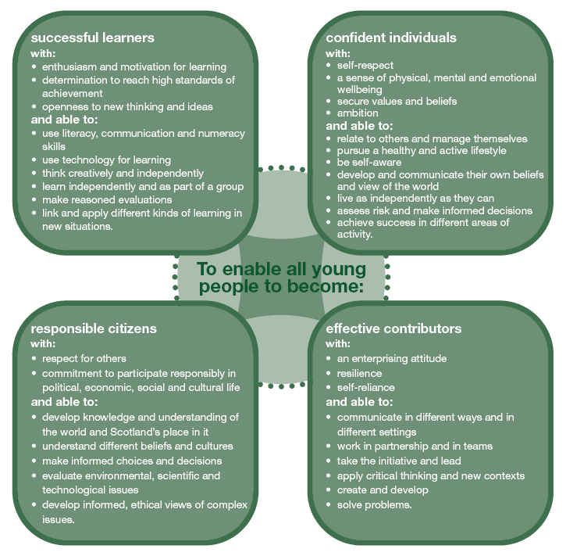
Further Information about Curriculum for Excellence and the Experiences and Outcomes can be found on the Curriculum for Excellence website.

Extra-Curricular Activities

Our extra curricular activities vary throughout the year but examples are recorder, choir, country dancing, musical theatre, coding, chess, football, science club, tennis, craft, golf, megaclub multisports, dungeons and dragons.

We very much respond to children’s interests and are active in finding experts or activities in which the children have shown a particular curiosity, need or talent .

Assessing Children’s Progress in the Broad General Education (BGE) Early Years – end of S3

Assessment is a central part of everyday learning and teaching for children and young people. Evidence of progress is gathered on an ongoing and informal basis through asking questions, observing children working together and making formative comments on their work. Children may also assess their own work or that of their classmates; this is called self and peer assessment. Some assessment is more formal such as projects, investigations and standardised assessments.

The assessment of children’s progress throughout the BGE (Early Years – S3) is based on teachers’ professional judgement. Teachers draw on their professional knowledge and understanding of the child; on the benchmarks for literacy and numeracy, which provide clear information about what children and young people should be able to do and demonstrate by the end of a Curriculum for Excellence Level; and on a wide range of assessment information.

Teachers of P1, P4, P7 and S3 are asked at the end of every school year whether children have achieved the relevant Curriculum for Excellence level for their stage in reading, writing, talking and listening (literacy), and their ability to understand and work with numbers (numeracy). Most children are expected to have achieved the early level by the end of P1, first level by the end of P4, second level by the end of P7 and third or fourth level by the end of S3.

The government has also introduced new national standardised assessments (SNSA) which cover some aspects of reading, writing and working with numbers. These assessments are completed online and are automatically marked by the online system giving teachers immediate feedback to help plan next steps and support children’s progress.

Teachers remain best placed to know how the children in their class are progressing. Their professional judgement will continue to be the most important way of assessing your child’s progress at school.

Parents, families and carers have a key role in helping children to learn. Your child’s teacher will keep you informed about their progress. Please contact us if you have any concerns about their learning, assessment or for more information on how you can support your child’s learning at home.

Homework
Parents, carers and families have a very important role in helping children get the best out of school and it is important to take an active interest in your child's progress at school. This can be done by:

- Encouraging hard work and high standards at all times
- Stressing the importance and relevance of what is learned at school
- Supporting the school's policy on homework and discipline

The type of homework will vary depending on the age and ability of individual pupils. Reading commonly forms part of the homework set and will be specified by the teacher. Learning to read can be challenging and the process is made easier if families read with their child and discuss the story and pictures in a way that encourages enjoyment and a love of books and stories.

In the early and middle stages oral reading should be practised regularly at home whereas in the upper primary, where children are competent in the mechanics of reading, a greater emphasis may be placed on silent reading and comprehension. Reading for enjoyment should be encouraged at all stages.

Spelling is also an important part of homework from P3 onwards (although some children may be asked to practise even earlier). Maths homework will be given to consolidate understanding and proficiency at all stages of the school.

From time to time pupils are given assignments and personal projects which may involve research, investigation, preparing a speech, learning a poem or a similar activity.

We really appreciate the involvement of parents, carers and families and are very grateful to those who so faithfully sign work to confirm that they have seen each piece of work.

Section 6: School Improvement

S&Q Report/Improvement Plan

Schools in North Ayrshire follow a Quality Improvement process designed to highlight strengths and identify areas for improvement. The process is based on the school’s self-evaluation process with Heads of Service and Senior Managers involved in at least three formal validation visits each session.

This validation process involves talking to pupils, staff and parents about learning and improvements made by the school. This results in actions for improvement for the school to take forward in their planning process.

In addition, themed reviews are undertaken from time to time e.g. to look and report on the quality of the Broad General Education (3-18) and Senior phase Education within secondary schools. This process is based upon standards and expectations contained within the following National Standards documentation:

- National Improvement Framework
- How Good is Our School? 4
- How Good is Our Early Learning and Childcare?

A Standards and Quality Report and School Improvement Plan are produced on an annual basis by every school and centre. Staff, Parents/ Carers, Young People and School Partners will play an active role in the development of these key school documents.

Standards & Quality Report 2019-2020
Cumbrae Primary School
& Early Years Class

Our School
Cumbrae Primary School is situated in Millport on the Isle of Cumbrae, a short ferry ride from Largs. This session we had 59 children in four classes across Primaries 1 to 7 and 9 children in the Early Years Class which runs morning only sessions. We are very proud of our nurturing ethos and our experienced staff team who are fully committed to helping every child reach their potential. We make best use of our local community and outdoor environment. Together, we strive for the best learning experiences for our children with every activity underpinned by our shared values of Teamwork, Respect, Ambition, Inclusion and Nurture.
2020 has certainly been a year to remember! We had a very different end to our academic year and a very different start to this year. Lockdown, despite its challenges, was an opportunity to make lots of memories & learn in unique and creative ways. Children shared those memories on SeeSaw with the staff and talked to staff on the phone. We grew, we believed and we achieved! We have put together some pictures taken from SeeSaw which encapsulated the journey we went on together.
We are delighted to report that since returning to school, our children across all stages, have settled well and are thriving being back in school. Children, staff and families have taken the changes in policies and procedures in their stride and we are on track for another fantastic year of learning at Cumbrae Primary School & Early Years Class.
Our school improvement priorities in 2019/2020 were
- To create conditions for our children to access high quality learning experiences from age 3 to 12.
- To ensure self-evaluation and performance improvement were embedded throughout the school.
- To engage families and offer opportunities to play a more active role in school life to secure better outcomes for children.
- To work with children, staff and families to build their resilience, supporting their mental health and physical wellbeing.
Attainment
Throughout the year we gather lots of information on how our children are progressing in their learning. To monitor their progress we watch children working through tasks, listen to what they say, ask important questions, set challenges and use a variety of standardised assessments. We gather as a team and analyse our collection of data and observations to plan targeted learning activities for children to ensure they are making appropriate progress.
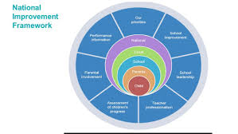
North Ayrshire Council and The Scottish Government also ask us to summarise our children’s progress in Reading, Writing, Listening and Talking and Numeracy. We are required to make professional judgements regarding children’s progress towards the Early, First and Second Levels: P1, P4 and P7. We come to these judgements using a variety of evidence such as performance in lessons, progress in class work and results from standardised assessments.
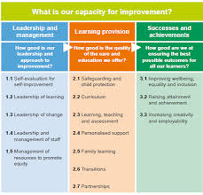
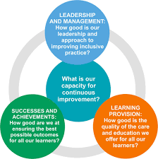
As part of this process we self-evaluate how well our school is performing using a range of quality indicators set out in the framework ‘How Good Is Our School’. These support us to take a closer look at specific aspects of our work and are applied at classroom, whole-school, cluster and local authority level. There is a set of quality indicators within three categories; Leadership and Management, Learning Provision and Success and Achievements.

We self-evaluate using a 6 point scale for grading the quality indicators. 1=unsatisfactory, 2=weak, 3=satisfactory, 4=good, 5=very good, 6=excellent.
At Cumbrae Primary School & Early Years Class we self-evaluated where we currently are on our journey to excellence:
Q Quality Indicator 1.3 | Quality Indicator 2.3 | Quality Indicator 3.2 | Quality Indicator 3.1
Leadership of Change | Learning, Teaching & Assessment | Raising Attainment & Achievement | Ensuring wellbeing, equality & Inclusion
5 | 4 | 4 | 5

Successes and Achievements
Health & Wellbeing
Ensuring our children are healthy with a positive outlook is our key priority and success in this area is fundamental to ensuring their readiness to learn and ability to progress in other curricular areas.
In 2019/2020 our high level successes were
- Working in partnership with Cumbrae Community Radio building our own radio station in school providing the children with the opportunity to write, read, produce and present shows.
- Continuing the ‘Fitnut’ programme has further increased children’s knowledge of the positive effects foods have on our bodies and the importance of regular exercise.
- Continuing and developing our Skills Academy which incorporated staff and parents being trained as Cycle Leaders by Brian Salvona of Cycling Scotland to enable us to access more remote areas of the island in groups to further engage in outdoor learning. The children were then trained as Cycle Leaders and planned routes, completed risk assessments and led groups.
- We increased the opportunity for school clubs and sports this year with children experiencing badminton, multi sports, zumba, country dancing, and rugby.
- Using our local environment to provide creative learning experiences for our children continues to be a top priority. Our children, across the school have benefitted from a range of outdoor learning experiences such as science on the beach, forest schools in the cathedral grounds, developing the community garden and running the daily mile and of course hosting our hugely popular Cumbrae Community Café.
- The promotion of reading for enjoyment across the school and into the community by having inspirational visits from authors including A H Proctor author of the Thumble Tumble series.
- Successfully achieving our Bronze Award for Rights Respecting Schools.
- As part of their World Book Day celebrations Cumbrae Primary worked with North Ayrshire’s Library Development Officer Helen Stewart to host a virtual Book Blether. Pupils had the chance to talk to Glebe Primary pupils over the airwaves about the books they were reading and had an opportunity to hear and ask questions about the books being read at Glebe Primary.
- Developing our delivery of expressive arts through the introduction of Charanga – a new innovative resource to help enhance children’s appreciation of music, performance skills and knowledge of music theory. The children were given the opportunity to listen to a wide variety of music styles. They were encouraged to move to the beat, play instrumental accompaniments and talk about how the music made them feel. The children were taught to recognise genres, dynamics, structure, sounds of instruments, tempo, mood etc. It has been proven that regular music lessons help raise achievement in other areas and aid positive mental health & wellbeing.

Pupil Equity Fund
Our Pupil Equity Fund (PEF), monies allocated by the Scottish Government to help schools close the attainment gap enabled us to focus on Getting It Right For Every Child. We pride ourselves in knowing our children very well and providing a nurturing environment in which to learn.
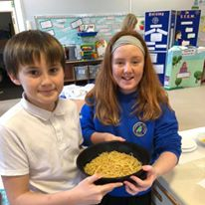
Our PEF money in 2019 was spent in working towards improving children’s Health and Wellbeing and Attainment through
- Nessy Spelling/ Reading resources for specific children which has resulted in all who participated in this activity significantly raising their spelling ages.
- Purchasing Clicker software tool to support literacy at Cumbrae Primary School.
- Increased Classroom assistant support to develop STEM and Food Technology across the school.
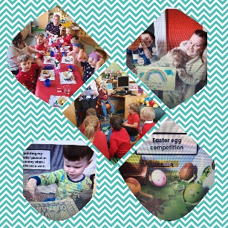
- The organisation of a motivational and inspiring Tree of Knowledge cluster workshop event to upskill staff in promoting the Health and Wellbeing of their staff, children and families.
- Participating in the Live Literature Programme run by the Scottish Book Trust by having an Author in Residency promoting the art of poetry. This culminated in the production of a publication of works by the children!
- Purchasing homework diaries & target boards to enable learning targets to be shared at home and displayed for the children.
- Purchasing a range of resources to support coding skills including Coding Bugs & Turing Tumbles which teaches coding strategy as well as abstract concepts like binary, binary operations, and logic gates in a fun, tangible way.
- Purchasing Phonics Readers, decodable books which consolidate the phonics taught with step-by-step progression to support children to become confident, fluent readers.
- Developing our young workforce and raising awareness of employability skills and opportunities remains a high priority to ensure our children have high aspirations and see purpose and value in their learning. We have achieved this through working with partners to deliver lessons or talks to the children eg. Royal Bank of Scotland, Police Scotland, local solicitors and quantity surveyors, Mock Court, handiwives group and our skills development through Plant 2 Plate.
- Thumble Tumble Author Visit to inspire budding young authors within our school.
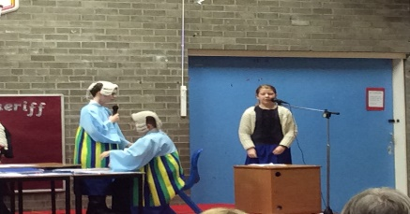
Across The Curriculum
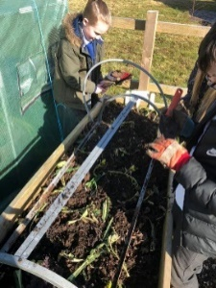
- Primary 6/7 again participated in the national ‘Mock Court’ challenge, a valuable cross-curricular project which simulates the development, debate and role play of a real of court case. For the fourth year running we were prize winners with Cumbrae Primary Defender & Pursuer teams winning a top place in the Ayrshire region!
- Primary 4/5 used their digital technology skills to produce a Cumbrae Community Café radio advertisement. The children also demonstrated how to use the equipment to a team from Caledonian MacBrayne.
- The whole school has benefitted hugely from our Plant2Plate initiative which has involved us in developing various partnerships with groups across the island, and indeed world, as we designed and developed our garden in the grounds of Cumbrae Parish Church. All children have been involved in learning across the curriculum through this project which has literally grown from seed to providing a termly community cafe. The successes of this project will continue as we strive to ensure our children appreciate sustainability and learn how to cook meals from the plant to the plate.
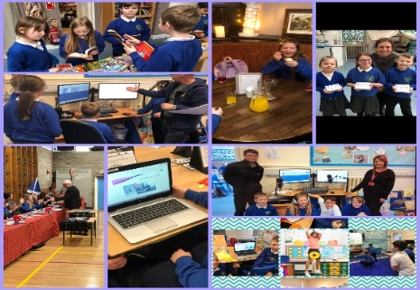
- Developing Science, Technology, Engineering and Mathematics skills within Cumbrae has been a success this year as we have turned our middle building into a STEAM room. The children regularly use this room for science, cooking, developing digital technology and we have held successful parental events in this room to showcase the work.
- Pupil leadership in learning continues to be a key strength in Cumbrae and our committees and Skills Academy are well established. Our pupil voice is strong in Cumbrae and has driven forward improvements in outdoor learning, the playground, working with the community and the development of our new STEAM room.
- Primary 1-3 had a wonderful visit to the Beacon Arts Centre in Greenock to see Scottish Ballet’s ‘Wee Hansel and Gretel’. It was an excellent opportunity for the children to see professional dancers and allowed them to take their class work on Fairy Tales beyond the classroom.

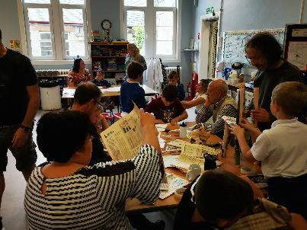
Parental Involvement
Providing opportunities for active collaboration with parents and family learning underpins our ethos in Cumbrae.
- Our curricular showcases gave parents an opportunity to gain more knowledge of our curriculum within Cumbrae Primary and how children can be supported at home.
- All parents were invited to our Community Café which featured information sessions delivered by the children on food dehydration processes.
- Our Family Learning Worker held a number of well attended cooking classes for families across the school and EYC.
- All parents were invited to participate in our Parent Consultation via questionnaire and the feedback provided was very positive.
- Within the Early Years parents are regularly invited in to share learning experiences with their children.
- The Seesaw app was introduced across the school this session to develop communication with parents and to allow children to report their learning experiences directly and immediately to parents through the use of digital technology. This received very successful feedback from staff, pupils and parents who all appreciated the value of sharing the learning and progress with one another. It was a particularly useful tool in maintaining contact with children & families throughout the period of home learning.

Looking Forward
Our priorities for 2020/21 continue to be influenced by the National Improvement Framework while taking recognition of our own context and children’s needs. We will continue to raise attainment in Literacy and Numeracy and enhance children’s Health & Wellbeing by
- Continuing to promote reading for enjoyment across the school and into the community along with our Family Learning Team we will offer parental opportunities and intergenerational activities through our community project ‘Cumbrae Loves to Read’.
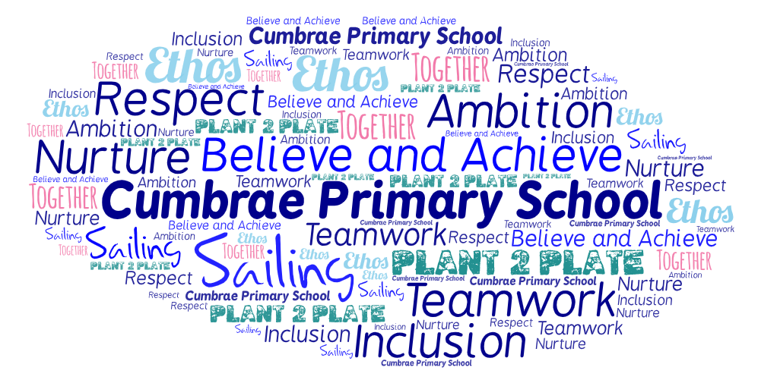
- In partnership with Cumbrae Community Radio station we will give all the children the opportunity to write, read, produce and present shows and music on a regular basis, using this as a way to involve the community and reduce loneliness during the isolation related to COVID-19.
- Our Plant 2 Plate project will continue with children planning and harvesting the produce. Instead of hosting our termly community cafe, the children have adapted plans to offer recipe boxes to provide to members of our community. We will continue to investigate the possibility of dehydrating harvested veg to provide regular healthy snacks for children.
- The upper primary will work collaboratively with Millport Conservation and Regeneration Scheme (CARS) to help the children appreciate our local heritage and engage in various activities to develop understanding of traditional building methods, architecture, graphic design, computing and photography.
- Teachers will use their professional judgements and assessment information to provide targeted interventions for specific groups of children to support and challenge their learning.
- The Seesaw app will continue to be used across the EYC and school to develop children’s profiles and evidence learning and progress.
- Plan and implement a Growth Mindset in Numeracy Project through Mindset Matters.

Section 7: Support for your Child

Equalities
In line with North Ayrshire Council policy, educational provision is open to all pupils, regardless of sex, age, religion, race, disability or any other potential barrier and all reasonable measures will be taken to ensure that the curriculum is available to every child. Schools also have a duty to promote equality and to eliminate racist and other discriminatory behaviours.

Equality Act 2010
The Equality Act 2010 has been drawn up to tackle inequality and prevent discrimination against people on the basis of ‘protected characteristics’. It brings together several existing laws and aims to make understanding the law simpler and also introduces a new single public sector equality duty, which requires public bodies to actively advance equality.

The duties set out in Chapter 1 of Part 6 of the Equality Act apply to all schools. These provisions protect pupils at the school and in the case of admissions, those applying or wishing to apply for admission. Former pupils are also protected from discrimination or harassment.

Guidance on the Act and its requirements for schools in relation to the provision of education can be accessed via the Scottish Government website via here:

http://www.gov.scot/Publications/2012/02/7679/3

Child Protection
Education Services has a fundamental duty to contribute to the care and safety of all children and young people in North Ayrshire. In fulfilling this duty, the service must engage in close partnership with parents/carers and relevant agencies, primarily the Health and Social Care Partnership and where appropriate the Scottish Children’s Reporter’s Administration. The Service will work in partnership with a number of levels within the establishment or school within the cluster or local area and through Integrated Children’s Services and Community Health Partnership.

The Standard Circular entitled, “Protecting and Safeguarding North Ayrshire’s Children” provides guidance for policy and practice within all educational establishments. The Council is one of the key partners in the North Ayrshire Child Protection Committee, a multi-agency group which takes the lead role in ensuring that our children and young people are cared for, protected from harm and grow up in a safe environment.

Each school has a named Child Protection Co-ordinator who is the main point of contact for school staff and for external agencies seeking contact with the school on child protection matters. There is an extensive staff-training programme available to staff and, in addition, at the beginning of each school session all staff receive an update on child protection policies, safeguarding and procedures.

Inclusion
North Ayrshire Council is committed to supporting the well-being and educational progress of all learners including those with Additional support needs. Including learners requires all staff to demonstrate commitment, innovation and flexibility in order to ensure that all children and young people have access to quality learning opportunities and experiences. Our Inclusion Strategy states that:

- An inclusive approach to education supports an ethos of achievement and high expectation, recognises difference, respects these differences and sees differences between learners as opportunities for learning.
- An inclusive approach to education promotes tolerance and a positive understanding of diversity.
- An inclusive approach to education alleviates the barriers to learning, supports the achievement of all and has positive relationships at its heart.

The presumption of mainstream as outlined in the Standards in Scotland’s Schools (2000) sets out that children will be educated in a mainstream setting unless exceptional circumstances apply. North Ayrshire therefore has a duty to ensure that clear assessment outlines the additional support needs of a child or young person which may require support in an alternative provision.

Where this is the case, North Ayrshire has a clear process that supports the Team around the Child to make a recommendation for consideration of alternative provision. This is outlined in the Standard Circular E19 and requires establishment staff to work with parents/carers to ensure all supports have been put in place to support a child or young person in their mainstream context before submitting clear evidence of what has been implemented and going on to request alternative provision. North Ayrshire council staff will then make a recommendation based on the evaluation of this evidence and a review of the needs of the young person and the current peer group in each setting.

The Education (Disability Strategies and Pupils’ Educational Records) (Scotland) Act, October 2002, requires local education authorities to prepare and implement accessibility strategies to improve, over time, access to education for young people with disabilities. Access covers:

- The physical building and grounds
- The curriculum (both formal and informal)
- Information on any educational planning that might affect the child’s/young person’s education

The Education (Additional Support for Learning) (Scotland) (2009) Act sets out certain duties on local education authorities and confers certain rights on children and their parents. These duties include the need to:

- Identify, assess and address the need for additional support for any child or young person failing to benefit from school education, for whatever reason
- Seek and take account of the views of the child or young person on issues relating to their education
- Engage in helpful partnership working with parents/carers and staff from other agencies

These are the various pieces of legislation that support the right to inclusion and that define the main features of that right.

Additional Support for Learning
Any child who needs more or different support to what is normally provided in schools or pre-schools is said to have ‘additional support needs’. This includes children who may need extra help with their education as a result of issues arising from social and emotional difficulties, bullying, physical disability, having English as an additional language, a sensory impairment or communication difficulty.

The Additional Support for Learning Act
The Education (Additional Support for Learning) (Scotland) Act 2004 came into force in November 2005. In June 2009, the Act was amended. These amendments form the Education (Additional Support for Learning) (Scotland) Act 2009 and came into force on November 2010.

Main provisions of the Act
- The Act provides the legal framework underpinning the system for supporting children and young people in their school education, and their families.
- This framework is based on the idea of additional support needs. This broad and inclusive term applies to children or young people who, for whatever reason, require additional support, long or short term, in order to help them make the most of their school education and to be included fully in their learning.
- The 2009 Act automatically deems that all looked after children and young people have additional support needs unless the education authority determine that they do not require additional support in order to benefit from school education.
- In addition, education authorities must consider whether each looked after child or young person for whose school education they are responsible requires a co-ordinated support plan.

Duties under the ‘Additional Support for Learning’ legislation
North Ayrshire must assess any pupil with additional support needs and provide with any support necessary for them to benefit fully from their education. All the evidence says that it is best to intervene early to prevent any difficulties developing and taking root. For example, by making sure reading is very well taught and that all pupil gets encouragement and support at home we can hopefully reduce later difficulties.

Whatever the type of challenge that arises, it is important to detect it early, develop a shared understanding of what is needed (the school may request extra specialised help to do this) and take action to help to pupil achieve. Whenever we start this process for any child or young person, we will always explain to them and to their parents/carers what our concerns are and what we will do to help.

The school can get support from a range of visiting professionals including Educational Psychologists. These professionals are regularly in all schools and teachers and others will ask for informal advice on supporting pupils for example on the best way to support a pupil who is having difficulties with reading. If the school wants more detailed individual help, then they would talk to you about formally involving the educational psychologist. The educational psychologist can only be involved in consultation, collaborative assessment and planning interventions for your child after you agree to this.

For a few children and young people their needs are so complex that professionals from two or more agencies need to work together over a significant length of time to enable the child to benefit from school education.

The authority approach to staged intervention has been updated to take ensure it is line with the CYP (2014) and ASL (2004) (amended 2009) Acts. The aim is to ensure children and young people get the right support at the right time.

Where a child or young person has additional support needs, extra planning is required every time there is a move to a new class, new school or college. How far ahead this transition planning needs to start depends on the particular type of needs but for most children and young people with Additional Support Needs transition planning should start at least one year before the date of the planned move.

Detailed advice on transition planning is provided in the Supporting Children’s Learning Code of Practice, which can be accessed at the following link:

http://www.gov.scot/Resource/Doc/348208/0116022.pdf

Dispute Resolution Procedures
If you feel that things are not being done properly to support your child then the Council has a range of ways to work with you to resolve any issues. You can ask at any time for a copy of the booklet called ‘Resolving Disagreements’. This booklet will give you ways to make sure your concerns are listened to and addressed.

Further Support
The following organisations are able to provide advice, further information and support to parents of children and young people with ASN.

- Enquire: Scottish Advice and Information Service for Additional Support for Learning
Website: http://enquire.org.uk/
Helpline: 0345 123 2303
Email: info@enquire.org.uk

- Scottish Independent Advocacy Alliance
Website: http://www.siaa.org.uk/
Telephone: 0131 260 5380
Email: enquiry@siaa.org.uk
- Scottish Child Law Centre
Website: http://www.sclc.org.uk/
Telephone: 0131 667 6333
Email: enquiries@sclc.org.uk

Getting It Right for Every Child – Ensuring their Wellbeing
The Children and Young People (Scotland) Act 2014 puts children and young people at the heart of planning and services and ensures their rights are respected across the public sector. It seeks to improve the way services work to support children, young people and families.

- The act ensures that all children and young people from birth to 18 years old have access to a Named Person.
- The act puts in place a single planning process to support those children who require it.
- The act places a definition of wellbeing in legislation.
- The act places duties on public bodies to coordinate the planning, design and delivery of services for children and young people with a focus on improving wellbeing outcomes, and report collectively on how they are improving those outcomes.

Taking a ‘Getting it Right for Every Child’ approach to supporting every child is a priority within our school and we aim to assist every child in our school to reach their potential. The wellbeing of children and young people is at the heart of Getting it right for every child. The approach uses eight areas to describe wellbeing in which children and young people need to progress in order to do well now and in the future.

The eight indicators of wellbeing (SHANARRI)

Safe | Healthy | Achieving | Nurtured
Active | Respected | Responsible | Included

Why we have to get it right for every child
Education Services must safeguard, support and promote the wellbeing of all children and young people and address need at the earliest opportunity. These functions are the responsibility of schools and establishments and those who work in them and with them. All who work in Education Services and in partnership with Education Services have a responsibility to ensure the wellbeing of North Ayrshire’s children and young people.

For more information on Getting it Right for every Child in North Ayrshire go to www.girfecna.co.uk

Psychological Services

The Educational Psychology Service in North Ayrshire is part of and contributes to the aims of Education Services by improving outcomes for children and young people. Educational Psychologists work together with teachers, parents and other professionals to help children and young people achieve their full potential, within educational settings and the wider community. Educational Psychologists are involved in working with individuals, but also have a significant role in offering training, support and consultation to increase capacity in education establishments on a wide range of issues. They are also involved in supporting research to evaluate how effective approaches to support children and young people are.

Your child’s school/ Early Years Centre already has a system of staged intervention for identifying, assessing, monitoring and reviewing the ongoing progress of all children and young people. As part of this wider system of support, each school and authority early years centre has a link educational psychologist.

When concerns arise about a particular child or young person the establishment will take action to address these concerns. If the concerns continue, school/ early years may have an informal discussion with the educational psychologist and ask about general advice.

If needed, a formal consultation meeting with parents/carers involving the educational psychologist can then be arranged. This will be discussed with you beforehand. This may be a one off or may lead to longer term involvement. Through this process the educational psychologist can, if required, contribute to the ongoing assessment and support for your child including providing support to the family. The educational psychologist will be involved while there is a specific role for them and will use a strengths based, solution oriented approach which takes into account the wider context of the child, family and community.

Find out more at:

http://www.northayr-edpsychs.co.uk/

Data Protection
Personal data is required to be collected by North Ayrshire Council in order to deliver education services. It is necessary to collect personal data regarding pupils, parents, carers and other individuals to enable us to carry out our duties under the Education (Scotland) Act 1980 and the Education (Scotland) Act 2016.

The Data Protection Act 2018 sets out the legal basis for processing data. You can refer to our privacy notice for details of the different basis under which we may process individuals’ data.

https://www.north-ayrshire.gov.uk/Documents/EducationalServices/eye-privacy-policy.pdf

We may also share or receive an individual’s personal data with the following:

- Scottish Government & Education Scotland
- Private Nurseries’
- Strathclyde Passenger Transport
- Scottish Children’s Reporter Administration
- Social Work Services
- Scottish Public Services Ombudsman

Where we are required we will also make disclosures required by law and may also share information with other bodies responsible for detecting/preventing fraud or auditing/.administering public finds. Individuals’ have legal rights under the data protection legislation including the right of access. Further details can be found in the Council’s Privacy Policy at:

https://www.north-ayrshire.gov.uk/privacy-policy.aspx

Medical and Health Care
Medical examinations are carried out at various times during a child’s primary school years. Parents are given notice of these and encouraged to attend. Vision and hearing tests and dental examinations, which parents need not attend, are also carried out and parents informed of any recommended action or treatment. All examinations are carried out by Ayrshire and Arran Health Board staff.

If a pupil takes ill or has an accident at school, which requires that the child be sent home or for treatment, First Aid will be provided and parents or carers contacted immediately. (In the event of a serious illness or accident, a member of staff will accompany the child to a doctor or hospital and parents/ carers will be notified immediately.)
For this reason it is important that the school has contact details for parents/ carers and an additional contact person in case parents/ carers cannot be reached. It is also important that the school is kept fully informed and updated with regards to any medical condition.

It is the parent’s responsibility to notify the school and keep medical information updated as required.

Children will not be sent home unaccompanied.

Section 8: Parental Involvement
Parental Engagement and Involvement

North Ayrshire Council Positive Family Partnership Strategy

NAC Parental Involvement Strategy

All schools have clear systems in place for communicating with everyone in the parent forum. Communications with parents are clear, jargon-free, specific and easily accessible. A variety of methods and approaches are used by schools to communicate with the parent forum including face to face, traditional communication methods and digital media e.g. Twitter, Facebook. Considerations will always be given when communicating with parents who have literacy, language and communication challenges.

Schools ensure that parents know who to contact when they wish to discuss their child’s learning or wellbeing and will seek to provide a private space for such discussions and make sure parents are given adequate time and support. Consideration will be given to family circumstances.

Parents are welcome to contact the school at any time to arrange an appointment to discuss any matter with the class teacher, Depute Head, Head Teacher or Head of Centre. New families are welcome to contact the school and request a suitable visiting time at any point throughout the session

Parents are given opportunities to understand the way learning and teaching takes place in the classroom. This may be in the form of class visits to take part in the learning experience alongside their child or attending events which share the learning. Frequent invitations are issued to parents to participate in school activities such as open days, class assemblies, workshops and to assist with outings and visits, sports and concerts. There will be a series of early meetings for the parents of Primary 1 pupils and parents are kept informed of events with a range of newsletters, website updates, texts, invitations and social media sites.

A variety of methods will be used to ensure information about your child’s progress is shared. Schools are encouraged to provide parents/carers with information on their children’s progress at regular intervals throughout the year through a range of activities. There is an expectation that part of this will be in a written format.

Reporting Examples:

Individual Learners | Groups of learners
Written reports/ tracking reports | Assemblies
Learning conversations with pupil/ teacher/ parent/ carer | Open day events
Pupil reflections on their learning in logs | School concerts/shows
Parent/ carer consultation/ Parents’ Meetings involving parent/ teacher/ pupil, as appropriate | Social media
Home/ school diaries | Curriculum workshops led by children and young people and staff
Profiling activities | Parent Council meetings
Learning walls and displays | School / class newsletters

Parent Council The chair of our Parent Council is Gail Murphy and can be contacted on 07974760370

Parentzone Scotland is a unique website for parents and carers in Scotland, from early years to beyond school. The website provides up-to-date information about learning in Scotland, and practical advice and ideas to support children’s learning at home in literacy, numeracy, health and wellbeing and science.

Information is also available on Parentzone Scotland regarding additional support needs, how parents can get involved in their child’s school and education. Furthermore, the website has details about schools including performance data for school leavers from S4-S6; and links to the national, and local authority and school level data on the achievement of Curriculum for Excellence levels.

Parentzone Scotland can be accessed at https://education.gov.scot/parentzone

Section 9: Pupil Data Collection and Protection Policies

The Scottish Government and its partners collect and use information about pupils through the Pupil Census to help to improve education across Scotland. This note explains why we need this information, how we use it and what we do to protect the information supplied to us.

Why do we need your data?
In order to make the best decisions about how to improve our education service, Scottish Government, education authorities and other partners such as the SQA and Skills Development Scotland need accurate, up-to-date data about our pupils. We are keen to help all our pupils do well in all aspects of school life and achieve better examination results. Accurate and up-to-date data allows us to:

- plan and deliver better policies for the benefit of all pupils
- plan and deliver better policies for the benefit of specific groups of pupils
- better understand some of the factors which influence pupil attainment and achievement
- plan and implement targeted approaches to reducing the poverty-related attainment gap
- share good practice
- conduct teacher workforce planning
- target resources better
- enhance the quality of research to improve the lives of young people in Scotland
- provide a window on society, the economy and on the work and performance of government by:
  - publishing statistical publications and additional tables about School Education
  - providing school level information

Data policy
Information about pupils’ education is collected through our statistical surveys in partnership between the Scottish Government and Local Authorities through the ScotXed Programme which aims to help schools and Local Authorities by supporting efficient collection, processing and dissemination of statistical information. The Scottish Government then provides analysis of the data to support research, planning, management and monitoring of education services as well as to produce National Statistics publications.

Education data within Scottish Government is managed effectively by secure systems on secure servers and is exploited as a valuable corporate resource, subject to confidentiality restraints. As part of its data policy, Scottish Government will not publish or make publicly available any information that allows individual pupils to be identified, nor will data be used by Scottish Government to take any actions in respect of individuals. Data is held securely and no information on individual pupils can or would be made publicly available by Scottish Government.

The individual data collected by Scottish Government through the Pupil Census is used for statistical and research purposes only.

Your data protection rights
Any sharing or linkage of data will be done under the strict control of Scottish Government, and will be consistent with their data policy and the National Data National Data Linkage Guiding Principles Guiding Principles. Decisions on the sharing or linkage of data will be taken in consultation with relevant colleagues and individuals within and outwith Scottish Government as part of a Data Access Panel. At all times the rights of the individual (children or adults) under the GDPR and other relevant legislation will be ensured. Further information can be found on:

https://www2.gov.scot/topics/statistics/scotxed/schooleducation/ESPrivacyNotices
Concerns
If you have any concerns about the ScotXed data collections you can email the Data Protection & Information Assets Team on dpa@gov.scot or the Head of Education Analytical Services, Mick Wilson, at mick.wilson@gov.scot or by writing to Education Analytical Services, Area 2A-North, Victoria Quay, Leith, EH6 6QQ. Alternative versions of this page are available, on request from the ScotXed Support Office, in other languages, audio tape, Braille and large print.

Alternatively complaints may be raised with the Information Commissioners Office at casework@ico.org.uk.

Appendix 1
Important Contacts

Interim Executive Director (Communities)
Audrey Sutton
North Ayrshire Council
Cunninghame House
IRVINE
KA12 8EE
01294 324414

Head of Service
Caroline Amos
North Ayrshire Council
Cunninghame House
IRVINE
KA12 8EE
01294 324416

Head of Service
Andrew McClelland
North Ayrshire Council
Cunninghame House
IRVINE
KA12 8EE
01294 324413

