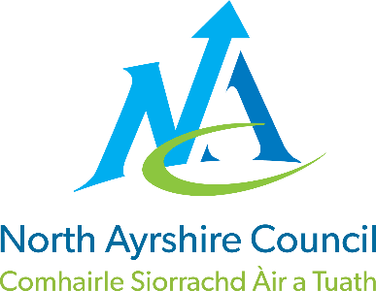
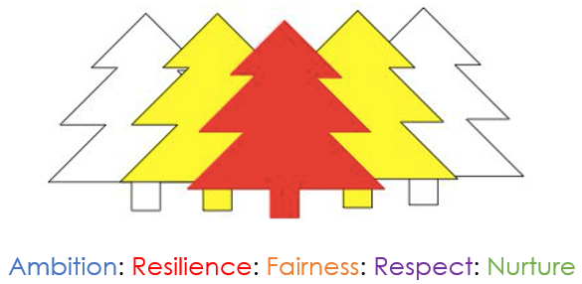

Corsehill Primary School

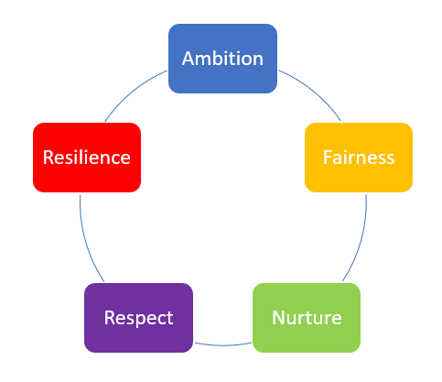

STANDARDS AND QUALITY REPORT
June 2026
This report will inform you of the school’s progress and achievements in the last session and let you know about our plans for 2025-2026.
I hope that you find it helpful and informative.

Mrs Nicola Collins
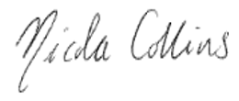
Head Teacher

OUR SCHOOL
Corsehill is a non-denominational school with a school roll of 197 learners in eight primary classes with a further 66 children in our Early Years Classes (EYC). Early Years children are offered either a morning or afternoon place with additional hours being provided via local childminders.

Our staffing consists of one Head Teacher, one Depute Head Teacher and one Principal Teacher. There are a further 10 Class Teachers, one Targeted Support Teacher who is employed 4 days per week and 9 full time / part time Pupil Support Assistants. Our EYC is staffed by one Manager, one Senior Early Years Practitioner, one Lead Practitioner, and 12 Early Years Practitioners and 1 Early Years Assistant. Five Education Business Assistants work part-time within our office and the school building is maintained by our janitor.

OUR VISION, VALUES AND AIMS
Our vision is to develop a curiosity about our world and enable our children to contribute positively now and in the future.
Our aims for our children
- To enable our children to become ambitious and motivated lifelong learners with a passion to succeed.
- To equip children with well-developed literacy and numeracy skills in order that they can be successful in life.
- To nurture a sense of well-being in our children so that they grow into respectful young people able to make sound judgements and choose a healthy lifestyle.
Our aims for our families and the community
- To support and inform our parents so that they can work in partnership to help their child be ambitious and achieve success.
- To be engaged in the life of the school in order that they can contribute to school decision making and our improvement journey.
- To develop partnerships between staff, parents and the wider community which promotes a positive ethos and image.

ATTAINMENT & ACHIEVEMENT
Throughout the year we gather lots of information on how our children are progressing in their learning. To monitor their progress, we observe children in their learning, listen to what they say, ask important questions, set challenges and use standardised assessments.
North Ayrshire Council also ask us to summarise our children’s progress in reading, writing, listening and talking as well as numeracy and maths. They ask us to look particularly at children who have reached the end of the Early, First and Second Levels:
- Almost all of our children in Primary 1 are making good progress through early level in listening and talking and the majority of children in P1 are making good progress in reading, writing and numeracy.
- Most of our children in Primary 4 are making good progress through first level listening and talking and the majority are making good progress in reading, writing and numeracy.
- Almost all of our children in Primary 7 are making good progress through second level listening and talking with most achieving reading and majority of P7 children achieving in writing and numeracy.

WIDER ACHIEVEMENT
- Children’s wider achievements have been celebrated on a monthly basis through school assemblies and shared visually across the school.
- Bronze Level EmotionWorks accreditation has been successfully achieved, recognising our commitment to emotional literacy.
- Recognition as a Bronze Level ‘Reading School’ highlights the progress made in promoting a positive reading culture.
- Across all classes, leadership initiatives have empowered learners to create positive change within the community.
- A highly effective World of Work and Health Week provided valuable insight into a wide range of positive destinations for our learners.
- Participation in a residential experience has supported our P7 pupils in developing key skills as they prepare for the transition to S1.
- Success in North Ayrshire tournaments has been a highlight for both boys’ and girls’ football teams reaching the All Ayrshire Final for the boys’ final and coming runners up.
- Partnership with the Royal Highland Education Trust has enabled engagement in a potato growing project, enriching learning through real-life experiences.
- Collaboration with UCAN has enhanced our outdoor learning environment, creating new opportunities for den building and outdoor play.
- Ongoing fundraising efforts have allowed continued support for a range of charities.
- Successful grant applications, including Cash4Kids and ACES Woodwynd, have enabled targeted support for families in need throughout the session.
- Strong community links have been maintained through events such as the Burns Supper and P7 Leavers celebration at the Love Hall.
- Bucket Drums have continued this year for our Primary 5 children resulting in a successful showcase to families.
- Brass instrument tuition has been offered to our Primary 6 children this session and will continue into P7 next session.
- Strong links with our Parent Council this session have led to an increase in fundraising through whole school events such as a Summer Fayre, Christmas Fayre and a whole school sponsored challenge.

HOW SUCCESSFUL HAVE WE BEEN IN IMPROVING OUR ESTABLISHMENT?
Last year we worked hard to build upon our school experiences, focusing on:
Improve attainment and teaching in numeracy with a specific focus on basic operations and problem solving.
Progress has been made in improving consistency and confidence in numeracy teaching through the introduction of Number Talks, clearer progression pathways and increased use of concrete resources in line with the Professional Learning Academy. There is emerging evidence of improved pupil confidence and engagement, particularly in mental strategies and mathematical language. Early tracking and assessment information indicates a positive trend in attainment. School wide attainment in numeracy has increased from 67% to 71% with the introduction of White Rose Maths next session to consolidate and develop key numerical concepts.
Learners to experience consistently high quality writing instruction across all stages, leading to improvement in attainment and confidence in writing underpinned by a robust framework and assessment practices.
There has been strong progress in developing a more consistent and structured approach to writing through the introduction of refreshed writing pedagogy, improved planning and increased moderation activities. Staff confidence has improved and there is greater consistency in expectations, alongside a clear focus on phonics and handwriting in early stages. Early evidence from moderation, tracking and pupil voice suggests improvements in writing confidence and quality, although attainment gains are still emerging and continued focus is required to secure sustained improvement across all stages. Our trial work with the Professional Learning Academy’s CYPIC approach is looking to support learners attainment in key cohorts for writing. The evidence from the CYPIC approach looks incredibly promising as attainment in the targeted cohort has risen from 44% to 70%.
Learners will experience a high quality, coherent curriculum underpinned by progressive planning, robust assessment practices and consistent moderation ensuring equity, improved attainment and confident achievement of a level across stages.
Good progress has been made in establishing more consistent approaches to planning, assessment and moderation, with the introduction of a refreshed whole-school planning framework, refreshed assessment calendar and structured moderation processes. Staff engagement in professional learning and moderation activities has strengthened throughout the session, understanding of standards and improved confidence in professional judgement has also improved. There is increasing evidence of more coherent planning and better use of data to inform next steps, leading to improved consistency in learner experiences.
QUALITY INDICATORS
Provide your evaluation & brief summary statement for each of the 4 core QIs
QI 1.3 Leadership of Change | Evaluation | 4 Good
Our vision remains focused on improving outcomes for all learners, with a clear emphasis on raising attainment in literacy. Professional learning, including our Deep Learning work, is supporting staff to reflect on and strengthen pedagogy. Leadership is increasingly distributed through working groups and collaborative enquiry, promoting greater ownership of improvement. Next session, we will further build leadership capacity at all levels, with a focus on evidence-informed change to improve reading and writing outcomes.
QI 2.3 Learning, Teaching & Assessment | Evaluation | 4 Good
Our work last session has allowed us to deliver pedagogy in line with our new Teaching and Learning Policy, improving consistency and professional dialogue. There is a stronger focus on effective questioning, learner engagement, and the use of high-quality talk.
Next session, we will prioritise high-impact literacy approaches, particularly in writing and reading, alongside strengthened assessment and moderation to improve pace and challenge.
QI 3.1 Ensuring Wellbeing, Equality & Inclusion | Evaluation | 5 Very Good
A strong ethos of inclusion and positive relationships underpins our school community which was highlighted in our Learning Visit from North Ayrshire Council in January 2026. Targeted support from our AIW worker has improved engagement for identified children and families. Pupil voice continues to develop through opportunities such as the pupil council. Next session, we will further strengthen inclusive practice and review our positive relationships and behaviour policy.
QI 3.2 Raising Attainment & Achievement | Evaluation | 5 Very Good
Most learners are making progress, with steady improvement at key stages. Teacher judgement is increasingly robust, supported by assessment and moderation. The school has a robust strategy in place to raise attainment across literacy and numeracy over the next three years. This session we are seeing positive gains across the school for reading, writing and numeracy. Next session, we will accelerate progress in literacy, particularly writing and reading, while strengthening differentiation to ensure all learners achieve their potential.

PUPIL EQUITY FUNDING
0.2FTE Class Teacher
We delivered a targeted intervention to reduce literacy barriers in the Primary 3 and Primary 4 cohorts where speech and language has presented a challenge for identified learners.
63 Hours per week of Pupil Support Assistants to deliver a number of interventions to reduce barriers to learning.
This funding has allowed increased adult support to identified individuals who experience barriers to their learning.
Resources and licenses to support high quality literacy, numeracy, assessment and home engagement.
Most online resources have increased our parental engagement and learner participation. We have been able to deliver high quality learning resources to meet the needs of our young people.
Curriculum Experiences
We have reduced the cost where possible for families to allow children to participate in a range of educational experiences throughout the session linked to the learning they have been undertaking within the classroom.

IMPROVEMENT PLAN PRIORITIES 2026-2027
After meeting with our staff team, our children and our families we have selected four priorities for next session to focus on which are in line with North Ayrshire Council priorities in education.
Priority 1
- Improve attainment in literacy with a specific focus on reading and writing for all learners
Priority 2
- Improve pedagogy through the implementation of SSERC and embed Deep Learning approaches through this curricular area
Priority 3
- To empower staff to support the wellbeing of all through the New Authority approach with a focus on expectations, consequences and attendance
Priority 4
- To strengthen professional judgement using effective assessment and moderation practices embedded across all stages

