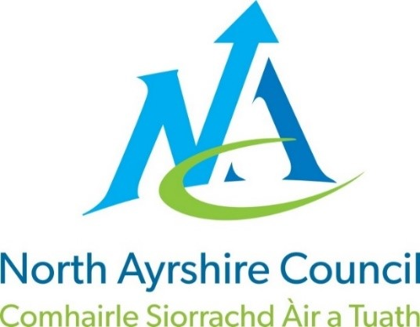

North Ayrshire Council: Communities and Education

Corsehill Primary School

School Handbook
Session: 2022-2023

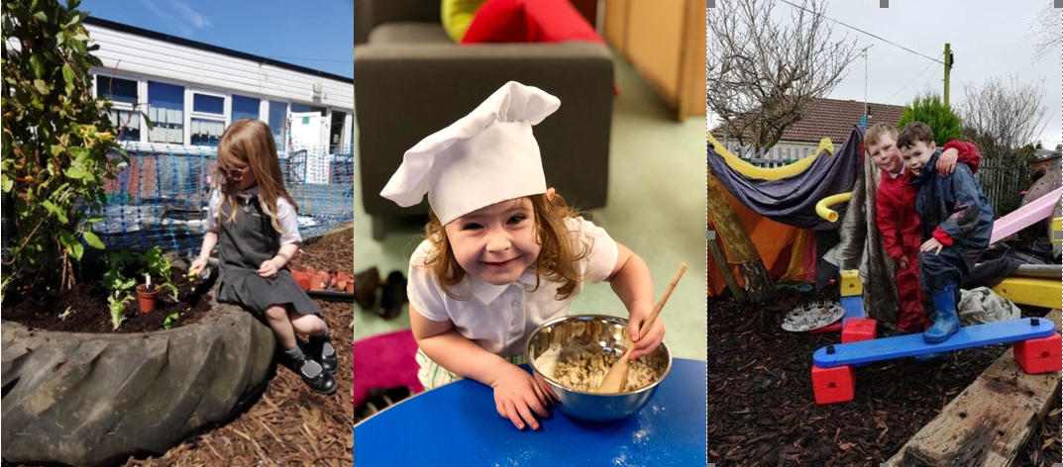

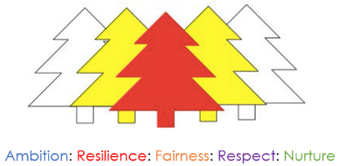

Contents Page
Head Teacher Introduction ……………………………………………………………. 4

Communities & Education Directorate ………………………………………5
- Directorate Aims and Priorities

Section 1: School Information ………………………………………………………….6
- School Aims, Values, Ethos
- School Contact Details (Address, Telephone, Email)
- School Staff
- School Calendar/Holidays

Section 2: School Procedures …………………………………………………………..10
- School Security
- Positive Relationships
- Playground Supervision
- Absence from School Premises at Breaks
- School Dress Code
- Dress Code for PE
- Personal Belongings
- Mobile Phones
- Information in Emergencies
- Listening and Learning

Section 3: Footwear, Clothing, Free School Meals and Transport ………………15
- Footwear and Clothing Grants
- Free School Meals
- School Transport Policy

Section 4: School Registration, Enrolment and Attendance ……….…………….17
- Registration and Enrolment
- Attendance at School
- Structure of Classes
- Transfer to Secondary School

Section 5: Curriculum for Excellence ………………………………………………19
- Curriculum for Excellence
- The Capacities
- Extra-Curricular Activities
- Assessment and Reporting
- Homework

Section 6: School Improvement ……………………………………………………23
- S&Q Report/Improvement Plan

Section 7: Support for your Child ……………………………………………...…32
- Additional Support for Learning
- Dispute Resolution Procedures
- Further Support
- Equalities
- Equality Act 2010
- Child Protection
- Inclusion
- GIRFEC
- Psychological Services
- Data Protection
- Medical and Health Care

Section 8: Parental Involvement …………………………………………………38
- Parent Council
- Home School Links
- Reports to Parents
- Homework
- School Committees

Section 9: Pupil Data Collection and Protection Policies ……………………40

Appendix 1: Important Contacts

Message from the Head Teacher
I’d like to personally welcome you to Corsehill Primary School and Early Years Class. Thank you for choosing our school for your child and offering us the privilege of being able to be a part of your family’s life.
We have an incredibly talented and committed staff in Corsehill and together we will ensure your child’s every need is met to ensure they achieve their potential. Our staff are caring individuals who will model and encourage our school values of: AMBITION, FAIRNESS, NURTURE, RESPECT and RESILIENCE
Our vision is to develop your child’s curiosity and you will see this for yourselves with the exciting learning opportunities your child will experience. Our Play Zone, Learning Zone, Discovery Zone and Outdoor Zone are the highest quality environments for your child to explore new ideas and challenge themselves while developing skills to help them in the future.
We value you and see you as a key partner in your child’s education. We recognise the benefit of teamwork between the family and school and offer a number of opportunities for families to engage in their child’s learning at school such as Termly Top Target parents meetings, family groups, Parent Council events or just helping out in our zones.
Your child’s learning out of school is important too and we value the time you take to share their out of school achievements with us. There are lots of clubs in school for your child to be involved in too. We will provide you with a sign up form for activities including netball, choir, football, athletics, gardening, dance and multi-sports.
There is lots more for you to find out about our school at this exciting time in your child’s life. You can read our most recent HMIE inspection report at:
Corsehill Primary School Inspection Report.
Please keep up to date with all our activities on our school website:
Corsehill Primary School website or our twitter page: corsehillps

My door is always open if you would like to have a chat about anything else or give me a call on:
01294 552418.
Best regards,
Lorna Marshall
Head Teacher

Communities Directorate (Education Services)

What we want to achieve

Our Overall Aim
Ensuring our children and young people experience the best start in life.

Our Priorities
- We will create the conditions for our children and young people to access the highest quality learning experiences from ages 3-18.

- We will support our children and young people to become successful learners, confident individuals, effective contributors and responsible citizens.

- We will offer opportunities to our young people and their families to play a more active role in school life and encourage more participation in learning.

- We will work with all young people to build their resilience, supporting their mental health and physical well-being.

School Information
Our Vision, Values and Aims
To develop a curiosity about our world and enable our children to contribute positively now and in the future.
Our Values:
- Ambition
- Resilience
- Fairness
- Respect
- Nurture
Our aims for our children:
- To enable our children to become ambitious and motivated life-long learners with a passion to succeed.
- To equip children with well-developed literacy and numeracy skills in order that they can be successful in life.
- To nurture a sense of wellbeing in our children that they grow into respectful young people able to make sound judgements and choose a healthy lifestyle.

Our aims for our families and the community:
- To support and inform our parents so that they can work in partnership to help their child be ambitious and achieve success.
- To be engaged in the life of the school in order that they can contribute to school decision making and our Improvement Journey.
- To develop partnerships between staff, parents and the wider community which promotes a positive ethos and image.

Contact Details
Corsehill Primary School,
Fergushill Road,
Kilwinning
Ayrshire
KA13 7GW
01294 552418

Stages taught: Early Years to Primary 7
Present Roll: 67 (Early Years) and 219 (school)
School capacity: 302 (Please note that the working capacity of the school may vary dependent upon the number of pupils at each stage and the way in which the classes are organised)
Associated Secondary: Kilwinning Academy

School Day
Early Years Class: 8.45 a.m. -12.15 p.m. 1.00 p.m. - 4.30 p.m.
School:
Entry - 9.00 a.m.
Interval - 10.30 a.m. to 10.45 a.m.
Lunch - Sitting 1 - 12:15 p.m. to 1:00 p.m. and Sitting 2 – 12:45 p.m. – 1:30 p.m.
Close - 3.00 p.m.

At home time we expect that all P1, 2 & 3 pupils will have an adult collect them at the end of the day to ensure their safety. P4 – 7 are released into the school playground. However, all children are expected to make full use of the School Crossing Patrol Officer who is situated on Fergushill Road to assist them in crossing. Bikes and scooters should not be used while crossing the road and pupils should refrain from using them within the playground and should push to the bike or scooter stands. Please encourage your child to adhere to these rules for their own safety and that of those around them.

Our Staff

Senior Leadership Team:
Mrs. L. Marshall (Head Teacher) Mr. G. Kirk (Depute Head Teacher)
Mrs. L. Hogg (Principal Teacher)

Early Years staff:
Vivianne McWhinnie (Lead Practitioner) Nadine Muir (Senior Early Years Practitioner)
Linda Cameron (Early Years Practitioner) Rachel Scott (Early Years Practitioner)
Perrie Scott (Early Years Practitioner) Melanie Morrison (Early Years Practitioner)
Angela Sloan (Early Years Practitioner) Kellie Hamilton (Early Years Practitioner)

Teaching Staff:
Mrs. D. Burns Mrs. E. Meechan Mrs. S. Clark Miss B. Sproat
Miss N. Kirkwood Mrs. H. Slater Mrs. F. McNulty Mrs. R. Ennis
Miss L. McNeillie Mrs. R. Grier Miss K. Duff Mr. D. Downey
Mr. B. Rennie (Nurture) Miss. K. Wilson (Recovery Teacher)

Education Assistant (Support):
Miss L. Whyte Mrs. K. Duff Mrs. G. Cassidy

Classroom Assistants:
Mrs. J. Hill Mr. C. Frew Mrs. H. Rennie
Miss. K. Russell Miss C. Cunningham Mr. D. Young

Janitor:
Mr. G. Galloway

School Nurse:
Nurse T. Mathieson

School Chaplain:
Mr. A. Young Deacon I. Beck

School Holiday and In-Service Dates 2022/2023 (Mainland Schools)
Term | Dates of Attendance | Day | Date | Cumulative Holiday/Closure Total | Cumulative Working Days
Term 1 | Teacher (In-Service) | Wednesday | 17-Aug-22
 | Pupils Return | Thursday | 18-Aug-22
 | Teacher (In-Service) | Monday | 19-Sep-22
 | Close | Friday | 14-Oct-22 |  | 43
Term 2 | Pupils Return | Monday | 24-Oct-22 | 5
 | Local Holiday | Friday | 18-Nov-22
 | Local Holiday | Monday | 21-Nov-22 | 7
 | Teacher (In-Service) | Tuesday | 22-Nov-22
 | Close | Friday | 23-Dec-22 |  | 86
Term 3 | Re-open | Monday | 09-Jan-23 | 17
 | Local Holiday | Friday | 10-Feb-23
 | Local Holiday | Monday | 13-Feb-23
 | Teacher (In-Service) | Tuesday | 14-Feb-23
 | Pupils Return | Wednesday | 15-Feb-23 | 19
 | Close | Friday | 31-Mar-23 |  | 144
Term 4 | Re-open | Monday | 17-Apr-23 | 29
 | May Day | Monday | 01-May-23 | 30
 | Local Holiday | Monday | 29-May-23 | 31
 | Teacher (In-Service) | Tuesday | 30-May-23
 | Pupils Return | Wednesday | 31-May-23
 | Close | Wednesday | 28-Jun-23 | 66 | 195
Pupils attendance will be 190 days after deducting 5 in-service days

School Security
North Ayrshire Council has introduced procedures to ensure the safety and security of children and staff when attending or working in a school. A number of security measures are used including the use of a visitors’ book, badges and escorts while visitors are within the school building. Any parent/carer or visitor at a school for any reason will be asked to report to the school office. The school staff will then make any necessary arrangements in connection with the visit to the school.
It is the policy of the school that any member of staff will approach a visitor and ask for verification of identity. This measure ensures that children work in a safe and protected environment. We appreciate your support in carrying out all of the above measures.

Positive Relationships
The school is committed to developing a nurturing approach and promoting positive relationships. Like every community, our school is built on the relationships within it, across it and its connections with others. Every member of staff is responsible for establishing and maintaining positive relationships with each other, with parents and with partners and most importantly with the young people in their care.
Our expectations of behaviour for children and young people are high. Some children may require additional support in relation to their behaviour, and the school will work positively with the young person and the parents, and other partners, as appropriate, to ensure positive outcomes are achieved.
North Ayrshire Council is committed to the principles of restorative practices. This is a solution-focused approach to managing behaviour and resolving difficulties and which promotes healthy relationships that enable better behaviour and better learning. The school has a code of conduct to ensure the safety and well-being of all and parents are asked to support the school fully in this matter.
We operate a House System in Corsehill Primary. All children from our Early Years Class onwards are assigned a House. Each year the children vote for their House Captains. Throughout the year they can achieve points for their house for demonstrating appropriate actions and achievements. The winning house receive rewards throughout the year and at the end of the year we have a House Reward. At the end of the session we hold an Awards Assembly either within the school or in the Kilwinning Abbey Church where we recognise the achievements and hard work of the children in our school.
Your child’s achievements out of school are just as important to us. Please share these with us on Seesaw to allow us to celebrate them also and to include them in their online profiles.

Playground Supervision
The Council meets the terms of the legal requirement that pupils be supervised in the playground by at least one adult during the interval or lunchtime if there are fifty or more pupils at the school. Our policy reflects that of North Ayrshire Council in terms of the Schools (Safety and Supervision of Pupils) (Scotland) Regulations 1990.
An adult presence is provided in playgrounds at break and lunch times. We provide more than the minimum requirement at Corsehill Primary, as we always have at least two adults in the playground during playtime and lunchtime. Pupils who travel by contracted school transport and arrive at school more than ten minutes before the start of the school day have accommodation allocated to them within the school during inclement weather.
We value the opportunity for outdoor play and children will only be kept inside during extreme weather conditions. Our parents and children helped us to fundraise to install a fantastic fitness trail. We have a good variety of outdoor toys and games and children are able to access an all-weather pitch, a netball and basketball court, a football pitch and an outdoor balancing area. We have ‘Activity Huts’ organised by our pupil leader group, allowing children to participate in technology, art, craft and literacy activities.
Primary 6 pupils are trained in playground games and lead an outdoor play team called ‘Bouncing Bananas’ offering younger children the opportunity to participate in a range of activities. Primary 7 pupils undertake ‘Sports Leadership’ training and assist in the playground.
Our ‘Red Caps’ are children who are trained to enable them to have restorative conversations with children in the playground and we have a number of children volunteering to be ‘Junior Janitors’.

Absence from school premises at breaks
Schools have a duty to look after the welfare of their pupils. This means that the staff should take the same care of pupils as a sensible parent would take, and this includes taking reasonable care of pupils' safety during intervals and lunchtimes.
It is the policy of North Ayrshire Council that pupils should not leave school grounds at intervals. Primary pupils should only leave at lunchtimes when they are going home for lunch with their parents’ agreement. Parents should then contact the school office via phone call or email. Pupils will leave and return through the main entrance door of the school at the office.
Parents should encourage their children to follow these rules in the interests of safety.

School Dress Code
It is the Policy of North Ayrshire Council to support the introduction of a reasonable and flexible dress code in schools in its area. The Council encourages each school to adopt its own code, after discussions with parents and pupils.
The Council believes that establishing a school dress code has many benefits. These include improvements in safety, security, positive behaviour and community spirit and a decrease in bullying and in expense for parents.
The Council will support schools in encouraging and helping pupils to conform to the chosen dress code. Some types of clothing will not be allowed at school in any circumstances, for reasons of safety, decency or wellbeing. Types of clothing which will not be allowed include:-
- Clothes which are a health or safety risk
- Clothes which may damage the school building
- Clothes which may provoke other pupils (e.g. football colours)
- Clothes which are offensive or indecent
- Clothes which encourage the use of alcohol or tobacco
All items of clothing should be clearly labelled with the child's name in case of loss. It is appreciated that parents and pupils are distressed over the occasional loss of pupils' clothing and/or personal belongings. Parents are asked to assist in this area by ensuring that valuable items of clothing or personal belongings are not brought to school.
Our school dress code is:
All children White polo shirt with school crest
Dark trousers or skirt
Gingham Dress – Red (P1 – P3) Navy (P4 – P7)
Tartan Skirt – Red (P1 – P3) Navy (P4 – P7)
Sweatshirts Nursery Yellow with sunshine crest
P1 – P3 Red with school crest
P4 – P7 Navy blue with school crest
Cardigan P1 – P3 Red with school crest
P4 – P7 Navy blue with school crest
Black school shoes should be worn in preference to trainers.
At Corsehill Primary school, we like our pupils to be smart and to take pride in their appearance and our school, so the wearing of uniform is strongly encouraged. In order to further reduce the cost of the school day for families, we provide a very well stocked bank of pre-loved uniforms that are in perfect condition free of charge. Families can access this at any time from the main office.
It is recommended for Health and Safety reasons that jewellery is kept to a minimum, especially on gym days when all jewellery must be removed. Newly pierced ears should be covered with tape.

Dress code for PE
For health and safety reasons all pupils must wear suitable clothing for PE. This consists of shorts and t-shirts with soft shoes for indoor activities.
We adhere strictly to health and safety guidelines and pupils must remove any item that may cause danger, i.e. metal buckles, jewellery. These items are the responsibility of the pupil. Long hair should be tied back.

Personal Belongings
It is appreciated that parents and pupils may be distressed over the occasional loss of pupil’s clothing and/or personal belongings. Parents are asked to assist by ensuring that their child’s name is clearly marked on their belongings and that valuable items of clothing or personal belongings are NOT brought to school.
Parents should note that the authority does not carry insurance to cover the loss of such items.

Mobile Phones
While the benefits of mobile phones are recognised, they can be a serious distraction to work. Pupils whose mobile phones disrupt lessons may have them confiscated until the end of the school day. Repeated disruption may result in phones being retained until uplifted by a parent. All pupils are requested to turn mobile phones off when entering the school gates and throughout the day and store them in their bag. Any contact to or from parents or carers throughout the school day should be made via the school office.
Inappropriate use of text messages and/or photographs, recordings (video and audio) whilst in school may be treated as a breach of the school’s code of conduct or a serious incident, which could be referred to the police.

School Meals
Meals are served daily from the multi-choice cafeteria. The meals are planned to offer a healthy diet for the children. Pupils in P1 – 4 benefit from a free school meal from the Scottish Government since August 2021. Pupils in P5 will also benefit from a free school meal from January 2022. Parents should sign up to the iPay programme from North Ayrshire and will be able to pre-order their child’s meal each day, or a week in advance. Please inform us if your child has any specific allergies. Parents of pupils who require a special diet can arrange this by contacting the school or Early Years Class.
There are arrangements in place for pupils who would prefer to eat a packed lunch.

Information in emergencies
We make every effort to maintain a full educational service but on some occasions circumstances arise which lead to disruption. Schools may be affected by, for example, severe weather, and temporary interruption of transport, power failures or difficulties of fuel supply. In such cases, we shall do all we can to let you know about the details of closure or re-opening. We will keep you in touch by using seesaw, xpressions, emails, letters, texts, NAC website, notices in local shops and community centres, announcements in the press and West FM.
Should you have doubts about deteriorating weather conditions during the day, it may be advisable to contact the school. Parents should ensure that the school is aware of the emergency arrangements made for their child and have responsibility to update us with contact numbers.

Listening and Learning
The North Ayrshire Council Education Service encourages feedback from parents and pupils and forms part of the Council’s overall commitment to providing the best possible service and to support partnership working.
We are therefore very interested in feedback of all kinds, whether it be compliments, suggestions or complaints. If you wish to raise a comment of any type about the school you can do this in writing, by telephone or by making an appointment to see someone. All feedback is welcome and helps us keep in touch.
If, in particular, you have a complaint about the school, it is better that these things are shared openly so any damage to the home/school relationship can be minimised. There are no negative consequences arising from making a complaint and we will deal with the issue sensitively and confidentially if required. If we have made a mistake we will apologise and try to put things right.
There are some things which you should note in relation to making a complaint:
- The Council has a Two Stage procedure when handling complaints from parents and members of the public. More details on the two stages can be found in the Council’s complaint page here:

https://www.north-ayrshire.gov.uk/contact-us/complaints-and-feedback/make-a-complaint.aspx

- It is helpful if complaints are made initially to the school’s Head Teacher. This ensures the school is made aware of what is going on and has an opportunity to investigate and try to resolve the issue at Stage One first.

- We try to resolve all complaints as quickly as possible but if a complaint is complex more time may be needed to investigate. It is therefore helpful if you can provide full details of the issue at the outset and ask for an early appointment to discuss it.

- If you are not satisfied with a response you receive at Stage One, you can ask that your complaint is escalated to Stage Two. Should you wish to do this you should contact Education Services at Cunninghame House, Irvine, KA12 8EE or by telephone on (01294) 324400.

- If, after receiving the Stage Two final response letter you remain dissatisfied you can ask the Scottish Public Services Ombudsman to consider your complaint and we’ll tell you how to do this in the Stage Two response letter.

- Parent Councils have an important role in developing links between the school and the wider parent body and can often be helpful in dealing with issues of general concern. However, parents are advised that individual, personal complaints are not appropriate for raising via Parent Councils due to the possible need for confidentiality.

- Please note you can also raise concerns you may have with your local Councillor, MSP or MP but these will be handled under a different process to the Two Stage complaint process.

Section 3: Footwear, Clothing, Free School Meals & Transport

Footwear and Clothing Grants
Parents receiving Universal Credit will normally be entitled to grants for footwear and clothing for their children. Universal Credit claimants’ monthly income must not exceed £625.00, however, some parents earning more than this may still be eligible.
Parents who receive Income Support, Income based Job Seeker’s Allowance, any income related element of Employment and Support Allowance, Support under part V1 of the Immigration and Asylum Act 1999, Child Tax Credit only (with income under £16,105), both Working Tax Credit and Child Tax Credit (with an income up to £7,500) may also still be entitled to grants for footwear and clothing for their children.
Parents who may be unsure whether they can apply should contact the Council Contact Centre on 01294 310000 or the Council’s Welfare Reform Team on 0300 99 4606 for further advice. Information and application forms may be obtained from schools.
Free School Meals
Children of parents receiving Universal Credit (claimants’ monthly income must not exceed £625.00), Income Support, Income based Job Seeker’s Allowance, any income related element of Employment and Support Allowance, Support under part V1 of the Immigration and Asylum Act 1999, both Working Tax Credit and Child Tax Credit (with an income up to £7,500) are entitled to a free midday meal and free milk. Parents and Carers should contact 01294 310000 for further information.
Please Note: ALL pupils in P1-4 are entitled to a free school meal, which includes milk.
Other than P1-P4 pupils, only those children whose parents receive job seeker's allowance or income support will be entitled to free milk. Milk may however be available for purchase in the school during the lunch period.
Further information can be found here: https://www.north-ayrshire.gov.uk/education-and-learning/grants-and-allowances/footwear-clothing-and-free-school-meals.aspxPupils are supplied with a menu in advance and we encourage you to discuss this with your child before school and pre-order their lunch options on the iPay site.
You are welcome to provide your child with a packed lunch if you prefer and we encourage pupils to make healthy choices and eat a balanced diet. We request that pupils do not bring in cans or bottles of fizzy or isotonic juice to drink and that take-away food is not provided as a packed lunch.
Arrangements for those with special dietary requirements can be made when advance notice and details are supplied to the school from a dietician.

School Transport
North Ayrshire Council has a policy of providing free transport to all primary pupils who live more than two miles from their catchment area school by the recognised shortest suitable walking route or through the link attached below:
School Transport forms

These forms should be completed and returned before the end of February for those pupils beginning school in August to enable the appropriate arrangements to be made.
Applications may be submitted at other times throughout the year but may be subject to delay while arrangements are made. The appropriate officer has discretion in special circumstances to grant permission for pupils to travel in transport provided by the authority, where places are available and no additional costs are incurred.
Where free transport is provided it may be necessary for pupils to walk a certain distance to the vehicle pick-up point. Walking distance in total, including the distance from home to the pick-up point and from the drop-off point to the school in any one direction, will not exceed the Council's limits (see above section). It is the parents’ responsibility to ensure that their child arrives at the pick-up point on time. It is also the parents’ responsibility to ensure that their child behaves in a safe and acceptable manner while boarding, travelling in and leaving the vehicle. Misbehavior can result in children losing the right to free transport.
Please see attached link to the Council’s School Transport Policy:
NAC School Transport policy

Drop off and Pick Up Procedures
In the interests of Health and Safety we ask you to adhere to our policy on drop off and pick up procedures. Cars should park sensibly within the community and be mindful of local residents and the school crossing patrol.
For security reasons the school gates are locked during the school day and access is only through the main office via McGavin Avenue. Should you require to collect your child during the school day please park within a designated parking bay within the school car park. All pedestrians are asked to use the designated pedestrian walkways when moving around the school grounds.
Section 4: School Registration, Enrolment and Attendance

Registration and Enrolment
The date for registration of school beginners is advertised in the local press and is normally in January each year. Pupils will be registered in the school for their catchment area.

Parents are provided with information about the school and procedures for making placing requests, if required. Arrangements for meetings with parents and induction days for pupils will be notified during the spring and summer terms.

Parents of pupils who have moved to the area or who wish their child to transfer to the school should contact the school office for information about appropriate procedures and to arrange a visit to the school.

Parents are welcome to contact the Head Teacher at any time by visiting or telephoning the school.

Attendance in school and lateness
It is the responsibility of parents of children of school age to educate their child(ren). Most do this by ensuring that their child(ren) attend(s) school regularly.
Attendance is recorded twice a day, morning and afternoon. Absence from school is recorded as authorised, unauthorised or temporarily excluded.
Parents are asked to inform the school by letter, text, email or telephone if their child is likely to be absent for some time, and to give the child a note on his or her return to school, confirming the reason for absence. If there is no explanation from a child’s parents, the absence will be regarded as unauthorised
Every effort should be made to avoid family holidays during term time as this both disrupts the child’s education and reduces learning time. Parents should inform the school by letter, before going on holiday, of the dates. Such absence will be authorised only where certain and very specific family circumstances exist. The majority of family holidays taken during term time will be categorised as unauthorised absence.
Parents may request that their children be permitted to be absent from school to make an extended visit to relatives. Only written requests detailing the destination, the duration and the provision that will be made for their continuing education will be granted. Such extended absences will be recorded separately from the normal attendance and absence information.
Your child’s attendance is carefully monitored every 4 weeks by the HT. Perfect attendance stickers will be presented at assemblies for this period. The School Inclusion Worker investigates unexplained absence, and the authority has the power to write to, interview or prosecute parents, or refer pupils to the Reporter to the Children’s Panel, if necessary.

Structure of classes
Primary schools educate pupils at seven broad year stages, Primary 1 to Primary 7. A year stage is defined as a group of pupils entering primary education at a common date. Schools are staffed based on the total number of pupils. However, the numbers of pupils at each year stage will vary. This means that Head Teachers are required to organise classes to make best use of available staff, resources and space to the benefit of all children in the school.
Pupils may, therefore, be taught in a single stage class or a composite class where two or more year stages are grouped together. This may also change as pupils move from one year to the next.
National guidelines on the curriculum indicate that pupils should progress through learning experiences tailored to their own needs and abilities. This means that pupils in all classes follow programmes designed to help them progress at their own level. This applies to all pupils regardless of whether or not they are in a composite or single year stage class.
The National agreement on class sizes states that the maximum number of pupils in a class is 25 in P1, 30 in P2 – P3, and 33 in P4 -7. In a composite class, the maximum number is 25.

Transfer to Secondary School
Pupils are normally transferred between the ages of eleven and a half and twelve and a half so that they will have the opportunity to complete at least four years of secondary education. Parents will be informed of the arrangements no later than December of the year preceding the date of transfer at the start of the new session.
Corsehill Primary School is an associated primary school of:-
Kilwinning Academy, Dalry Road, Kilwinning
Telephone: 01294 551316
Head Teacher: Mr. Swan
We try to make the transition from primary to secondary as smooth as possible. Throughout the year there is an excellent transition programme in place with events for pupils to meet children from other schools. Visits to Kilwinning Academy are arranged for P7 pupils to give them an opportunity to follow the secondary school timetable. Parents are invited to a meeting at Kilwinning Academy in June to meet members of the staff of Kilwinning Academy who will give a general talk and answer any specific questions.
Section 5: Curriculum for Excellence

Curriculum for Excellence
Curriculum for Excellence is the national curriculum for Scottish schools for learners from age 3 to 18. It aims to raise standards, prepare our children for a future they do not yet know and equip them for the jobs of tomorrow in a fast changing world.

Curriculum for Excellence enables professionals to teach subjects creatively, to work together across the school and with other schools, to share best practice and explore learning together. Glow, Scotland’s unique, world-leading, online network supports learners, teachers and families in this.

Teachers and practitioners will share information to plan a child’s “learning journey” from 3-18, ensuring children continue to work at their own pace whilst providing challenge upon which they can thrive.

Curriculum for Excellence balances the importance of knowledge and skills. Every child is entitled to a broad and deep general education where every single teacher and practitioner will be responsible for literacy and numeracy – the language and number skills that unlock other subjects and are vital to everyday life. There is emphasis too on health and wellbeing – to ensure that the school is a place where children feel safe and secure.

Curriculum for Excellence develops skills for learning, life and work to help young people go on to further study, secure work and navigate life. It brings real life into the classroom, making learning relevant and helps young people apply lessons to their life beyond the classroom. It links knowledge in one subject area to another helping children understand the world and make connections. It develops skills so that children can think for themselves, make sound judgements, challenge, enquire and find solutions.

Children’s progress is assessed using a broad range of approaches to ensure children achieve their potential. Ultimately, Curriculum for Excellence aims to improve our children’s life chances, to nurture successful learners, confident individuals, effective contributors, and responsible citizens, building on Scotland’s reputation for great education.

A Curriculum for Excellence aims to enable young people to meet the four capacities listed overleaf.

The Capacities
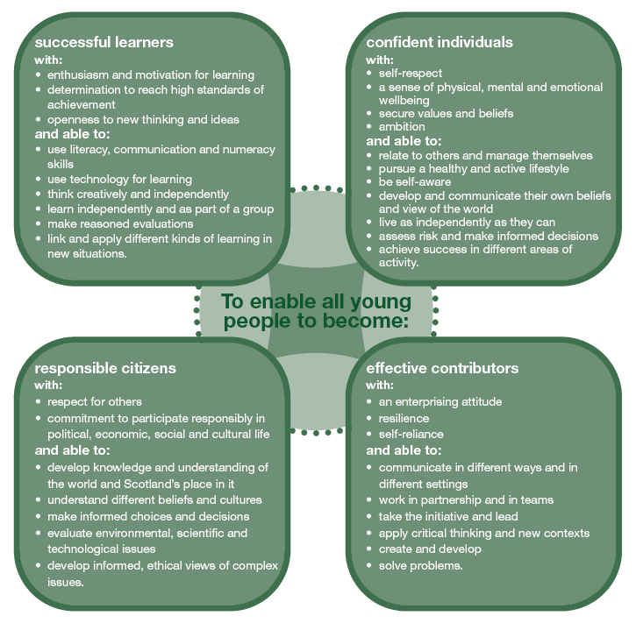
Further information about Curriculum for Excellence and the Experiences and Outcomes can be found on the Curriculum for Excellence website.

The curriculum
There are currently 8 areas covered under the Curriculum for Excellence:
- Health and Wellbeing
- Languages (English, modern languages, Gaidhlig and Gaelic learners)
- Expressive arts
- Mathematics
- Sciences
- Technologies
- Social Studies
- Moral and religious education
Numeracy, health and well-being and literacy are all recognised to be especially important and are the responsibility of every member of staff, regardless of their specialist subject.
For more information, please see the link below:
What is Curriculum for Excellence?
Within Corsehill our learners have access to a range of innovative learning spaces throughout the school including: The Play Zone, The Learning Zone, The Discovery Zone and the Outdoor Zone to complement the learning that takes places within the classroom.

Extra-curricular activities
As we rebuild and recover from Covid-19 we will be running extra-curricular opportunities for four week blocks at different stages throughout the school. We are very fortunate in that our staff are very dedicated and lead extra-curricular clubs within the school. These include clubs such as: football, athletics, basketball, gardening, choir, guitar, dance, netball, Zumba, STEM and eco-art.
We also have strong links with NAC Sports Development Team who also provide a number of experiences for our young people throughout each session.
Assessing Children’s Progress in the Broad General Education (BGE) Early Years – end of S3
Assessment is a central part of everyday learning and teaching for children and young people. Evidence of progress is gathered on an ongoing and informal basis through asking questions, observing children working together and making formative comments on their work. Children may also assess their own work or that of their classmates; this is called self and peer assessment. Some assessment is more formal such as projects, investigations and standardised assessments.
The assessment of children’s progress throughout the Broad General Education (BGE - Early Years – S3) is based on teachers’ professional judgement. Teachers draw on their professional knowledge and understanding of the child; on the benchmarks for literacy and numeracy, which provide clear information about what children and young people should be able to do and demonstrate by the end of a Curriculum for Excellence Level; and on a wide range of assessment information.
Teachers of P1, P4, P7 and S3 are asked at the end of every school year whether children have achieved the relevant Curriculum for Excellence level for their stage in reading, writing, talking and listening (literacy), and their ability to understand and work with numbers (numeracy). Most children are expected to have achieved the early level by the end of P1, first level by the end of P4, second level by the end of P7 and third or fourth level by the end of S3.
The government has also introduced new national standardised assessments (SNSA) which cover some aspects of reading, writing and working with numbers. These assessments are completed online and are automatically marked by the online system giving teachers immediate feedback to help plan next steps and support children’s progress.
Teachers remain best placed to know how the children in their class are progressing. Their professional judgement will continue to be the most important way of assessing your child’s progress at school.
Parents, families and carers have a key role in helping children to learn. Your child’s teacher will keep you informed about their progress. Please contact us if you have any concerns about their learning, assessment or for more information on how you can support your child’s learning at home. You will be invited to Termly Top Target Meetings four times a year to engage in learning conversations with your child and their teacher.

Homework
Parents have a very important role in helping their children to get the best out of school and it is important that they take an active interest in their child’s progress at school. This can be done by:
- Encouraging hard work and high standards at all times
- Stressing the importance and relevance of what is learned at school
- Supporting the school’s policy on homework and positive relationships
The type of homework will vary depending on the age and ability of individual pupils. Reading commonly forms part of the homework set and will be specified by the teacher. Learning to read can be challenging and the process is made easier if families read with their child and discuss the story and pictures in a way that encourages enjoyment and a love of books and stories. You will be issued with a login for Bug Club, our online reading programme. This will allow your child to access a wide selection of texts at home.
In the early and middle stages oral reading should be practiced regularly at home whereas in the upper primary, where children are competent in the mechanics of reading, a greater emphasis may be placed on silent reading and comprehension. Reading for enjoyment should be encouraged at all stages. Phonics and spelling are also an important part of homework. Maths homework will be given to consolidate understanding and proficiency at all stages of the school. To provide our children with a wide variety of learning experiences at home we use Seesaw, Education City and Bug Club as a resource. You will be provided with an individual login for these.
From time to time pupils are given assignments and personal projects which may involve research, investigation, preparing a speech, learning a poem or a similar activity. We really appreciate the involvement of parents and are very grateful to those parents who so faithfully support their child’s learning at home.
Section 6: School Improvement

Standards and Quality Report and School Improvement Plan
Schools in North Ayrshire follow a Quality Improvement process designed to highlight strengths and identify areas for improvement. The process is based on the school’s self-evaluation process with Heads of Service and Senior Managers involved in at least three formal validation visits each session.

This validation process involves talking to pupils, staff and parents about learning and improvements made by the school. This results in actions for improvement for the school to take forward in their planning process.

In addition, themed reviews are undertaken from time to time e.g. to look and report on the quality of the Broad General Education (3-18) and Senior phase Education within secondary schools. This process is based upon standards and expectations contained within the following National Standards documentation:
- National Improvement Framework
- How Good is Our School? 4
- How Good is Our Early Learning and Childcare?
- How Good is OUR School?

A Standards and Quality Report and School Improvement Plan are produced on an annual basis by every school and centre. Staff, Parents/ Carers, Young People and School Partners will play an active role in the development of these key school documents.

Both our School Improvement Plan and our Standards and Quality Report are detailed below and also are available on our website.

Standard and Quality Report
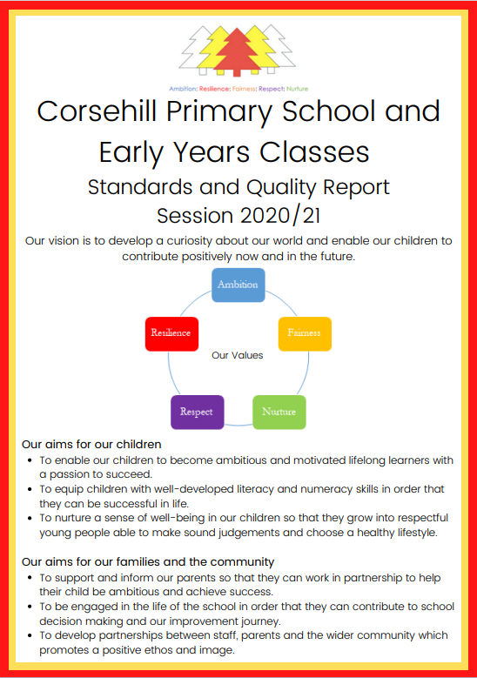

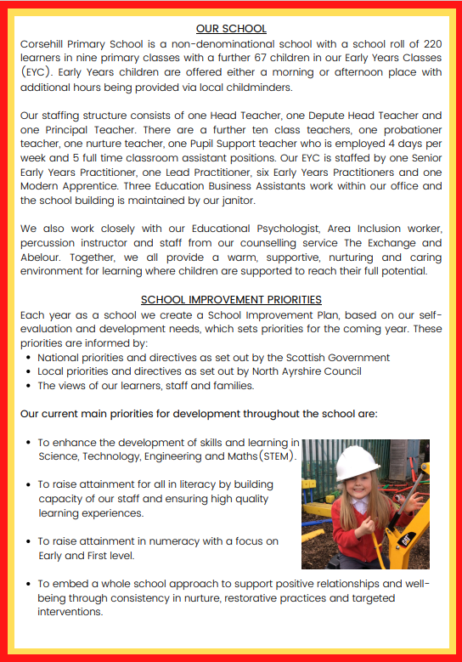
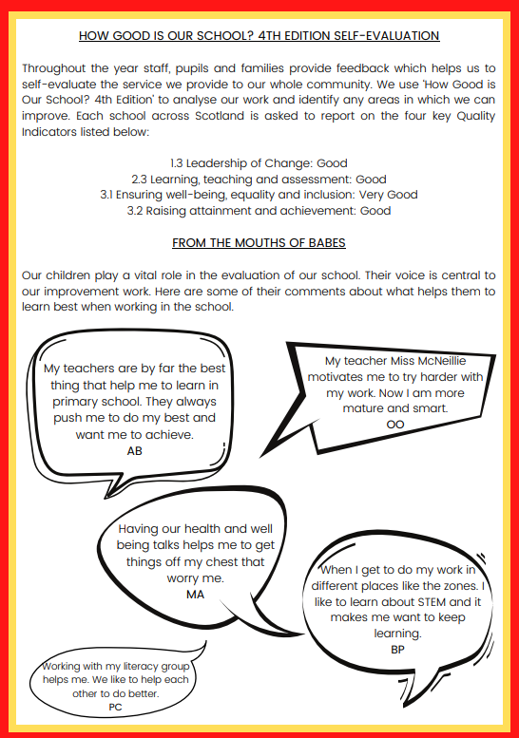

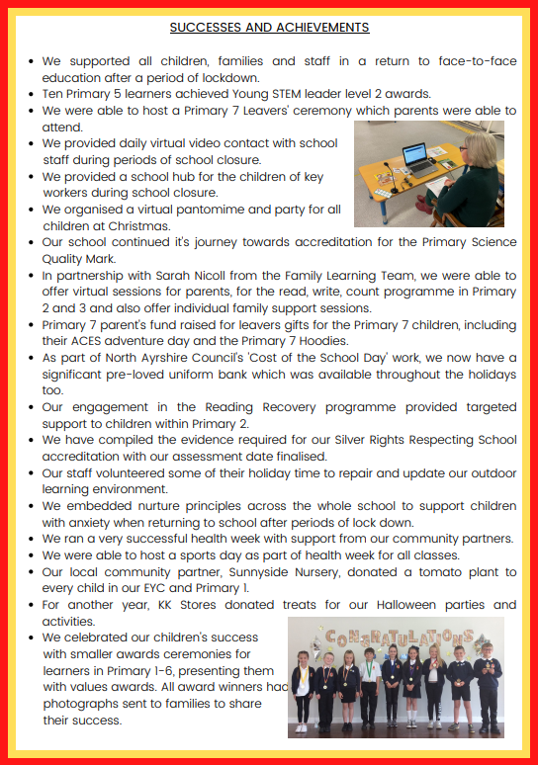
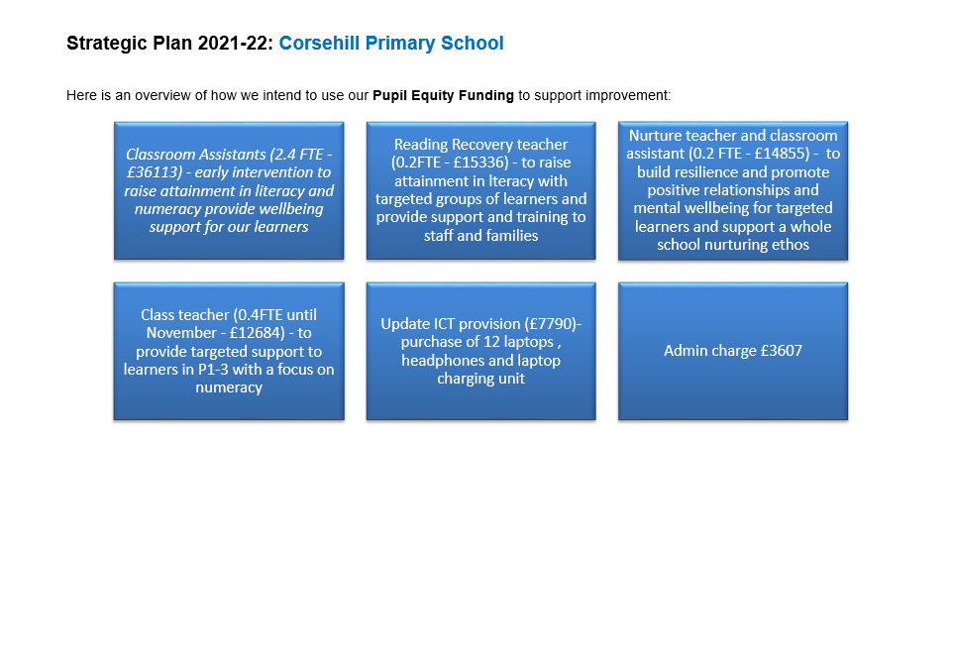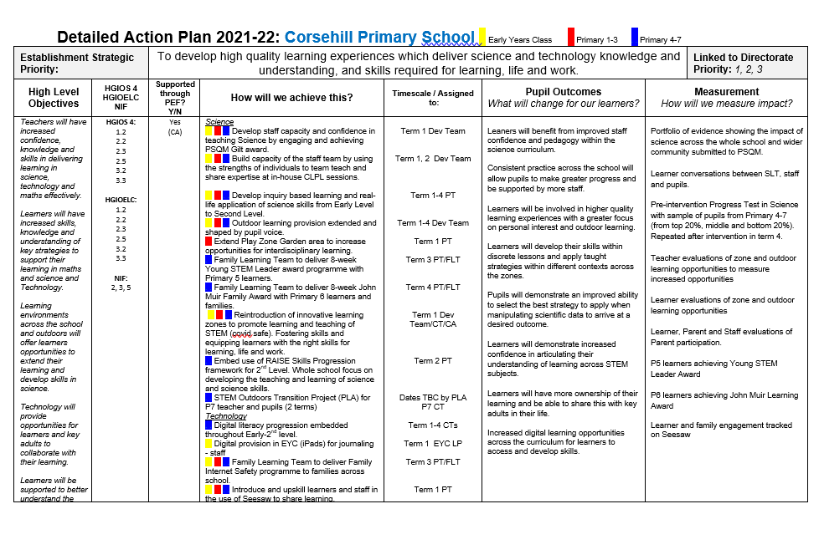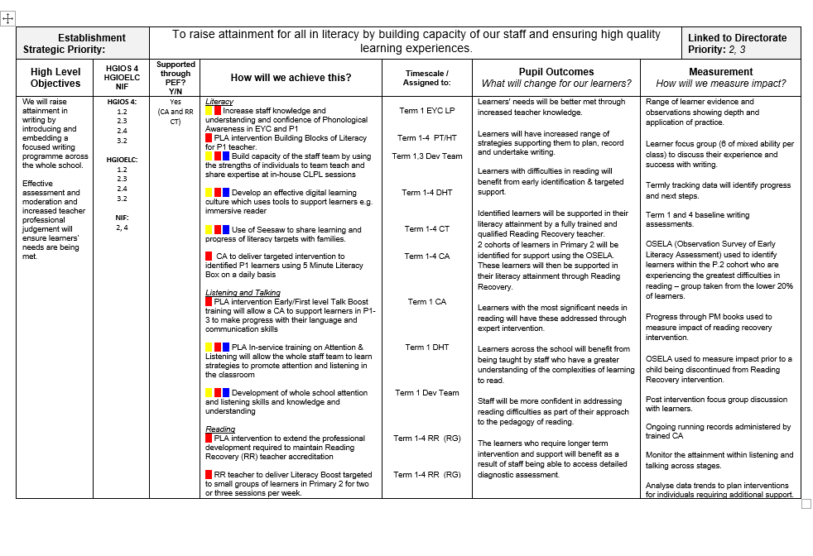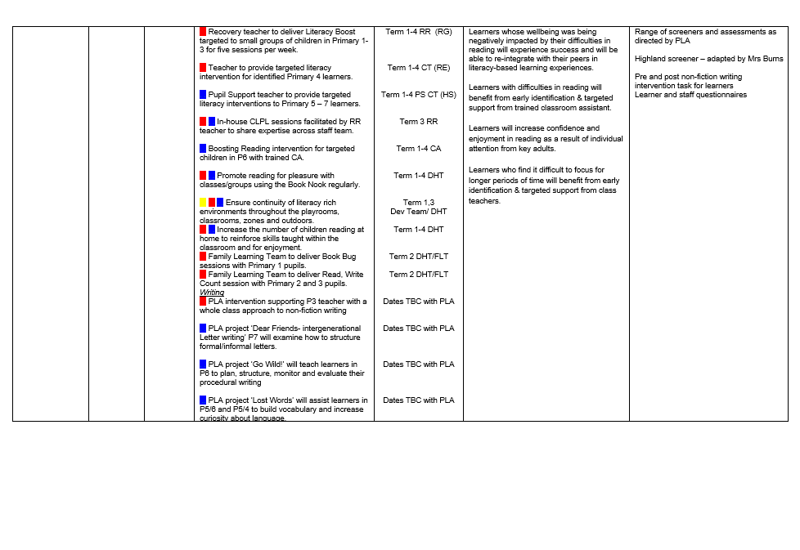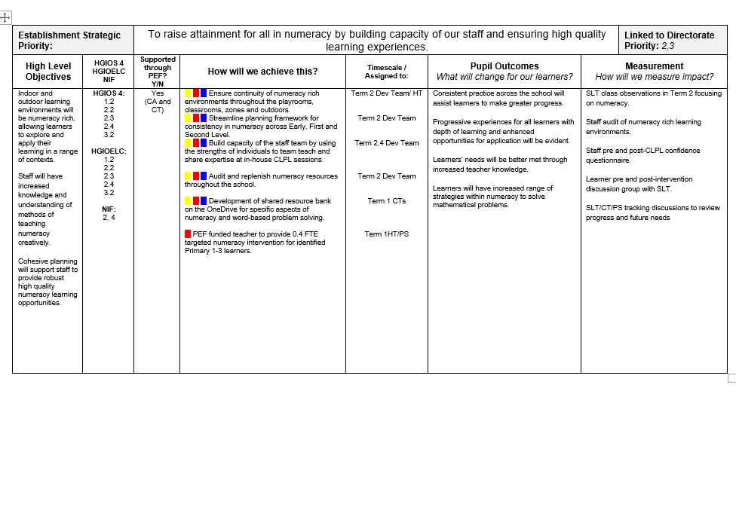
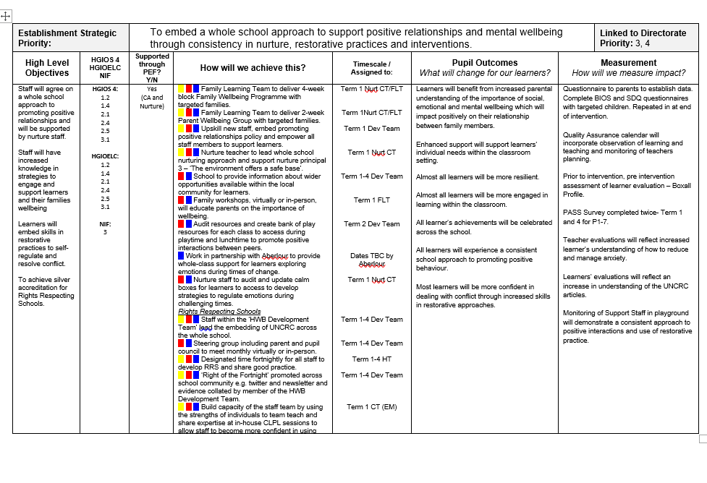
Section 7: Support for your Child

Equalities
In line with North Ayrshire Council policy, educational provision is open to all pupils, regardless of sex, age, religion, race, disability or any other potential barrier and all reasonable measures will be taken to ensure that the curriculum is available to every child. Schools also have a duty to promote equality and to eliminate racist and other discriminatory behaviours.
Equality Act 2010
The Equality Act 2010 has been drawn up to tackle inequality and prevent discrimination against people on the basis of ‘protected characteristics’. It brings together several existing laws and aims to make understanding the law simpler and also introduces a new single public sector equality duty, which requires public bodies to actively advance equality.
The duties set out in Chapter 1 of Part 6 of the Equality Act apply to all schools. These provisions protect pupils at the school and in the case of admissions, those applying or wishing to apply for admission. Former pupils are also protected from discrimination or harassment.
Guidance on the Act and its requirements for schools in relation to the provision of education can be accessed here:
Equality Act 2010

Child Protection
Educational Services has a fundamental duty to contribute to the care and safety of all children and young people in North Ayrshire. In fulfilling this duty, the service must engage in close partnership with parents / carers and relevant agencies, primarily Social Services and Health and where appropriate the Scottish Children’s Reporter’s Administration. Service will work in partnerships with a number of levels within the establishment or school, within the cluster or local area and through Integrated Children’s Services and Community Health Partnership.
The Standard Circular entitled “Protecting North Ayrshire Children” provides guidance for policy and practice within all educational establishments. The Council is one of the key partners in North Ayrshire. Child Protection Committee, multi-agency group which takes the lead role in ensuring that our children and young people are cared for, protected from harm and grow up in a safe environment.
Each school has a named Child Protection Co-ordinator who is the main point of contact for school staff and for external agencies seeking contact with the school on child protection matters. There is an extensive staff training programme available to staff and, in addition, at the beginning of each school session of all staff receive an update on child protection policies and procedures.

Inclusion
North Ayrshire Council is committed to the well-being and educational development of all learners. The process of inclusion requires all involved in the business of learning and teaching to demonstrate commitment, innovation and flexibility in order to ensure that all children and young people have access to quality learning opportunities and experiences. Our Inclusion Strategy states that:
- An inclusive approach to education supports an ethos of achievement and high expectation, recognises difference, respects these differences and sees differences between learners as opportunities for learning.
- An inclusive approach to education promotes tolerance and a positive understanding of diversity.
- An inclusive approach to education alleviates the barriers to learning, supports the achievement of all and has positive relationships at its heart.
The presumption of mainstream as outlined in the Standards in Scotland’s Schools (2000) sets out that children will be educated in a mainstream setting unless exceptional circumstances apply. North Ayrshire therefore has a duty to ensure that clear assessment outlines the additional support needs of a child or young person which may require support in an alternative provision.
Where this is the case, North Ayrshire has a clear process that supports the Team around the Child to make a recommendation for consideration of alternative provision. This is outlined in the Standard Circular E19 and requires establishment staff to work with parents/carers to ensure all supports have been put in place to support a child or young person in their mainstream context before submitting clear evidence of what has been implemented and going on to request alternative provision. North Ayrshire council staff will then make a recommendation based on the evaluation of this evidence and a review of the needs of the young person and the current peer group in each setting.
The Education (Disability Strategies and Pupils’ Educational Records) (Scotland) Act, October 2002, requires local education authorities to prepare and implement accessibility strategies to improve, over time, access to education for young people with disabilities. Access covers:
- The physical building and grounds
- The curriculum (both formal and informal)
- Information on any educational planning that might affect the child’s/young person’s education
The Education (Additional Support for Learning) (Scotland) (2009) Act sets out certain duties on local education authorities and confers certain rights on children and their parents. These duties include the need to:
- Identify, assess and address the need for additional support for any child or young person failing to benefit from school education, for whatever reason
- Seek and take account of the views of the child or young person on issues relating to their education
- Engage in helpful partnership working with parents/carers and staff from other agencies
These are the various pieces of legislation that support the right to inclusion and that define the main features of that right.

Additional Support for Learning
Any child who needs more or different support to what is normally provided in school or pre-schools is said to have ‘additional support needs’. This includes children who may need extra help with their education as a result of issues arising from social and emotional difficulties, bullying, physical disability, having English as an additional language, a sensory impairment or communication difficulty.
The Additional Support for Learning Act
The Education (Additional Support for Learning) (Scotland) Act 2004 came into force in November 2005. In June 2009, the Act was amended. These amendments form the Education (Additional Support for Learning) (Scotland) Act 2009 and came into force on November 2010.
Main provisions of the Act
- The Act provides the legal framework underpinning the system for supporting children and young people in their school education and their families.
- This framework is based on the idea of additional support needs. This broad and inclusive term applies to children or young people who, for whatever reason, require additional support, long or short term, in order to help them make the most of their school education and to be included fully in their learning.
- The 2009 Act automatically deems that all looked after children and young people have additional support needs unless the education authority determine that they do not require additional support in order to benefit from school education.
- In addition, education authorities must consider whether each looked after child or young person or whose school education they are responsible requires a co-ordinated support plan.
Duties under the ‘Additional Support for Learning’ legislation
North Ayrshire must assess any pupil with additional support needs and provide with any support necessary for them to benefit fully from their education. All the evidence says that it is best to intervene early to prevent any difficulties developing and taking root. For example by making sure reading is very well taught and that all pupil gets encouragement and support at home we can hopefully reduce later difficulties.
Whatever the type of challenge that arises, it is important to detect it early, develop a shared understanding of what is needed (the school may request extra specialised help to do this) and take action to help to pupil achieve. Whenever we start this process for any child or young person, we will always explain to them and to their parents/carers what our concerns are and what we will do to help.
The school can get support from a range of visiting professionals including Educational Psychologists. These professionals are regularly in all schools and teachers and others will ask for informal advice on supporting pupils for example on the best way to support a pupil who is having difficulties with reading. If the school wants more detailed individual help then they would talk to you about formally involving the educational psychologist. The educational psychologist can only be involved in consultation, collaborative assessment and planning interventions for your child after you agree to this.
For a few children and young people their needs are so complex that professionals from two or more agencies need to work together over a significant length of time to enable the child to benefit from school education.
The authority approach to staged intervention has been updated to take ensure it is line with the CYP (2014) and ASL (2004) (amended 2009) Acts. The aim is to ensure children and young people get the right support at the right time.
Where a child or young person has additional support needs, extra planning is required every time there is a move to a new class, new school or college. How far ahead this transition planning needs to start depends on the particular type of needs but for most children and young people with Additional Support Needs transition planning should start at least one year before the date of the planned move.
Detailed advice on transition planning is provided in the Supporting Children’s Learning Code of Practice, which can be accessed at the following link:
Supporting Children's Learning Code of Practice

Dispute Resolution Procedures
If you feel that things are not being done properly to support you child then the Council has a range of ways to work with you to resolve any issues. You can ask at any time for a copy of the booklet called ‘Resolving Disagreements’. This booklet will give you ways to make sure your concerns are listened to and addressed.

Further Support
The following organisations are able to provide advice, further information and support to parents of children and young people with ASN.
1. Enquire: Scottish Advice and Information Service for Additional Support for Learning
Website: Enquire
Helpline: 0345 123 2303
Email: info@enquire.org.uk
2. Scottish Independent Advocacy Alliance
Website: Scottish Independent Advocacy Alliance
Telephone: 0131 260 5380
Email: enquiry@siaa.org.uk
3. Scottish Child Law Centre
Website: Scottish Child Law Centre
Telephone: 0131 667 6333
Email: enquiries@sclc.org.uk

Getting It Right For Every Child – Ensuring their wellbeing
The Children and Young People (Scotland) Act 2014 puts children and young people at the heart of planning and services and ensures their rights are respected across the public sector. It seeks to improve the way services work to support children, young people and families.
- The Act ensures that all children and young people from birth to 18 years old have access to a Named Person.
- The Act puts in place a single planning process to support those children who require it.
- The Act places a definition of wellbeing in legislation.
- The Act places duties on public bodies to co-ordinate the planning, design and delivery of services for children and young people with a focus on improving wellbeing outcomes, and report collectively on how they are improving those outcomes.
Taking a ‘Getting it Right for Every Child’ approach to supporting every child is a priority within our school and we aim to assist every child I our school to reach their potential. The wellbeing of children and young people is at the heart of Getting it Right for Every Child. The approach uses eight areas to describe wellbeing in which children and young people need to progress in order to do well now and in the future.
The eight indicators of wellbeing (SHANARRI)
- Safe
- Healthy
- Achieving
- Nurtured
- Active
- Respected
- Responsible
- Included
Why we have to get it right for every child
Education and Youth Employment must safeguard, support and promote the wellbeing of all children and young people and address need at the earliest opportunity. These functions are the responsibility of schools and establishments and those who work in them and with them. All who work in Education and Youth Employment and in partnership with Education and Youth Employment have a responsibility to ensure the wellbeing of North Ayrshire’s children and young people.
For more information on GIRFEC within North Ayrshire go to North Ayrshire GIRFEC

Psychological Services
The Educational Psychology Service in North Ayrshire is part of and contributes to the aims of Education Services by improving outcomes for children and young people. Educational Psychologists work together with teachers, parents and other professionals to help children and young people achieve their full potential, within educational settings and the wider community. Educational Psychologists are involved in working with individuals, but also have a significant role in offering training, support and consultation to increase capacity in education establishments on a wide range of issues. They are also involved in supporting research to evaluate how effective approaches to support children and young people are.
Your child’s school / Early Years Centre already has a system of staged intervention for identifying, assessing, monitoring and reviewing the ongoing progress of all children and young people. As part of this wider system of support, each school and authority early years centre has a link educational psychologist.
When concerns arise about a particular pupil the school takes action to address these concerns. If the concerns continue, school / early years may have an informal discussion with the educational psychologist, and ask about general advice.
If needed, a formal consultation meeting with parents/carers involving the educational psychologist can then be arranged. This will be discussed with you beforehand. This may be a one off or may lead to longer term involvement. Through this process the educational psychologist can, if required, contribute to the ongoing assessment and support for your child including providing support to the family. The educational psychologist will be involved while there is a specific role for them and will use a strengths based, solution oriented approach which takes into account the wider context of the child, family and community.
Find out more at:
North Ayrshire Educational Psychology Service

Data Protection
Personal data is required to be collected by North Ayrshire Council in order to deliver education services. It is necessary to collect personal data regarding pupils, parents, carers and other individuals to enable us to carry out our duties under the Education (Scotland) Act 1980 and the Education (Scotland) Act 2016.
The Data Protection Act 2018 sets out the legal basis for processing data. You can refer to our privacy notice for details of the different basis under which we may process individuals’ data. Privacy Notice Statement
We may also share or receive an individual’s personal data with the following:
- Scottish Government & Education Scotland
- Private Nurseries’
- Strathclyde Passenger Transport
- Scottish Children’s Reporter Administration
- Social Work Services
- Scottish Public Services Ombudsman
Where we are required we will also make disclosures required by law and may also share information with other bodies responsible for detecting/preventing fraud or auditing/.administering public finds. Individuals’ have legal rights under the data protection legislation including the right of access. Further details can be found in the Council’s Privacy Policy at:
North Ayrshire Council Privacy Policy Statement

Medical and Health Care
Medical examinations are carried out at various times during a child’s primary school years. Parents are given notice of these and encouraged to attend. Vision and hearing test and dental examinations, which parents need not attend, are also carried out and parents informed of any recommended action or treatment. All examinations are carried out by Ayrshire and Arran Health Board staff.
If a pupil takes ill or has an accident at school, which requires that the child be sent home or for treatment, First Aid will be provided and parents or carers contacted immediately. (In the event of a serious illness or accident, a member of staff will accompany the child to a doctor or hospital and parents/ carers will be notified immediately.)
For this reason it is important that the school has contact details for parents/ carers and an additional contact person in case parents/ carers cannot be reached. It is also important that the school is kept fully informed and updated with regards to any medical condition.
It is the parent’s responsibility to notify the school and keep medical information updated as required.
Children will not be sent home unaccompanied.

Section 8: Parental Involvement

Parental Engagement and Involvement

NAC Parental Involvement Strategy

All schools have clear systems in place for communicating with everyone in the parent forum. Communications with parents are clear, jargon-free, specific and easily accessible. A variety of methods and approaches are used by schools to communicate with the parent forum including face to face, traditional communication methods and digital media e.g. Seesaw, Twitter, and Facebook. Considerations will always be given when communicating with parents who have literacy, language and communication challenges.

Schools ensure that parents know who to contact when they wish to discuss their child’s learning or wellbeing and will seek to provide a private space for such discussions and make sure parents are given adequate time and support. Consideration will be given to family circumstances.

Parents are welcome to contact the school at any time to arrange an appointment to discuss any matter with the class teacher, Depute Head, Head Teacher or Head of Centre. New families are welcome to contact the school and request a suitable visiting time at any point throughout the session

Parents are given opportunities to understand the way learning and teaching takes place in the classroom. This may be in the form of class visits to take part in the learning experience alongside their child or attending events which share the learning. Frequent invitations are issued to parents to participate in school activities such as open days, class assemblies, workshops and to assist with outings and visits, sports and concerts. There will be a series of early meetings for the parents of Primary 1 pupils and parents are kept informed of events with a range of newsletters, website updates, texts, invitations and social media sites.

A variety of methods will be used to ensure information about your child’s progress is shared. Schools are encouraged to provide parents/carers with information on their children’s progress at regular intervals throughout the year through a range of activities. There is an expectation that part of this will be in a written format.

Reporting Examples:

Individual Learners | Groups of learners
Written reports/ tracking reports | Assemblies
Termly Top Target conversations | Open day events
Pupil reflections on their learning on Seesaw | School concerts/shows
Box of Brilliance | Social media
Home/ school diaries where appropriate | Curriculum workshops led by children and young people and staff
Profiling activities | Parent Council meetings
Learning walls and displays | School / class newsletters

Parent Council
The Scottish Parliament has passed a law called the Scottish Schools (Parental Involvement) Act 2006 to encourage and support more parents to become involved in their child’s education.
The main aims of the Act are to:
- Help parents become more involved with their child’s education and learning.
- Welcome parents as active participants in the life of the school.
- Provide easier ways for parents to express their views and wishes.
To help achieve these aims, all parents are automatically members of the Parent Forum at their child’s school and are entitled to have a say in selecting the Parent Council (the representative body) to work on behalf of all parents at the school.
The objectives of the Parent Council are:
- To work in partnership with staff to create a welcoming school which is inclusive for all parents.
- To promote partnership between the school, its pupil and all its parents.
- To develop and engage in activities which support the education and welfare of the pupils.
- To identify and represent the views of parents on the education provided by the school and other matters affecting the education and welfare of pupils.
- To be involved in the recruitment process for appointing the Head Teacher and Depute Head Teacher of the school.
Corsehill Primary School has a Parent Council:
Staff Members are: Mrs. Marshall and Mr. Kirk
Chairperson: Ms. Crighton
Secretary: Mrs. McConnachie
Treasurer: Mrs. Wilson
Any parent or carer of a child at the school can volunteer to be a member of the Parent Council. The Head Teacher is the professional adviser to the Parent Council and has a right to attend and speak at Parent Council.

Parentzone Scotland
Parentzone Scotland is a unique website for parents and carers in Scotland, from early years to beyond school. The website provides up-to-date information about learning in Scotland, and practical advice and ideas to support children’s learning at home in literacy, numeracy, health and wellbeing and science.
Information is also available on Parentzone Scotland regarding additional support needs, how parents can get involved in their child’s school and education. Furthermore, the website has details about schools including performance data for school leavers from S4-S6; and links to the national, and local authority and school level data on the achievement of Curriculum for Excellence levels.
Parentzone Scotland can be accessed at Parentzone Scotland .

School Committees
Within Corsehill we value pupil voice. Children help to shape learning and prioritise improvements across the school. Part of this process involves children working within different committees such as: Pupil Council, Eco-Committee, HGIOURS Helpers, Rights Respecting, Digital Leaders, Junior Road Safety Officers and Sports Leaders.

Section 9: Pupil Data Collection and Protection Policies
The Scottish Government and its partners collect and use information about pupils through the Pupil Census to help to improve education across Scotland. This note explains why we need this information, how we use it and what we do to protect the information supplied to us.

Why do we need your data?
In order to make the best decisions about how to improve our education service, Scottish Government, education authorities and other partners such as the SQA and Skills Development Scotland need accurate, up-to-date data about our pupils. We are keen to help all our pupils do well in all aspects of school life and achieve better examination results. Accurate and up-to-date data allows us to:

- plan and deliver better policies for the benefit of all pupils
- plan and deliver better policies for the benefit of specific groups of pupils
- better understand some of the factors which influence pupil attainment and achievement
- plan and implement targeted approaches to reducing the poverty-related attainment gap
- share good practice
- conduct teacher workforce planning
- target resources better
- enhance the quality of research to improve the lives of young people in Scotland
- provide a window on society, the economy and on the work and performance of government by:
Pupil Census Supplementary Statistics

Data policy
Information about pupils’ education is collected through our statistical surveys in partnership between the Scottish Government and Local Authorities through the ScotXed Programme which aims to help schools and Local Authorities by supporting efficient collection, processing and dissemination of statistical information. The Scottish Government then provides analysis of the data to support research, planning, management and monitoring of education services as well as to produce National Statistics publications.

Education data within Scottish Government is managed effectively by secure systems on secure servers and is exploited as a valuable corporate resource, subject to confidentiality restraints. As part of its data policy, Scottish Government will not publish or make publicly available any information that allows individual pupils to be identified, nor will data be used by Scottish Government to take any actions in respect of individuals. Data is held securely and no information on individual pupils can or would be made publicly available by Scottish Government.

The individual data collected by Scottish Government through the Pupil Census is used for statistical and research purposes only.

Your data protection rights
Any sharing or linkage of data will be done under the strict control of Scottish Government, and will be consistent with their data policy and the National Data Linkage Guiding Principles. Decisions on the sharing or linkage of data will be taken in consultation with relevant colleagues and individuals within and out with Scottish Government as part of a Data Access Panel. At all times the rights of the individual (children or adults) under the GDPR and other relevant legislation will be ensured. Further information can be found on: Scottish Exchange of Data: privacy Information

Concerns
If you have any concerns about the ScotXed data collections you can email the Data Protection & Information Assets Team on dpa@gov.scot or the Head of Education Analytical Services, Mick Wilson, at mick.wilson@gov.scot or by writing to Education Analytical Services, Area 2A-North, Victoria Quay, Leith, EH6 6QQ. Alternative versions of this page are available, on request from the ScotXed Support Office, in other languages, audio tape, Braille and large print.

Alternatively complaints may be raised with the Information Commissioners Office at casework@ico.org.uk.

Important Contacts
Interim Executive Director (Communities)
Caroline Amos
North Ayrshire Council
Cunninghame House
IRVINE
KA12 8EE
01294 310000

Head of Service
Andrew McClelland
North Ayrshire Council
Cunninghame House
IRVINE
KA12 8EE
01294 310000

Interim Head of Service
Lindsay Morris
North Ayrshire Council
Cunninghame House
IRVINE
KA12 8EE
01294 310000

