**Communities and Education Directorate**

**Corsehill Primary School & Early Years**

**Improvement Plan 2021-2022**

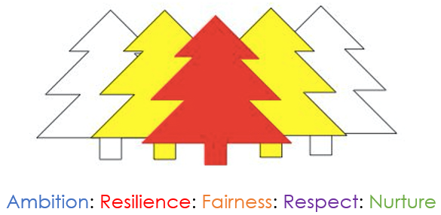



**Vision, Values and Aims**

Our vision is to develop a curiosity about our world and enable our children to contribute positively now and in the future.

Our aims for our children

* To enable our children to become ambitious and motivated lifelong learners with a passion to succeed.
* To equip children with well-developed literacy and numeracy skills in order that they can be successful in life.
* To nurture a sense of wellbeing in our children so that they grow into respectful young people able to make sound judgements and choose a healthy lifestyle.

Our aims for our families and the community

* To support and inform our parents so that they can work in partnership to help their child be ambitious and achieve success.
* To be engaged in the life of the school in order that they can contribute to school decision making and our improvement journey.
* To develop partnerships between staff, parents and the wider community which promotes a positive ethos and image.

**The North Ayrshire Annual Improvement Plan**

The North Ayrshire Education annual improvement plan sets out our priorities for the year ahead in pursuit of the joint aims of achieving excellence and equity for our learners. It takes account of the feedback from consultation with our stakeholders across the Council and community and ensures the delivery of the locally agreed priorities of the Council Plan and the nationally agreed priorities of the National Improvement Framework. In the delivery of this plan, we will work in close partnership across the Council and communities of North Ayrshire and as part of the South West Educational Improvement Collaborative (SWEIC).

The COVID-19 pandemic has presented us with a fresh set of challenges and this plan reflects this new evolving context. Therefore, this is a plan like no other previously devised. However, as well as the context, it draws on the rigorous self-evaluation undertaken in establishments and across the service of the progress towards the previous year’s plan. The process of arriving at the service level priorities and strategic actions included engagement of Head Teachers and the service leadership team in evaluation and planning sessions. At school level, this exercise was repeated with pupils, staff, parents/carers and key partners.

**Council Priorities:**

The Council strategic priorities for 2019-24 are detailed below:

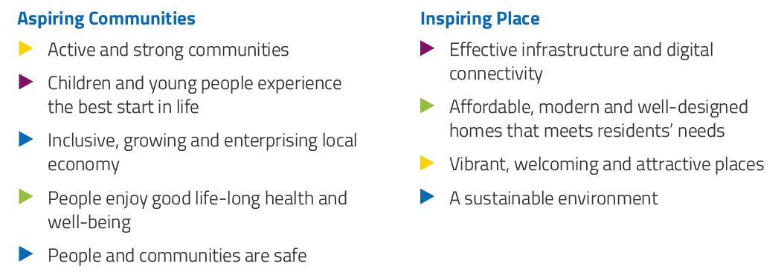

**National Improvement Framework:**

The National Improvement Framework for Education is designed to help us deliver the twin aims of excellence and equity; galvanising efforts and aligning our collective improvement activities across all partners in the education system to address our key priorities. These priorities remain as:

* Improvement in attainment, particularly in literacy and numeracy
* Closing the attainment gap between the most and least disadvantaged children
* Improvement in children and young people’s health and wellbeing
* Improvement in employability skills and sustained, positive school-leaver destinations for all young people

Alignment to Local and National Plans

This plan is aligned to local and national plans as follows:

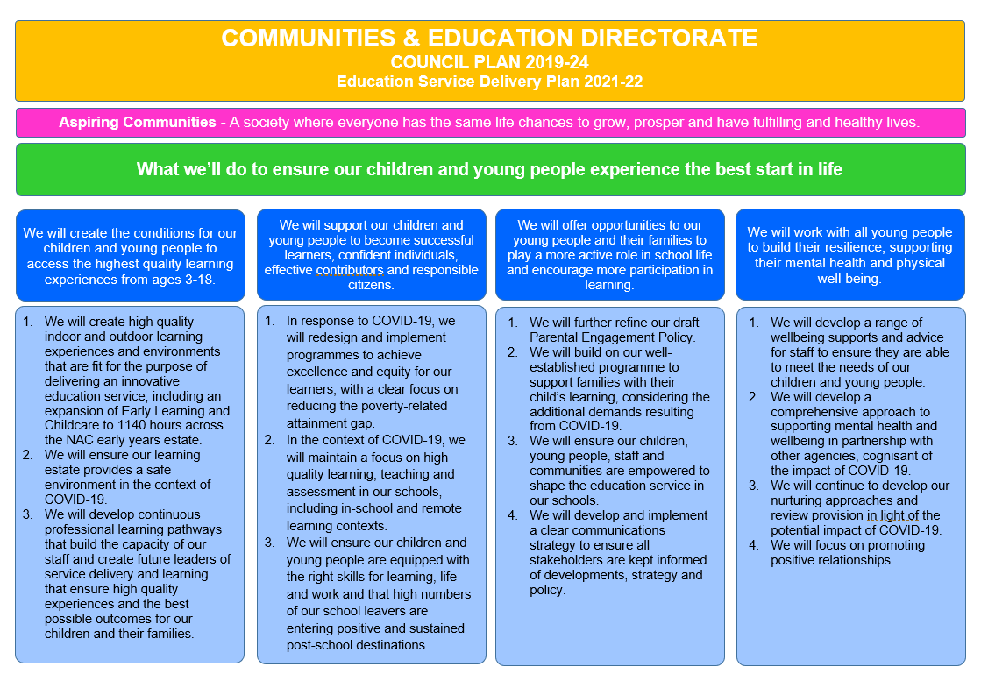

**Strategic Plan 2021-22: Corsehill Primary School & Early Years**

|  |  |  |  |  |
| --- | --- | --- | --- | --- |
| **School Priorities** | To enhance the development of skills and learning in Science, Technology, Engineering and Maths (STEM) | To raise attainment for all in literacy by building capacity of our staff and ensuring high quality learning experiences. | To raise attainment in numeracy with a focus on Early and First level | To embed a whole school approach to support positive relationships and wellbeing through consistency in nurture, restorative practices and targeted interventions. |
| **High Level Objectives** | Teachers will have increased confidence, knowledge and skills in delivering learning in science, technology and maths effectively.  Learners will have increased skills, knowledge and understanding of key strategies to support their learning in maths and science and Technology.  Learning environments across the school and outdoors will offer learners opportunities to extend their learning and develop skills in science.  Technology will provide opportunities for learners and key adults to collaborate with their learning.  Learners will be supported to better understand the world of work by working in collaboration and partnership with cluster peers. | Reading Recovery teacher will use diagnostic assessment to identify the needs of our Primary 2 learners and support the most suitable learners in P2 with the RR intervention.  Staff will share their vast knowledge of tailored interventions with the whole staff and specific families.  Identified learners will be provided with additional literacy support.  Staff will engage with universal and targeted interventions to improve the literacy provision across the establishment. | Indoor and outdoor learning environments will be numeracy rich, allowing learners to explore and apply their learning in a range of contexts.  Staff will have increased knowledge and understanding of methods of teaching numeracy creatively.  Cohesive planning will support staff to provide robust high quality numeracy learning opportunities. | Staff will agree on a whole school approach to promoting positive relationships and will be supported by nurture staff.  Staff will have increased knowledge in strategies to engage and support learners and their families’  wellbeing.  Learners will embed skills in restorative practices to self-regulate and resolve conflict.  To achieve silver accreditation for Rights Respecting Schools. |

**Strategic Plan 2021-22: Corsehill Primary School**

Here is an overview of how we intend to use our **Pupil Equity Funding** to support improvement:

**Detailed Action Plan 2021-22: Corsehill Primary School** . . Early Years Class . . Primary 1-3 . . Primary 4-7

|  |  |  |  |  |  |  |  |
| --- | --- | --- | --- | --- | --- | --- | --- |
| **Establishment Strategic Priority:** | | To develop high quality learning experiences which deliver science and technology knowledge and understanding, and skills required for learning, life and work. | | | | | **Linked to Directorate Priority:** *1, 2, 3* |
| **High Level Objectives** | **HGIOS 4**  **HGIOELC**  **NIF** | **Supported through PEF?**  **Y/N** | **How will we achieve this?** | **Timescale / Assigned**  **to:** | **Pupil Outcomes**  *What will change for our learners?* | **Measurement**  *How will we measure impact?* | |
| *Teachers will have increased confidence, knowledge and skills in delivering learning in science, technology and maths effectively.*    *Learners will have increased skills, knowledge and understanding of key strategies to support their learning in maths and science and Technology.*  *Learning environments across the school and outdoors will offer learners opportunities to extend their learning and develop skills in science.*  *Technology will provide opportunities for learners and key adults to collaborate with their learning.*  *Learners will be supported to better understand the world of work by working in collaboration and partnership with cluster peers.* | **HGIOS 4:**  1.2  2.2  2.3  2.5  3.2  3.3  **HGIOELC:**  1.2  2.2  2.3  2.5  3.2  3.3  **NIF:**  2, 3, 5 | Yes  (CA) | *Science*  . . . . . . Develop staff capacity and confidence in teaching Science by engaging and achieving PSQM Gilt award.  . . . . . . Build capacity of the staff team by using the strengths of individuals to team teach and share expertise at in-house CLPL sessions.  . . . . . . Develop inquiry based learning and real-life application of science skills from Early Level to Second Level.  . . . . . . Outdoor learning provision extended and shaped by pupil voice.  . . Extend Play Zone Garden area to increase opportunities for interdisciplinary learning.  . . Family Learning Team to deliver 8-week Young STEM Leader award programme with Primary 5 learners.  . . Family Learning Team to deliver 8-week John Muir Family Award with Primary 6 learners and families.  . . . . . . Reintroduction of innovative learning zones to promote learning and teaching of STEM (covid safe). Fostering skills and equipping learners with the right skills for learning, life and work.  . . Embed use of RAISE Skills Progression framework for 2nd Level. Whole school focus on developing the teaching and learning of science and science skills.  . . STEM Outdoors Transition Project (PLA) for P7 teacher and pupils (2 terms)  *Technology*  . . Digital literacy progression embedded throughout Early-2nd level.  . . Digital provision in EYC (iPads) for journaling - staff  . . . . . . Family Learning Team to deliver Family Internet Safety programme to families across school.  . . . . . . Introduce and upskill learners and staff in the use of Seesaw to share learning.  . . . . . . Promote engagement with families through digital platforms and in person when permitted.  *Developing Young Workforce*  . . . . . . Engage with cluster SLT to develop a Developing Young Workforce project agreed at cluster level (action plan to be agreed in Aug 21). | Term 1 Dev Team  Term 1, 2 Dev Team  Term 1-4 PT  Term 1-4 Dev Team  Term 1 PT  Term 3 PT/FLT  Term 4 PT/FLT  Term 1 Dev Team/CT/CA  Term 2 PT  Dates TBC by PLA  P7 CT  Term 1-4 CTs  Term 1 EYC LP  Term 3 PT/FLT  Term 1 PT  Term 1-4 CT  Term 1-4 DHT | Leaners will benefit from improved staff confidence and pedagogy within the science curriculum.  Consistent practice across the school will allow pupils to make greater progress and be supported by more staff.  Learners will be involved in higher quality learning experiences with a greater focus on personal interest and outdoor learning.  Learners will develop their skills within discrete lessons and apply taught strategies within different contexts across the zones.  Pupils will demonstrate an improved ability to select the best strategy to apply when manipulating scientific data to arrive at a desired outcome.  Learners will demonstrate increased confidence in articulating their understanding of learning across STEM subjects.  Learners will have more ownership of their learning and be able to share this with key adults in their life.  Increased digital learning opportunities across the curriculum for learners to access and develop skills. | Portfolio of evidence showing the impact of science across the whole school and wider community submitted to PSQM.  Learner conversations between SLT, staff and pupils.  Pre-intervention Progress Test in Science with sample of pupils from Primary 4-7 (from top 20%, middle and bottom 20%).  Repeated after intervention in term 4.  Teacher evaluations of zone and outdoor learning opportunities to measure increased opportunities  Learner evaluations of zone and outdoor learning opportunities  Learner, Parent and Staff evaluations of Parent participation.  P5 learners achieving Young STEM Leader Award  P6 learners achieving John Muir Learning Award  Learner and family engagement tracked on Seesaw | |

|  |  |  |  |  |  |  |  |
| --- | --- | --- | --- | --- | --- | --- | --- |
| **Establishment Strategic Priority:** | | To raise attainment for all in literacy by building capacity of our staff and ensuring high quality learning experiences. | | | | | **Linked to Directorate Priority:** *2, 3* |
| **High Level Objectives** | **HGIOS 4**  **HGIOELC**  **NIF** | **Supported through PEF?**  **Y/N** | **How will we achieve this?** | **Timescale / Assigned to:** | **Pupil Outcomes**  *What will change for our learners?* | **Measurement**  *How will we measure impact?* | |
| We will raise attainment in writing by introducing and embedding a focused writing programme across the whole school.  Effective assessment and moderation and increased teacher professional judgement will ensure learners’ needs are being met. | **HGIOS 4:**  1.2  2.3  2.4  3.2  **HGIOELC:**  1.2  2.3  2.4  3.2  **NIF:**  2, 4 | Yes  (CA and RR CT) | *Literacy*  . . . . Increase staff knowledge and understanding and confidence of Phonological Awareness in EYC and P1  . . PLA intervention Building Blocks of Literacy for P1 teacher.  . . . . . . Build capacity of the staff team by using the strengths of individuals to team teach and share expertise at in-house CLPL sessions  . . . . . . Develop an effective digital learning culture which uses tools to support learners e.g. immersive reader  . . . . . . Use of Seesaw to share learning and progress of literacy targets with families.  . .CA to deliver targeted intervention to identified P1 learners using 5 Minute Literacy Box on a daily basis  *Listening and Talking*  . . PLA intervention Early/First level Talk Boost training will allow a CA to support learners in P1-3 to make progress with their language and communication skills  . . . . . . PLA In-service training on Attention & Listening will allow the whole staff team to learn strategies to promote attention and listening in the classroom  . . . . . . Development of whole school attention and listening skills and knowledge and understanding  *Reading*  . . PLA intervention to extend the professional development required to maintain Reading Recovery (RR) teacher accreditation  . . RR teacher to deliver Literacy Boost targeted to small groups of learners in Primary 2 for two or three sessions per week.  . . Recovery teacher to deliver Literacy Boost targeted to small groups of children in Primary 1-3 for five sessions per week.  . . Teacher to provide targeted literacy intervention for identified Primary 4 learners.  . . Pupil Support teacher to provide targeted literacy interventions to Primary 5 – 7 learners.  . . . . In-house CLPL sessions facilitated by RR teacher to share expertise across staff team.  . . Boosting Reading intervention for targeted children in P6 with trained CA.  . . . . Promote reading for pleasure with classes/groups using the Book Nook regularly.  . . . . . . Ensure continuity of literacy rich environments throughout the playrooms, classrooms, zones and outdoors.  . . . . Increase the number of children reading at home to reinforce skills taught within the classroom and for enjoyment.  . . Family Learning Team to deliver Book Bug sessions with Primary 1 pupils.  . . Family Learning Team to deliver Read, Write Count session with Primary 2 and 3 pupils.  *Writing*  . . PLA intervention supporting P3 teacher with a whole class approach to non-fiction writing  . . PLA project ‘Dear Friends- intergenerational Letter writing’ P7 will examine how to structure formal/informal letters.  . . PLA project ‘Go Wild!’ will teach learners in P6 to plan, structure, monitor and evaluate their procedural writing  .. PLA project ‘Lost Words’ will assist learners in P5/6 and P5/4 to build vocabulary and increase curiosity about language. | Term 1 EYC LP  Term 1-4 PT/HT  Term 1,3 Dev Team  Term 1-4 DHT  Term 1-4 CT  Term 1-4 CA  Term 1 CA  Term 1 DHT  Term 1 Dev Team  Term 1-4 RR (RG)  Term 1-4 RR (RG)  Term 1-4 RR (RG)  Term 1-4 CT (RE)  Term 1-4 PS CT (HS)  Term 3 RR  Term 1-4 CA  Term 1-4 DHT  Term 1,3  Dev Team/ DHT  Term 1-4 DHT  Term 2 DHT/FLT  Term 2 DHT/FLT  Dates TBC with PLA  Dates TBC with PLA  Dates TBC with PLA  Dates TBC with PLA | Learners' needs will be better met through increased teacher knowledge.  Learners will have increased range of strategies supporting them to plan, record and undertake writing.  Learners with difficulties in reading will benefit from early identification & targeted support.  Identified learners will be supported in their literacy attainment by a fully trained and qualified Reading Recovery teacher.  2 cohorts of learners in Primary 2 will be identified for support using the OSELA. These learners will then be supported in their literacy attainment through Reading Recovery.  Learners with the most significant needs in reading will have these addressed through expert intervention.  Learners across the school will benefit from being taught by staff who have a greater understanding of the complexities of learning to read.  Staff will be more confident in addressing reading difficulties as part of their approach to the pedagogy of reading.  The learners who require longer term intervention and support will benefit as a result of staff being able to access detailed diagnostic assessment.  Learners whose wellbeing was being negatively impacted by their difficulties in reading will experience success and will be able to re-integrate with their peers in literacy-based learning experiences.  Learners with difficulties in reading will benefit from early identification & targeted support from trained classroom assistant.  Learners will increase confidence and enjoyment in reading as a result of individual attention from key adults.  Learners who find it difficult to focus for longer periods of time will benefit from early identification & targeted support from class teachers. | Range of learner evidence and observations showing depth and application of practice.  Learner focus group (6 of mixed ability per class) to discuss their experience and success with writing.  Termly tracking data will identify progress and next steps.  Term 1 and 4 baseline writing assessments.  OSELA (Observation Survey of Early Literacy Assessment) used to identify learners within the P.2 cohort who are experiencing the greatest difficulties in reading – group taken from the lower 20% of learners.  Progress through PM books used to measure impact of reading recovery intervention.  OSELA used to measure impact prior to a child being discontinued from Reading Recovery intervention.  Post intervention focus group discussion with learners.  Ongoing running records administered by trained CA  Monitor the attainment within listening and talking across stages.  Analyse data trends to plan interventions for individuals requiring additional support.  Range of screeners and assessments as directed by PLA  Highland screener – adapted by Mrs Burns  Pre and post non-fiction writing intervention task for learners  Learner and staff questionnaires | |

|  |  |  |  |  |  |  |  |
| --- | --- | --- | --- | --- | --- | --- | --- |
| **Establishment Strategic Priority:** | | To raise attainment for all in numeracy by building capacity of our staff and ensuring high quality learning experiences. | | | | | **Linked to Directorate Priority:** *2,3* |
| **High Level Objectives** | **HGIOS 4**  **HGIOELC**  **NIF** | **Supported through PEF?**  **Y/N** | **How will we achieve this?** | **Timescale / Assigned to:** | **Pupil Outcomes**  *What will change for our learners?* | **Measurement**  *How will we measure impact?* | |
| Indoor and outdoor learning environments will be numeracy rich, allowing learners to explore and apply their learning in a range of contexts.  Staff will have increased knowledge and understanding of methods of teaching numeracy creatively.  Cohesive planning will support staff to provide robust high quality numeracy learning opportunities. | **HGIOS 4:**  1.2  2.2  2.3  2.4  3.2  **HGIOELC:**  1.2  2.2  2.3  2.4  3.2  **NIF:**  2, 4 | Yes  (CA and CT) | . . . . . . Ensure continuity of numeracy rich environments throughout the playrooms, classrooms, zones and outdoors.  . . . . . . Streamline planning framework for consistency in numeracy across Early, First and Second Level.  . . . . . . Build capacity of the staff team by using the strengths of individuals to team teach and share expertise at in-house CLPL sessions.  . . . . . . Audit and replenish numeracy resources throughout the school.  . . . . . . Development of shared resource bank on the OneDrive for specific aspects of numeracy and word-based problem solving.  . . PEF funded teacher to provide 0.4 FTE targeted numeracy intervention for identified Primary 1-3 learners. | Term 2 Dev Team/ HT  Term 2 Dev Team  Term 2,4 Dev Team  Term 2 Dev Team  Term 1 CTs  Term 1HT/PS | Consistent practice across the school will assist learners to make greater progress.  Progressive experiences for all learners with depth of learning and enhanced opportunities for application will be evident.  Learners’ needs will be better met through increased teacher knowledge.  Learners will have increased range of strategies within numeracy to solve mathematical problems. | SLT class observations in Term 2 focusing on numeracy.  Staff audit of numeracy rich learning environments.  Staff pre and post-CLPL confidence questionnaire.  Learner pre and post-intervention discussion group with SLT.  SLT/CT/PS tracking discussions to review progress and future needs | |

|  |  |  |  |  |  |  |  |
| --- | --- | --- | --- | --- | --- | --- | --- |
| **Establishment Strategic Priority:** | | To embed a whole school approach to support positive relationships and mental wellbeing through consistency in nurture, restorative practices and interventions. | | | | | **Linked to Directorate Priority:** 3, 4 |
| **High Level Objectives** | **HGIOS 4**  **HGIOELC**  **NIF** | **Supported through PEF?**  **Y/N** | **How will we achieve this?** | **Timescale / Assigned to:** | **Pupil Outcomes**  *What will change for our learners?* | **Measurement**  *How will we measure impact?* | |
| Staff will agree on a whole school approach to promoting positive relationships and will be supported by nurture staff.  Staff will have increased knowledge in strategies to engage and support learners and their families wellbeing  Learners will embed skills in restorative practices to self-regulate and resolve conflict.  To achieve silver accreditation for Rights Respecting Schools. | **HGIOS 4:**  1.2  1.4  2.1  2.4  2.5  3.1  **HGIOELC:**  1.2  1.4  2.1  2.4  2.5  3.1  **NIF:**  3 | Yes  (CA and Nurture) | . . . . . . Family Learning Team to deliver 4-week block Family Wellbeing Programme with targeted families.  . . . . . . Family Learning Team to deliver 2-week Parent Wellbeing Group with targeted families.  . . . . . . Upskill new staff, embed promoting positive relationships policy and empower all staff members to support learners.  . . . . . . Nurture teacher to lead whole school nurturing approach and support nurture principal 3 – ‘The environment offers a safe base’.  . . . . School to provide information about wider opportunities available within the local community for learners.  . . . . Family workshops, virtually or in-person, will educate parents on the importance of wellbeing.  . . . . Audit resources and create bank of play resources for each class to access during playtime and lunchtime to promote positive interactions between peers.  . . Work in partnership with Aberlour to provide whole-class support for learners exploring emotions during times of change.  . . . . Nurture staff to audit and update calm boxes for learners to access to develop strategies to regulate emotions during challenging times.  *Rights Respecting Schools*  . . . . . . Staff within the ‘HWB Development Team’ lead the embedding of UNCRC across the whole school.  . . . . Steering group including parent and pupil council to meet monthly virtually or in-person.  . . . . . . Designated time fortnightly for all staff to develop RRS and share good practice.  . . . . . . ‘Right of the Fortnight’ promoted across school community e.g. twitter and newsletter and evidence collated by member of the HWB Development Team.  . . . . . . Build capacity of the staff team by using the strengths of individuals to team teach and share expertise at in-house CLPL sessions to allow staff to become more confident in using the language associated with RRS i.e. duty bearers  . . . . Each class has their own ‘pupil voice box’ where children can make suggestions to make improvements for the school and wider community. These ideas are then discussed with pupil council members. | Term 1 Nurt CT/FLT  Term 1Nurt CT/FLT  Term 1 Dev Team  Term 1 Nurt CT  Term 1-4 Dev Team  Term 1 FLT  Term 2 Dev Team  Dates TBC by Aberlour  Term 1 Nurt CT  Term 1-4 Dev Team  Term 1-4 Dev Team  Term 1-4 HT  Term 1-4 Dev Team  Term 1 CT (EM)  Term 1 Dev Team | Learners will benefit from increased parental understanding of the importance of social, emotional and mental wellbeing which will impact positively on their relationship between family members.  Enhanced support will support learners’ individual needs within the classroom setting.  Almost all learners will be more resilient.  Almost all learners will be more engaged in learning within the classroom.  All learner’s achievements will be celebrated across the school.  All learners will experience a consistent school approach to promoting positive behaviour.  Most learners will be more confident in dealing with conflict through increased skills in restorative approaches. | Questionnaire to parents to establish data. Complete BIOS and SDQ questionnaires with targeted children. Repeated in at end of intervention.  Quality Assurance calendar will incorporate observation of learning and teaching and monitoring of teachers planning.  Prior to intervention, pre intervention assessment of learner evaluation – Boxall Profile.  PASS Survey completed twice- Term 1 and 4 for P1-7.  Teacher evaluations will reflect increased learner’s understanding of how to reduce and manage anxiety.  Learners’ evaluations will reflect an increase in understanding of the UNCRC articles.  Monitoring of Support Staff in playground will demonstrate a consistent approach to positive interactions and use of restorative practice. | |