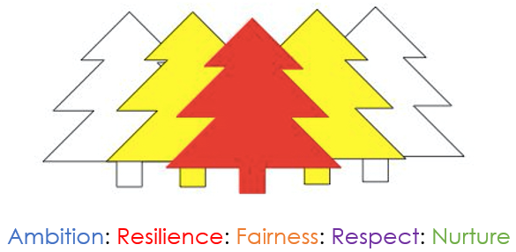

**Corsehill Primary School and Early Years Classes**

*“To develop a curiosity about our world and enable our children to contribute positively now and in the future.”*

**Standards and Quality Report**

**2019 – 2020**

**Scotland’s National Improvement Priorities:**

1. Improvement in attainment, particularly in literacy and numeracy
2. Closing the attainment gap between the most and least disadvantaged children
3. Improvement in children and young people’s health and wellbeing
4. Improvement in employability skills and sustained, positive school-leaver destinations for all young people

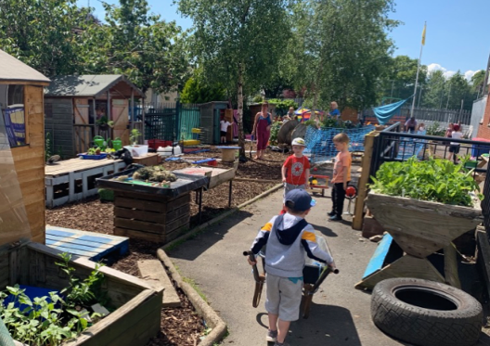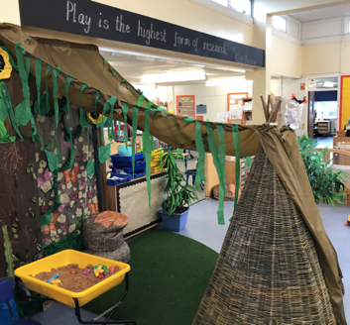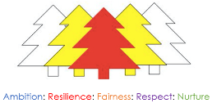

**Resilience**

Scan the QR code to be taken to our survey about improvements.

We keep this survey open all year so if you have any ideas for improvement throughout the session, let us know and this will help us with our priorities for next year.

**Ambition**

**Respect**

**Nurture**

**Fairness**

**How Good is Our School 4:**

**1.3 Leadership of Change: Very Good**

**NIF Priorities: 1, 2, 3**

**Vision, values and aims**

Staff have reviewed our analysis of the school context and know the Corsehill locality. Our vision of developing children’s curiosity about the world is the foundation of our learning opportunities. All pupils experience a challenging, motivating and fun curriculum, which encourages them to be active learners, develop skills and value independence, personalisation and choice.

Staff promote the school values and they underpin the nurturing ethos of our school. All children receive a certificate for displaying school values with the majority receiving a gold star badge on their uniform, indicating they have achieved a value certificate at least three times that session. Our values are celebrated at our end of year ceremony with every class selecting pupils to receive value medals.

Our school community, alongside partners such as Tesco Irvine Community group and Barnardos, work together to provide the best for our families. We are supported by a successful Parent Council who help fund termly educational outings, a whole school Christmas Panto and nursery theatre visit and fund school development work such as our Primary Science Quality Mark award.

**Improvement**

Families, children and staff evaluate current practice so that our plans for improvement are created by our whole school community. Time is prioritised to ensure all staff can take forward aspects of the improvement plan. All staff take on leadership roles and demonstrate lifelong learning. School staff then share this with one another at planned times throughout the year, positively impacting on their colleagues and a wider number of children within the school.  All teaching staff analyse and identify key messages for their class and year groups and most support staff analyse data alongside teaching staff. We use data to help plan our next priorities in our improvement plan alongside the feedback from families and partners.

Pupils evaluate progress of school priorities, identifying interventions they find to be successful and make suggestions on how to develop this. Pupils know they have a voice and exercise this in a variety of different ways. We seek the views of our community in a variety of ways including Termly Top Targets, Survey Monkey, Parent Council Meetings and Breakfast Blethers and use these to inform change.

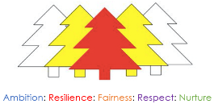

**How Good is Our School 4:**

**2.3 Learning, Teaching and Assessment: Very Good**

**NIF Priorities: 1, 2, 3, 4**

**Learning and teaching**

The Senior Leadership Team facilitates opportunities to improve learning and teaching. Teachers work with colleagues across the local schools’ cluster to evaluate and develop teaching and learning.  Our dynamic, challenging and creative Play Zone, Learning Zone and Discovery Zone have been further complimented this session with the development and expansion of our Outdoor Zone. Some of our Pupil Equity Fund from the Scottish Government has allowed us to employ five additional members of staff to provide the very best learning experiences and support for children and families.  Children benefit from small group teaching and a flexible curriculum which not only meets a variety of learning styles and needs but also promotes personalisation and choice.

A range of strategies are embedded across the school which help each child to take ownership for their learning. Children are given high quality feedback by almost all staff and most can give quality feedback to their peers, helping them to improve.

Digital technologies continue to have a positive impact on engagement. Staff and children have been trained on ‘green screen’ technology to record and share their learning, new methods to utilise iPads within the classroom to increase attainment and a wide range of software to support learning such as the Clicker7 programme.  This is evidenced as we continue to raise attainment, while offering a wider range of interventions to support and challenge our children.

**Assessment**

Teacher judgements on pupil progress and next steps are reinforced using a wide range of information from different assessments, some of which may be on a computer or occur at different points in the year in our different zones. Staff use benchmark guidance published from the Scottish Government in order to moderate each child’s achievements and plan for their next steps. All children experience an appropriate level of challenge and are nurtured to reach their full potential.

Data from a wide range of assessments and conversations between key staff members and children are gathered to build a holistic picture of a child and their personal achievements both within and out-with the school. These conversations review learning and inform future targets. Almost all pupils can confidently discuss their learning with key adults. Time is prioritised every term to involve all families in their child’s learning journey through our Termly Top Target meetings with a Progress Report Card based around our values being written in collaboration with each child and their family in term four.  Achievements are celebrated across the school community for example at our weekly achievement assemblies, school shows, family tracking meetings etc.

**Planning, tracking and monitoring**

There is strong collegiate approach to planning within the school. The Senior Leadership Team has ensured weekly timetables provide all staff with the opportunities to meet during the working day in their planning teams to discuss and plan challenging, engaging and motivating learning opportunities based on the needs and interests of the children.

Through tracking meetings and analysis of data, children are identified for support or challenge. Targeted interventions are then put in place to ensure we are meeting their needs which are reviewed on a 6 weekly basis. Identified families are invited to attend Team Around the Child meetings to discuss interventions, evaluate supports and inform next steps. Our Quality Assurance calendar ensures that planning, tracking and monitoring is consistent throughout the year, supporting teachers to meet the needs of their children.

**How Good is Our School 4:**

**3.1 Ensuring Wellbeing, Equality and Inclusion: Excellent**

**NIF Priorities: 2, 3**

**Wellbeing**

Staff demonstrate a strong commitment to the wellbeing of all children, prioritising

time to have a one to one conversation with every child on a termly basis. Wellbeing

wheels are a tool to focus and record these discussions. Staff are aware of

individual children’s circumstances and potential barriers to learning. We consult with

all children on their learning and they identify targets and next steps. We work closely

alongside our Family Learning Team, Area Inclusion Worker and Educational

Psychologist to benefit from their specialist knowledge to ensure the very best possible support for our children and their families.

All staff have undertaken the tier one and two autism training, received training on the guidance from NAC on identifying dyslexia and strategies to remove barriers to learning, attachment theory, restorative approaches, mindfulness, foetal alcohol syndrome and nurture. These training opportunities have increased the number of staff confident in identifying and implementing interventions to support children.

There is a breakfast club with space for 30 children and multiple after school clubs focussed around sport and active lifestyles offered. Class teachers track children’s engagement with clubs and encourage wider engagement with activities alongside parents at termly top targets.  Bug Club Hub is available for families after school to ensure all can access technology to support and enhance learning.

Each year, ‘Red Cap’ pupil leaders apply, interview and are trained in restorative conversations in order to use these skills in the playground to resolve conflict in a positive manner. Children’s wellbeing is promoted and developed through initiatives such as i-Cycle, cluster sports leagues, Pocket Garden competitions, transition events with the Academy including the residential to PGL and charity events within school.

We work in conjunction with our partners including ACES Woodwynd, Kilwinning Sports Club, NA Active Schools and Eglinton Park to promote healthy lifestyles and deliver events such as Health Mondays, No Knives Better Lives, country dancing, cross county, North Ayrshire Athletics, etc.

**Inclusion and equality**

All learners are included, engaged and involved in developing the positive, nurturing ethos of our school. Almost all children feel challenged and well supported to reach their full potential. All classes create and display their own Rights Respecting Charter which is reviewed on a termly basis and is supported during assemblies with the Senior Leadership Team who review the right of the fortnight.

Our Promoting Positive Relationships policy provides a consistent approach for our school community. Our Health and Wellbeing curriculum ensures that children are taught throughout their time in Corsehill to celebrate diversity. Effective partnerships with families and other agencies assist in identifying and supporting those children experiencing difficult times. Interventions support the child and their family and are reviewed in an appropriate timescale.

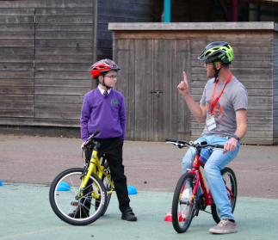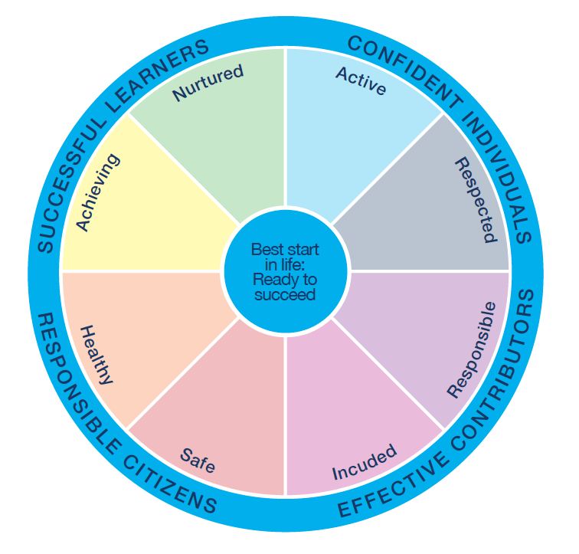



**What now?**

Consultation with our children, families and staff have informed our improvement plan this session. Some of the things we will be developing this year are:

1. **To further raise attainment across the school**

* Reviewing our numeracy planning and writing planning
* Increasing parental engagement with support of our Family Learning Team
* Make increased links with Kilwinning Academy staff to support French and Spanish teaching.
* Create new resources to help Early Years children to achieve Early Years Milestones

1. **To provide the highest quality targeted support to individual children and their families**

* Supporting children at First and Second Level with Talk Boost to improve literacy attainment
* Deliver year 2 of the Reading Recovery programme
* Nurture staff will extend family wellbeing discussions
* Further staff training on the Boosting Reading initiative
* All teaching staff to receive training from Speech and Language specialist
* Audit resources across the school and ensure there is a strong provision to support sensory development

1. **To further develop the quality of learning experiences and environments and our systems for recording observations and assessment**

* Outdoor learning will be accessible to all classes every week
* Identify teaching staff to participate in a teacher leadership course to promote high quality learning and teaching
* Parent Council will fund Primary Science Quality Mark application to gain recognition for our innovative curriculum

 To keep up to date with our latest news scan below to be taken to:

**Our website:  Our Twitter:**

**How Good is Our School 4:**

**3.2 Raising Attainment and Achievement**

**NIF Priorities: 1, 2**

**Attainment**

Data is tracked each year for our school and other schools with similar catchment areas and pupil numbers across North Ayrshire. As a school we look at this data to see our improvements and to identify areas to work on in the coming year. Our data in the table below shows the children achieving the expected level of the curriculum for that stage. Overall, the data this year shows a continued improvement across the school from last year.

|  |  |  |  |
| --- | --- | --- | --- |
|  | **P1** | **P4** | **P7** |
| **Reading** | 90-100% | 70-80% | 80-90% |
| **Writing** | 70-80% | 70-80% | 80-90% |
| **Listening and Talking** | 80-90%% | 90-100% | 80-90% |
| **Numeracy** | 70-80% | 70-80% | 80-90% |

Interventions for literacy, including reading recovery, phonological awareness Early Years and P1 talk boost 1 and 2, MARRLL, etc. are having a positive impact on pupil attainment for identified pupils. Attainment data highlights that we maintained high standards for our children.