

**Education and Youth Employment**

**Corsehill Primary School, Kilwinning**

**Improvement Plan 2019-20**



**Vision, Values and Aims**



To develop a curiosity about our world and enable our children to contribute positively now and in the future.

Our aims for our children

* To enable our children to become ambitious and motivated lifelong learners with a passion to succeed.
* To equip children with well-developed literacy and numeracy skills in order that they can be successful in life.
* To nurture a sense of wellbeing in our children so that they grow into respectful young people able to make sound judgements and choose a healthy lifestyle.

Our aims for our families and the community

* To support and inform our parents so that they can work in partnership to help their child be ambitious and achieve success.
* To be engaged in the life of the school in order that they can contribute to school decision making and our improvement journey.
* To develop partnerships between staff, parents and the wider community which promotes a positive ethos and image.

**Council Priorities:**

The Council strategic priorities for 2019-24 are detailed below:

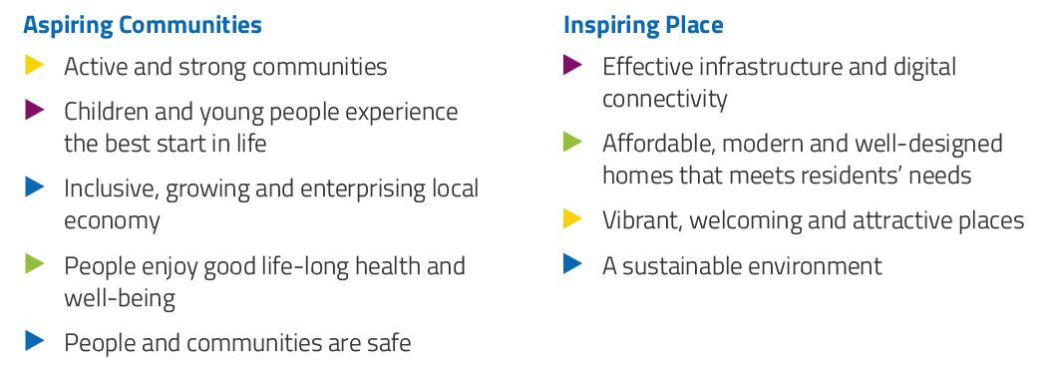

**National Improvement Framework:**

The National Improvement Framework for Education is designed to help us deliver the twin aims of excellence and equity; galvanising efforts and aligning our collective improvement activities across all partners in the education system to address our key priorities. These priorities remain as:

1. Improvement in attainment, particularly in literacy and numeracy
2. Closing the attainment gap between the most and least disadvantaged children
3. Improvement in children and young people’s health and wellbeing
4. Improvement in employability skills and sustained, positive school-leaver destinations for all young people

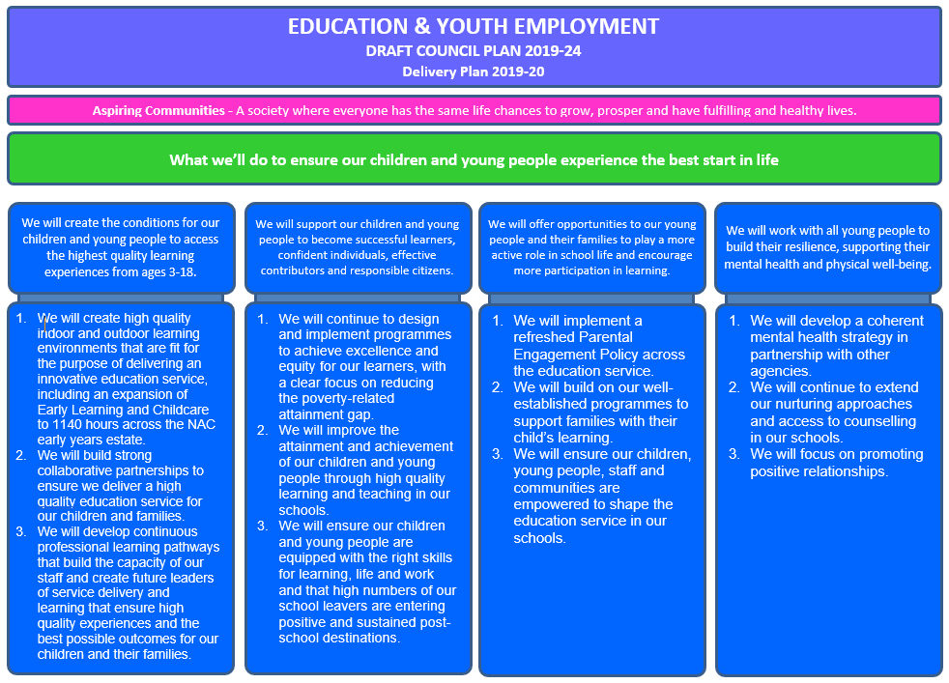

**Strategic Plan 2019-20: Corsehill Primary School**

|  |  |  |  |
| --- | --- | --- | --- |
| **School Priorities** | To raise attainment and achievement for all learners. | To provide high quality targeted support to individual children and their families. | To further develop the quality of learning experiences and environments, systems for recording observations and methods of assessment. |
| **High Level Objectives** | We will improve the attainment and achievement of our children and young people through high quality learning and teaching in our schools. | We will build on our well established programmes to support families with their child’s learning. | We will create high quality indoor and outdoor learning environments that are fit for the purpose of delivering an innovative education service, including an expansion of Early Learning and Childcare to 1140 hours across NAC early years estate. |

**Strategic Plan 2019-20: Corsehill Primary School**

Here is an overview of how we intend to use our Pupil Equity Funding to support improvement:

**Detailed Action Plan 2019-20: Corsehill Primary School** . .EYC . . P1-3 . . P4-7

|  |  |  |  |  |  |  |  |
| --- | --- | --- | --- | --- | --- | --- | --- |
| **School Strategic Priority:** | | To raise attainment and achievement for all learners. | | | | | **Linked to Directorate Priority:** 2 |
| **High Level Objectives** | **HGIOS 4**  **HGIOELC**  **NIF** | **Supported through PEF?**  **Y/N** | **How will I achieve this?** | **Timescale / Assigned to:** | **Pupil Outcomes** | **Measurement** | |
| We will improve the attainment and achievement of our children and young people through high quality learning and teaching in our schools. | HGIOS  2.2  2.3  3.2  NIF  1 | No | Numeracy . .  Class teachers who have children working within Second level to attend Numeracy framework training.  Review and adapt current planners and consistency guides used within the school to incorporate this training. | Term 2-4  Class teachers  Term 4  Class teachers | Consistent practice across the school will assist pupils to make greater progress.  Progressive experiences for all pupils with depth of learning and enhanced opportunities for application will be evident.  Pupils needs will be better met through increased teacher knowledge.  Pupils will have increased range of strategies within numeracy. | SLT class observations in Term 1 and Term 3 focusing on Numeracy within P5-7  Staff pre and post confidence questionnaire  Pupil pre and post discussion group with SLT | |
| HGIOS  2.2  2.3  3.2  NIF  1 | Yes  0.4 FTE  teacher | Writing . . . .  Review and adapt current writing planners and consistency guides used within the school to incorporate previous training on Slow Writing, Time to Talk and Steve Graham’s Creating a Balanced Reader and Writer approach.  Using team teaching approach to target identified learners within SIMD 1 and 2. | Term 1  Act DHT and class teachers  Term 1-2  Act DHT and PEF teacher | Pupils needs will be better met through increased teacher knowledge.  Pupils will have increased range of strategies supporting them to plan, record and undertake writing. | Range of pupil evidence and observations showing depth and application of practice.  Pupil focus group (6 of mixed ability per class) to discuss their experience and success with writing.  Termly tracking data will identify progress and next steps.  Term 1 and 4 baseline assessments. | |
| HGIOS  2.5  NIF  1 and 4 | No | Engaging with Families . .  Read Write Count Bookbug for P1 children and their families  Read Write Count gifting for P2&3 and their families  Family STEM workshops for identified families supported by FLT- to raise the understanding and profile of STEM subjects and possible careers  Family Seasonal Crafts workshops supported by FLT- encouraging engagement within different aspects of the curriculum. | Term 1 Act HT and FLT  Term 3 Act HT and FLT  Term 3 Act HT and FLT  Term 1-4 Act HT and FLT | Pupils will be better supported by family members as their understanding of the curriculum will be enhanced.  Pupils will be able to share their learning with family members leading to more positive attitudes between home and school. | Survey of parent invited to attend.  Discussion between SLT and parents involved in initiatives to evaluate and provide next steps.  Numbers of families who attended are recorded. | |
| HGIOS  1.2  2.3  HGIOELC  1.2  2.3  NIF  1 | Yes  0.2 FTE  teacher | 1+2 . . . . . .  1+2 co-ordinator will continue to engage with SALT development team at national level to develop 1+2.  1+2 co-ordinator to share her Progression Pathway Planner with NAC 1+2 Development Officer to ensure continuity across stages and across schools.  1+2 co-ordinator to upskill teaching and support staff and build their confidence in daily use of modern languages by team teaching (funded by PEF) and leading training at staff meetings.  Teachers will support learners to build confidence in learning and using languages through daily use of the modern language.  Make links with Kilwinning Academy to be supported in class by S5 and 6 pupils acting as positive role models and 1+2 ambassadors. | Term 1-4  1+2 Co-ordinator  Term 1  1+2 Co-ordinator  Term 1-2  1+2 Co-ord, PEF teacher and class teachers  Term 1-4 class teachers  Term 1-2  1+2 Co-ord | Pupils will be using the language predominantly orally and will be beginning to explore the languages in written form.  Pupil confidence will grow as practitioners integrate daily language use into learning experiences across the curriculum.  Pupil outcomes will be increased as staff are supported by and use the new planning to ensure consistency across stages and authority wide.  1+2 PEF funded teacher (0.2) to support the teaching of Spanish from P5-7 and the delivery of French from EYC to P7. | Pupils’ pre and post intervention survey based on exposure and enjoyment to L3.  Staff pre and post intervention survey based on confidence and ability to deliver L2 and L3.  Discussion with pupils to feedback on impact of S5 and S6 ambassadors supporting L2 and L3. | |
|  | HGOIELC  1.1  2.3  2.4  2.5  NIF  1 and 2 | No | EY Milestones . .  EY and P1 staff to evaluate data from 2017-2018 and 2018-2019 and identify trends and patterns. Prioritise next steps and interventions, incorporating information gleaned from data into long and short term planning.  Create Milestone bags and family learning workshops to support families to encourage learning at home.  Using data, create a programme of targeted interventions prioritising SIMD 1-2 using initiatives such as Phonological Awareness, I Can Toolkit, small group EY Numeracy framework | Term 1  P1 class teacher and SEYP/LP and EYP  Term 1-2  SEYP and LP  Term 1-4  LP | Children will be better supported by family members as their understanding of the curriculum will be enhanced.  Children will be able to share their learning with family members leading to more positive attitudes between home and school. | Pre and post intervention data.  Survey of families’ views pre and post workshops and interventions. Audit planning termly during SLT tracking discussions, focusing on provision of identified milestones. | |

**Detailed Action Plan 2019-20: Corsehill Primary School** . .EYC . . P1-3 . . P4-7

|  |  |  |  |  |  |  |  |
| --- | --- | --- | --- | --- | --- | --- | --- |
| **School Strategic Priority:** | | To provide high quality targeted support to individual children and their families. | | | | | **Linked to Directorate Priority:** 3 |
| **High Level Objectives** | **HGIOS 4**  **HGIOELC**  **NIF** | **Supported through PEF?**  **Y/N** | **How will I achieve this?** | **Timescale / Assigned to:** | **Pupil Outcomes** | **Measurement** | |
| We will build on our well established programmes to support families with their child’s learning. | HGIOS  2.4  3.2  NIF  1 and 2 | Yes  1.0 FTE CA | First and Second Talk Boost . . . .  Supporting children in Primary 1-3 and Primary 4-7 with their language and communication skills.  In P1-3 14 week intervention comprising of 3 x 30 min sessions per week per group with trained member of staff and supported by 1 whole class lesson per week led by class teacher.  In P4-7 12 week intervention comprising of 3 x 40 min sessions per week per group with trained member of staff and supported by 1 whole class lesson per week led by class teacher. | Term 1-2 and repeated in Term 3-4  PEF funded CA and class teachers | Pupils with difficulties in listening, talking and attention will benefit from early identification & targeted support.  Pupils will be supported in their literacy attainment by a fully trained and qualified Talk Boost practitioner. | Online Talk Boost Tracker  Pupil Questionnaire  Teacher evaluations | |
| HGIOS  2.4  3.2  NIF  1 and 2 | Yes  0.4 FTE  teacher | Reading Recovery . .  To continue to implement reading recovery- 4 pupils identified from P.2 cohort & permission from parents/families sought (lowest performing learners from cohort with priority being given to SIMD 1 and 2. Ages of pupils will help determine whether they will be in Cohort 1 or 2.) First cohort of learners begin Reading Recovery (16-20 weeks)  Mid-point data collated & shared with CT, HT & wider staff team. Sharing practice collegiate time for staff (teachers & classroom assistants)  Repeat with second cohort.  Reading Recovery trained teacher to upskill teaching and support staff termly as timetabled in the CLPL calendar.  Create a list of book titles suitable for each of the instructional stages within Reading Recovery to support parents selecting texts at home. | Term 1  RR teacher and act HT  Term 2  RR teacher  Term 3  RR teacher  Term 1-4  RR teacher  Term 1  RR teacher | Learners with difficulties in reading will benefit from early identification & targeted support.  Learners will be supported in their literacy attainment by a fully trained and qualified Reading Recovery teacher.  2 cohorts of learners in Primary 2 will be identified for support using the OSELA. These learners will then be supported in their literacy attainment through Reading Recovery.  Learners with the most significant needs in reading will have these addressed through expert intervention.  Learners across the school will benefit from being taught by staff who have a greater understanding of the complexities of learning to read.  Staff will be more confident in addressing reading difficulties as part of their approach to the pedagogy of reading.  The pupils who require longer term intervention and support will benefit as a result of staff being able to access detailed diagnostic assessment.  Pupils whose wellbeing was being negatively impacted by their difficulties in reading will experience success and will be able to re-integrate with their peers in literacy based learning experiences. | OSELA (Observation Survey of Early Literacy Assessment) used to identify learners within the P.2 cohort who are experiencing the greatest difficulties in reading – group taken from the lower 20% of learners based on TJS August 2019 – analysed September 2019.  Observation survey completed for 4 identified children September 2019. Reading recovery teacher will analyse October 2019.  Semi-structured interviews with parents & carers pre and post intervention. September 2019-march 2020, march 2020 – June 2020  Progress through pm books used to measure impact of reading recovery intervention. Weekly – main collation march 2020 & June 2020.  Osela used to measure impact prior to a child being discontinued.  Post intervention focus group discussion with learners and their families December 2019 & May 2020. | |
| HGIOS  2.5  3.1  NIF 3 | Yes  0.2 FTE  Assistant and teacher | Nurture . . . .  Nurture staff will work alongside class teachers, support staff and SLT to identify pupils with P1-3 who would meet criteria and benefit from in class nurture provision.  Nurture staff will engage with targeted parents to roll out programme to include:  Wellbeing evaluation and card tools, attachment workshops, resilience training and empowerment training.  Supporting family Learning 1:1 sessions with identified families in SIMD 1 and 2 for a 4 week block led by FLT and supported by nurture staff.  Extend family wellbeing discussions prioritising SIMD 1 and 2. Discussions to coincide with SLT tracking focus weeks and will involve families identified by staff members who require additional wellbeing support. | Term 1  Act DHT,  Nurture staff and teachers  Term 2-3  Act DHT,  Nurture staff and teachers  Term 1  Act DHT, nurture staff and FLT  Term 1-4  Act HT, act DHT and teachers | Pupils will benefit from increased parental understanding of the importance of social, emotional and mental wellbeing which will impact positively on their relationship between family members.  Enhanced support will supports pupils’ individual needs within the classroom setting. | Questionnaire to parents to establish data. Complete BIOS and SDQ questionnaires with targeted children. Repeated in at end of intervention.  Quality Assurance calendar will incorporate observation of learning and teaching and monitoring of teachers planning. | |
| HGIOS  2.4  3.2  NIF  1 and 2 | Yes | Boosting Reading . . . .  Two classroom assistants to undertake Boosting Reading at Primary training to work with children within SIMD 1 and 2 initially and provide 10 week 1:1 support consisting of 3 x 15/20 minute sessions | Term 1-4  2 x Classroom assistants | Pupils with difficulties in reading will benefit from early identification & targeted support from trained classroom assistant.  Pupils will increase confidence and enjoyment in reading as a result of the individual attention. | Ongoing running records administered by trained CA | |
| HGIOS  2.4  3.2  NIF  1 | No | Speech and language . . . .  Teaching staff training in speech sound development and strategies to help children who have SLT difficulties by attending PLA training on Speech Sounds and Speech and Language Top Tips.  Invite Speech and Language to attend Breakfast Blether parent support group to provide advice and support for families. | Nov and February  Class Teachers  Nov and February  Act HT | Pupils with difficulties with speech will benefit from early identification & targeted support from class teachers. | Time scheduled at staff meeting to have pre and post training discussion surrounding confidence, delivery and impact of training. | |
| HGIOS  2.4  3.2  HGIOELC  2.4  3.2  NIF  1 | No | Attention and Listening . . . . . .  Staff training to develop current knowledge of strategies to promote attention and listening for children working within Early/First to Second level. | September  EYP and Class Teachers | Pupils who find it difficult to focus for longer periods of time will benefit from early identification & targeted support from class teachers. | Monitor the attainment within listening and talking across stages.  Analyse data trends to plan interventions for individuals requiring additional support. | |
| HGIOS  2.4  3.1  HGIOELC  2.4  3.1  NIF  3 | No | Provision of sensory development . . . . . .  Audit staff and pupil knowledge and understanding of self-regulation strategies  Training for staff on techniques for self-regulation and sensory processing at in-house CLPL sessions (Using Autism Toolbox and Parent Council member Miss Crighton –Masters in ASD)  Audit provision and resources currently available  Purchase and create resources and spaces to support self-regulation  Tier 2 ASD training to all staff  Work in partnership with families and young person to create a sensory profile providing key information to designated members of staff.  Review the development of sensory play within the EYC and the Play Zone. | Term 1  Act DHT  Term 2  Nurture Staff + EP  Term 1  Act DHT  Term 2  Act DHT and Nurture Staff  Term 1  EP  Term 1  Act SLT  Term 2  SEYP, P1 Teacher | Addressing sensory issues may benefit fine motor skills, personal organisation, interactions with peers, toileting, eating and drinking, carrying our tasks involving gross motor skills.  Pupils will be better supported by staff having increased knowledge and understanding of auditory sensitivity, physical contact, visual stimulation and physical environment. | Focus group will demonstrate pupils’ knowledge and understanding of techniques.  Observations will highlight effective use of techniques and resources being utilised.  Pre and post intervention tracking of incidents in which staff were required to support children presenting in a distressed manner.  Parent focus group with identified parents. | |

**Detailed Action Plan 2019-20: Corsehill Primary School** . .EYC . . P1-3 . . P4-7

|  |  |  |  |  |  |  |  |
| --- | --- | --- | --- | --- | --- | --- | --- |
| **School Strategic Priority:** | | To further develop the quality of learning experiences and environments, systems for recording observations and methods of assessment. | | | | | **Linked to Directorate Priority:** 1 |
| **High Level Objectives** | **HGIOS 4**  **HGIOELC**  **NIF** | **Supported through PEF?**  **Y/N** | **How will I achieve this?** | **Timescale / Assigned to:** | **Pupil Outcomes** | **Measurement** | |
| We will create high quality indoor and outdoor learning environments that are fit for the purpose of delivering an innovative education service, including an expansion of Early Learning and Childcare to 1140 hours across NAC early years estate. | HGIOS  2.2  2.3  NIF  1 and 4 | Yes  1.8FTE CAs | Indoor/outdoor learning provision. . . .  Review and adapt current long term and short term planning formats for collaborative planning within indoor/outdoor learning zones.  Audit the opportunities being offered within the different learning environments and pupils’ engagement with these.  Audit and agree on a consistent system for recording observations, interactions and next steps when working within the associated zones for each class.  To ensure skills are identified and made explicit within learning experiences. | Term 1  SLT and teachers  Term 1  SLT  Term 2  SLT, class teachers and  support staff | Pupils will be more engaged in their learning.  Pupils’ individual needs will be better met as all learnings styles will be catered for throughout the various learning environments.  Higher quality observations will provide more detailed holistic information about pupil progress.  Pupils will be able to discuss transferable skills used across the curriculum. | Leuvens’ Scale observations to be completed on a sample of children working within each Zone prior to any development work.  Pupil learner conversations to ascertain their experience and understanding of application of skills.  Teaching staff discussion about provision.  Support staff discussion about the provision.  Moderation of learning experiences and environment with staff from various Zones. | |
| HGIOS  1.1  NIF  1 | No | Improvement in pedagogy . .  One teacher to participate in Olevi Programme which provides in-depth coaching to deepen teachers’ understanding of classroom practice. Participants undertake facilitated practice activities as structured opportunities to reflect on teaching approaches and their quality and impact. | Term 1 and 2  Class teacher | Pupils will benefit from practitioners increased knowledge, understanding and skills in highly effective pedagogical practice with a key focus on Visible Learning. | Pre and post intervention participant questionnaire  Audit of Professional Skills completed by participants | |
| HGIOS  1.3  2.2  3.3  NIF  4 | No | Primary Science Quality Mark . . . . . .  Plan improvement in science learning and teaching by auditing existing provision and agreeing on appropriate award to work towards.  Create and implement an action plan to develop all aspects of science learning and teaching.  Complete a reflective submission with key pieces of evidence to demonstrate the impact of science leadership within the school. | Term 1  Teachers & support staff  Term 2  Teachers & support staff  Term 4  SLT and science co-ordinator | Pupils will benefit from improved staff confidence and pedagogy within the science curriculum.  Consistent practice across the school will allow pupils to make greater progress.  Pupils will be involved in higher quality learning experiences with a greater focus on personal interest and outdoor learning. | Portfolio of evidence showing the impact of science across the whole school and wider community submitted to PSQM.  Learner conversations between SLT, staff and pupils.  Pre-intervention Progress Test in Science with sample of pupils from Primary 4-7 (from top 20%, middle and bottom 20%). Repeated after intervention in term 4. | |
| HGIOS  2.4  3.1  HGIOELC  2.4  3.1  NIF  2 | No | 1140 hours expansion . .  Further develop protocol and procedures for children attending full time  Audit the opportunities being offered within the different learning environments and pupils’ engagement with these.  Audit and agree on a consistent system for recording communication, observations, interactions and next steps when working with different key workers.  Evaluate planning cycle to ensure high quality learning experiences across service. | Term 1  Act SLT, SEYP and LP  Term 1  Act SLT, SEYP  Term 2  Act SLT, SEYP, LP, EYP  Term 2  Act SLT, SEYP, LP, EYP | Children will experience a wide range of high quality and engaging learning experiences tailored to individual needs and targets.  Children’s development will be accurately recorded and tracked with appropriate next steps being identified and shared with key staff and family members. | Leuvens’ Scale observations to be completed on a sample of children working within each area prior to any development work.  Child learner conversations to ascertain their experience and views.  EY staff discussion about provision.  Moderation of learning experiences and environment with staff from various areas.  SLT to monitor planning on a termly basis. | |