

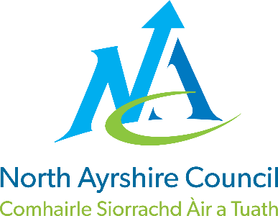

Blacklands Primary School and Early Years Class

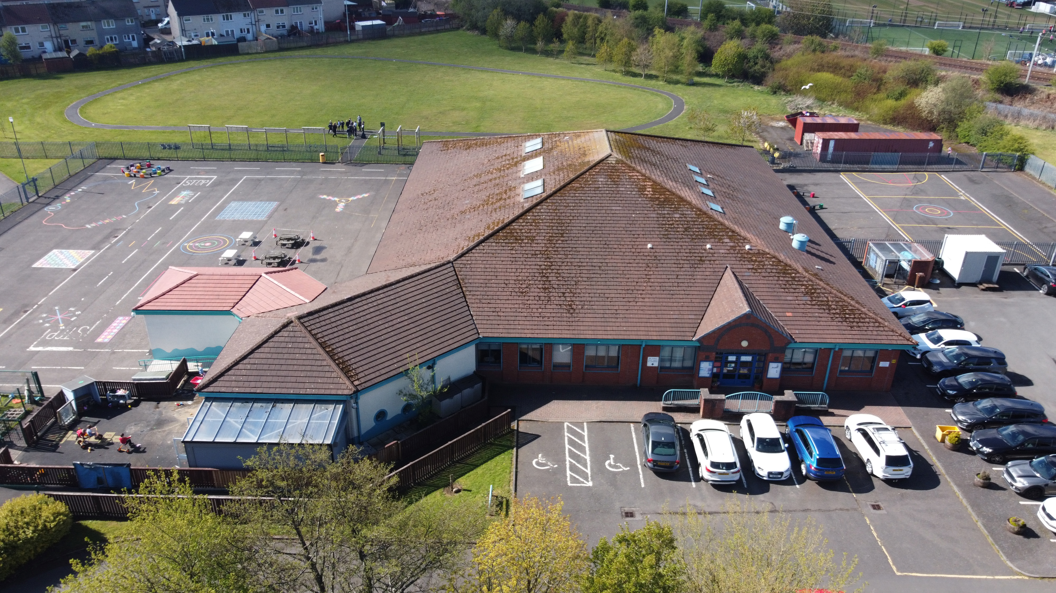

STANDARDS AND QUALITY REPORT
June 2026
This report will inform you of the school’s progress and achievements in the last session and let you know about our plans for 2025-2026.
I hope that you find it helpful and informative.
Mrs Lynne Gibson

Head Teacher

OUR SCHOOL
Blacklands Primary and Early Years Class is a non-denominational school with a roll of 110 pupils in our school (5 primary classes) and 16 children in our Early Years Class. Our school and Early Years Class start at 9am and finish at 3pm each day.

The school serves the Blacklands and Dirrans area of Kilwinning. The current staff structure consists of 1 Headteacher, 1 Depute Headteacher, 6 Teachers, 1 Nurture teacher, 0.6 Targeted Support Teacher, 1 Senior Early Years Practitioner, 2 Early Years Practitioners, Pupil Support Assistants (1 full time, 5 part time), 1 Education Business Assistant and 1 Janitor. We are very proud of our nurturing ethos and our experienced staff team who strive to provide the best learning experiences for our children with every activity underpinned by our shared values and positive culture.

Within our school, we have an Early Years Class and a Nurture Class (our Cosy Corner). We have a breakfast club which runs each morning and is open to all. Each class also has a class breakfast, once a week providing an opportunity to build relationships and a community. We pride ourselves on our inclusive approach to education, removing barriers to allow success.

Working in partnership within a caring and stimulating environment, we aim to provide quality learning experiences, which will encourage positive attitudes, enabling pupils to achieve their potential as valued members of the community.

OUR VISION, VALUES AND AIMS
Two years ago, we worked with staff, parents/carers and pupils to refresh our school vision, values, and aims. At Blacklands, we strive for Excellence and Equity for all learners, underpinned by our values of Kindness, Respect, Knowledge and Fun.

HMiE’s 2024 inspection recognised that these values are evident in interactions throughout the school daily. This session, we have continued to promote these values through assemblies, the curriculum and wider school events, encouraging pupils to make links to their own experiences and live them. We remain committed to developing responsible citizens, successful learners, confident individuals and effective contributors. Over the last few years, we have drawn on the work of Paul Dix to strengthen our approach to positive relationships, adopting the motto ‘Ready, Respectful, Safe’ alongside a consistent restorative approach. Our Positive Relationships policy outlines clear strategies for promoting positive behaviour. We set high expectations for learning and behaviour and provide supportive and engaging learning experiences that help pupils to develop as valued members of the community. House points, stickers, texts and positive notes home have been embedded to celebrate positive behaviour and achievement. Whole-school assemblies and morning meetings, our ‘WHOOSH Wall’, parent newsletters, and social media all celebrate a wide range of pupil successes in and beyond school.

ATTAINMENT & ACHIEVEMENT
In order to assess achievement we gather a wide range of evidence over the school year in a range of ways including formatively and summatively. Tracking attainment across Curriculum for Excellence allows us to ensure pupils are meeting targets appropriately. By tracking in this way, we are also able to identify gaps in learning and plan appropriate interventions to support closing these.

Twice a session we complete a Pupil Attitude to Self and School (PASS) survey. The survey demonstrated that most almost all children in P1-3 and the majority of children in P4-7 are happy and feel good about school. Where responses demonstrate low self-esteem and confidence, we use our staff to deliver planned and targeted interventions to support pupils wellbeing.

As well as assessing pupils Health and Wellbeing we also employ standardised assessments in Literacy and Numeracy to assess attainment. In P1, P4 and P7 we use Scottish National Standardised Assessments (SNSAs) and in P2, P3, P5 and P6 we utilise Scottish Online Formative Assessments (SOFAs) along with classroom assessments to support teacher judgements of where children are in their learning. This information also allows us to identify children’s strengths and next steps in learning meaning we can plan effectively for all children in our care.

Our attainment as at June 2025 was as follows:

Year Group | Listening and Talking | Reading | Writing | Numeracy and Mathematics
P1 | 74% | 74% | 80% | 83%
P4 | 93% | 73% | 60% | 83%
P7 | 100% | 95% | 73% | 68%

This session attendance has continued to be a focus for all children across the school and Early Years Class. Overall, our average attendance is 92.28% which in in line with the Scottish average of 91% and lower than the North Ayrshire average of 92%. We continue to track monthly attendance and support families to improve attendance to provide our children the best chance of success.
This session we have had 4 exclusions.

WIDER ACHIEVEMENT
As always, we have lots to celebrate! Our strengths include:
- The ethos and life of the school community
- Our nurturing and inclusive practice
- Partnership working to support children and their families
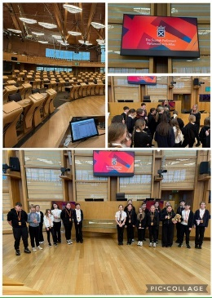
In 2025/26 we are particularly proud of these achievements:
- We achieved our Rights Respecting Schools Gold Award. We worked exceptionally hard to achieve this award and our children demonstrated that they know and understand the United Nations Convention of the Rights of the Child.
- We have had a wide range of extracurricular sporting activities. 1 child gained their ‘Platinum’ award for sport, attending over 100 clubs this session. 15 children achieved their ‘Gold’ award for sport, attending over 50 clubs this session.
- Our netball team reached the final of the North Ayrshire Schools tournament, winning the Kilwinning locality event.
- Our football teams took part in the locality, Ayrshire Schools League and the Mrs Lauder Legacy event. Our teams did extremely well and had a great time.
- 15 children gained their iCycle award.
- We have a strong relationship with Kilwinning Sports Club and we access this resource often as possible.
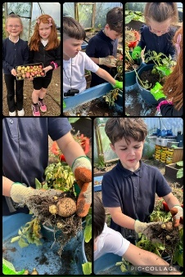
- Our P7 children took part in Scottish country dance lessons and then the North Ayrshire Day of Dance.
- Our cross country team took part in a series of races with some excellent resilience and determination on display.
- Our basketball team took part in a Day of Basketball at the Portal.
- A group of children from P4-7 took part in dance classes, this culminated in a performance at St Matthews Academy and an award for Teamwork.
- All children participated in an in school ‘Stay Safe’ workshop.
- P5/6 took part in ‘bucket drum’ lessons and showcased their new skills to their parent/carers.
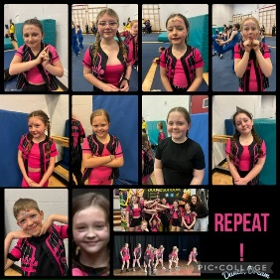
- We took part in the Kilwinning Flower Show and won a range of awards.
- We aim to give children experience of as many off site educational experiences as possible. P7 had a fully funded residential to Inverclyde. All children have benefited from experiential learning. Some of our trips include: Our Early Years Class visiting the library for Bookbug sessions and the Harbour Arts Centre to see the MacDougalls, P1 visiting the Science Centre in Glasgow, P2/3 going to the Maritime Museum and the beach, P3/4 visiting the Burns Museum in Alloway, P5/6 going to Ayr Beach and P7 to the Science Centre, Scottish Parliament and Belfast.
- Primary 7 experienced a fabulous trip to the Titanic Museum in Belfast. They absolutely loved this and were a real credit to us.
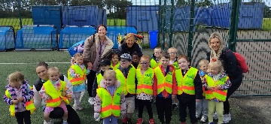
- All children took part in assembly and class activities to support and promote World Mental Health Day, Earth Day and Safer Internet Day.
- Primary 7 experienced a fabulous trip to the Titanic Museum in Belfast. They absolutely loved this and were a real credit to us.
- All of our children from P3-7 are in a leadership group, helping drive our school improvement. These are established for: Pupil Council, Gardening, Digital, Rights Respecting Schools, Eco, Sport, Developing the Young Workforce, Respect Me, STEM, Fairtrade and Reading.
- Primary 6 and 7 took part in the KA Leisure ‘Champions of Change’ programme.
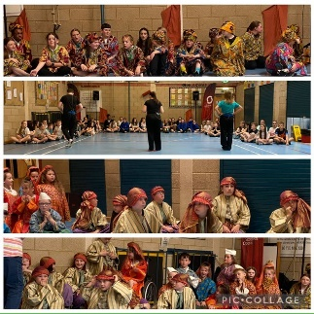
- We continue to work towards our next Digital Schools, RSPB and Eco Awards. As well as beginning work to regain our Fairtrade Award
- Our P4-7 children were outstanding when taking part in the Scottish Opera performance of ‘The Dragon of the Western Seas.’
- All children participate in weekly ‘My Happy Mind’ lessons to promote good mental health and strategies to support emotional regulation.

HOW SUCCESSFUL HAVE WE BEEN IN IMPROVING OUR ESTABLISHMENT?
Priority 1- To further develop a love for learning through enhancing environments, pedagogies and by providing relevant and exciting learning experiences for all children.
- The school has successfully developed interdisciplinary planning and skills development using Deep Learning pedagogy. Learners are active and engaged participants in a diverse and relevant curriculum which offers appropriate challenge to achieve a specified outcome through experiential learning opportunities. Learning experiences are well planned to promote character, critical thinking, creativity, collaboration, communication and citizenship, enabling children to develop skills in real-life and meaningful contexts.
Deep Learning rubrics are beginning to now be used by staff and learners to make skills progression clear.
- Some teacher observations show improvements in learner engagement. An increasing number of learners report that learning is exciting and fun, and some can identify the skills they are developing and explain why these skills are important. Learners continue to develop their understanding of learning targets and are beginning to describe the steps needed to achieve them.
As a result of deep learning approaches, learners show increased motivation, confidence and ownership of their learning, leading to improved engagement and progress in skills development across the curriculum.
- Through purposeful outdoor play and learning, learners have been actively engaged in hands-on, real-life experiences which support the development of creativity, problem-solving and physical wellbeing. With support from learning through Landscapes and Mrs Shanks, outdoor learning experiences have been well planned and provide appropriate challenge, allowing learners to explore, investigate and apply skills.
As a result, learners show high levels of engagement, increased confidence and improved collaboration. They demonstrate growing resilience, creativity and physical competence, contributing positively to their overall health, well-being and progress in learning.
- Staff have made progress in supporting learners to develop knowledge and skills for a digital world. Staff have developed a shared understanding of the North Ayrshire Council Digital Strategy and have begun implementing it across the school. Targeted learning opportunities have increased staff confidence and competence in using a range of digital technologies to support the delivery of engaging, relevant and supportive learning experiences.
Digital technologies are becoming increasingly embedded across planning and practice in some classes, both indoors and outdoors, with digital skills taught explicitly and applied meaningfully through deep learning approaches. Classroom observations and pupil voice indicate improving levels of engagement. The achievement of the Digital Early Learning and Childcare Award reflects a positive whole-setting approach to digital learning.
As a result, our youngest learners are better prepared to use digital technologies safely, confidently and creatively to support their learning and wider achievement.

Priority 2- Learners will benefit from an enhanced, holistic Early level experience.
- This session we have begun working on a more coherent and holistic Early Level experience. Early Years staff and the P1 teacher, supported by senior leaders, are beginning to develop more effective collaborative working to improve shared understanding of progress and achievement across the level. This is allowing strengthened continuity in learning, particularly at points of transition.
Staff are increasingly using self-evaluation to reflect on and improve practice. Joint planning is now being developing, and floor books are beginning to be used to capture and evidence children’s learning and skills development across Early Years and P1. The use of NAC trackers is supporting consistency in professional dialogue around progress and providing a vital link between Early Years and P1.
These approaches are beginning to result in greater confidence among staff in supporting progression across Early Level and improved coherence in children’s learning experiences. Continued collaboration will further strengthen consistency and impact for learners.

Priority 3- Raise attainment in literacy through delivery of consistent, high-quality learning, teaching and assessment approaches for all our learners.
- This session we have increased teacher confidence in providing quality experiences in literacy. All staff have developed a shared understanding of the new NAC Literacy Progression Framework through targeted CLPL, which has strengthened their understanding and confidence in the teaching of literacy across the school. We have used this training to develop our own framework which we are currently implementing for reading and writing.
As a result of professional learning and collaborative working, Primary 7 staff have successfully developed and are implementing a new approach to the teaching of writing, this is currently being rolled out across all other classes. This has improved clarity in expectations, progression and pacing in learning. Learners benefit from more structured, engaging and appropriately challenging writing experiences and are increasingly active participants in their learning.
Overall, improved staff confidence is leading to more cohesive practice and enhancing the quality of literacy learning and teaching, with a positive impact on learner engagement and enjoyment.
- Staff have begun reviewing and refreshing the Blacklands consistency guides, strengthening shared expectations and coherence in practice.
As a result, approaches to the teaching of writing are now more consistent and progressive across stages, supporting improved learner outcomes. This collaborative review process has increased staff confidence and clarity in planning for progression. The planned focus on reading in the next session provides a strong foundation for continued improvement in attainment and consistency across literacy.
- There is increasing evidence that parents and carers are better supported to contribute positively to their children’s progress in literacy and numeracy. Share the Learning, has provided families with ideas of activities that are taught in school and that can be replicated at home. These opportunities have supported stronger home–school partnerships. The introduction of a fun, family-focused homework club has further strengthened engagement, providing inclusive and enjoyable opportunities for families from Early Years to P7 to develop literacy and numeracy skills together.
QUALITY INDICATORS
Provide your evaluation & brief summary statement for each of the 4 core QIs
QI 1.3 Leadership of Change | Evaluation | 5 Very Good
There is a very warm, inclusive and respectful ethos across the school and all staff create a nurturing an inclusive learning environment. The whole staff team work very well together and demonstrate enthusiasm and ambition to improve outcomes for children and their families. Senior leaders conduct an extensive and thorough range of quality assurance and self-evaluation activities across the year. There is a clear commitment to children’s rights throughout the school and pupil participation is evident in decision-making and school improvements. Pupils lead learning, in class and at clubs. Staff support children’s leadership groups effectively. Every child from P3 to P7 is fully involved in a leadership group where they work regularly in collaboration with their peers
QI 2.3 Learning, Teaching & Assessment | Evaluation | 4 Good
Teachers are effectively implementing aspects of development work in learning and teaching. They are promoting children’s engagement by ensuring the classroom environment meets the needs of all children and providing relevant, interesting learning activities. Staff use an assessment calendar well to provide consistency in approach across the school and then use the data from these assessments to inform practice and next steps in learning. Teachers use digital technology creatively to extend and deepen children’s learning. Senior leaders alongside teaching and support staff engage in regular tracking meetings to monitor children’s progress and attainment across the school and Early Years Class.
QI 3.1 Ensuring Wellbeing, Equality & Inclusion | Evaluation | 5 Very Good
Blacklands Primary School has a nurturing and inclusive ethos. All members of the school community work closely as a team to support wellbeing for all our children, with the aim of supporting them to feel confident, respected and valued. Senior Leadership, along with the whole staff team work closely to support our children requiring additional support. The Acting Depute Head Teacher provides strong leadership in developing practices to meet the needs of our children using a wide range of research-based practices. Support staff are well trained and confident in delivering targeted interventions which have a positive impact in allowing children to meet their targets. As a result of this, most of our children feel safe, listened to and respected.
QI 3.2 Raising Attainment & Achievement | Evaluation | 4 Good
Overall attainment is good. Formative and summative teacher assessments inform judgements and provide an accurate and detailed picture of children’s attainment. Data is used to track progress each year and attainment over a child’s time at school. Targeted interventions have supported us to improve attainment for identified children. Our Pupil Equity Fund (PEF) is used well to employ additional staff and purchase new resources, which allows the delivery of effective, targeted support for identified children in literacy and numeracy. Senior Leaders monitor the impact of these interventions to ensure their effectiveness and support future planning. All staff encourage and celebrate our children’s wider achievements and aim to provide opportunities to explore and try out new activities. Participation is tracked to ensure all children have the opportunity to engage in and enjoy different activities.

PUPIL EQUITY FUNDING
Pupil Equity Funding (PEF) at Blacklands Primary has had a clear, positive impact on attainment, wellbeing and equity through targeted staffing and inclusive support. The PT Attainment role has strengthened identification of need and ensured effective, timely interventions across literacy, numeracy and health and wellbeing. Tracking data shows measurable improvements, with several learners moving to being “on track”. Interventions such as Morning Group and Together Time have improved regulation, communication and readiness to learn for neurodivergent pupils, while My Happy Mind has supported a strong whole-school focus on mental health.
Additional pupil support assistant time and targeted numeracy teaching have further improved outcomes through consistent 1:1 and small group support. Most pupils have made good or significant progress in closing gaps, alongside increased confidence, engagement and inclusion. Wider investment in experiential learning and resources has enhanced motivation, participation and skill development for all learners. Overall, PEF funding has been used effectively to reduce barriers linked to poverty, with key staffing and targeted interventions demonstrating strong impact and identified to continue.

IMPROVEMENT PLAN PRIORITIES 2026-2027
Priority 1: Improving learning outcomes for all
- Learners will develop stronger foundational reading skills, particularly in phonemic
awareness, phonics, fluency, vocabulary, and comprehension.
- Learners will experience more consistent, high-quality explicit, systematic phonics instruction across the whole school.
- Learners will benefit from increased opportunities to read for enjoyment, fostering motivation and positive reading attitudes.
- All learners will experience explicit and systematic teaching of phonics through a universal approach to instruction of the alphabetic code.
- Learners requiring targeted support will access more effective, evidence-based interventions to support them to bridge the gaps in their knowledge.
- Progress in reading and spelling will accelerate for identified groups, helping close equity gaps.
Priority 2: Supporting needs, wellbeing, equality and inclusion
- Strengthened consistent and relational practice across the school and Early Years resulting in improved emotional regulation, increased feelings of safety and belonging, greater engagement in learning and a reduction in behaviour incidents.
- Increase in staff confidence in responding to children’s behaviours.
- There will be a reduction in escalation and reactive responses leading to calm and regulated children.
- All staff will support children to feel safe, understood and regulated.
- Staff will promote timely repair and restoration of relationships when faced with issues in the classroom and playground.
- Learners are consistently taught expectations and experience relational and natural consequences when appropriate.

Priority 3: Building a self-improving service
- Learners will demonstrate increased confidence, motivation and engagement through meaningful interdisciplinary and enquiry-based learning experiences which promote the 6Cs of Deep Learning across the curriculum.

