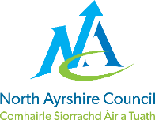
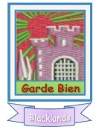
BLACKLANDS PRIMARY SCHOOL AND EYC

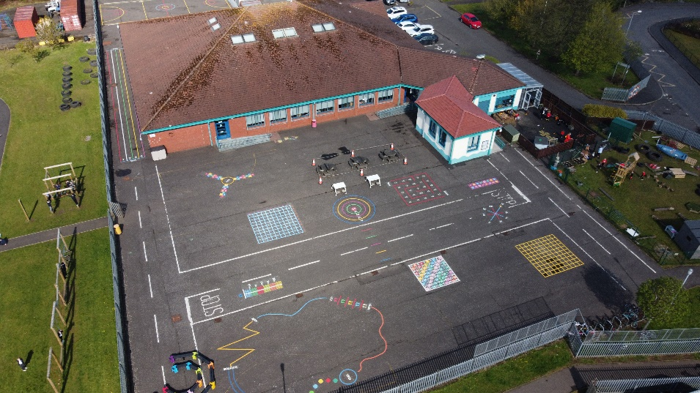

STANDARDS AND QUALITY REPORT
June 2025
This report will inform you of the school’s progress and achievements in the last session and let you know about our plans for 2025-26.
I hope that you find it helpful and informative.
Susan Lauder
Head Teacher

Our School
Blacklands Primary and Early Years Class is a non-denominational school with a roll of 118 pupils in our school (6 primary classes) and 16 children in our Early Years Class. Our school and Early Years Class start at 9am and finish at 3pm each day.

The school serves the Blacklands and Dirrans area of Kilwinning. The current staff structure consists of 1 Headteacher, 1 Depute Headteacher, 1 Principal Teacher (PEF funded), 8 Teachers (including one Attainment Teacher), 1 Nurture teacher, 0.6 Pupil Support Teacher, 1 Senior Early Years Practitioner, 2 Early Years Practitioners, Pupil Support Assistants (1 full time, 5 part time), 2 Education Business Assistants and 1 Janitor. We are very proud of our nurturing ethos and our experienced staff team who strive to provide the best learning experiences for our children with every activity underpinned by our shared values and very positive ethos.

Within our school, we have an Early Years Class and a Nurture Class (our Cosy Corner). We have a breakfast club which runs each morning and is open to all. We also have a class breakfast, once a week. We pride ourselves on our nurturing, inclusive approach to education.

Working in partnership within a caring and stimulating environment, we aim to provide quality learning experiences, which will encourage positive attitudes, enabling pupils to achieve their potential as valued members of the community.

Our Vision, Values and Aims
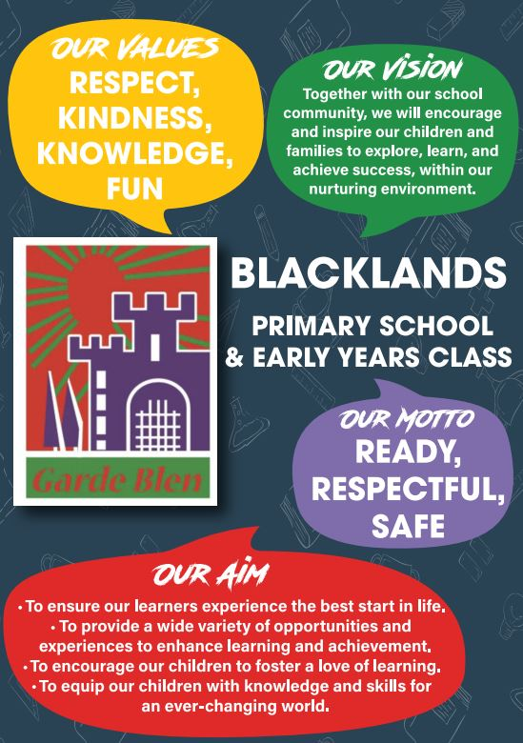

ATTAINMENT & ACHIEVEMENT
Attainment and Achievement
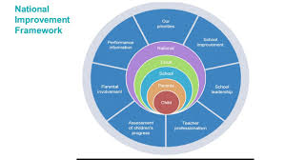
Every year we gather lots of information on how our children are progressing in their learning. To monitor their attainment and achievement we observe children working through tasks, listen to what they say, ask important questions, set challenges and use a variety of standardised assessments. We gather as a team and analyse our collection of data and observations to plan targeted learning activities for children to ensure they are making appropriate progress.
North Ayrshire Council and The Scottish Government also ask us to summarise our children’s progress in Reading, Writing, Listening and Talking and Numeracy.

We are proud of how our children in Blacklands Primary and EYC are progressing. They are considerate of the needs of others and demonstrate understanding of inclusion.
In the Early Years almost all preschool children achieved their expected milestones. In Primary 1, most children achieved their expected levels in Literacy & Numeracy. In Primary 4 the majority of children achieved first level in Literacy & Numeracy and in Primary 7 all children achieved second level in listening and talking, almost all in reading and the majority in writing and numeracy/maths.
All children are making progress across the curriculum because of the carefully planned programmes meeting their needs.
Our attendance overall is 92.17%. This is higher than the North Ayrshire average. We have had two exclusions.

WIDER ACHIEVEMENT
As always, we have lots to celebrate! Our strengths include:
- The ethos and life of the school community
- Our nurturing and inclusive practice
- Partnership working to support children and their families
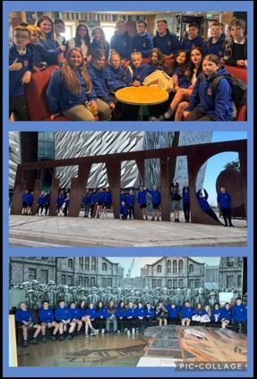
In 2024/25 we are particularly proud of these achievements:
- We have a wide range of extracurricular activities. 15 children gained their ‘Platinum’ award for sport, attending over 100 clubs this session. 42 children achieved their ‘Gold’ award for sport, attending over 50 clubs this session.
- Our netball team reached the final of the North Ayrshire Schools tournament, winning the Kilwinning locality event.
- Our football team made it to the North Ayrshire finals. They won the Ayrshire Salvar Cup this session, a massive achievement!
- 12 children gained their iCycle award.
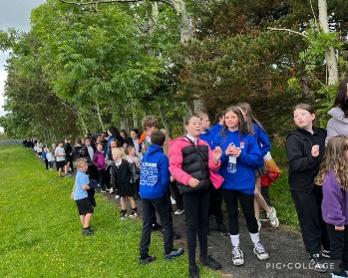
- We have a strong relationship with Kilwinning Sports Club and we access this resource for our daily mile most weeks and our ‘wellbeing walk’ once a month.
- All children participated in the NSPCC ‘Stay Safe’ workshop.
- P4/5 took part in ‘bucket drum’ lessons, showcasing their new skills to their parent/carers.
- Primary 7 took part in the Youth Council, sharing their ideas for improvement across North Ayrshire Council.
- All children took part in our wellbeing walk and class activities to support and promote World Mental Health Day.
- Primary 7 experienced a fabulous trip to the Titanic Museum in Belfast. They absolutely loved this and were a real credit to us.
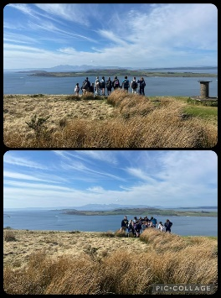
- We aim to give children experience of as many off site educational experiences as possible. P7 had a fully funded residential to Inverclyde. All children have benefited from experiential learning. Some of our trips include: Our Early Years Class visiting the library for Bookbug sessions, P1 visiting the Riverside Museum in Glasgow, P2/3 going to Dundonald Castle with P3/4 and the Maritime Museum, P3/4 doing a hill walk in Largs, P4/5 going to the RSPB in Lochwinnoch and visiting Inverclyde, P6 going to the Maritime Museum.
- P4-7 children attended an ‘Into Film’ event at the Glasgow Film Theatre
- P4-7 worked with Glasgow Science Centre to enhance teaching and learning of science – this involved a day trip to the Science Centre.
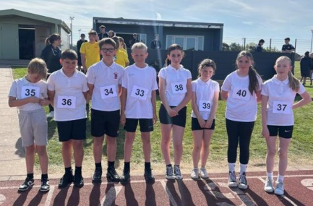
- All of our children from P3-7 are in a leadership group, helping drive our school improvement. These are established for: Pupil voice, Gardening, Digital, Rights Respecting Schools, Eco, Sport, Developing the Young Workforce, Respect Me and Reading.
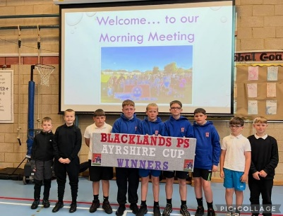
- All P1 and P2/3 children took part in a 15 week block of Active Play. This was followed up with successful family Active Play sessions.
- Primary 6 completed ‘Bounce Back your Resilience’ delivered by North Ayrshire Youth Services.
- We continue to work towards our Rights Respecting Schools GOLD award.
- We received the Digital Schools ‘Digital Wellbeing Award’.
- Primary 6 and 7 took part in the KA Leisure ‘Champions of Change’ programme.
- All children participate in weekly ‘My Happy Mind’ lessons to promote good mental health and strategies to support emotional regulation.

HOW SUCCESSFUL HAVE WE BEEN IN IMPROVING OUR ESTABLISHMENT?
Priority 1 - To nurture our children’s passion for learning – working to ensure they experience consistent, high-quality learning and teaching experiences.
Almost all our children told us in our pupil survey that they enjoy learning in our school and they benefit from exciting and engaging experiences developing skills across the curriculum. Children have fun and demonstrate increased curiosity, independence and a love for learning. Environments continue to be improved, particularly outdoors, to further develop our areas for high-quality learning and teaching experiences.
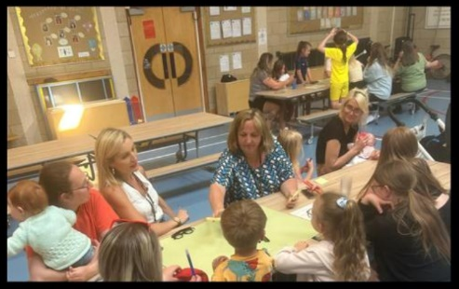
Priority 2 - Following a review of our Vision, Values and Aims a curriculum rationale will be created so that everyone involved in our school and Early Years Class will be clear on ‘What we want for our children and how we will work together to achieve this’.
Staff, children, parent/carers and partners contributed to the creation of our new Vision, Values and Aims and curriculum rationale which is understood and permeates everything we do at Blacklands.
Priority 3 - Continue work to increase attendance in all stages and in the Early Years Class in session 2024-25.

Attendance has improved across the school by 3.2%. (Attendance data in May ’24 was 88.97% and in May ’25 is 92.17%). Parent/carers and children have told us the positive impact having a ‘Mystery Day’ has had.

QUALITY INDICATORS
QI 1.3 Leadership of Change | Evaluation Very Good
There is a very warm, inclusive and respectful ethos across the school. The whole staff team work very well together and demonstrate enthusiasm and ambition to improve outcomes for children and their families. The school community reviewed and refreshed effectively their values this session. Senior leaders conduct an extensive range of quality assurance activities across the year. All staff support children’s leadership groups effectively. Every child from P3 to P7 is fully involved in a leadership group where they work regularly in collaboration with their peers
QI 2.3 Learning, Teaching & Assessment | Evaluation – Good
Teachers are effectively implementing aspects of development work in learning and teaching. They are promoting children’s engagement by ensuring the classroom environment meets the needs of all children and providing relevant, interesting learning activities. Staff use an assessment calendar well to provide consistency in assessment across the school. Teachers use digital technology creatively to extend and deepen children’s learning.
QI 3.1 Ensuring Wellbeing, Equality & Inclusion | Evaluation - Very Good
Almost all children feel safe at school and believe that children behave well. Almost all say that staff treat them with respect and that they have someone in school to speak to about worries or concerns. Staff comply fully with statutory duties relating to safeguarding, attendance, bullying and supporting children with additional needs.
QI 3.2 Raising Attainment & Achievement | Evaluation Good
Overall attainment is good. Most children at P1 achieve the expected Curriculum for Excellence (CfE) level in all aspects of literacy. The majority of children in P4 achieve the expected level in reading and writing. Almost all children in P4 and P7 achieve the expected level in listening and talking. Most children who require additional support with their learning make good progress towards their individual targets.

PUPIL EQUITY FUNDING
Our Pupil Equity Fund (PEF), monies allocated by the Scottish Government to help schools close the attainment gap, enabling us to focus on Getting It Right For Every Child. We pride ourselves in knowing our children very well and using our pupil equity fund to ensure children are able to make progress in a nurturing learning environment.
In 2024/25 we used PEF for the following
- Purchasing software licences to provide exciting and engaging activities for children to improve Literacy and Numeracy skills - Clickview, IDL, SOFA.
- We have purchased new play resources to further enhance the play opportunities our children have.
- We continue to resource our health and wellbeing curriculum and purchase ‘My Happy Mind’ to support this.
- We pay for a Principal Teacher to lead on attainment and support, who coordinates our Pupil Support Assistants and supports children who require bespoke interventions.
- We use some of our PEF to provide transport and off-site trips as part of our experiential learning – to Inverclyde and to Belfast to the Titanic Museum.
- We have purchased 20 laptops and 20 iPads to further develop our digital learning across the school.
In 25/26 we intend to
- Further develop our outdoor learning provision by developing a skills-based curriculum
- Our Principal Teacher will be funded to continue to improve attainment and achievement by ensuring children are supported and challenged.
- A raising attainment teacher will focus on supporting achievements in Numeracy across the school.
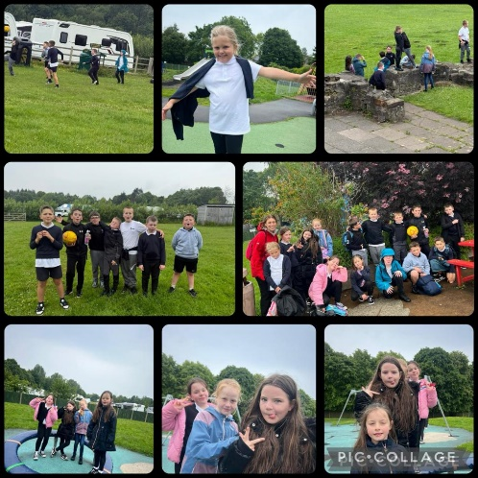
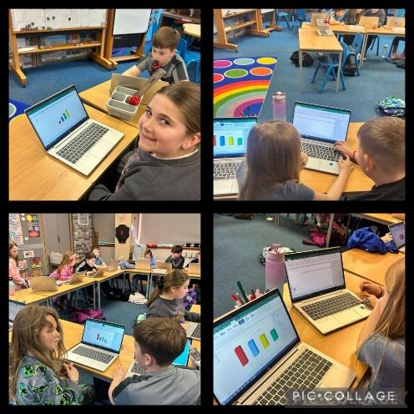
- Continue to seek opportunities for off-site learning and also partners to bring interesting learning activities to Blacklands Primary and EYC to enhance children’s learning experiences in our context.
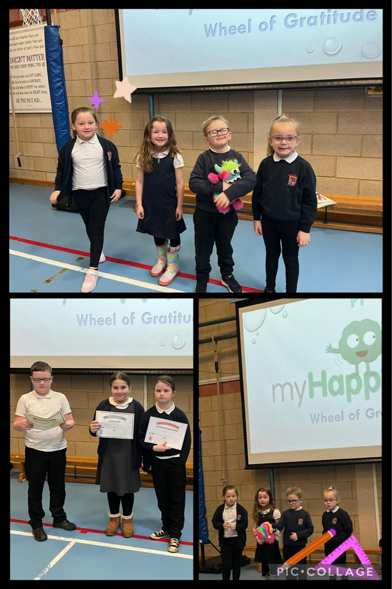

Education Scotland Inspection
In November 2024, a team of inspectors from Education Scotland visited Blacklands Primary and Early Years Class. During their visit, they talked to parents/carers and children and worked closely with the headteacher and staff.

The inspection team found the following strengths in the school’s work.

- Children in the school and Early Years class are happy, confident and responsible. They are proud to be members of the Blacklands community. All children benefit from warm, nurturing relationships with staff and each other. As a result, children are calm, settled and feel safe.
- The headteacher provides clear leadership and strong direction to the staff team. All staff in the school and Early Years class evaluate their practice on a very regular basis. They feel empowered to lead improvements and activities. This results in a very strong sense of staff teamwork and has a positive impact on children’s experiences.
- Staff in the school and Early Years class deliver a very effective range of interventions and opportunities to support children’s emotional and social wellbeing. They know the children’s needs very well and use highly appropriate strategies and resources to help them become more ready to learn.
- In the early years class, children engage very well in their learning. They are making very good progress in their learning and development.

IMPROVEMENT PLAN PRIORITIES 2025-26
Priority 1
To further develop a love for learning through enhancing environments, pedagogies and by providing relevant and exciting learning experiences for all children.
Priority 2
Learners will benefit from an enhanced, holistic Early level experience.
Priority 3
To raise attainment in literacy through delivery of consistent, high-quality learning, teaching and assessment approaches for all our learners.

