Our School  Blacklands Primary and Early Years Class is a non-denominational school with a roll of 110 pupils in 6 primary classes and 19 children in our Early Years Class.  The school serves the Blacklands and Dirrans area of Kilwinning. The current staff structure consists of 1 Headteacher, 1 Depute Headeacher, 1 Principal Teacher (PEF funded) 9 Teachers (including one Numeracy & Literacy Teacher), 1 Nurture teacher, 1 Nurture Early Years Practitioner, 0.6 Pupil Support Teacher, 1 Senior Early Years Practitioner, 1 Early Years Practitioner, 1 Early Years Practitioner working with P1, 4 Classroom Assistants, 2 Education Assistants and 1 Janitor.  We have an Early Years Class and a Nurture Class (our Cosy Corner). We have a breakfast club which runs each morning and is open to all. We also have a once a week class breakfast. We pride ourselves on our nurturing, inclusive approach to education.  Working in partnership within a caring and stimulating environment, we aim to provide quality learning experiences which will encourage positive attitudes, enabling pupils to achieve their potential as valued members of the community. | Our School Improvement Plan  Our vision: In partnership with our school community, our vision is to provide a nurturing environment that encourages and inspires children and families to explore, learn and achieve success.  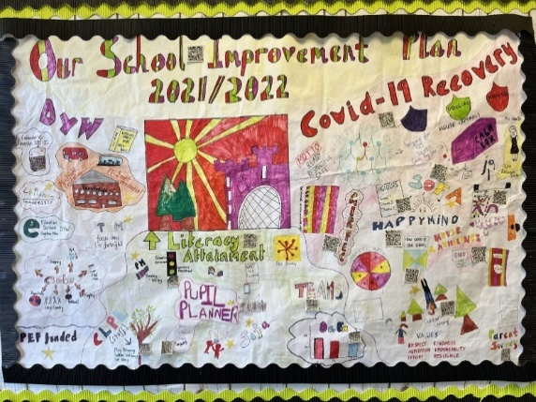  For 2022-23 we are focussing on:  - Embedding Mental Health and Wellbeing Strategies.  - Improving outcomes in attainment for all learners in our Early Years Class and School  - Developing our knowledge of NACs ‘Learning, Teaching and Assessment’ policy. | Looking Back  Last year we worked hard to re-establish our school community, focusing on  - Ensuring our road to recovery focused on the strengths and development needs of our school.  - Raising attainment in literacy – with a specific focus on reading and writing within the school  - Developing the Young Workforce and creating aspirations through experiential learning  All staff completed ‘Nurturing North Ayrshire’, continuing to develop our nurturing approaches in line with the Education Service Delivery Plan. We have invested in ‘MyHappyMind’ to create a positive mental wellbeing culture in which children are building resilience, self-esteem and character, while developing lifelong habits.  We have had a coordinated approach to supporting writing in classrooms which has seen attainment improving in all classes. Reading has also improved across the school.  Children have benefited from our experiential learning, data has shown these make them feel valued and more confident.
Our Attainment Overview  Throughout the year we gather lots of information on how our children are progressing in their learning. To monitor their progress we watch children working through tasks, listen to what they say, ask important questions, set challenges and use some standardised assessments. We get together and look carefully at the Curriculum for Excellence experiences and outcomes and Early Years Milestones to ensure children are making progress.  North Ayrshire Council also ask us to summarise our children’s progress in Reading, Writing, Listening and Talking as well as Numeracy and Maths. They ask us to look particularly at children who have reached the end of the Early, First and Second Levels in P.1, P.4 and P.7.  - Almost all of our children in Primary 1 are making good progress through Early level Reading, Writing, Talking & Listening and Numeracy.  - Most of children in Primary 4 are making good progress through First level Reading, Writing, Talking & Listening and numeracy.  - Majority of children in Primary 7 are making good progress through Second level Reading, Writing, Talking & Listening and Numeracy. | Our Achievements  As always we have lots to celebrate! Our strengths include:  - The ethos and life of the school community  - Our nurturing and inclusive practice  - Partnership working to support children and their families  We are particularly proud of these achievements:  - Our successful bid for ‘Learning for Sustainability’ where we have bought and erected a polytunnel in our field for all children from Early Years to P7 to access  - Being awarded School of the Year, for ‘Excellence in Kindness’  - Gaining £16,000 worth of funding to build an ‘Outdoor Classroom’ and second polytunnel  - Refreshing our digital technologies using PEF – we now have more iPads and laptops to enhance our learning and teaching  - All our children have attended an extracurricular club – we are now a ‘Gold Qualified’ school  - We used PEF funding to pay for a residential for P6 and 7 children and funded experiential trips for all children | 