School badge/ North Ayrshire Logo


**Blacklands Primary**

**&**

**Early Years Class**

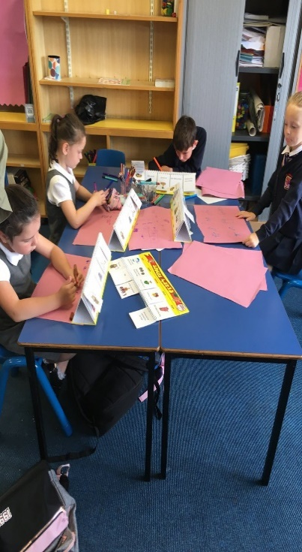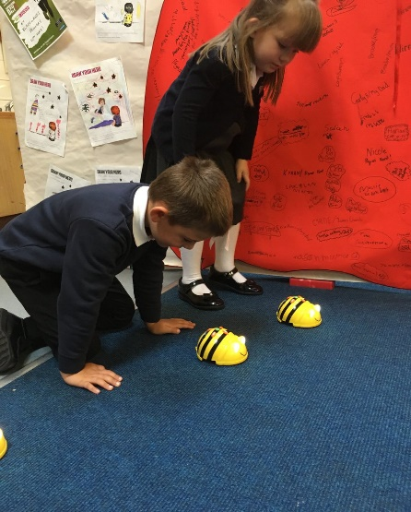****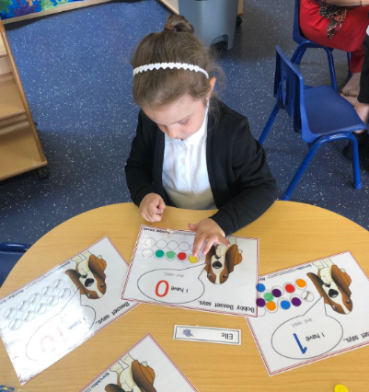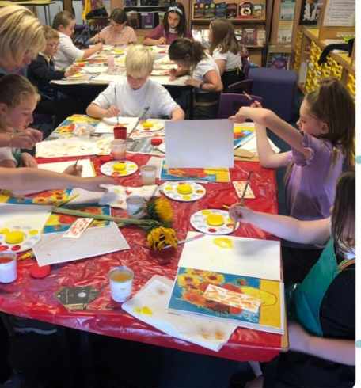

**Handbook 2020/21**

**@Blacklandsps**

**Contents**

Head Teacher Introduction

Education and Youth Employment Directorate…………………………….…..…………p5

* Directorate Aims and Priorities

Section 1: School Information……..…………………………………………….……………………p6

* School Aims, Values, Ethos
* School Contact Details (Address, Telephone, Email, Fax)
* School Staff
* School Calendar/Holidays

Section 2: School Procedures……………………………………………………….…………………p11

* School Security
* Positive Relationships
* Playground Supervision
* Wet Weather Arrangements
* Absence from School Premises at Breaks
* School Dress Code
* Dress Code for PE
* Personal Belongings
* Mobile Phones
* No Smoking Policy
* Information in Emergencies
* Listening and Learning

Section 3: Footwear, Clothing, Free School Meals and Transport…………………p17

* Footwear and Clothing Grants
* Free School Meals
* School Lunch
* School Transport Policy

Section 4: School Registration, Enrolment and Attendance…………………………..p19

* Registration and Enrolment
* Attendance at School
* Pupil Late Coming Procedure
* Attendance/Absence Data
* Structure of Classes
* Transfer to Secondary School

Section 5: Curriculum for Excellence…………………………………………………………….p22

* Curriculum for Excellence
* The Capacities
* Curricular Areas
* Outdoor Activities and School Trips
* Extra-Curricular Activities
* School Committees/Pupil Council
* Assessing Children's Progress
* Curricular Levels
* Homework

Section 6: School Improvement ……………………………………………………….………..p29

* Standards and Qualities Report/Improvement Plan

Section 7: Support for your Child……………………………………………………..………...p30

* Additional Support for Learning
* Dispute Resolution Procedures
* Further Support
* Equalities
* Equality Act 2010
* Child Protection
* Inclusion
* GIRFEC
* Psychological Services
* Data Protection
* Medical and Health Care

Section 8: Parental/Carer Involvement ………………………………………………………..p37

* Parental/Carer Engagement and Involvement
* Reports to Parents/Carers
* Supporting Your Child

Section 9: Pupil Data Collection and Protection Policies………………………….……p40

* Transferring Educational Data About Pupils
* Data Policy
* Your Data Protection Rights
* Concerns

**Appendix 1:** Important Contacts ………………………….……………………………………………p42

Rights Respecting Schools LogoEco Schools Logo

# Head Teacher’s Introduction

Dear Parent/Carer,

It gives me great pleasure to welcome you and your child to Blacklands Primary School. This handbook contains helpful information regarding all aspects of school life. Please do not hesitate to contact me at the school if you wish to clarify any points mentioned in the handbook or discuss any issues relating to your child’s education.

At Blacklands Primary School we try to ensure that all children achieve success in every area of a wide curriculum and leave the school with skills for life long learning. We also try to ensure that each child attains, to the best of his/her ability, the objectives set out for the areas of the curriculum.

To this end we celebrate all successes and achievements across the curriculum and in children's’ wider life.

The staff work very hard as a team to maintain a positive ethos in the school within which the children will work in a happy and nurturing atmosphere, where they will learn to be independent, to be responsible for themselves and to carry out their tasks with a spirit of co-operation, courtesy and respect for others.

The role of parents/carers cannot be stressed too greatly. There will be many opportunities for you to meet with your child’s teacher throughout the session, including fun events, family learning events, concerts, showcases and Parents’ Evening however our open -door policy means you are welcome at any time. Please feel free to contact me if I can assist you in any way.

I look forward to working with you and your child.

Yours sincerely

Mrs Susan Lauder

Headteacher

****Education and Youth Employment Directorate

## What We Want To Achieve

### Our Overall Aim

Ensuring people have the right skills for learning, life and work.

### Our Priorities

We are reducing inequalities and delivering improved outcomes for children and young people.

High quality learning and teaching is taking place in our establishments.

Self-evaluation and performance improvement are embedded throughout our schools and central support teams.

Levels of attainment and achievement are improving for all learners.

High numbers of our young people are entering positive and sustained post-school destinations.

# Section 1: School Information

Blacklands Primary and Early Years Class is a non-denominational school with a roll of 127 pupils in 6 Primary Classes, and 32 children in our Early Years provision. Blacklands Primary School and Early Years Class serves the Blacklands and Dirrans area of Kilwinning.

The school, opened in October 1995 is open-plan. The accommodation comprises of an Early Years Class, six class bays, a nurture classroom, a library/music room, one gym hall/dining hall, a medical room and three small offices. The school is built on one level, has ramps at all entry/exit doors and has disabled toilet facilities.

We have separate and spacious playgrounds for pre-school children, infants and seniors. We have a large field at the back of the school for sports, nature work and outdoor learning. We have a very successful Early Years Class, a Nurture Class and a Breakfast Club. We pride ourselves on our nurturing, inclusive approach to education.

Working in partnership within a caring and stimulating environment, we aim to provide quality learning experiences which will encourage positive attitudes, enabling pupils to achieve their potential as valued members of the community.

We are very proud of our school and our learning environment. Our aim, at all times is to ensure our learning and teaching is of the highest quality, meeting all children’s needs within a stimulating and nurturing environment.

## Present Roll

The current roll for each class and year group is:

**Primary 1**-14 **Primary 2**-15 **Primary 3/4**- 25

**Primary 4/5**- 25 **Primary 5/6**- 25 **Primary 7**- 19

Parents/carers should note that the working capacity of the school may vary dependent upon the number of pupils at each stage and the way in which classes are organised.

There are at present 6 classes covering from Primary 1 to Primary 7, and two Early Years classes, one class meeting in the morning and the other in the afternoon.

## Vision, Values, Aims

**Our Vision**

In partnership with our school community, our vision is to provide a nurturing environment that encourages children and families to explore, learn and achieve success.

**Our Values**

**\* Resilience * Responsibility**

**\* Respect * Fairness**

**\* Effort * Kindness**

**Our Aims**

To create a safe, healthy and welcoming school.

To ensure our children feel happy and secure within our school community.

To support children and families educationally, emotionally and socially.

To provide a wide variety of opportunities and experiences to enhance learning and achievement.

To encourage our children to be independent and take responsibility for their own learning.

To equip our children with the knowledge and skills to make good choices now and in the

future.

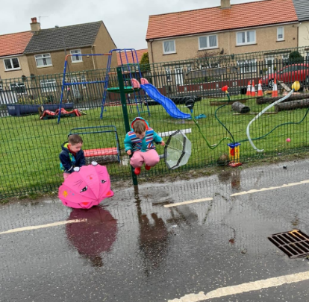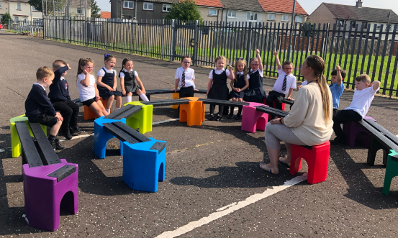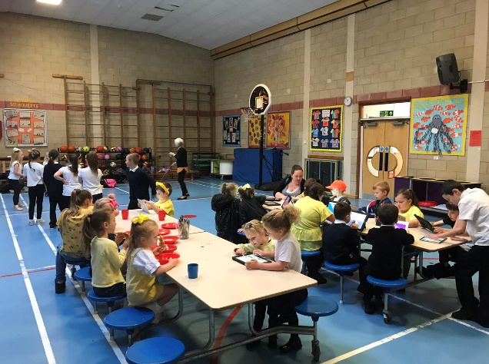

## School Contact Details

Blacklands Primary School and Early Years Class

David’s Crescent, Kilwinning, KA13 6JJ.

Telephone: 01294 552626

Fax: 01294 556308

Email: [blacklands@ea.n-ayrshire.sch.uk](mailto:blacklands@ea.n-ayrshire.sch.uk)

Website: [Blacklands Website](http://www.blacklands.northayrshireschools.co.uk/) Twitter @BlacklandsPS

### School staff

### Teaching Staff

Headteacher……………………………………….Mrs S Lauder

Depute Headteacher Mrs L Gibson

Principal Teacher/Pupil Support Mrs J Wilde

Primary 1……………………………………………..Miss E Pursley

Primary 2……………………………………………. Miss T Weeks

Primary3/4.…………………………………………Mrs L Taylor

Primary 4/5…………………………………………Mrs D Gibb and Mrs L Gibson

Primary 5/6…………………………………………Mr R Graham

Primary 7……………………………………………..Mrs H McKie and Miss L Hughes

Nurture Teacher Mrs L Shanks

Nurture EYP……………………………………….Mrs E Langan

### Early Years Staff

Senior Early Years Practitioner Mrs T Main

Early Years Practitioner Ms C Payne

Early Years Practitioner Mrs T Shields

Early Years Practitioner Miss J Turley

Early Years Modern Apprentice Miss B Robertson

### Visiting Staff

School Nurse………………………………………Mrs C Hodge

Music Instructor Mr Cowling and Mr Boax

Home Link Worker Mrs E Connor

### Ancillary Staff

Janitor………………………………………………….Mr G Devlin

Clerical Assistants Mrs K Smith and Mrs A Spence (Part time)

Classroom Assistants Mrs H Rennie, Ms L Taylor, Mrs A Spence, Miss D Gillies and Ms L Scott

Cleaning Staff Mrs Murphy, Mr G Devlin and Miss Van Heddegem

Catering Staff Ms S McIlroy, Mrs S Welsh and Mrs S Tierney

## School Day

School hours

Start…………………………………………………….9.00am, 9.10am, 9.20am

Mid-Morning Interval 10.20am, 10.40am

Lunch…………………………………………………….12.10pm, 12.45pm

Close………………………………………………………2.25pm, 2.35pm, 2.45pm

Early Years Class hours

Morning Session…………………………………8.30- 12.00pm

Afternoon Session…………………………….12.45pm-4.15pm

## School Holidays and In-Service Dates 2020-2021

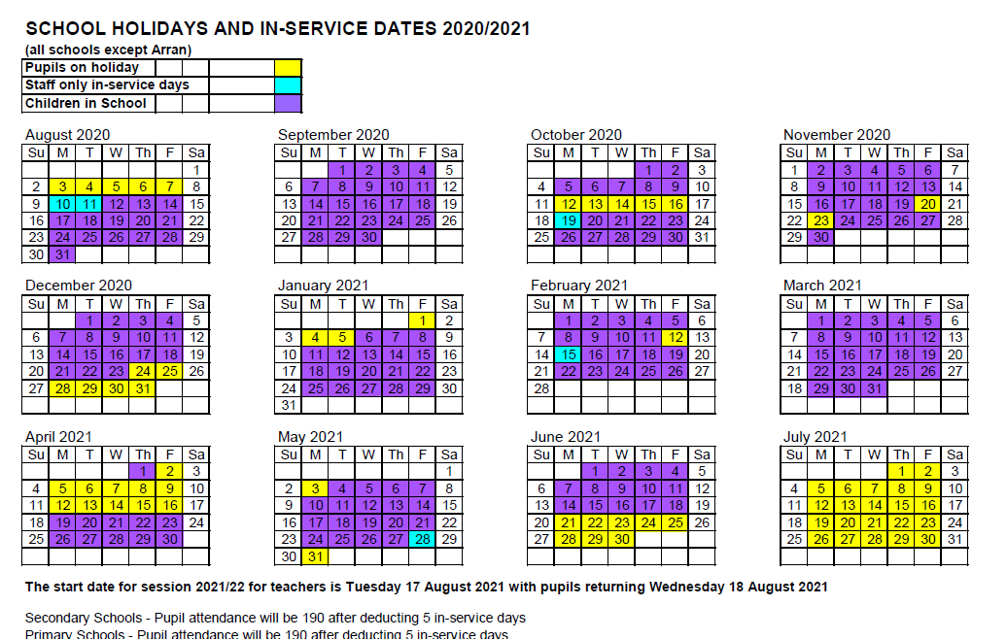

# Section 2: School Procedures

North Ayrshire Council has introduced procedures to ensure the safety and security of children and staff when attending or working in a school.

## Security in school

A number of security measures are used including the use of a visitors’ book, badges and escorts while visitors are within the school building. Anyone, parent/carer or visitor at a school for any reason, will be asked to report to the school office. The school staff will then make any necessary arrangements in connection with the visit to the school.

It is the policy of Blacklands Primary that any member of staff will approach a visitor and ask for verification of identity. This measure ensures that children work in a safe and protected environment. We appreciate your support in carrying out all of the above measures.

The school procedures in relation to anyone visiting this school are:

All visitors should enter the school building via the main entrance (pupil entry doors are adjusted to become ‘exit only’ doors during class time).

All visitors should report to the school office upon entering the school — a controlled entry system is in operation.

Visitors whose business will take them beyond the office area should sign the visitors’ book and receive a visitor’s badge which they should display at all times.

Visitors should hand back their visitor’s badge to the office staff when leaving the school.

All workmen visiting the school should report to the janitor in the first instance and sign the property manual logbook.

CCTV systems have been installed providing further security for the school campus.

## Positive Relationships

Blacklands Primary School is a place of learning but also a place for the social and personal development of each child. We promote positive behaviour at all times and put a strong emphasis on approaches to prevent, rather than react to indiscipline. The school is committed to developing a nurturing approach and promoting positive relationships. Like every community, our school is built on the relationships within it, across it and its connections with others. Every member of staff is responsible for establishing and maintaining positive relationships with each other, with parents/carers and with partners and most importantly with the young people in their care.

Our expectations of behaviour for children and young people are high. Some children may require additional support in relation to their behaviour, and the school will work positively with the young person, the parents/carers, and other partners, as appropriate, to ensure positive outcomes are achieved. North Ayrshire Council is committed to the principles of restorative practices. This is a solution-focused approach to managing behaviour and resolving difficulties and which promotes healthy relationships that enable better behaviour and better learning.

The school has a code of conduct to ensure the safety and well-being of all and parents/carers are asked to support the school fully in this matter. In Blacklands Primary School we use many systems which promote positive behaviour.

At the start of the session the school endorses school rules which aim to highlight concepts of morality and responsibility enabling children to become more aware of their choices. School rules are taught and reinforced through assemblies and also with their class teacher. Each class makes up their own set of classroom rules, referred to as the Full Value Contract and Class Charter.

All pupils are expected to conduct themselves in such a manner as to ensure their own safety and that of others. Classroom behaviour must be good enough to allow teachers to teach and pupils to learn.

## Playground Supervision

The Council meets the terms of the legal requirement that pupils be supervised in the playground by at least one adult during the interval or lunchtime if there are fifty or more pupils at the school.

Blacklands policy reflects that of North Ayrshire Council in terms of the Schools (Safety and Supervision of Pupils) (Scotland) Regulations 1990.

An adult presence is provided in playgrounds at break times. Pupils who travel by contracted school transport and arrive at school more than ten minutes before the start of the school day will have accommodation allocated to them within the school during inclement weather.

## Wet Weather Arrangements

In general children are allowed into the classrooms at playtime and lunch-time if the weather is inclement. Pupils are not normally admitted into school before 9.00 am. We realise that some pupils like to come earlier, but we would ask you not to send your child before 8.45 am as the playground is unsupervised. If the weather is particularly unfavourable then from 8.45am the children will be able to enter the building by their usual entrance. The children will then be supervised by members of staff in the gym or library before going to class at the bell.

## Absence from School Premises at Breaks

Schools have a duty to look after the welfare of their pupils. This means that the staff should take the same care of pupils as a sensible parent/carer would take, and includes taking reasonable care of pupils’ safety during intervals and lunchtimes. It is the policy of North Ayrshire Council that pupils should not leave school grounds at intervals. Primary pupils should only leave at lunch times when they are going home for lunch with their parents’/carers’ agreement. Our policy is that pupils are not allowed to visit the shops at lunchtime. If parents/carers wish their child(ren) to go home for lunch then they should notify the class teacher by letter or contact the school office in advance to make arrangements. Pupils will leave and return through the main entrance door of the school.

Pupils are not allowed out of the school grounds during class time or playtime unless under the direct supervision of a member of staff.

Parents/carers should encourage their children to follow these rules in the interests of safety.

## School Dress

It is the policy of North Ayrshire Council to support the introduction of a reasonable and flexible dress code in schools in its area. The Council encourages each school to adopt its own code, after consultation with parents and pupils.

The Council believes that establishing a school dress code has many benefits. These include improvements in safety, security, positive behaviour and community spirit and a decrease in bullying and in expense for parents.

The Council will support schools in encouraging and helping pupils to conform to the chosen dress code. Some types of clothing will not be allowed at school in any circumstances, for reasons of safety, decency or wellbeing.

Types of clothing which will not be allowed include;

* Clothes which are a health or safety risk.
* Clothes which may damage the school building.
* Clothes which may provoke other pupils.
* Clothes which are offensive or indecent.
* Clothes which encourage the use of alcohol or tobacco.

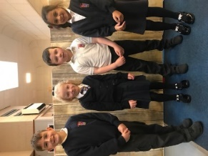

Our school uniform consists of;

School shirt & tie or

School/plain white polo shirt with

School/plain navy sweatshirt

Plain navy/black trousers or skirt or blue gingham summer dress.

All items of clothing should be clearly labelled with the child's name in case of loss.

School sweatshirts and ties are available for purchase from the school office. The expectation is that all pupils wear their school uniform every day.

## Dress Code for PE

For health and safety reasons all children must wear suitable clothing for PE. This consists of shorts and t-shirt, with soft shoes for indoor activities.

We adhere strictly to health and safety guidelines and pupils must remove any items that may cause danger, i.e., metal buckles, jewellery. These items are the responsibility of the pupil. Long hair should be tied back.

## Earrings

Earrings can be dangerous in a school environment. If you wish your child to wear them, please ensure that stud-type ones are worn, as other kinds are too easily caught up in hair or clothing when children are working or playing together. Earrings should be removed or covered with an adhesive dressing, provided by their parent/carer, for PE lessons.

## Personal Belongings

It is appreciated that parents/carers and pupils may be distressed over the occasional loss of pupil’s clothing and/or personal belongings. Parents/carers are asked to assist by ensuring that valuable items of clothing or personal belongings are NOT brought to school.

Parents/carers should note that the authority does not carry insurance to cover the loss of such items.

## Mobile Phones

While the benefits of mobile phones and electrical devices are recognised, they can be a serious distraction to work. Pupils whose mobile phones/electrical devices disrupt lessons can have them confiscated until the end of the school day. Repeated disruption may result in phones/electrical devices being retained until uplifted by a parent/carer. Inappropriate use of text messages and/or photographs/recordings (video and audio) whilst in school may be treated as a breach of school discipline or a serious incident, which could be referred to the police.

## No Smoking Policy

North Ayrshire Council has a non-smoking policy. Smoking is not permitted in any area of the school or the school grounds.

## Information in Emergencies

At Blacklands Primary and Early Years Class we make every effort to maintain a full educational service but on some occasions circumstances arise which lead to disruption. Schools may be affected by, for example, severe weather, and temporary interruption of transport, power failures or difficulties of fuel supply. In such cases, we shall do all we can to let you know about the details of closure or re- opening. We will keep you in touch by using letters, texts (where possible), NAC website, notices in local shops and community centres, announcements in the press and West FM.

Should you have doubts about deteriorating conditions during the day, it may be advisable to contact the school. **Parents/carers** should ensure that the school is aware of the emergency arrangements made for their child and **have responsibility to update us** with contact numbers.

It may be necessary, on rare occasions, to close the school at short notice. The school will make every effort to contact parents/carers or emergency contacts. It would be helpful should an emergency arise that your child (each child, for it may not be possible to connect brothers and sisters) should know where to go in an emergency.

Due to the above reasons it is vital that our records regarding emergency contacts are always up to date. New entrants are asked to supply the addresses and phone numbers of two emergency contacts and to ensure this is updated regularly.

It is the **responsibility of parents/carers** to ensure that any changes in circumstances regarding emergency contacts be brought to our attention as soon as possible.

## Listening and Learning

It is the policy of North Ayrshire Council to try to encourage feedback on the education service from parents and pupils. This is part of our overall commitment to giving the best possible service and to working in partnership.

We are therefore very interested in feedback of all kinds, whether it is compliments, suggestions or complaints. If you wish to register a comment of any type about the school you can do this by writing, telephoning or making an appointment to see someone. All feedback is welcome and helps us keep in touch.

If, in particular, you have a complaint about the school please let us know. It is better that these things are shared openly and resolved fairly, rather than being allowed to damage the home/school relationship. There will be no negative consequences arising from making a complaint and we will deal with the issue as confidentially as possible. If we have made a mistake we will apologise quickly and clearly and try to put things right.

There are some things which you should take note of in relation to making a complaint:

* The Council has a Two Stage Policy when dealing with complaints from parents.
* It is helpful if complaints are made initially to the Head Teacher. This makes sure that the school knows what is going on and has an opportunity to respond and resolve the issue.
* We will try to respond as quickly as possible, but often issues are complex and need time to investigate. It is therefore helpful if you can give some details of the issue and ask for an early appointment to discuss it.
* If you are not satisfied with our response then you still have the right to request that your complaint is raised as a Stage 2 Complaint. Should you wish to request this you should contact Education and Youth Employment at Cunninghame House, Irvine, KA12 8EE, Telephone (01294 324400).
* If, after receiving our final decision on your complaint, you remain dissatisfied with our decision or the way we have handled your complaint, you can ask the [SPSO](http://www.spso.org.uk/%22%20%5Co%20%22Scottish%20Public%20Services%20Ombudsman) to consider it. We’ll tell you how to do this when we send you our final decision.
* You should also note that you have the right to raise unresolved concerns with your local Councillor, MSP or MP.
* Parent Councils have an important role in developing links between the school and the wider parent body and can often be helpful in helping to deal with issues of general concern. However, parents are advised that individual, more personal complaints are not appropriate for raising via Parent Councils due to the need for appropriate confidentiality.

# Section3: Footwear, Clothing, Free School Meals and Transport

Parents receiving Universal Credit will normally be entitled to grants for footwear and clothing for their children. Universal Credit claimants monthly income must not exceed £610.00, however, some parents earning more than this may still be eligible. Parents who still receive Income Support, Income based Job Seeker’s Allowance, any income related element of Employment and Support Allowance, Support under part V1 of the Immigration and Asylum Act 1999, Child Tax Credit only (with income under £16,105), Working Tax Credit or Housing Benefit may also still be entitled to grants for footwear and clothing for their children.

Parents who may be unsure whether they can apply should contact the Council’s Welfare Reform Team on 0300 99 4606 or the Council Contact Centre on 01294 310000 for further advice.

Information and application forms may be obtained from schools.

## Free School Meals

Children of parents/carers receiving job seeker’s allowance or income support are entitled to a free midday meal and free milk. Parents/carers should contact 01294 310000 for further information.

Please Note: **ALL** pupils in P1-3 are entitled to a free school meal, which includes milk.

Other than P1-P3 pupils, only those children whose parents/carers receive job seeker's allowance or income support will be entitled to free milk. Milk may however be available for purchase in the school during the lunch period.

## School Lunch

At Blacklands we operate a cafeteria system where children have a choice of hot meals, snacks, filled rolls or sandwiches, drinks, home baking, desserts or fruit. The meals are planned to offer a healthy diet for the children. The emphasis is on healthy eating and the reduction of sugar and fat intake.

Children pre-order their meal in the morning. At the start of each session, pupils are issued with a menu over a 3 week rolling programme. The kitchen staff have a note of the children who are entitled to a free school meal.

Children who bring a packed lunch to school eat their lunch in the dinner hall with those taking school dinners. Parents/carers are asked to ensure that containers are safe, suitable for the purpose and have the child’s name clearly shown on the outside. All rubbish should be taken home. Fizzy drinks in cans and bottles should not be brought to school as these can cause accidents e.g. cuts from cans or broken glass.

Entry to the lunch hall is on a rota system designed to provide the best possible service with no discriminations. Parents/carers should inform the school if their child requires a special diet - the details of this will be discussed with the school catering manager, who is based in Abbey Primary.

## School Transport Policy

North Ayrshire Council has a policy of providing free transport to all primary pupils who live more than two miles from their catchment area school by the recognised shortest safe walking route or through the link attached below:

[https://www.north-ayrshire.gov.uk/Forms/EducationalServices/free-school-transport.doc](http://www.north-ayrshire.gov.uk/Forms/EducationalServices/free-school-transport.doc)

These forms should be completed and returned before the end of February for those pupils beginning school in August to enable the appropriate arrangements to be made.

Applications may be submitted at other times throughout the year but may be subject to delay while arrangements are made.

The appropriate officer has discretion in special circumstances to grant permission for pupils to travel in transport provided by the authority, where places are available and no additional costs are incurred.

Where free transport is provided it may be necessary for pupils to walk a certain distance to the vehicle pick-up point. Walking distance in total, including the distance from home to the pick-up point and from the drop-off point to the school in any one direction, will not exceed the Council's limits (see above section). It is the parents/carers responsibility to ensure that their child arrives at the pick- up point on time.

It is also the parents/carers responsibility to ensure that their child behaves in a safe and acceptable manner while boarding, travelling in and leaving the vehicle. Misbehaviour can result in children losing the right to free transport.

Please see attached link to the Council’s School Transport Policy:

[https://www.north-ayrshire.gov.uk/Documents/EducationalServices/school-transport-policy.pdf](http://www.north-ayrshire.gov.uk/Documents/EducationalServices/school-transport-policy.pdf)

# Section 4: School Registration, Enrolment and Attendance

The date for registration of school beginners is advertised in the local press and is normally in January each year. Pupils will be registered in the school for their catchment area.

Parents/carers are provided with information about the school and procedures for making placing requests, if required. Arrangements for meetings with parents/carers and induction days for pupils will be notified during the spring and summer terms.

Parents/carers of pupils who have moved to the area or who wish their child to transfer to the school should contact the school office for information about appropriate procedures and to arrange a visit to the school. Parents/carers are welcome to contact the Headteacher at any time by visiting or telephoning the school.

## Attendance at School

It is the responsibility of parents/carers of children of school age to educate their child(ren). Most do this by ensuring that their child(ren) attend(s) school regularly. Attendance is recorded twice a day, morning and afternoon. Absence from school is recorded as authorised, unauthorised or temporarily excluded.

Parents/carers are asked to inform the school by letter or telephone if their child is likely to be absent for some time, and to give the child a note on his or her return to school, confirming the reason for absence. If there is no explanation from a child’s parents/carers, the absence will be regarded as unauthorised.

Every effort should be made to avoid family holidays during term time as this both disrupts the child’s education and reduces learning time. Parents/carers should inform the school, of the dates, by letter, before going on holiday. Such absence will be authorised only where certain and very specific family circumstances exist.

The majority of family holidays taken during term time will be categorised as unauthorised absence. Parents/carers may request that their children be permitted to be absent from school to make an extended visit to relatives.

Only written requests detailing the destination, the duration and the provision that will be made for their continuing education will be granted. Such extended absences will be recorded separately from the normal attendance and absence information.

The School Inclusion Worker investigates unexplained absence, and the authority has the power to write to, interview or prosecute parents, or refer pupils to the Reporter to the Children’s Panel, if necessary.

## Pupil Late-coming Procedures

Late arrival at school can be disruptive to your child’s education, and parents/carers are requested to ensure children arrive promptly at the beginning of the school day. The following procedures are in place in relation to pupil late-coming:

1. Parents/carers are requested to inform the school if they are aware that their child will be late for school.
2. If a child arrives at school after 9.00 a.m. then they must report to the office and sign in, children arriving very late must be brought to school by an adult who would then sign the child in.
3. The Headteacher monitors the late-coming and will make contact with parents/carers in cases where pupils are arriving late on a regular basis.

## Attendance/Absence Data

Absence rates are calculated as a percentage of the total number of possible attendances for all pupils of the school in the stage shown, each morning and afternoon of each school day being a separate possible attendance. The school has clearly defined procedures for monitoring the pupils’ attendance. If non-attendance follows a regular pattern e.g. Monday and/or Fridays or when a pupil’s absences reach a number that would cause concern i.e. approximately 10 - 15% of the total possible attendances, it will be reported to the Headteacher.

The Headteacher will take appropriate action and liaise with the School Attendance Officer. In the first instance a letter will be sent to parents/carers making them aware of their child’s number of absences. If there is no improvement then a second and possibly a third letter will be sent inviting the parents/carers to the school to discuss the situation.

As previously stated, if necessary the School Attendance Officer will be called upon to investigate absences and it should be noted that the authority has the power to write to, interview or prosecute parents/carers or to refer pupils to the Reporter to the Children’s Panel, if necessary.

## Structure of Classes

Primary Schools educate pupils at seven broad year stages, primary 1 to primary 7. A year stage is defined as a group of pupils entering primary education at a common date. Schools are staffed based on the total number of pupils. However, the numbers of pupils at each year stage will vary. This means that Headteachers are required to organise classes to make best use of available staff, resources and space to the benefit of all children in the school.

Pupils may, therefore, be taught in a single stage class or a composite class where two or more year stages are grouped together. This may also change as pupils move from one year to the next.

National guidelines on the curriculum indicate that pupils should progress through learning experiences tailored to their own needs and abilities. This means that pupils in all classes follow programmes designed to help them progress at their own level. This applies to all pupils regardless of whether or not they are in a composite or single year stage class.

The National agreement on class sizes states that the maximum number of pupils in a class is 25 in P1, 30 in P2 – P3, and 33 in P4 -7. In a composite class, the maximum number is 25.

## Transfer to Secondary School

Pupils are normally transferred between the ages of eleven and a half and twelve and a half, so that they will have the opportunity to complete at least 4 years of secondary education. Parents/carers will be informed of the arrangements no later than January of the year preceding the date of transfer at the start of the new session.

During their time in P7, pupils are taken to Kilwinning Academy as part of the induction programme. Teachers from local primary schools and their secondary colleagues have worked together to create a Pupil Profile of Achievements which will be completed in Primary 7 and passed onto the secondary school. Teachers from both schools liaise to ensure a smooth transition which focuses on progression for pupils. Parents/carers will be informed of the details of the visits when appropriate.

Parents/carers are fully informed and involved in the transition process. Excellent P7/S1 transition arrangements are in place with the children having various opportunities to work in Kilwinning Academy with cluster schools and Kilwinning Academy staff.

The culmination of this process is an outdoor residential trip with the pupils being accompanied by staff from both Kilwinning Academy and the five Primaries. These initiatives enable the P7 pupils to meet, work and socialise with their new S1 peers.

Pupils from Blacklands Primary School normally transfer to:



Kilwinning Academy

Dalry Road

Kilwinning

Phone - 01294 551316

Fax - 01294 552980

[Email - kilwinning@ea.n-ayrshire.sch.uk](mailto:kilwinning@ea.n-ayrshire.sch.uk) Twitter - @Kilwinning_Acad

# Section 5: Curriculum for Excellence

Curriculum for Excellence is the national curriculum for Scottish schools for learners from age 3 to 18. It aims to raise standards, prepare our children for a future they do not yet know and equip them for the jobs of tomorrow in a fast changing world.

Curriculum for Excellence enables professionals to teach subjects creatively, to work together across the school and with other schools, to share best practice and explore learning together. Glow, Scotland’s unique, world-leading, online network supports learners and teachers in this and plans are already in place for parents/carers across the country to have access to Glow.

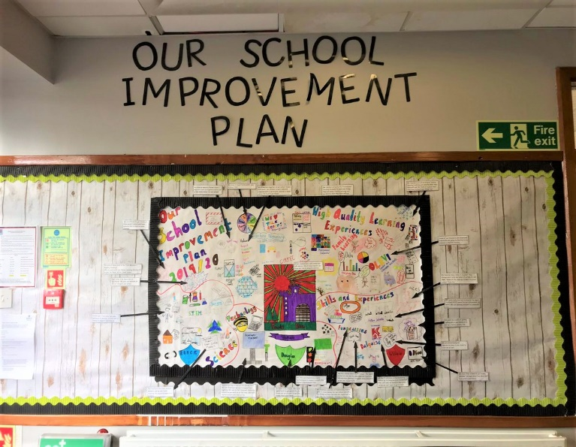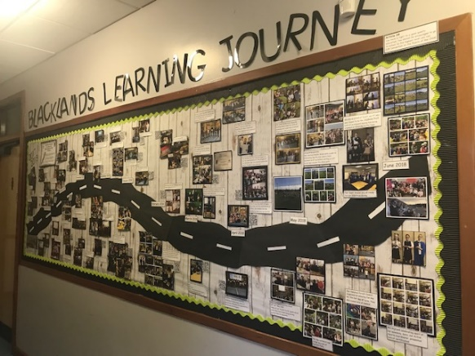

Teachers and practitioners will share information to plan a child’s “learning journey” from 3-18, ensuring children continue to work at a pace they can cope with and with challenge they can thrive on. Curriculum for Excellence balances the importance of knowledge and skills. At Blacklands Primary School we believe that children should have ownership of their learning, we do this by first finding out what they know about the subject and asking the pupils what they would like to find out. From this, the teacher plans experiences (lessons) based around finding the answer.

Every child is entitled to a broad and deep general education where every single teacher and practitioner will be responsible for literacy and numeracy – the language and number skills that unlock other subjects and are vital to everyday life. There is emphasis too on health and wellbeing – to ensure that the school is a place where children feel safe and secure.

Curriculum for Excellence develops skills for learning, life and work to help young people go on to further study, secure work and navigate life. It brings real life into the classroom. It brings knowledge in one subject area to another helping children understand the world and make connections. It develops skills so that children can think for themselves, make sound judgements, challenge, enquire and find solutions.

Ultimately, Curriculum for Excellence aims to improve our children’s life chances, to nurture successful learners, confident individuals, effective contributors, and responsible citizens, building on Scotland’s reputation for great education.

Curriculum for Excellence aims to enable young people to meet the four capacities listed.

## Curriculum for Excellence: The Capacities

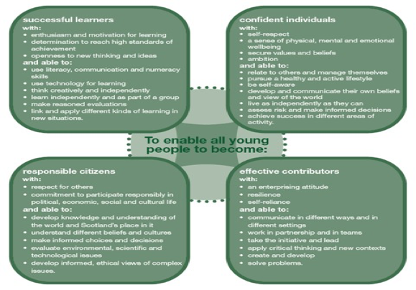

Further Information about Curriculum for Excellence and the Experiences and Outcomes can be found on the Curriculum for Excellence website. [www.educationscotland.gov.uk/thecurriculum/whatiscurriculumforexcellence.](http://www.educationscotland.gov.uk/thecurriculum/whatiscurriculumforexcellence)

## Curricular Areas

The curriculum is structured under eight curricular areas; Literacy, Numeracy and Mathematics, Health and Wellbeing, Expressive Arts, Religious and Moral Education, Sciences, Social Subjects and Technologies.

These curricular areas should ensure that learning takes place across a broad range of contexts. They support the progressive development of ideas, skills and ways of thinking. Children are encouraged to take responsibility for their own learning and to work both independently and as part of wider group.

### Literacy

Language is the means by which we achieve effective communication, and it is the area of the curriculum that integrates fully with all of the others. Language comprises the disciplines of Talking, Listening, Reading and Writing.

**READING**

Reading is a major part of the whole language process which enriches the child’s vocabulary and experience. We encourage our pupils to read a variety of texts, encouraging an enthusiasm for reading and catering for their interests and levels of understanding. We use a variety of resources and activities to develop reading skills and comprehension.

**TALKING AND LISTENING**

In spoken language, children gain understanding and participate in various forms of communication, discussion, debate, interviews, descriptive role-play etc. Talking and listening skills are developed and encouraged throughout the curriculum.

**WRITING**

In written language, skills are taught within an integrated programme. Spelling, punctuation and language usage are taught as part of a structured approach throughout the school to help the child express himself/herself more accurately and fluently. Writing skills are developed through a series of learning outcomes and demonstrated through the curriculum.

**1+2 LANGUAGES**

All children are taught French from our Early Years Class to Primary 7. Primary 6 and Primary 7 pupils receive tuition in French. They are taught through games, songs and various other activities.

### Numeracy and Mathematics

Our Mathematics Curriculum allows the development of a variety of skills within a broad framework of activities, e.g., Numeracy, Money, Measure, Shape, Position/Movement, Information Handling and Problem Solving. A variety of active and interactive resources are used to stimulate children’s interest and enthusiasm. Additional resources are used for revision, consolidation, extension and challenge.

### Health and Wellbeing

A whole school programme is supported by a wide variety of resources and activities which cover social, physical and emotional wellbeing as well as physical activity. There is a programme for Sexual Health Education in Primary 6 and Primary 7 which is delivered by their class teacher.

The school will contact parents/carers to let them know that this programme will be starting and parents/carers will be made aware to contact the school if they do not wish their child to take part in the lesson.

Our programme for Health and Wellbeing forms an integral part of school ethos and this curricular area permeates the whole of school life.

The experiences and outcomes for Health and Wellbeing are organised under the following headings:-

* Mental, emotional, social and physical well being
* Planning for choices and change
* Physical education, physical activity and sport
* Food and health
* Substance misuse
* Relationships

This area of the curriculum encourages the child to learn more and appreciate the world around him/ her and equips him/her with some of the skills he/she needs to interpret it. A concept skills approach is used within a topic programme.

Photo

### ExpressiveArts

Expressive Arts involves the disciplines of art, music and drama and it is the aim of the school that every child should develop each discipline to their full potential. It is vital that pupils learn to appreciate the aesthetic value of the Expressive Arts as well as developing their individual talents in each area.

#### ART AND DESIGN

Through art and design, learners have the opportunity to be creative and to experience inspiration and enjoyment. They will study the work of different artists.

#### DRAMA

Drama in conjunction with language develops understanding and cooperation with others through group activities, role play and improvisation.

#### MUSIC

Music development encourages singing, learning about rhythm and pitch, music making, etc. P5 pupils receive tuition in percussion instruments.

### Religious and Moral Education

Our whole school programme reflects a balanced approach to the teaching of Religious Education. World religions will be taught throughout the session. Events such as Burns Day and St Andrew’s Day are also celebrated thus embracing our Scottish culture.

### Religious Education and Observance

Under the terms of the Education (Scotland) Act 1980, parents/carers have the right to ask for their child to be withdrawn from religious observance. The school will deal with such requests with sensitivity and understanding. The Headteacher will offer to meet with any parent/carer wishing to withdraw their child to ensure that they are clear about the school policy on religious observance.

In particular, parents/carers should be reassured that the religious observance planned by the school adopts an open and respectful approach and does not seek to compromise the beliefs of any pupils or their families.

Parents/carers from ethnic minority religious communities may request that their children be permitted to be absent from school in order to celebrate recognised religious events. Only written requests detailing the proposed arrangements will be considered. Appropriate requests will be granted on not more than three occasions in any one school session and the pupil noted as an authorised absentee in the register.

Our church representative is Reverend I Beck from Abbey Church

### Science

In science, children will have the opportunity to investigate their environment through observation, exploration and investigation. They will develop an understanding of the impact science makes on their lives, on the lives of others, on the environment and on culture.

The science experiences and outcomes are structured in the following way:-

* Planet Earth
* Materials
* Forces, Electricity and Waves
* Biological Systems
* Topical Science

### Social Studies

Social Studies include the following:

* People, Past Events and Societies
* People, Place and Environment
* People in Society, Economy and Business

Within these general themes pupils will experience many curricular links. As part of this programme it is very likely that the children will go out of school on educational visits or we may also invite specialists in to school to talk to the children. We have a variety of business links which help develop the pupils’ entrepreneurial skills.

#### Technologies

Children will be provided with opportunities to develop an understanding of technologies and their impact on society. They will also develop confidence and skill in the use of these technologies to create, present and record their own ideas and materials. In ICT, children will develop skills in emailing, word-processing, graphics and information handling from P1-P7. The use of a range of technology, including cameras, iPads, laptops and Interactive Promethean Boards in every classroom, further supports learning and teaching across the curriculum. A range of software and the World Wide Web are used to enhance learning.

## Outdoor Activities and School Trips

In normal times when outings or excursions for children are planned, the Headteacher or a member of staff will advise you in advance, by letter. You will be asked to complete consent forms which give your permission for your child’s participation. **Please note that children cannot take part in outings unless completed consent forms have been submitted by their parent/carer. However at present times NO trips will take place due to COVID-19.**

In line with Curriculum for Excellence, we make use of a variety of outdoor learning activities and school trips to enhance the learning experience for our pupils. Learning doesn’t take place solely within the school building. The outdoor environment has massive potential for learning. Learning outdoors can be enjoyable, creative, challenging and adventurous and helps children to learn by experience and grow as confident and responsible citizens.]

For more information on CfE you can visit the website: [Education Scotland](http://www.educationscotland.gov.uk/)

## Extra-Curricular Activities

A variety of extra curricular activities/clubs may be offered during the school year including; football, netball, crafts, athletics, Lego, Scottish country dancing and gymnastics.

Some of these clubs are pupil led (supported by staff) at playtimes and lunchtimes as part of our Senior Pupil Leadership programme.

The school always welcomes the help and support of any parent/carer who is able to offer an extra curricular activity however due to the COVID-19 pandemic we are not able to offer these opportunities at the present time.

## School Councils/Pupil Council

There are several pupil led councils where children across the school have the opportunity to lead change. Each pupil is the member of a school council. They have the responsibility of helping to make school improvements.

Each class votes annually for a pupil who will represent them on the Pupil Council. The Council meets with Mrs Lauder regularly, to discuss and make decisions on issues which affect the school. Children in P1-3 will have a consultant to help them. These will be Pupil Council representatives from the senior classes.

## Assessing Children’s Progress

Assessment is a central part of everyday learning and teaching for children and young people. Evidence of progress is gathered on an ongoing and informal basis through asking questions, observing children working together and making formative comments on their work. Children may also assess their own work or that of their class mates; this is called self and peer assessment. Some assessment is more formal such as projects, investigations and standardised assessments.

The assessment of children’s progress throughout the BGE (Early – S3) is based on teachers’ views: their professional judgement. Teachers draw on their professional knowledge and understanding of the child; on the benchmarks for literacy and numeracy, which provide clear information about what children and young people should be able to do and demonstrate by the end of a Curriculum for Excellence Level; and on a wide range of assessment information.

Teachers of P1, P4, P7 and S3 are asked at the end of every school year whether children have achieved the relevant Curriculum for Excellence level for their stage in reading, writing, talking and listening (literacy), and their ability to understand and work with numbers (numeracy). Most children are expected to have achieved the early level by the end of P1, first level by the end of P4, second level by the end of P7 and third or fourth level by the end of S3.

The government has also introduced new national standardised assessments which cover some aspects of reading, writing and working with numbers. These assessments are completed online and are automatically marked by the online system giving teachers immediate feedback to help plan next steps and support children’s progress.

Teachers remain best placed to know how the children in their class are progressing. Their professional judgement will continue to be the most important way of assessing your child’s progress at school.

As a parent/carer, you continue to have a key role in helping your child to learn. Your child’s teacher will keep you informed about how your child is progressing. Please contact us if you have any concerns about their learning, assessment or for more information on how you can support your child’s learning at home.

### Theexpectationsaboutprogressthroughcurriculumlevelsareas follows:

Early Level - Early Years Class – P1 (Secure by end of P1)

1st Level P2-4 (Secure by end of P4)

2nd Level P5-7 (Secure by end of P7)

3rd Level S1+

# Section 6: School Improvement

Schools in North Ayrshire follow a Quality Improvement process designed to highlight strengths and identify areas for improvement. The process is based on the school’s self evaluation process with Heads of Service and Senior Managers involved in at least three formal validation visits each session.

This validation process involves talking to pupils, staff and parents/carers about learning and improvements made by the school. This results in actions for improvement for the school to take forward in their planning process.

In addition, themed reviews are undertaken from time to time e.g. to look and report on the quality of the Broad General Education (3-18) and Senior phase Education within secondary schools.

This process is based upon standards and expectations contained within the following National Standards documentation:

National Improvement Framework

How Good is Our School? 4

How Good is Our Early Learning and Childcare?

A Standards and Quality Report and School Improvement Plan are produced on an annual basis by every school and centre. Staff, Parents/carers, Carers, Young People and School Partners will play an active role in the development of these key school documents.

Blacklands documents can be found on the school website.

# Section 7: Support for your Child Additional Support for Learning

Any child who needs more or different support to what is normally provided in schools or pre-schools is said to have ‘additional support needs’. This includes children who may need extra help with their education as a result of issues arising from social and emotional difficulties, bullying, physical disability, having English as an additional language, a sensory impairment or communication difficulty.

## The Additional Support for Learning Act

The Education (Additional Support for Learning) (Scotland) Act 2004 came into force in November 2005. In June 2009, the Act was amended. These amendments form the Education (Additional Support for Learning) (Scotland) Act 2009 and came into force on November 2010.

Main provisions of the Act;

The Act provides the legal framework underpinning the system for supporting children and young people in their school education, and their families.

This framework is based on the idea of additional support needs. This broad and inclusive term applies to children or young people who, for whatever reason, require additional support, long or short term, in order to help them make the most of their school education and to be included fully in their learning.

The 2009 Act automatically deems that all looked after children and young people have additional support needs unless the education authority determine that they do not require additional support in order to benefit from school education.

In addition, education authorities must consider whether each looked after child or young person for whose school education they are responsible requires a co-ordinated support plan.

Duties under the ‘Additional Support for Learning’ legislation

North Ayrshire must assess any pupil with additional support needs and provide with any support necessary for them to benefit fully from their education. All the evidence says that it is best to intervene early to prevent any difficulties developing and taking root. For example by making sure reading is very well taught and that all pupil gets encouragement and support at home we can hopefully reduce later difficulties.

Whatever the type of challenge that arises, it is important to detect it early, develop a shared understanding of what is needed (the school may request extra specialised help to do this) and take action to help to pupil achieve. Whenever we start this process for any child or young person, we will always explain to them and to their parents/carers what our concerns are and what we will do to help.

The school can get support from a range of visiting professionals including Educational Psychologists. These professionals are regularly in all schools and teachers and others will ask for informal advice on supporting pupils for example on the best way to support a pupil who is having difficulties with reading. If the school wants more detailed individual help then they would talk to you about formally involving the educational psychologist. The educational psychologist can only be involved in consultation, collaborative assessment and planning interventions for your child after you agree to this.

For a few children and young people their needs are so complex that professionals from two or more agencies need to work together over a significant length of time to enable the child to benefit from school education.

The authority approach to staged intervention has been updated to take ensure it is line with the CYP (2014) and ASL (2004) (amended 2009) Acts. The aim is to ensure children and young people get the right support at the right time.

Where a child or young person has additional support needs, extra planning is required every time there is a move to a new class, new school or college. How far ahead this transition planning needs to start depends on the particular type of needs but for most children and young people with Additional Support Needs transition planning should start at least one year before the date of the planned move.

Detailed advice on transition planning is provided in the Supporting Children’s Learning Code of Practice, which can be accessed at the following link:

[Supporting Children's Learning Code of Practice](http://www.gov.scot/Resource/Doc/348208/0116022.pdf)

## Dispute Resolution Procedures

If you feel that things are not being done properly to support your child then the Council has a range of ways to work with you to resolve any issues. You can ask, at any time, for a copy of the booklet called ‘Resolving Disagreements’. This booklet will give you ways to make sure your concerns are listened to and addressed.

## Further Support

The following organisations are able to provide advice, further information and support to parents/ carers of children and young people with ASN.

Enquire: Scottish Advice and Information Service for Additional Support for Learning Website: [Enquire website](http://enquire.org.uk/)

Helpline: 0345 123 2303 Email: [info@enquire.org.uk](mailto:info@enquire.org.uk)

Scottish Independent Advocacy Alliance Website: [SIAA website](http://www.siaa.org.uk/) Telephone: 0131 260 5380

Email: [enquiry@siaa.org.uk](mailto:enquiry@siaa.org.uk)

Scottish Child Law Centre Website: [SCLC website](http://www.sclc.org.uk/) Telephone: 0131 667 6333 Email: [enquiries@sclc.org.uk](mailto:enquiries@sclc.org.uk)

## Equalities

In line with North Ayrshire Council policy, educational provision is open to all pupils, regardless of sex, age, religion, race, disability or any other potential barrier and all reasonable measures will be taken to ensure that the curriculum is available to every child. Schools also have a duty to promote equality and to eliminate racist and other discriminatory behaviours.

### Equality Act 2010

The Equality Act 2010 has been drawn up to tackle inequality and prevent discrimination against people on the basis of ‘protected characteristics’. It brings together several existing laws and aims to make understanding the law simpler and also introduces a new single public sector equality duty, which requires public bodies to actively advance equality.

The duties set out in Chapter 1 of Part 6 of the Equality Act apply to all schools. These provisions protect pupils at the school and in the case of admissions, those applying or wishing to apply for admission. Former pupils are also protected from discrimination or harassment.

Guidance on the Act and its requirements for schools in relation to the provision of education can be accessed via the Scottish Government website via here:

[Scottish Government Guidance](http://www.gov.scot/Publications/2012/02/7679/3)

## Child Protection

The Education and Youth Employment Directorate has a fundamental duty to contribute to the care and safety of all children and young people in North Ayrshire. In fulfilling this duty, the service must engage in close partnership with parents/carers/carers and relevant agencies, primarily the Health and Social Care Partnership and where appropriate the Scottish Children’s Reporter’s Administration. The Service will work in partnership with a number of levels within the establishment or school within the cluster or local area and through Integrated Children’s Services and Community Health Partnership.

The Standard Circular entitled, “Protecting North Ayrshire Children” provides guidance for policy and practice within all educational establishments. The Council is one of the key partners in the North Ayrshire Child Protection Committee, a multi-agency group which takes the lead role in ensuring that our children and young people are cared for, protected from harm and grow up in a safe environment.

Each school has a named Child Protection Co-ordinator who is the main point of contact for school staff and for external agencies seeking contact with the school on child protection matters. At Blacklands this is the Headteacher Mrs S Lauder.

There is an extensive staff-training programme available to staff and, in addition, at the beginning of each school session all staff receive an update on child protection policies, safeguarding and procedures.

## Inclusion

North Ayrshire Council is committed to the well-being and educational development of all learners.

The process of inclusion requires all involved in the business of learning and teaching to demonstrate commitment, innovation and flexibility in order to ensure that all children and young people have access to quality learning opportunities and experiences. Our Inclusion Strategy states that:

* An inclusive approach to education supports an ethos of achievement and high expectation, recognises difference, respects these differences and sees differences between learners as opportunities for learning.
* An inclusive approach to education promotes tolerance and a positive understanding of diversity.
* An inclusive approach to education alleviates the barriers to learning, supports the achievement of all and has positive relationships at its heart.

Only in exceptional circumstances would it be deemed lawful to proceed to consider alternative educational planning for a child or young person.

The Education (Disability Strategies and Pupils’ Educational Records) (Scotland) Act, October 2002, requires local education authorities to prepare and implement accessibility strategies to improve, over time, access to education for young people with disabilities. Access covers:

* The physical building and grounds.
* The curriculum (both formal and informal).
* Information on any educational planning that might affect the child’s/young person’s education.

The Education (Additional Support for Learning) (Scotland) (2009) Act sets out certain duties on local education authorities and confers certain rights on children and their parents/carers. These duties include the need to:

Identify, assess and address the need for additional support for any child or young person failing to benefit from school education, for whatever reason.

* Seek and take account of the views of the child or young person on issues relating to their education.
* Engage in helpful partnership working with parents, carers/carers and staff from other agencies.

These are the various pieces of legislation that support the right to inclusion and that define the main features of that right.

## Getting It Right for Every Child- Ensuring their Wellbeing

The Children and Young People (Scotland) Act 2014 puts children and young people at the heart of planning and services and ensures their rights are respected across the public sector. It seeks to improve the way services work to support children, young people and families.

The act ensures that all children and young people from birth to 18 years old have access to a Named Person.

The act puts in place a single planning process to support those children who require it.

The act places a definition of wellbeing in legislation.

The act places duties on public bodies to coordinate the planning, design and delivery of services for children and young people with a focus on improving wellbeing outcomes, and report collectively on how they are improving those outcomes.

Taking a ‘Getting it Right for Every Child’ approach to supporting every child is a priority within our school and we aim to assist every child in our school to reach their potential. The wellbeing of children and young people is at the heart of Getting it Right for Every Child. The approach uses eight areas to describe wellbeing in which children and young people need to progress in order to do well now and in the future.

**Healthy** - Experiencing the highest standards of physical and mental health, and supported to make healthy safe choices.

**Achieving** - Receiving support and guidance in their learning.

**Nurtured** – Having a nurturing and stimulating place to learn.

**Active** – Offered opportunities to take part in a wide range of activities.

**Respected** – To be given a voice and involved in the decisions that affect their well-being.

**Responsible** – Taking an active role within the school.

**Included** – Receiving help and guidance to overcome social, educational, physical and economic inequalities; accepted as full members of the communities in which they live and learn.

And above all, to be **safe** …….. protected from abuse, neglect or harm.

Why we have to get it right for every child

Education and Youth Employment must safeguard, support and promote the wellbeing of all children and young people and address need at the earliest opportunity. These functions are the responsibility of schools and establishments and those who work in them and with them. All who work in Education and Youth Employment and in partnership with Education and Youth Employment have responsibility to ensure the wellbeing of North Ayrshire’s children and young people.

For more information on Getting it Right for Every Child in North Ayrshire go to

[GIRFEC website](http://www.girfecna.co.uk/)

## Psychological Services

The Educational Psychology Service in North Ayrshire is part of and contributes to the aims of Education & Youth Employment by improving outcomes for children and young people. Educational Psychologists work together with teachers, parents/carers and other professionals to help children and young people achieve their full potential, within educational settings and the wider community.

Educational Psychologists are involved in working with individuals, but also have a significant role in offering training, support and consultation to education establishments on a wide range of issues.

Blacklands already has a system of staged intervention for identifying, assessing, monitoring and reviewing the ongoing progress of all children and young people. As part of this wider system of support, each school and authority Early Years Centre has a link Educational Psychologist.

When concerns arise about a particular pupil the school takes action to address these concerns. If the concerns continue, school/early years may have an informal discussion with the Educational Psychologist, and ask about general advice.

If needed, a consultation meeting involving the Educational Psychologist can then be arranged. This will be discussed with you beforehand. This may be a one off, or may lead to longer term involvement. Through this process the Educational Psychologist can, if required, contribute to the ongoing assessment and support for your child. The Educational Psychologist will be involved while there is a specific role for them within the collaborative assessment process.

Find out more at: [North Ayrshire Educational Psychologists](http://www.northayr-edpsychs.co.uk/)

## Data Protection

Personal data is required to be collected by North Ayrshire Council in order to deliver education services. It is necessary to collect personal data regarding pupils, parents, carers and other individuals to enable us to carry out our duties under the Education (Scotland) Act 1980 and the Education (Scotland) Act 2016.

The Data Protection Act 2018 sets out the legal basis for processing data. You can refer to our privacy notice for details of the different basis under which we may process individuals’ data.

[Privacy Notice](https://www.north-ayrshire.gov.uk/Documents/EducationalServices/eye-privacy-policy.pdf)

We may also share or receive an individual’s personal data with the following:

Scottish Government & Education Scotland

Private Nurseries’

Strathclyde Passenger Transport

Scottish Children’s Reporter Administration

Social Work Services

Scottish Public Services Ombudsman

Where we are required we will also make disclosures required by law and may also share information with other bodies responsible for detecting/preventing fraud or auditing/administering public finds. Individuals’ have legal rights under the data protection legislation including the right of access. Further details can be found in the Council’s Privacy Policy at:

[**North Ayrshire's Privacy Policy**](https://www.north-ayrshire.gov.uk/privacy-policy.aspx)

## Medical and Health Care

Medical examinations are carried out at various times during a child’s primary school years. Parents/ carers are given notice of these and encouraged to attend. Vision and hearing tests and dental examinations, which parents/carers need not attend, are also carried out and parents/carers informed of any recommended action or treatment. All examinations are carried out by Ayrshire and Arran Health Board staff.

**Parents/carers should notify the school** of any medical requirements or allergies that their child may have. If medication is required it is better if this can be provided out with the school day but, in cases where it is necessary during the child’s time in school, parents/carers should contact the school to make appropriate arrangements for this. **Staff are not obliged to administer medicine.**

It is vital that parents/carers advise the school of any medical requirements their child may have.

If a child has to receive medication during school hours then the **parent must complete the ‘Medication in School’ form** (available from the School Office) detailing the type, frequency and dosage of the medication involved. **Medicine will NOT be administered without this consent form**. All medication brought to school should be kept locked in the First Aid cupboard.

Minor accidents will be dealt with by the school’s qualified First Aider. If a pupil takes ill or has an accident at school which requires that the child is sent home or for treatment, First Aid will be provided and parents/carers or carers contacted. For this reason, it is important that the school has contact details for parents/carers and an additional contact person in case parents/carers cannot be reached. This information should be updated as required.

It is the parent’s/carer’s responsibility to notify the school and keep medical information updated as required.

Please note children will not be sent home unaccompanied.

** In the event of a serious illness or accident, a member of staff will accompany the child to a doctor or hospital and parents/carers will be notified immediately.

# Section 8: Parental/Carer Involvement

North Ayrshire Council Positive Family Partnership Strategy NAC Parental Involvement Strategy. All schools have clear systems in place for communicating with everyone in the parent forum. Communications with parents/carers are clear, jargon-free, specific and easily accessible. A variety of methods and approaches are used by schools to communicate with the parent forum including face to face, traditional communication methods and digital media e.g. Twitter, Facebook. Considerations will always be given when communicating with parents/carers who have literacy, language and communication challenges.

Schools ensure that parents/carers know who to contact when they wish to discuss their child’s learning or wellbeing and will seek to provide a private space for such discussions and make sure parents/carers are given adequate time and support. Consideration will be given to family circumstances.

Parents/carers are welcome to contact the school at any time to arrange an appointment to discuss any matter with the Class Teacher, Depute Head or Headteacher. New families are welcome to contact the school and request a suitable visiting time at any point throughout the session

Parents/carers are given opportunities to understand the way learning and teaching takes place in the classroom. This may be in the form of class visits to take part in the learning experience alongside their child or attending events which share the learning. Frequent invitations are issued to parents/ carers to participate in school activities such as open days, class assemblies, workshops and to assist with outings and visits, sports and concerts.

There will be a series of early meetings for the parents/ carers of Primary 1 pupils and parents/carers are kept informed of events with a range of newsletters, website updates, texts, invitations and social media sites.

A variety of methods will be used to ensure information about your child’s progress is shared**.** Schools are encouraged to provide parents/carers with information on their children’s progress at regular intervals throughout the year through a range of activities. There is an expectation that part of this will be in a written format.

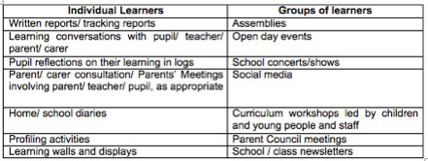

To help achieve these aims, all parents/carers are automatically members of the Parent Forum at their child’s school and are entitled to have a say in selecting the Parent Council (the representative body) to work on behalf of all parents/carers at the school.

The objectives of the Parent Council are:

To work in partnership with staff to create a welcoming school which is inclusive for all parents/carers.

To promote partnership between the school, its pupils and all its parents/carers.

To develop and engage in activities which support the education and welfare of the pupils.

To identify and represent the views of parents/carers on the education provided by the school and other matters affecting the education and welfare of pupils.

To be involved in the recruitment process for appointing the Headteacher and Depute Head.

Any parent or carer of a child at the school can volunteer to be a member of the Parent Council. The Headteacher is the professional adviser to the Parent Council and has a right to attend and speak at Parent Council or Parent Forum meetings.

For more information on the Parental Involvement Act or to find out about parents/carers as partners in their children’s learning please contact the school or North Ayrshire Council Educational Services or visit the Parentzone website on [ParentZone](http://www.parentzonescotland.gov.uk/)



Parentzone Scotland is a unique website for parents and carers in Scotland, from early years to beyond school. The website provides up-to-date information about learning in Scotland, and practical advice and ideas to support children’s learning at home in literacy, numeracy, health and wellbeing and science.

Information is also available on Parentzone Scotland regarding additional support needs, how parents can get involved in their child’s school and education. Furthermore, the website has details about schools including performance data for school leavers from S4-S6; and links to the national, and local authority and school level data on the achievement of Curriculum for Excellence levels.

Parentzone Scotland can be accessed at [ParentZone](https://education.gov.scot/parentzone).

## Reports to Parents/Carers

Learning conversations with teachers, pupils and parents/carers are held in school three times a year. Written reports are made to parents/carers annually in June and will contain information regarding their child's attainment. A copy of this report is kept on file in school for the purpose of transfer of information between teachers in the school and into the secondary sector.

## Supporting Your Child

There are many ways parents/carers can support the school and help their child to make progress.

**Pre-School**

* Provide your child with materials to stimulate interest e.g., books, paints, crayons, scissors, construction materials (Lego), dough etc.
* Let your child assist you in your daily tasks and discuss what you are doing e.g. setting out enough cutlery for the family; putting away and sorting out the shopping; baking-collecting and weighing the ingredients.
* Teach your child to dress/undress himself (don’t worry if shoelaces and anorak zips are too difficult).
* Read stories together and recite nursery rhymes.
* Count steps, lamp-posts, gates etc. up to ten.
* Use words like on, under, high, low, big, little, small, middle, in front of, behind etc., and help your child to understand meanings.

**At School**

* Continue to read to your child for as long as is comfortable for both of you.
* Encourage your child to make use of the local library.
* Set aside a quiet place and time for homework.
* Discuss schoolwork and homework.
* Ensure that your child gets enough sleep.
* Let the school know if you feel your child is worried about something.

All of these suggestions (and I’m sure you can add many more) will help your child to feel that home and school are in partnership and will assist both child and teacher to get the best from each other.

# Section 9: Pupil Data Collection and Protection Policies Transferring Educational Data about Pupils

The Scottish Government and its partners collect and use information about pupils through the Pupil Census to help to improve education across Scotland. This note explains why we need this information, how we use it and what we do to protect the information supplied to us.

Why do we need your data?

In order to make the best decisions about how to improve our education service, Scottish Government, education authorities and other partners such as the SQA and Skills Development Scotland need accurate, up-to-date data about our pupils.

We are keen to help all our pupils do well in all aspects of school life and achieve better examination results. Accurate and up-to-date data allows us to:

* Plan and deliver better policies for the benefit of all pupils
* Plan and deliver better policies for the benefit of specific groups of pupils
* Better understand some of the factors which influence pupil attainment and achievement
* Plan and implement targeted approaches to reducing the poverty-related attainment gap
* Share good practice
* Conduct teacher workforce planning
* Target resources better
* Enhance the quality of research to improve the lives of young people in Scotland
* Provide a window on society, the economy and on the work and performance of government by publishing statistical publications and additional tables about School Education providing school level information.

## Data Policy

Information about pupils’ education is collected through our statistical surveys in partnership between the Scottish Government and Local Authorities through the ScotXed Programme which aims to help schools and Local Authorities by supporting efficient collection, processing and dissemination of statistical information. The Scottish Government then provides analysis of the data to support research, planning, management and monitoring of education services as well as to produce National Statistics publications.

Education data within Scottish Government is managed effectively by secure systems and is exploited as a valuable corporate resource, subject to confidentiality restraints. As part of its data policy, Scottish Government will not publish or make publicly available any information that allows individual pupils to be identified, nor will data be used by Scottish Government to take any actions in respect of individuals. Data is held securely and no information on individual pupils can or would be made publicly available by Scottish Government.

The individual data collected by Scottish Government through the Pupil Census is used for statistical and research purposes only.

## Your Data Protection Rights

Any sharing or linkage of data will be done under the strict control of Scottish Government, and will be consistent with their data policy and the National Data [Linkage](http://www.gov.scot/Topics/Statistics/datalinkageframework) Guiding Principles. Decisions on the sharing or linkage of data will be taken in consultation with relevant colleagues and individuals within and outwith Scottish Government as part of a Data Access Panel.

At all times the rights of the individual (children or adults) under the GDPR and other relevant legislation will be ensured. Further information can be found on:

[Privacy Information](https://www2.gov.scot/topics/statistics/scotxed/schooleducation/ESPrivacyNotices)

## Concerns

If you have any concerns about the ScotXed data collections you can email the Data Protection & Information Assets Team on [dpa@gov.scot](mailto:dpa@gov.scot) or the Head of Education Analytical Services, Mick Wilson, at [mick.wilson@gov.scot](mailto:mick.wilson@gov.scot)or by writing to Education Analytical Services, Area 2A-North, Victoria Quay, Leith, EH6 6QQ. Alternative versions of this page are available, on request from the ScotXed Support Office, in other languages, audio tape, Braille and large print.

Alternatively complaints may be raised with the Information Commissioners Office at [casework@ico.org.uk](mailto:casework@ico.org.uk).

# Important Contacts Appendix 1

## Department of Education



Head of Service Caroline Amos

North Ayrshire Council,

Cunninghame House,

IRVINE

KA12 8EE

01294 324416

Head of Service Andrew McClelland

North Ayrshire Council

Cunninghame House

IRVINE

KA12 8EE

01294 324413