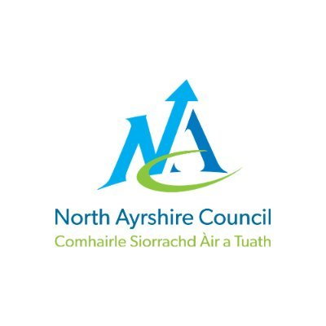



Triple P

A programme for parents and carers

We hope that all parents enjoy their children's 'Incredible Years', but being a parent is, without a doubt, the hardest job of all.
There are opportunities across North Ayrshire for parents to join Triple P groups.

Parenting can be fun!
The group sessions support and empower parents/carers to continue to build positive relationships and interaction with their child.
The programs are delivered to groups of parents/cares of children aged 2-12years.
The groups will help with:
- Building relationships between parents/carers and children
- Supporting children to develop independent behaviours and routines, such as mealtimes, bedtimes, getting dressed and following house rules.
- Managing behaviours such as tantrums.
- Helping to promote their children's learning, social, and emotional skills and address challenges such as conduct or emotional regulation.

For further information contact –

