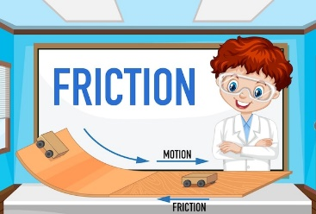

**IMPORTANT DATES THIS TERM**

**6th September Open evening 5 -7pm**

**9th September Carving event in the Manse Field**

**13th September Roald Dahl Day – Wear yellow or dress as favourite character.**

**18th September In-Service Day**

**25th September Maths Week Scotland**

**27th September Early Years Coffee Morning Fundraiser**

**9th October Rights Respecting Schools Week – Climate Change**

**13th October School Closes 3pm**

**23rd October School Returns**

Other Curricular Areas

* Science:

-Forces: investigating friction.

* French
* Numbers and greetings.
* Art
* Styles of art.
* Childrens Rights

-Right of the Week. Rights respecting schools focus week - Climate change.

**CLASS NEWS**

P.E. will be on a Tuesday and Friday. We have a bucket for PE kits if you wish for them to be kept in school. No jewellery should be worn on PE days (or children should be able to remove independently). Every () we will have Outdoor Learning. Please ensure your child brings old clothing which are suitable for all weathers. Children should come to school in their uniforms.

Literacy & English

* Reading:
* Novel study on our book ‘Wonder’.
* Visualising, predicting, and connecting.
* Writing:

-VCOP - Imaginative writing

- parts of speech and grammar.

* Talking and Listening:

- Presenting - Detailed responses to class novel.

Health & Wellbeing

* Substance misuse.
* SHANARRI (Wellbeing Indicators)
* Gymnastics and hockey.
* Establishing class charter.
* Working as a team.

Numeracy & Mathematics

* Place value using 5-digit numbers.
* Estimating and rounding.
* Addition and subtraction (carrying and exchanging).
* Word problems involving 2 or 3 step number processes.
* 2D and 3D shape.

**Please keep this newsletter in a safe place. Look out for updates from the school office via the Xpressions app and Seesaw notifications from your child’s teacher.**

**Beith Primary School Termly Newsletter Term 1, 2023 *P5***