Home Learning Grids – Early Level (P1 and P2)

Each day, choose 1 Literacy task, 1 Numeracy task and 1 ‘Other’ task. Send pictures or videos of any completed tasks to your teacher on Seesaw if you can.

If you would like extra things to do then try the challenges added to some of the tasks, and also see the list of additional activities below the grid.

Week 1
Literacy | Numeracy | Other
Phonics  Fill an empty clear plastic bottle with a variety of small items that start with various letters, using rice as a filler for the rest of the space. Now shake the bottle and try to find an object for each letter to practice beginnings sounds. | Number Parts  Choose a number between 3 and 20.  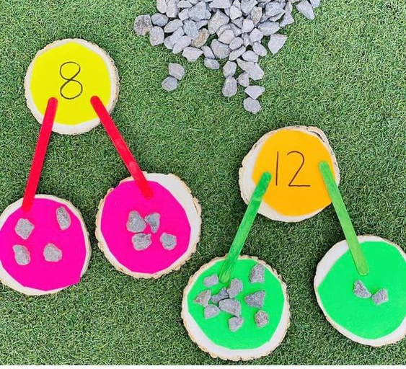  Use stones, pasta, cereal or lego bricks to split the number into 2 parts. | PE  Complete a ‘PE with Joe Wicks’ workout. Click here to take you to a list of videos to choose from.  *Challenge: Create your own workout for your family to try.
Draw/write  Draw a picture of your favourite animal.  *Challenge Write a sentence to describe your animal. Is it big or small? Fluffy or scaley? Does it live in water or on land? | Numbers all around us  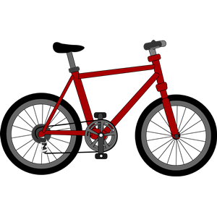  Look around your home and garden to see if you can spot numbers to 20. For example, you might see 1 tree in your garden, 3 bikes in your garage, 15 books on the shelf etc. | Health and Wellbeing  Watch this video of the colour monster story. Look out for the questions at the end of the video and try to answer them.  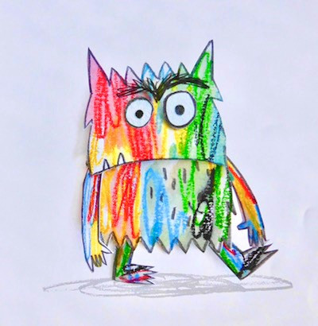  *Challenge: Can you draw a picture of the colour monster and colour him with the colour that you are feeling just now?
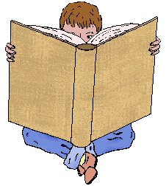  Story Book Reading Challenge  Read your favourite book and record a video of you telling us about it.  You can choose a book in your home or a book from bug club.  In your video, make sure to tell your teacher the title and author of the book. Tell your teacher if you enjoyed it and what part you liked best. *Challenge: Include what happened in the beginning, the middle and the end of the story. | Measure  Look around and find things in your house to measure. It could be a table, a bed, a book, a toy…anything!  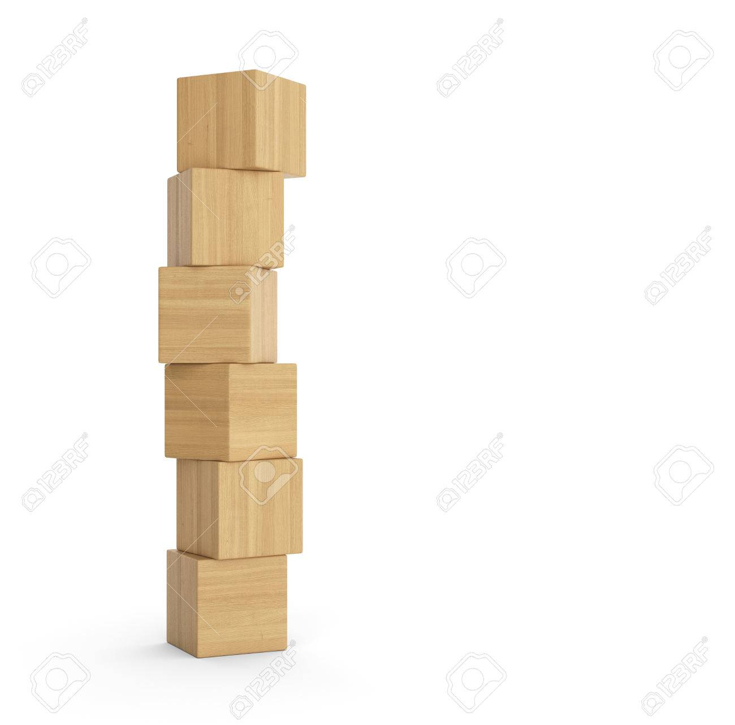  Can you measure how high it is?  What could you use to measure the height?  How many hands tall is it? How many cups / books / blocks high is it? | STEM Challenge  Design and make a musical instrument then play it along to your favourite song.  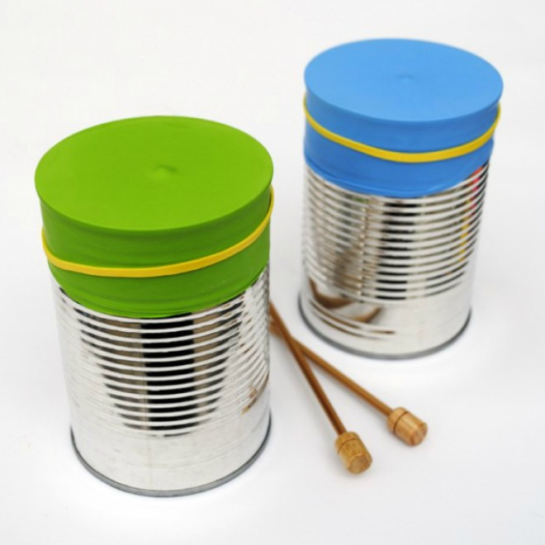  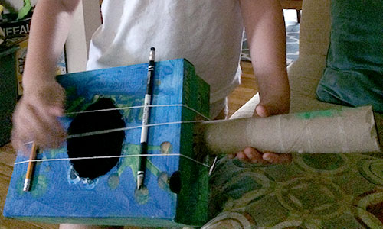
Spelling  Ask an adult to write out the numbers zero to twenty (in words). Practice writing them by:  - using your finger to trace the letters in a tray of salt, sugar or shaving foam.  - using play doh, wool or pasta to make the letters of each word  - using your finger to air write the words  *Challenge: Can you write the words using cursive letters? | Addition and Subtraction  The floor is lava! Ask someone else from your family to put numbers on the floor on bits of paper. They then have to ask you questions and you can jump onto the answer, but make sure you get it right, because the floor is lava! Can you cross to the other side of the room? | PE  Have a disco and dance to your favourite music.
Fine motor  Develop your finger muscles by drawing a spiral on a piece of paper and adding small objects to the spiral to cover all of the lines.  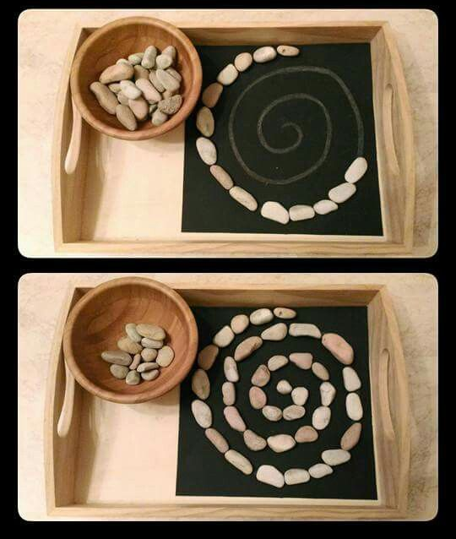  *Challenge: Try using these small objects to write your name rather than making a spiral. | Pattern  Use objects from your home to create a colour pattern.  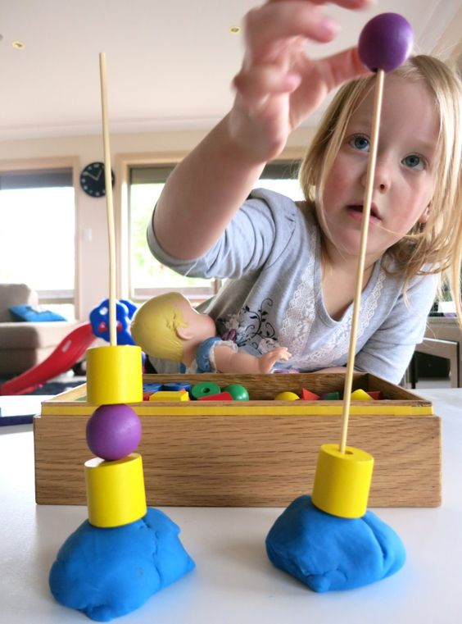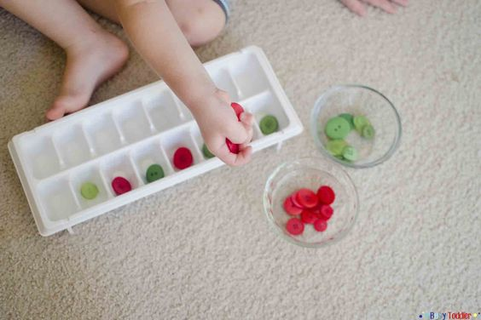  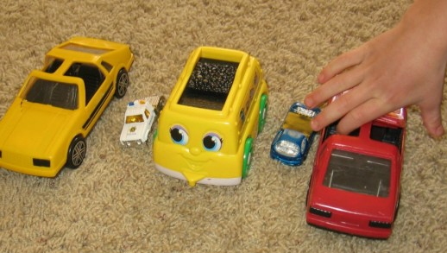  Can you try making a shape pattern? | 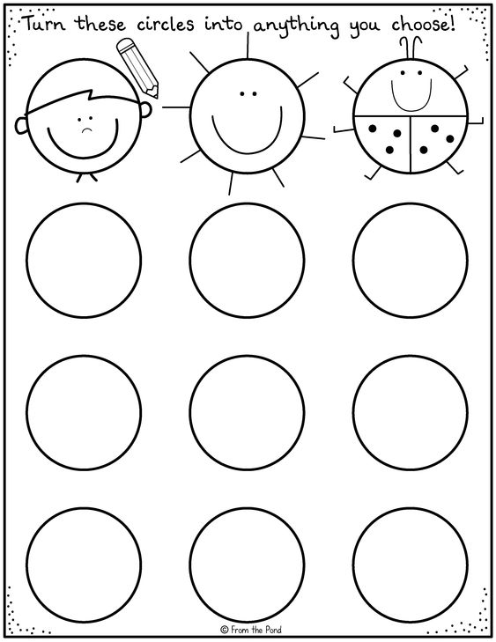  Art  Draw around a cup to make lots of circles on a piece of paper.  Now turn each circle into a different picture.
Please complete a minimum of 15 minutes per day reading. If you don’t have any books at home, try reading magazines, cookbooks, comics or online books via Bug Club. https://www.activelearnprimary.co.uk/ Your child should have their own log in.
Children have a log in for Espresso & Education City, which cover all areas of the curriculum https://www.educationcity.com/ (ask your child’s teacher if they don’t know their log in) https://online.espresso.co.uk/espresso/login/
Oxford Owls have a library of free books: https://www.oxfordowl.co.uk/
Free audiobooks for children: https://www.storynory.com/
Lots of free maths games: https://www.topmarks.co.uk/
Learn, create and play through exploring Scotland’s history and heritage: https://www.historicenvironment.scot/learn/
STEM (Science, Technology, Engineering & Maths) with Mr N: https://www.youtube.com/channel/UCxziq4omrQP-EKSLilOIPhw

Week 2
Literacy | Numeracy | Other
Story Time and Rhyme  Watch the story of The Lion Inside. Can you spot any rhyming words? | Counting in 5’s  https://www.bbc.co.uk/bitesize/articles/zhfjqp3  This link takes you to a bbc bitesize lesson about counting in 5’s. There are 2 short videos to watch and then an activity to do. Don’t worry about doing the worksheet at the end. | 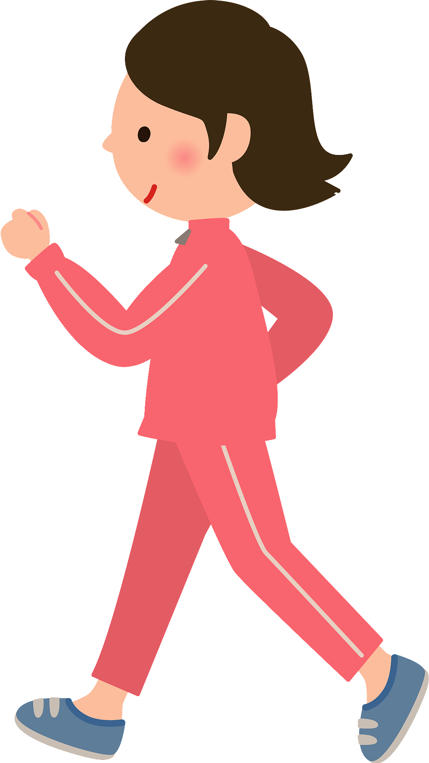  PE  Count yourself taking 200 steps around your house. Can you touch every wall in the house?
Draw/write  Make a card for someone special.  Draw a lovely picture on the front and write a nice message inside if you can.  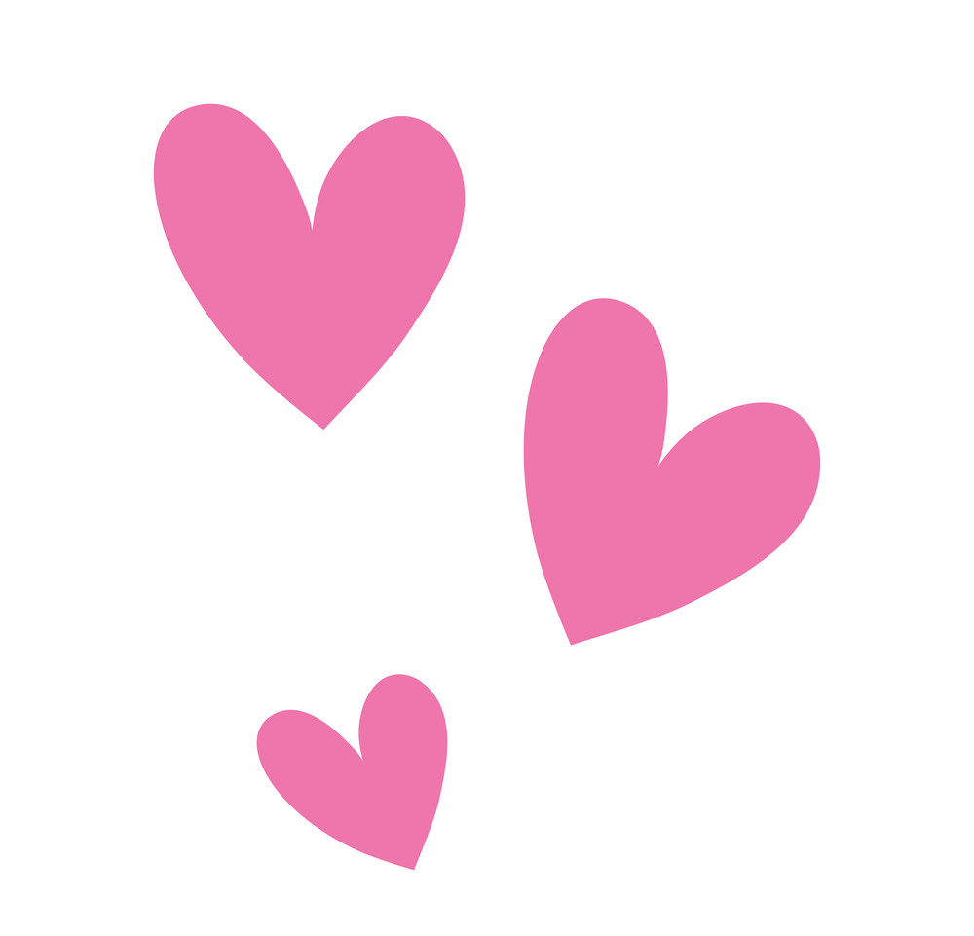  Tell the person what makes them so special to you. | Addition and Subtraction  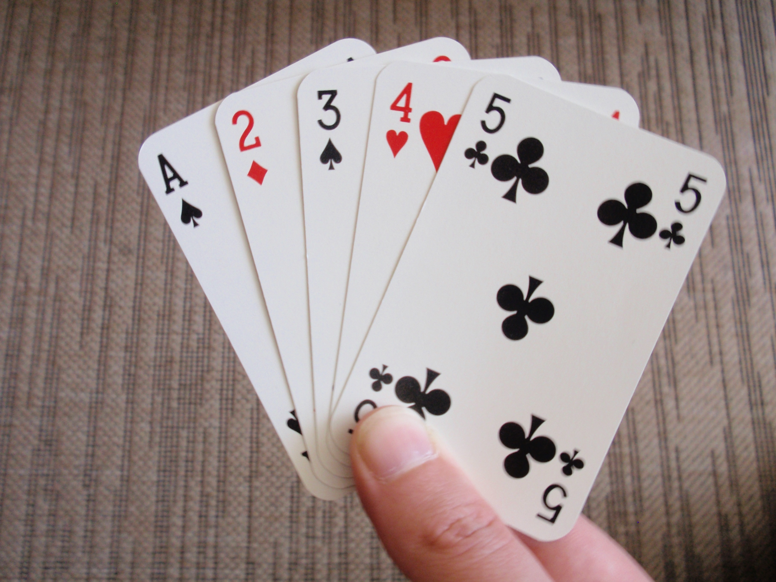  Make an addition and subtraction game using any cards you have in the house – playing cards / uno cards etc. Take turns to turn over the 2 cards at the top of the pile. Use those 2 numbers to add them together, and to subtract the smaller number from the bigger one. If you get the answers right, you get to keep the cards. The person with the most cards at the end is the winner! | Health & WellBeing  Discuss with your adult: What is a worry? Who might have worries? What do you do when you have a worry? Who could you ask for help?  On youtube watch and listen to The Worry Box story.  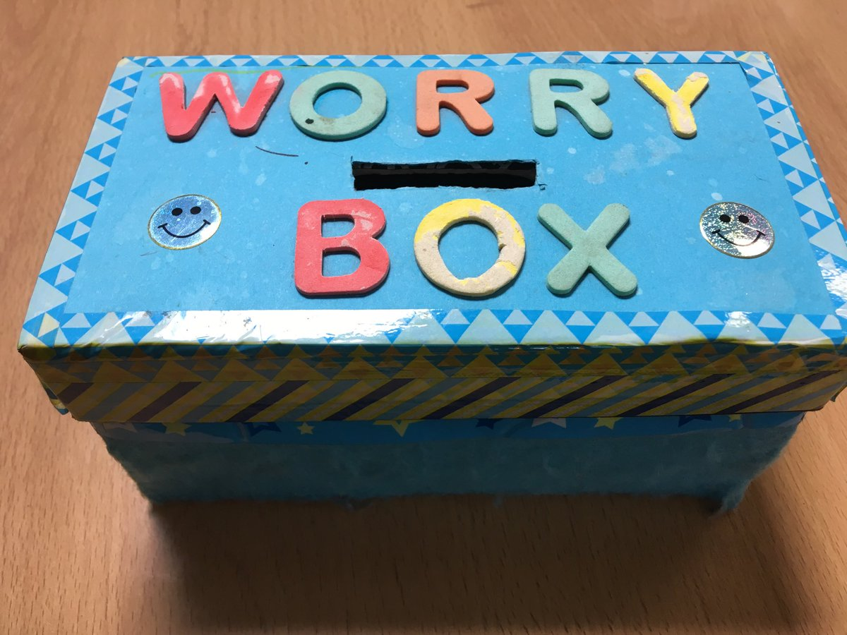  Design a worry box like Murray Bear’s.  You could decorate a cereal box, and leave a hole to put slips of paper in with your worries on.  Tell an adult about your worry box so that they can check it for any worries you have.
Story Book Reading Challenge  Read a book from your house or choose one from Bug Club.  Design a new front cover for the book. | Measure and Shape  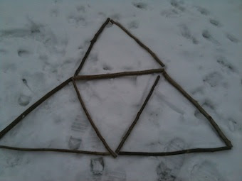  Collect as many sticks as you can from your garden or use some straws or dry spaghetti. First put the sticks in order from smallest to biggest. Now use them to see how many triangles you can make. What other shapes can you make? | STEM Challenge  Make an apple boat – does it float?  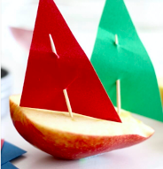
Spelling  Ask an adult to write out the months of the year. Practice writing them by:  - rainbow writing  - dotted writing  - cut letters out of magazines or newspapers and stick them to paper to make the word.  *Challenge: Can you write the words using your ‘wrong’ hand? | Addition  How many doors are in your house?  Double this number.  Add 2.  Take away 1.  What is your answer? | PE  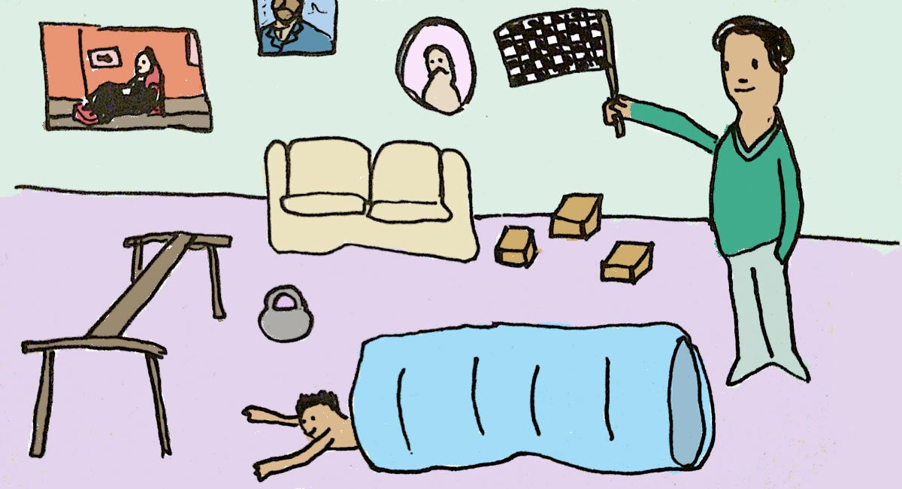  Make an obstacle course either inside or in your garden. Ask someone to time you to see how quickly you can complete it. Maybe you could have a family competition to see who is the fastest!
Fine motor  Make some play dough and have a dough disco!  Join in the dough disco here.  Play dough recipe:  8 tbsp plain flour, 2 tbsp table salt, 60ml warm water, food colouring, 1tbsp veg oil.  - Mix flour & salt. In separate bowl mix water, few drops of food colouring & the oil. Pour the coloured water into the flour mix and bring together with a spoon. Dust a work surface with a little flour and turn out the dough. Knead to form a smooth, pliable dough. Store in a sealed bag in the fridge to keep fresh! | Adding on 1 and 2  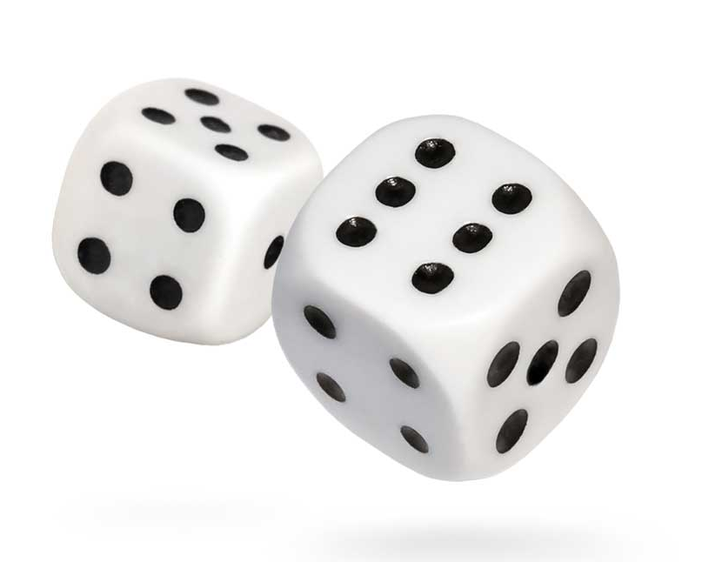  Roll a die and add 1 to whatever number you roll. Now add 2.  *Challenge yourself by using 2 dice. | Art  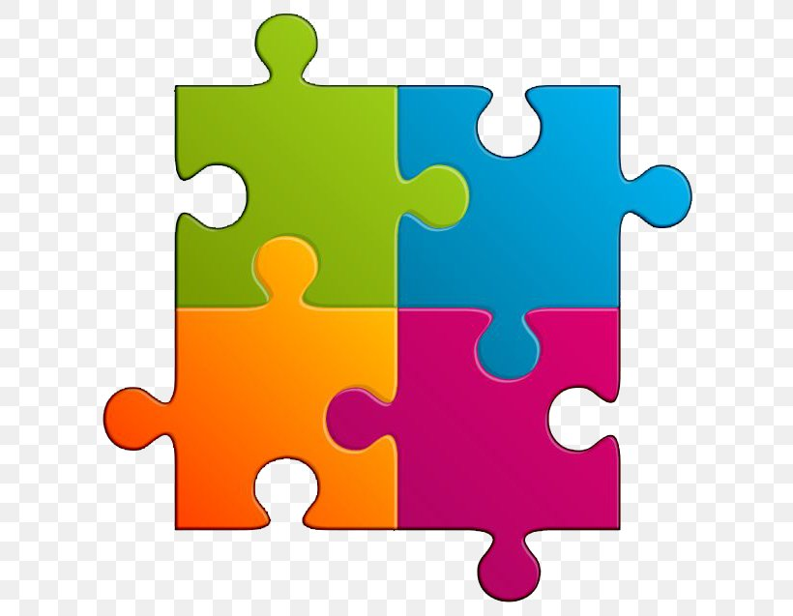  Draw a picture on the carboard from a cereal box and ask an adult to help you cut it to make a jigsaw.  Can you put it back together again once the pieces have been mixed up?
Please complete a minimum of 15 minutes per day reading. If you don’t have any books at home, try reading magazines, cookbooks, comics or online books via Bug Club. https://www.activelearnprimary.co.uk/ Your child should have their own log in.
Children have a log in for Espresso & Education City, which cover all areas of the curriculum https://www.educationcity.com/ (ask your child’s teacher if they don’t know their log in) https://online.espresso.co.uk/espresso/login/
Oxford Owls have a library of free books: https://www.oxfordowl.co.uk/
Free audiobooks for children: https://www.storynory.com/
Lots of free maths games: https://www.topmarks.co.uk/
Learn, create and play through exploring Scotland’s history and heritage: https://www.historicenvironment.scot/learn/
STEM (Science, Technology, Engineering & Maths) with Mr N: https://www.youtube.com/channel/UCxziq4omrQP-EKSLilOIPhw

