Home Learning Grids – Second Level (P5, 6 &7)

Each day, choose 1 Literacy task, 1 Numeracy task and 1 ‘Other’ task. Send pictures or videos of any completed tasks to your teacher on Seesaw if you can.

If you would like extra things to do then try the challenges added to some of the tasks, and also see the list of additional activities below the grid.

Week 1
Literacy | Numeracy | Other
Keep a diary  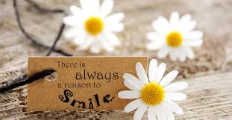  Write a diary entry for each day that you spend at home. Write about what you did that day and how you felt. Some days you might feel great and other days might be harder, but try to find 3 positive things to write about each day. You could illustrate your diary as well. | Area / Perimeter – Design an obstacle course  Create an official name, and design a logo for your obstacle race course.  Create a draft drawing of an obstacle course with at least 6 different obstacles. The perimeter of the course should be 100cm. There must be a clear direction for the course to be completed, there must be at least 2cm between each obstacle, and no obstacle should be more than 6cm².  Find the area and perimeter of each item on the course. Check that everything meets the requirements.  Now create the final version of your race. Include colour and detail! It can be 3D or 2D. | PE  Complete a ‘PE with Joe Wicks’ workout. Click here to take you to a list of videos to choose from.  *Challenge: Create your own workout for your family to try.
Choose a topic that interests you. It could be sport, music, cooking, animals, or anything else. Create a fact-file for your topic. Split it into different sections and have a page for each of them. This could be on paper on powerpoint. Include key facts and drawings/images. Make it colourful and interesting to read. | Can you complete the place value challenge cards?  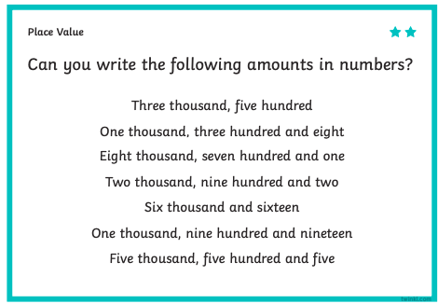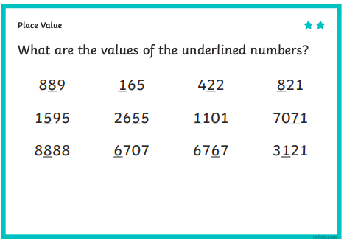 | Health and Wellbeing  Random Act of Kindness.  Being kind to others can also be a great boost for the person being kind. Think of 5 ways you can show kindness from where you are now at home, and then do them!
Read a book from your home or from Bug Club. Write a tweet summarising the book. Remember you can only use 140 characters in a tweet! | 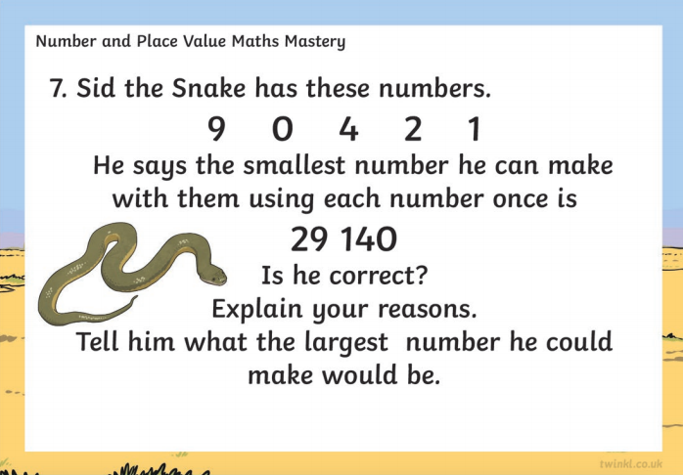  Can you complete the challenge? | STEM Challenge  In your basin, sink or bath build a dam that can withhold 750ml of water. Think about what materials you could use, they must be able to resist the water at one side!
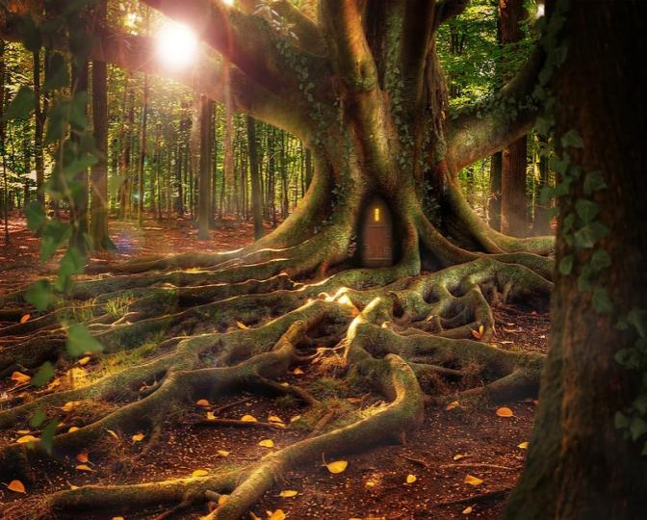  Writing – Imaginative  Imagine you are walking alone in the forest and you come across this tree. You go through the door…what do you find? What adventures are on the other side? Write a story with a beginning, middle and end all about what happens on the other side of this door. Remember to use VCOP to uplevel your writing. | Can you solve this problem?  James, Andrew and Lyndsey have a total age of 40. Lyndsey and Andrew’s combined age is 22. Lyndsey is older than Andrew but younger than James by 5 years. Andrew is half the age of James. What are their ages? | PE  How long can you run on the spot for?  *Challenge: Can you make your own obstacle course and try it out?  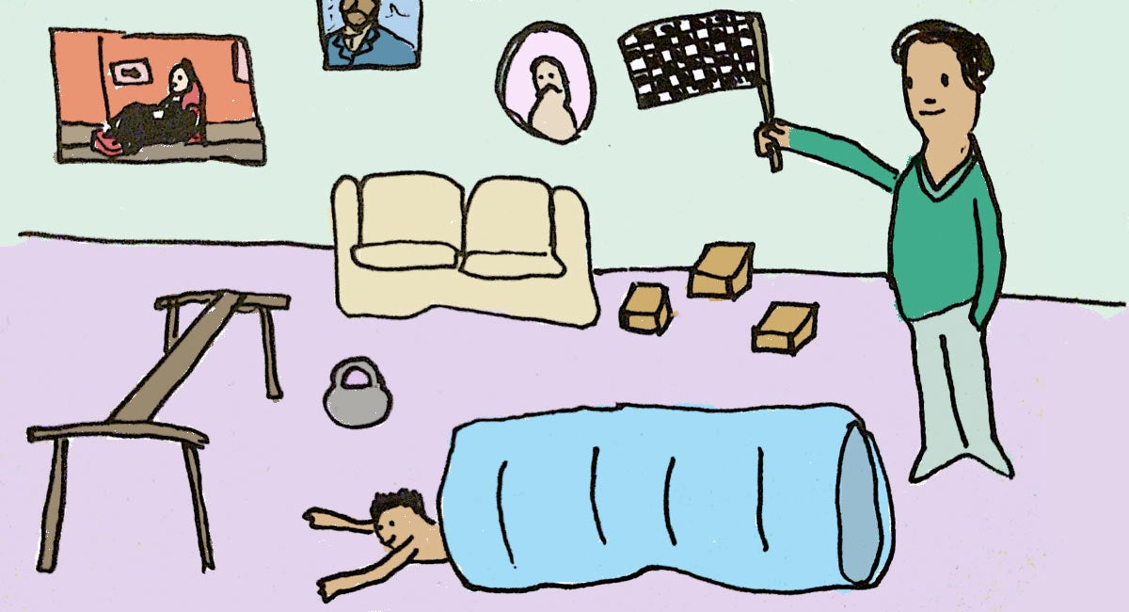
Research  Who is your hero? Is it a celebrity, a family member, someone you know from the community? It could even be a book or film character. Think about what makes them your hero.  Find out as much information as you can about your hero. Make a presentation (you could use paper or powerpoint) to display at least 5 facts about your chosen person. | Sumdog  Spend 45 minutes on Sumdog- if your teacher has set your class a challenge, complete this first. If not, choose your own games! https://pages.sumdog.com/ | STEM Challenge  What is the tallest structure you can build with just one pack of cards?  Measure the height of your structure!  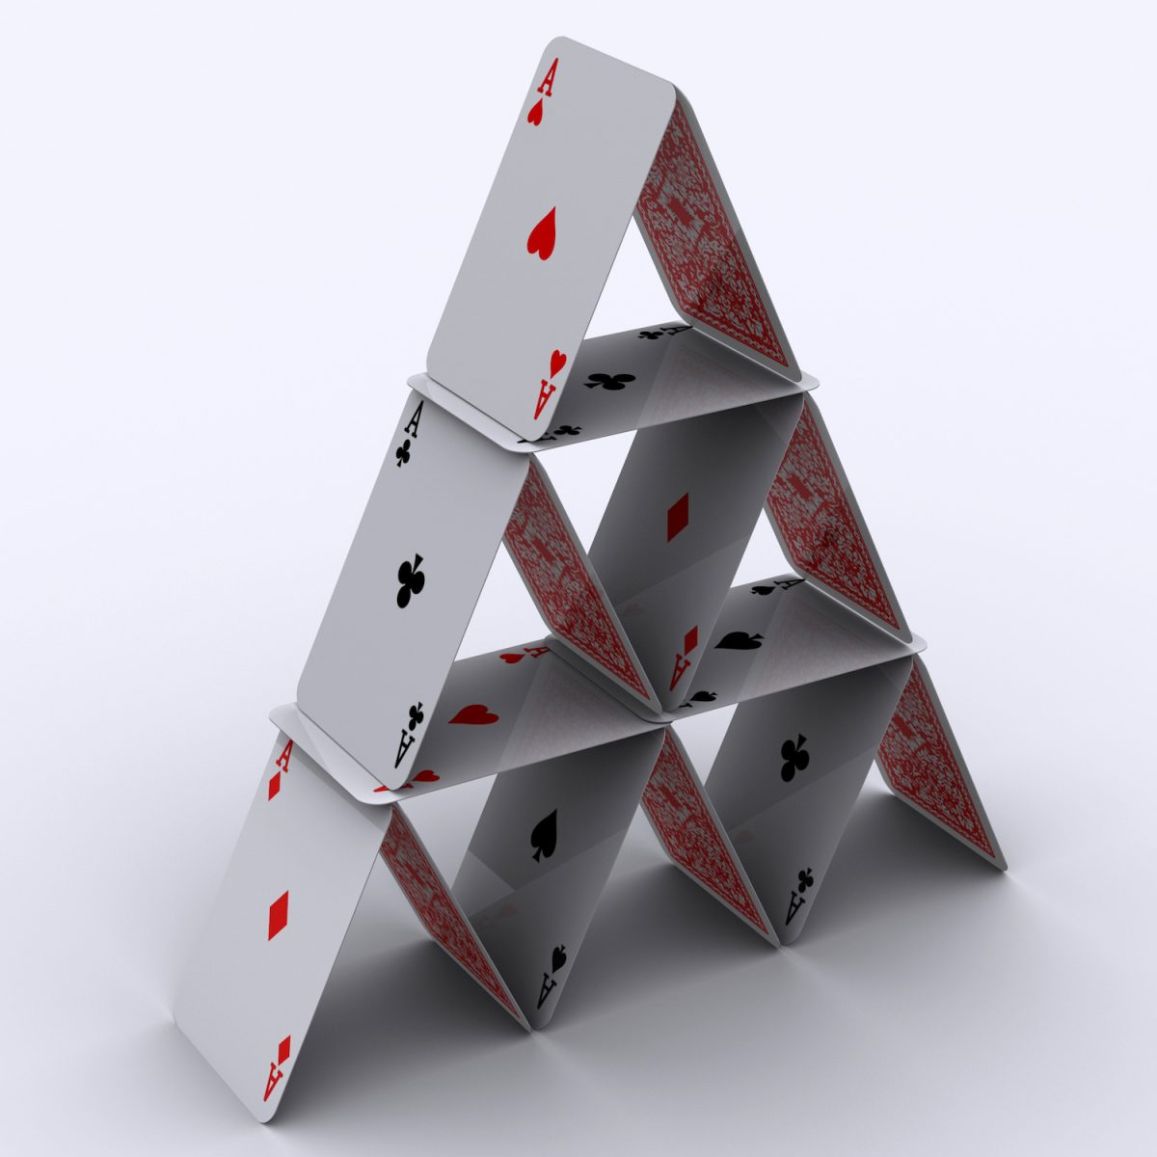
Please complete a minimum of 15 minutes per day reading. If you don’t have any books at home, try reading magazines, cookbooks, comics or online books via Bug Club. https://www.activelearnprimary.co.uk/ Your child should have their own log in.
Children have a log in for Espresso & Education City, which cover all areas of the curriculum https://www.educationcity.com/ (ask your child’s teacher if they don’t know their log in) https://online.espresso.co.uk/espresso/login/
Oxford Owls have a library of free books: https://www.oxfordowl.co.uk/
Free audiobooks for children: https://www.storynory.com/
Lots of free maths games: https://www.topmarks.co.uk/
Learn, create and play through exploring Scotland’s history and heritage: https://www.historicenvironment.scot/learn/
STEM (Science, Technology, Engineering & Maths) with Mr N: https://www.youtube.com/channel/UCxziq4omrQP-EKSLilOIPhw

Week 2
Literacy | Numeracy |  | Other
Here are lots of alternative words for ‘went’.  Now make a list of alternative words for ‘said’. |  | 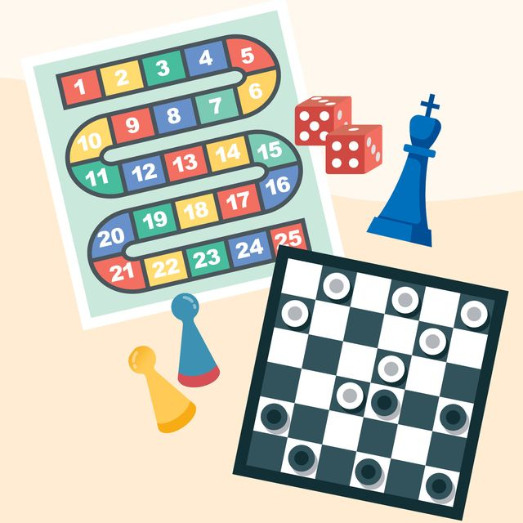  Create a new board game.  Your game must incorporate maths skills – maybe you have to answer maths questions to move on, or maybe it is similar to the game ‘battleships’ where you use your knowledge of co-ordinates.  Design your game, think about the instructions and rules, and then create the resources it needs. Now have a go at playing your new game with your family! |  | 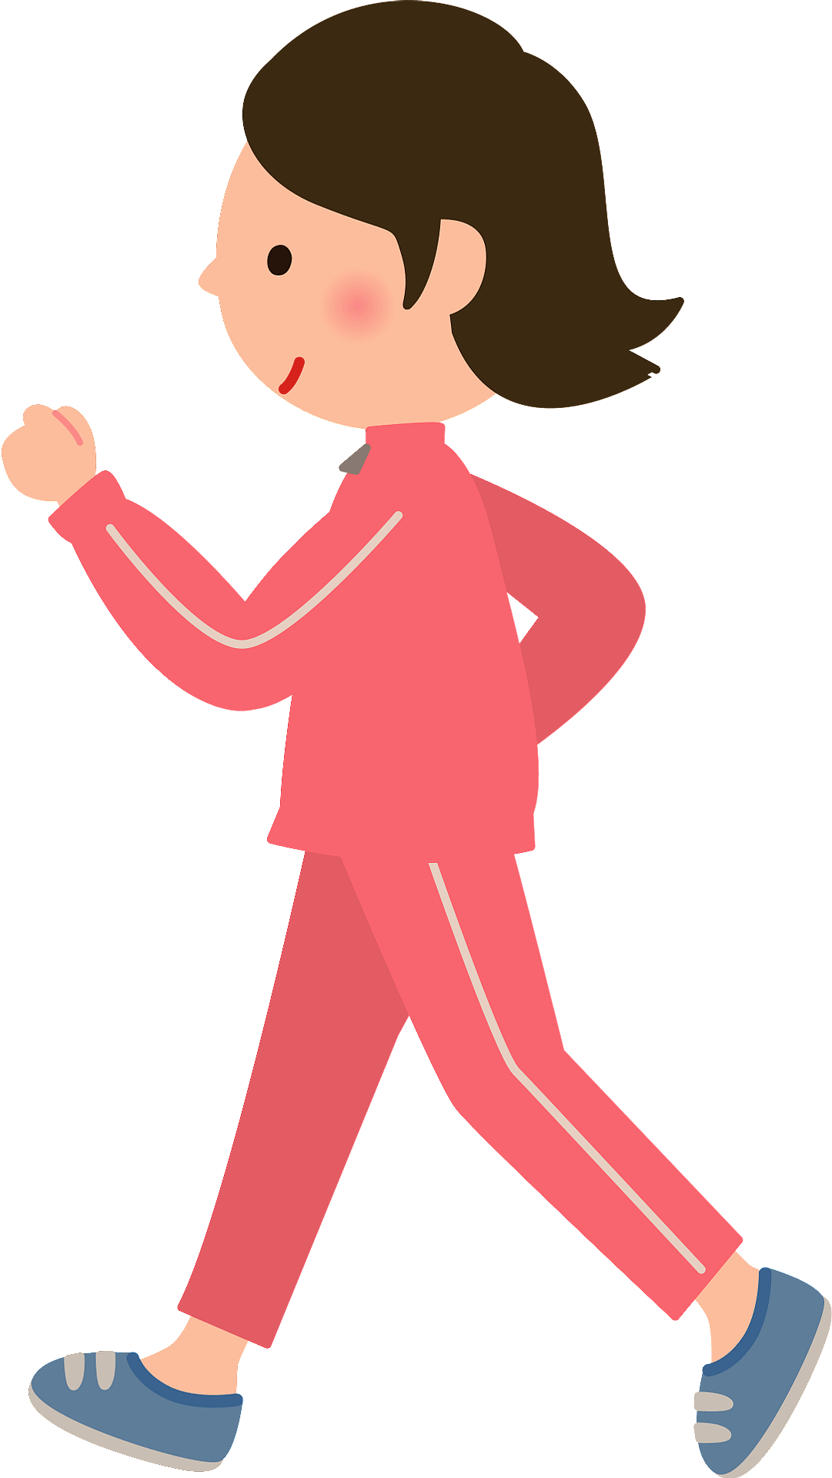  PE  Count yourself taking 200 steps around your house. Can you touch every wall in the house?
Writing  Write a letter to someone special. It could be a friend, a family member or even a famous person that you admire.  Start the letter with your address and the date in the top right corner.  Use paragraphs to write in sections. Your first paragraph could be about what makes them special to you.  If you have their address then you could keep it to post to them where you are able to, or you could send it on an email. | Think carefully about this one!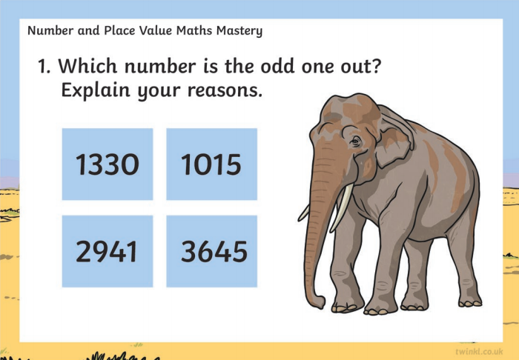 |  | Skittles Science  Watch the video then have a go yourself!  https://www.youtube.com/watch?v=4FHbbc8v1Cs  Make a circle with skittles on a plate, add warm water and enjoy the rainbow!
Reading Challenge  Read a book from your house or choose one from Bug Club.  Design a new front cover for the book.  *Challenge: write a different ending for the story | Have a go at these challenges!  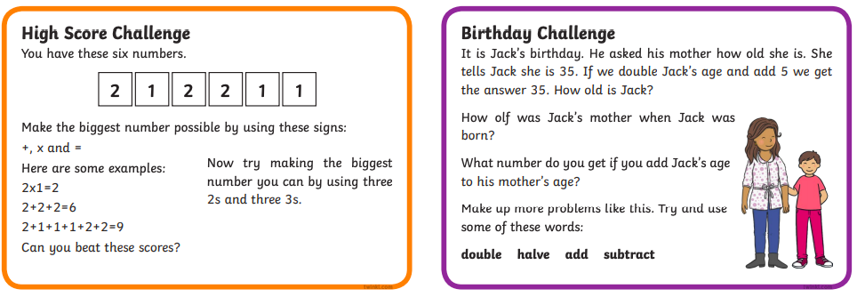 |  | STEM Challenge – Expanding Gases  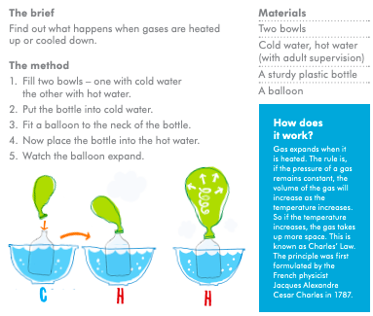
Writing – Imaginative  Once upon a time, far, far away there was a tiny kingdom that floated high above the clouds. Create a fairytale that is set in this city. Remember that fairy tales involve magic and end with Happily Ever After. | Have a go at lighting the lights on the link below. Can you work out the rule for making each of them light up?  https://nrich.maths.org/7044&part= |  | PE  Have a go at dancing to some of your favourite songs with Just Dance!  Try some from here to get started.
Reading Challenge  Read a book from your house or choose one from Bug Club.  Write a list of 5 questions that you would like to ask the main character.  Now try to imagine that you are that character, and see if you can answer the questions! | Have a go at playing Hit the Button. Challenge yourself with some of the harder levels!  https://www.topmarks.co.uk/maths-games/hit-the-button |  | 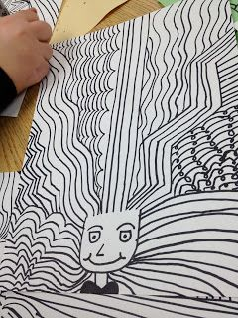  Art  Create a crazy hair day portrait!  Draw a U-shape near the bottom of the paper. Choose about 5 different types of line to ‘grow’ out of the U shape. Repeat each line at least 5 times. Continue to add lines until the space is filled. Add a neck, shoulders and a face for a crazy hair day!
Please complete a minimum of 15 minutes per day reading. If you don’t have any books at home, try reading magazines, cookbooks, comics or online books via Bug Club. https://www.activelearnprimary.co.uk/ Your child should have their own log in.
Children have a log in for Espresso & Education City, which cover all areas of the curriculum https://www.educationcity.com/ (ask your child’s teacher if they don’t know their log in) https://online.espresso.co.uk/espresso/login/
Oxford Owls have a library of free books: https://www.oxfordowl.co.uk/
Free audiobooks for children: https://www.storynory.com/
Lots of free maths games: https://www.topmarks.co.uk/
Learn, create and play through exploring Scotland’s history and heritage: https://www.historicenvironment.scot/learn/
STEM (Science, Technology, Engineering & Maths) with Mr N: https://www.youtube.com/channel/UCxziq4omrQP-EKSLilOIPhw

